Dartmouth Films Presents:
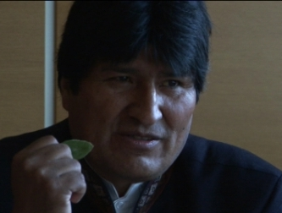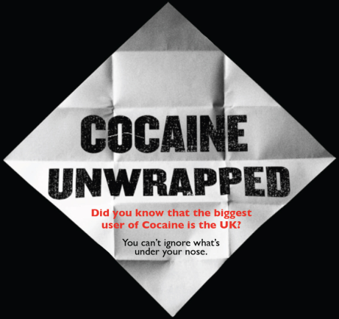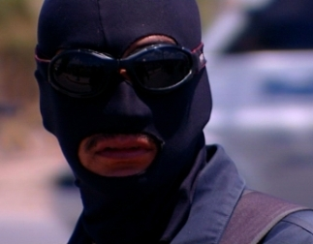

COCAINE UNWRAPPED
A film by Rachel Seifert
PREMIERE LAUNCH WEDNESDAY MAY 16 2012, 8.30pm Prince Charles Cinema, Leicester Square
Cocaine Unwrapped Do not miss this riveting mixture of front-line reportage and unprecedented access to the political leaders of Latin America. While Western demand for cocaine reaches record levels, so does the violence at every stage of the global trade in the drug. Cocaine Unwrapped explores the international network of violence, imprisonment, poverty and addiction caused it its wake. Highly topical and occasionally shocking, this is the ‘war on drugs’ as never seen before. This is Cocaine Unwrapped.
Screening followed by a Q&A discussion with Mike Trace (Chairman of the International Drug Policy Consortium and the former deputy UK drug tzar) and Grace Livingstone of the Latin American Bureau and author of ‘Inside Colombia: Drugs, Democracy and War’.
“A highly topical documentary…with fascinating interviews [which] make us aware of the West’s need to take more responsibility for the demand that drives the trade. Time Out, London

VIEW THE VIMEO TRAILER HERE
BUY TICKETS FOR THE PRINCE CHARLES PREVIEW HERE
NEWS, PICTURES, VIDEOS AND UPDATES ON OUR FACEBOOK PAGE

