CI-GCF/GEF AGENCIES
ENVIRONMENTAL AND SOCIAL SAFEGUARDS (ESS) SCREENING REPORT

Preliminary Screening (Conceptual Stage) Second Screening (Proposal Stage)

I. PROJECT INFORMATION

- Basic Project Profile
Countries: Brazil | GEF Project ID: 11124
Project Title: Restaura Biomas - Enabling large-scale restoration through National for Native Vegetation Recovery Policy in Brazil
Program: Ecosystem Restoration (Integrated Program)
Executing Agency (EA): WRI-Brasil
GEF Focal Area: Multi-focal
GEF Project Amount: USD$13,397,248
CI-GEF Project Manager: Daniela Carrion
ESS Analysis Performed by: Ian Kissoon, Senior Director of ESMF, CI-GCF/GEF Agencies
Date of Analysis: June 19, 2024

- Summary of Project Risk Categorization, ESS Standards Triggered and Mitigation Plans Required
Project Category: | Category A |  | Category B | Category C
Project Category: |  |  | X
The proposed project activities have the potential to cause negative environmental and social impacts. However, the impacts are anticipated to be less adverse than those of Category A projects, site-specific, and mitigation measures can be designed more readily than for Category A projects.
ESS Standards Triggered:
Environmental & Social Impact Assessment |  | Cultural Heritage
Protection of Natural Habitats and Biodiversity Conservation  Resett. & Physical/Economic Displacement  Indigenous Peoples  Resource Efficiency & Pollution Prevention |  | Labour and Working Conditions  Community Health, Safety and Security  Private Sector Direct Investments and Financial Intermediaries  Climate Risk and Related Disasters
Mitigation Measures Required:
Limited or Full ESIA  Environmental & Social Management Plan  Plan for Natural Habitat Protection and Biodiversity Conservation  Voluntary Resettlement Action Plan  Process Framework  Indigenous Peoples Plan |  | Resource Efficiency & Poll. Prevention Plan  Cultural Heritage Management Plan  Labour Management Procedures  Community Health, Safety and Security Plan  Environmental and Social Management Framework/System  Climate and Disaster Risk Management Plan

- Project Objective:
To mitigate greenhouse gas emissions, conserve biodiversity, enhance ecosystem resilience, and improve the socio-economic well-being of local communities.

- Project Description:
The project aims to support Brazil’s restoration commitments by directly supporting activities aligned with native vegetation recovery policies such as PROVEG and PLANAVEG to support native vegetation recovery activities across all biomes of Brazil.

The project will address various barriers to native vegetation recovery initiatives by focusing on four key components:

Component 1 - Public policies: National and subnational frameworks will be strengthened to promote cross-sector coordination and enable policy implementation. With the enabling conditions in place, native vegetation recovery at scale is achieved through public policies and instruments, such as programs, plans, incentives, and others, generating climate, biodiversity and social benefits.
Outcome 1.1: The recovery of native vegetation on a large scale is promoted through the alignment and coordination of public policies, programs, plans, strategies, and legal instruments, in a way that is inclusive and gender-responsive.
● Output 1.1.1: Inclusive and gender-responsive collegiate bodies and participatory decision-making instances are strengthened to enhance policy alignment and coordination.
● Output 1.1.2: Coherent standards and regulations that support large-scale recovery of native vegetation are endorsed by the government.
● Output 1.1.3: Environmental Regularization Programs (PRAs) are under implementation and lessons learned are shared across states.
● Output 1.1.4: A recovery program or plan for native vegetation is established for Federal Protected Areas and under implementation.
● Output 1.1.5: An official integrated monitoring platform/system for the recovery of native vegetation in Brazil is operational.

Component 2 - Networks: Capacity building will help to strengthen restoration coalitions. Native vegetation recovery in scale will restore ecosystem functions and services within public and private protected areas. Compliance with the forest code will be achieved through the improvement of a national program on extension services and technical assistance. Innovations in ecosystem restoration result in transformation impacts that generate global environmental benefits and livelihoods at the scale needed.
Outcome 2.1: Strengthened engagement of governments, private sector, and multi-stakeholder restoration networks supporting the implementation of restoration and improved practices on the ground in priority landscapes.
● Output 2.1.1: Biome-level restoration networks are strengthened with operational management plans under implementation and developing local capacities.
● Output 2.1.2: Public and private Technical Assistance and Rural Extension (ATER) services are strengthened and available to support the implementation of high-quality recovery of native vegetation and improved practices on the ground.
● Output 2.1.3: Demonstration landscape projects that generate benefits to biodiversity and local stakeholders (including women and men) through restoration and improved practices are implemented.

Component 3 - Financial mechanisms: Unlock financial flows and bridge different types of capital to support native vegetation recovery interventions led by local organizations from the civil society, companies from the private sector and governmental agencies. Strengthening policies and instruments helps to value environmental services, create demand for forest products, unlock financial flows, and incentivize environmental compliance of rural properties.
Outcome 3.1: New and/or improved public and private financing mechanisms investing in the recovery of native vegetation and improved practices.
● Output 3.1.1: New and/or improved public and private funding mechanisms (e.g., investment funds, rural credit, grants) financing the recovery of native vegetation and improved practices.
● Output 3.1.2: Payment for Ecosystem Services (PES) schemes and carbon markets (regulated and voluntary) financing the recovery of native vegetation and improved practices at the landscape level.
● Output 3.1.3: Bilateral and multilateral arrangements increase funding commitments to the recovery of native vegetation and improved practices at the landscape level.
● Output 3.1.4: Investments in value chains that promote the recovery of native vegetation and improved practices (agroforestry systems, silviculture of native species, and integrated crop-livestock and forestry systems) at the landscape level are secured.

Component 4 - Monitoring and Evaluation: In accordance with CI-GEF policies and procedures, the project will complete regular reporting of project metrics. These procedures are set out in the Monitoring and Evaluation Plan.
Outcome 4.1. The project monitoring and evaluation system that allows knowledge management and dissemination is developed and implemented.
● Output 4.1.1: Progress on the project workplan is measured through a robust M&E plan and system.
● Output 4.1.2: Project monitoring and evaluations conducted based on adaptive management approach.
Outcome 4.2: A knowledge management, learning, and dissemination system is developed and shared through the Program-wide Online Platform to be created by the Global Coordination Project (GCP).
● Output 4.2.1: Knowledge management, learning, and dissemination performed by the project and shared through the Program-wide Online Platform on a continuous basis.

Through these components, the project will work towards strengthening national and subnational policies, enhancing institutional capacity, promoting stakeholder participation, and unlocking financial flows.

- Project location, biophysical and socio-economic characteristics relevant to the safeguard analysis:

The project will be implemented in all biomes in Brazil (Amazon, Atlantic Forest, Cerrado, Caatinga, Pampa and Pantanal). The specific areas of intervention to achieve the project goals will be defined at the beginning of implementation, when it will be possible to evaluate in more detail the specific local realities of the potential indicated territories. Specific to the goal of “recovering 600,000 hectares of native vegetation”, there will be two main lines of action: (i) recovery of vegetation in public protected areas (Conservation Units and Indigenous Lands) and; (ii) recovery of vegetation in Permanent Preservation Areas - APP and Legal Reserve - RL in rural properties. For the recovery of vegetation in Conservation Units - UC, the project will support the National Vegetation Recovery Program in federal Conservation Units, being developed by ICMBio. Regarding the goal of promoting 1,200,000 hectares under sustainable practices by 2030, the project aims to promote better production systems in agriculture, pasture and forestry regions, based on environmental regularization actions. Based on these criteria, the project will operate preferentially in the states of Mato Grosso, Pará, São Paulo, Minas Gerais, Rondônia, Mato Grosso do Sul, and Bahia.
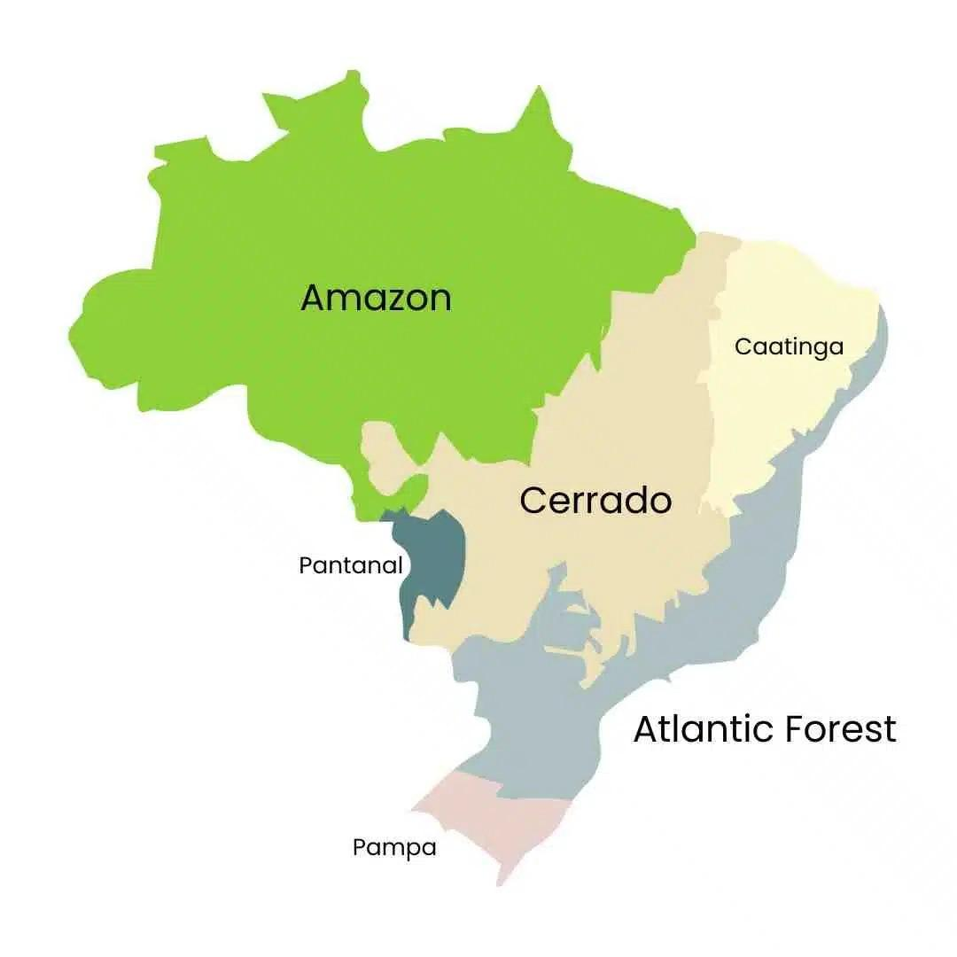
Figure 1: Map of the biomes of Brazil

As of 2022, there are 105,291,292 men (49% of the total population) and 109,034,931 women (51% of the total population) in Brazil. Marginalized groups in Brazil include indigenous and traditional communities, people of Afro descent, and people living with disabilities. There are about 305 tribes living in Brazil, totaling around 1.7 million people, or 0.8% of Brazil’s population. The Brazilian government has recognized 690 territories for its indigenous population, covering about 13% of Brazil’s land mass. Nearly all of this reserved land (98.5%) lies in the Amazon. The Brazilian government estimates that there are 18.6 million people aged 2 and older living with disabilities in Brazil as of 2023. Afro-Brazilians make up 10.2% of the population as of 2022 and face increased social and economic inequality. In 2022, 31.6% of the population was in poverty (income level of less than R$637 per month), 5.9% of which were living in extreme poverty (income level of less than R$200 per month). In 2022, over 125 million people experienced food insecurity. Female-led households in Brazil are over-represented among those in poverty and are more likely to experience food insecurity.

In Brazil, the access, utilization, management, and governance of natural resources vary between men and women across the six biomes. In the Amazon, men predominantly engage in the collection of high-value forest extractive resources like Brazil nuts and timber for trade, while women are more involved in the processing of these resources. However, there are exceptions, with some indigenous communities showcasing a more balanced distribution of tasks between genders. Despite women's involvement in processing, they often experience fewer benefits from agricultural production compared to men, who tend to take the majority of profits. Conversely, in the Cerrado biome, women play a crucial role in sustainable extractive activities such as the harvest of babaçu fruit, accounting for a significant portion of the workforce. Additionally, women's involvement in family farming and care for domestic livestock underscores their integral role in resource management within the biome. In the Caatinga, women's participation in agricultural production exceeds the national average, with initiatives like workers' cooperatives facilitating their engagement in agroecological businesses, thus contributing to the region's development. However, despite their active involvement, women-led farms tend to be smaller in size compared to those led by men, highlighting disparities in resource access and utilization.

Project activities have the potential to impact and benefit both women and men across various biomes in Brazil. For instance, efforts aimed at restoring 600,000 hectares within Conservation Units present employment opportunities for both genders. Women and men can participate in strategic planning, plantation development, and engagement with local stakeholders. In the long term, restored areas offer income sources from restoration value chains, employment possibilities in conservation management institutions, and ecosystem services to nearby communities. Similarly, initiatives targeting improved practices in 1,200,000 hectares of land benefit farmers, including women, by enabling access to new markets, financial incentives, and technical assistance. By targeting landholding areas owned by women and generating employment opportunities in the restoration supply chain sector, the project promotes gender equity and economic empowerment. Moreover, the growing role of women in seedling production and restoration activities aligns with broader trends of gender inclusivity in environmental conservation efforts.

Brazil is one of the most dangerous in the world for gender-based violence (GBV). Brazil has one of the highest GBV rates in South America, with about 3.5 per 100,000 women experiencing gender-based violence. Femicide rates vary by state in Brazil, with the highest recorded female homicide rates in the Amazonian states of Mato Grasso and Roraima (Mato Grosso is one of seven states in which Restaura Biomas will operate).

There is a chance that increased opportunities for women from the project could lead to gender-based violence (GBV). It is possible that men may not respond well to the increased opportunities for women in certain circumstances. Gender-based violence could occur if men do not agree with the women’s empowerment opportunities provided by Restaura Biomas. Men could feel threatened if their female relatives have increased financial freedom and opportunities and may resort to violence against these women. Similarly, men could feel that they have fewer employment and financial opportunities if women receive technical assistance and/or opportunities in restoration and they do not.

Moderate and high risks identified during PPG phase include risks associated with climate change such as extreme weather, risks to community livelihoods if their access to restoration areas is restricted. Additional risk factors include:
- Environmental Factors: Climate change such as weather patterns, increased frequency of extreme weather events;
- Socio-Economic Factors: Land tenure and ownership conflicts such as disputes over land ownership and usage rights, economic pressures;
- Political and Governance Factors: regions with unstable political environments may experience disruptions in project implementation due to conflict or lack of governance; and
- Social and cultural factors: Lack of involvement and buy-in from local communities can lead to resistance or non-cooperation with project activities, traditional land-use practices and beliefs may conflict with restoration goals, limited understanding of the benefits and techniques of restoration can affect community support and participation.

- Executing Agency (EA)’s Institutional Capacity to Implement ESMF:
The executing agency will be WRI-Brasil with support from the Ministry of Environment and Climate Change, The Nature Conservancy, and WWF-Brasil.

WRI Brasil has been developing projects focused on landscape and forest restoration since 2012. These projects encompass themes such as public policies, monitoring, capacity building, and restoration planning, resulting in the implementation of restoration policies at both national and subnational levels, the formation of coalitions, and the publication of technical reports that support decision-making on the subject. Throughout these processes, special attention is given to ensuring gender equity in consultative, deliberative, and training spaces. For both stakeholder engagement and gender inclusion, WRI relies on tools from the Restoration Opportunities Assessment Methodology (ROAM), such as Social Landscape Mapping, which identifies the main social actors within a given territory to develop effective engagement plans. In terms of staffing. WRI Brasil has one full-time Safeguards Specialist. The Safeguards Specialist will be a full-time professional spending 100% of his/her time on safeguard implementation and monitoring for the project. They will coordinate with all internal and external partners, as well as the grievance reporting platforms to be adapted from WRI Global process and localization of methodologies, with costs allocated for the hiring of these services.

The Ministry of Environment has been implementing international cooperation projects since its inception in the 1990s. This allowed the Ministry not only to follow the development of social safeguards, gender and stakeholder engagement policies, but also to coordinate the implementation of a number of GEF’s funded projects. The Ministry of Environment staff dedicated to Restaura Biomas will have at least one person with experience in GEF projects to support monitoring and implementation of social safeguards, gender and stakeholder engagement. The Ministry of Environment team has already participated in several training courses on GEF social safeguards, gender and stakeholder engagement; however, it is important to emphasize that further training and updates will be necessary to ensure that everyone is in line with the latest guidelines.

II. ESS STANDARDS TRIGGERED BY THE PROJECT
Based on the information provided in the ESS Screening Form, the following ESS Standards have been triggered:
ESS Standard | Yes | No | TBD | Justification
1. Environmental & Social Impact Assessment (ESIA) |  | X |  | The project activities are not likely to cause adverse environmental impacts.
2. Protection of Natural Habitats and Biodiversity Conservation | X |  |  | The project aims to recover 600,000 hectares of native vegetation via restoration.
3. Resettlement and Physical and Economic Displacement | X |  |  | The project aims to have 1.2 million hectares under improved management, which has the potential to limit the access of the local population to natural resources thus could indirectly cause economic displacement.
4. Indigenous Peoples | X |  |  | The project does plan to work with IPs or in areas with IPs. In fact, one of the lines of action is the recovery of vegetation in public protected areas (Conservation Units and Indigenous Lands). Indigenous Lands will be included based on the identification of opportunities with FUNAI and local indigenous populations.
5. Resource Efficiency and Pollution Prevention |  | X |  | There are no proposed activities related to the use of banned, restricted or prohibited substances, chemicals or hazardous materials. However, the project intends to implement livelihood interventions in agriculture and agroforestry.
6. Cultural Heritage |  |  | X | Restoration on Indigenous lands could overlap with areas that have cultural significance to those communities.
7. Labour and Working Conditions |  | X |  | The EA indicated that they have in place the necessary policies, procedures, systems and capabilities to meet ESS7.
8. Community Health, Safety and Security |  | X |  | CHSS risks have been identified and assessed as Medium. Some of these risks include natural disasters and weather events, conflict over land ownership, political violence and safety at restoration sites. Appropriate mitigation measures have been identified.
9. Private Sector Direct Investments and FIs |  | X |  | The project does not plan to invest GEF funds in any financial mechanisms.
10. Climate Risk and Related Disasters |  | X |  | While exact project sites will not be decided until implementation, the project will operate in high exposure areas such as arid and semi-arid zones (the Caatinga and parts of the Atlantic Forest and Cerrado biomes) and coastal zones (Amazon, Caatinga, and Atlantic Forest). In arid and semi-arid zones, the project is especially vulnerable to desertification, extreme temperatures, and wildfires. The coastal areas of the Amazon, Atlantic Forest, and Caatinga biomes could be at risk from sea level rise and tropical storms although these are extremely rare in Brazil.  These threats could make it difficult to reach the project goals of land under restoration. The project development team will consider these threats when determining sites for direct implementation of native vegetation recovery and aim to select areas that are less threatened by these climate risks. The project will also aim to train restoration networks, farmers, restoration supply chain stakeholders, and project staff on climate threats and mitigation to reduce the risk of climate-related threats.  Climate resilience measures will be incorporated into the planning and execution of restoration activities within the project's designated territories. One example of this is the emphasis on facilitating the natural regeneration of ecosystems, which serves to enhance climate resilience.  Through scaling up Assisted Natural Regeneration, the project targets 600,000 hectares for restoration, enhancing ecosystem resilience to climate-induced stresses. Additionally, the project aims to have 1.2 million hectares under improved management, which further strengthens landscape resilience to climate change impacts. These measures will help minimize the vulnerability of restored areas to climate change impacts and contribute to the overall resilience of ecosystems and landscapes.  The project will also engage with local communities and stakeholders to raise awareness about climate change risks and build adaptive capacity at the grassroots level. This would include restoration networks, seedling suppliers, and farmers who could be given technical assistance on how to identify and mitigate the impact of natural hazards such as wildfires, droughts, and flooding.
Note: Other ESS Standards may be triggered at any time during the project cycle.

III. PROJECT CATEGORIZATION

Based on the ESS Standards triggered, the project is categorized as follows:
PROJECT CATEGORY | Category A | Category B | Category C
PROJECT CATEGORY |  | X
The proposed project activities have the potential to cause negative environmental and social impacts. However, the impacts are anticipated to be less adverse than those of Category A projects, site-specific, and mitigation measures can be designed more readily than for Category A projects.

IV. MANAGEMENT OF ESS STANDARDS TRIGGERED

ESS2. Protection of Natural Habitats and Biodiversity Conservation
Habitat restoration projects need to demonstrate that they will restore or improve biodiversity and ecosystem composition, structure and functions, and that interventions are environmentally appropriate e.g. do not introduce invasive alien species, socially beneficial across genders, and economically viable. These considerations need to be reflected in the standards and regulations that support large-scale recovery of native vegetation, Environmental Regularization Programs (PRAs), recovery programs or plans for native vegetation, integrated monitoring platform/system for the recovery of native vegetation, biome-level restoration networks operational management plans, public and private Technical Assistance and Rural Extension (ATER) services, and demonstration landscape projects.

Further, the EA is required to monitor and report on the following minimum ESS2 indicators:

- Percentage of the ESMP/mitigation activities implemented to avoid/mitigate unintentional negative impacts.
- Number of hectares of natural and/or critical natural habitats negatively impacted by the project.

ESS3. Resettlement and Physical and Economic Displacement
The project is required to develop a Process Framework that describes how economic displacement will be addressed when encountered by the project, the participatory process by which restrictions will be agreed upon and/or compensated, how the criteria for identifying, negotiating and compensating economically displaced persons will be developed, and measures to restore livelihoods.

In addition, the EA is required to monitor and report on the following minimum ESS3 indicators:

- Number of persons economically displaced in a voluntary way.
- Number of persons compensated for voluntary economical displacement.

ESS4. Indigenous Peoples
The project is required to develop an Indigenous Peoples Plan (IPP) and outline how Free Prior and Informed Consent (FPIC) would be sought as well as how the project will avoid negative impacts on indigenous peoples, ensure their full and effective participation in decision making related to the project, and to provide indigenous peoples with culturally appropriate social and economic benefits that have been negotiated with them. The IPP must also take into consideration the Indigenous People’s cultural heritage that is material to the identity and/or cultural, ceremonial, or spiritual aspects, and provide measures to mitigate any adverse impact on the affected Indigenous People's lives or cultural heritage.

In addition, the EA is required to monitor and report on the following minimum ESS4 indicators:

- Percentage of indigenous/traditional communities where FPIC has been sought and documented.
- Number of Indigenous/traditional communities present in the project sites that participated in the project.

Other Plans
Apart from the ESS Policy, the program will be required to comply with the CI-GEF/GCF’s Accountability and Grievance Policy, Gender Policy, and Stakeholder Engagement Policy by preparing and submitting for review and approval to the CI-GEF/GCF during the project development stage, the following plans:

- Accountability and Grievance Mechanism (AGM)
To ensure that the project meets CI-GEF Project Agency’s Accountability and Grievance Mechanism Policy, the EA is required to develop an Accountability and Grievance Mechanism (template provided) that will ensure people affected by the project are able to bring their grievances to the EA for consideration and redress. The mechanism must be gender-sensitive, in place before the start of project activities, and disclosed to all stakeholders in a language, manner and means that best suits the local context.

In addition, the EA is required to monitor and report on the following minimum accountability and grievance indicators:
1. Number of times/events the AGM is disclosed to project stakeholders; and
2. Percentage of conflict and complaint cases reported to the project’s Accountability and Grievance Mechanism that have been addressed.

- Gender Mainstreaming Plan (GMP)
The GMP (template provided) should include a gender analysis including the role of men and women in decision-making, and appropriate interventions with gender-related outcomes to ensure that men and women have equal opportunities to participate and benefit from the project.

Further, the project should examine the extent of Gender Based Violence (GBV) and Sexual Exploitation and Harassment (SEAH), the likelihood of project activities contributing/exacerbating GBV and SEAH, and proposed mitigation measures as needed.

In addition, the EA is required to monitor and report on the following minimum gender indicators:

- Number of persons (disaggregated by gender) who received benefits during the implementation phase; and if relevant.
2. Number of documents (disaggregated by types) derived from the project that included gender considerations or address gender gaps.

- Stakeholder Engagement Plan (SEP)
To ensure that the project complies with the CI-GEF/GCF’s Stakeholders’ Engagement Policy, the EA is required to develop a Stakeholder Engagement Plan (template provided).

In addition, the EA is required to monitor and report on the following minimum stakeholder engagement indicators:
1. Number of stakeholder entities (disaggregated by type) involved during the project implementation phase;
2. Number of persons (disaggregated by gender) who participated in activities during the project implementation phase; and
3. Number of engagements (disaggregated by type of engagement) with stakeholders in during the project implementation phase.

V. DISCLOSURE
Following approval of the plans, the EA must disclose the plans to stakeholders no later than 30 days from date of approval.

