CI-GEF/GCF PROJECT AGENCIES
Accountability & Grievance Mechanism (AGM)

The CI-GEF/GCF Project Agencies require all project to have an Accountability and Grievance Mechanism in place so that project-affected communities and other stakeholders may raise a grievance at all times to the Executing Agency/Entity, CI, the GEF or GCF on non-compliance with the ESMF. Affected communities should be informed about this possibility and contact information of the respective organizations at relevant levels should be made available publicly. Affected communities should also be assured that their grievances will be addressed in a timely manner, they will not face retaliation for submitting a grievance, and they have the option to request confidentiality.

SECTION I: Project Information

PROJECT TITLE: | Beyond 30x30: Securing resilience in the Eastern Tropical Pacific through enhanced transboundary cooperation
GEF/GCF PROJECT ID: | 11267 |  | PROJECT DURATION: | 60 months
EXECUTING AGENCY/ENTITY: | Anticipated: Fundación Pacífico (Pacific Foundation)
PROJECT START DATE: | (mm/yyyy) |  | PROJECT END DATE: | (mm/yyyy)
AGM PREPARED BY: |  | Monika Bertzky, Asesoramiento Ambiental Estratégico (AAE)
DATE OF (RE)SUBMISSION TO CI-GEF/GCF:
AGM APPROVED BY: |  | (To be completed by CI-GEF/GCF)
DATE OF CI-GEF/GCF APPROVAL: |  | (To be completed by CI-GEF/GCF)
With its 2.1 billion hectares (ha) spanning from Mexico to Peru, the Eastern Tropical Pacific (ETP) is one of the most biodiverse and productive ocean areas on the planet. A critical 200,000,000 ha subsection known as the Central ETP is in the Pacific waters of Ecuador, Costa Rica, Colombia, and Panama and includes the ETP Marine Corridor (CMAR) and the world’s densest cluster of marine World Heritage Sites. The present project will be implemented in and around 11 Protected Areas (PAs) in the Marine Corridor (Corredor Marino or CMAR) of the central Eastern Tropical Pacific Seascape, which is found in the Pacific waters and islands of Ecuador, Costa Rica, Colombia, and Panama, with a total area of around 62,500,000 ha. The following map shows the CMAR marine protected areas (MPAs), divided by country (or exclusive economic zone) as well as showing the main connectivity (migration) routes.

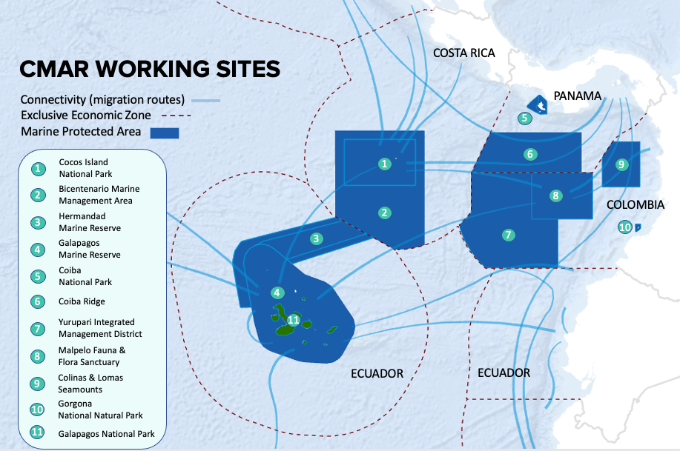
Figure 1. CMAR working sites

Uncontrolled development, habitat destruction, and illegal and unsustainable fishing are threatening this vast area, compromising livelihoods, ecosystem resilience, and fisheries production. While the Central ETP continues to attract sustainability investment, the scale of solutions does not match the current magnitude of threats.

This project objective is to ensure long-term sustainability of at least 31,250,000 ha (at least half of the area of the CMAR’s 11 large marine protected areas (MPAs)). The project consists of four components:
Component 1: Strengthening CMAR governance and long-term sustainability,
Component 2: Improving regional corridor management and climate resilience,
Component 3: Promoting a regional blue economy, and
Component 4: Strengthening Capacities for Regional Communications, Knowledge Management, and Learning.

This project’s Global Environment Benefits (GEBs) contributions in CMAR include: Strengthening the connectivity, protection, and management of at least 31,250,000 ha (i.e., at least half of the 62,500,00 hectares comprised by 11 large marine protected areas) (CI2.2); increased area of wetlands (including estuaries, mangroves) under restoration from ecosystem based adaptation (EbA) actions (CI 3.4); 5.1 (Fisheries under third-party certification incorporating biodiversity considerations); A shared water ecosystem under improved cooperative management (CI7); Improvement in sustainability levels of over-exploited marine fisheries (CI8); and 150,000 people benefited from GEF-financed investment (at least 30% women) (CI11).

SECTION II: Scope

- What kinds of grievances (e.g. lack of engagement, non-adherence to agreements, on-going conflicts over natural resources, disadvantage groups being excluded) are anticipated? List all potential grievances even if they fall outside of the scope of the ESMF. In the next question, identify those that would be considered eligible by the project’s AGM.
In thinking about the kinds of grievances that might occur in the context of the project, it helps to remember the governance structure of the project as well as local rightsholders and stakeholders. The project spans four countries and requires their coordination amongst the different governments to ensure concerted implementation of agreed activities. The activities are implemented in areas where different interest groups are present and with local marine resource users who might be affected in some way. Grievances that can be anticipated could thus arise in the context of:
- Lack of coordination/agreement between the four governments involved leading to power imbalances in the governance of the project;
- Lack of information provided to different interest groups on the planned project, its implications and opportunities to have their voices heard and considered;
- Stronger enforcement of existing access restrictions or enforcement of additional access restrictions (e.g. if: marine corridors with certain resource use restrictions are created; temporary closures during coral bleaching episodes are imposed to reduce additional stress; the use of destructive fishing/harvesting practices and destructive landings is eliminated; areas under restoration that were previously used by local actors, even if only to pass through, can no longer be accessed, etc.) leading to economic displacement of companies depending on vessels to cross the waters falling within the boundaries of the project as well as of local resource users.
- Compensation for access restrictions not meeting expectations or provided with time delays causing hardship to local resource users.
- Security risks are heightened by the project in case it contributes inadvertently (e.g. through more patrolling of certain areas) to more encounters between organized criminal groups involved in drug trafficking using marine routes and other users of the marine spaces.
- Blue economy initiatives under component 3 not providing equal opportunity to all, potentially aggravating existing inequalities (e.g. between women and men in the fisheries sector).
- Blue economy initiatives failing to provide sustainable incomes over time.
- Confusion over the boundaries within which fishing is permitted as well as potential tensions and conflict between authorities and the population and among citizens of the different countries part of CMAR as a result of the CMAR area not yet being officially delimited from a geographical or jurisdictional perspective.
- Tension between resource users resulting from diverted use of marine resources or marine transport routes following stronger enforcement of existing or new access and use restrictions.
- Unequal opportunity to participate in and benefit from IW: Learn and regional and international exchanges under component 4, in the national commissions and regional working groups to be established/strengthened and in the implementation of the financial sustainability strategy under component 1, and in the design of activities under components 2 and 3 that could affect the communities, i.e working groups, if and when relevant.
- Resource users disregarding existing regulations for the use of marine resources.
- What grievances are eligible and how would they be received?
Grievances that may get registered in the project-level AGM are eligible to be addressed when they:
a) are about adverse impacts on people and the environment that are caused or contributed to by the project and should have been avoided or at least minimized and managed as per the requirements of the CI-GEF ESMF; or
b) raise awareness of project activities failing to reach their objectives, whether because of false design, inadequate management or inadequate implementation, thereby potentially creating discontent and mistrust among stakeholders, or other medium- to long-term consequences, and thus threatening overall project success; or
c) point at behavior or decisions of individuals or groups of individuals (incl. governance and decision-making bodies) with the implementation of the project that are not lawful and/or contradict the CI-GEF Agency’s Code of Ethics;
d) are clearly project-related but fall outside a)-c) above.
That means that from the list of grievances displayed above, all the ones from 1-10 would be eligible. However, the last one provides an example for a grievance that would not be eligible, as it would point at an issue that is not caused by the project, unless it falls under category b above (the project fails to achieve one of its objectives).
The project is expected to support CMAR (under Component 1) to develop its own AGM. However, since designing and implementing a grievance mechanism takes time, it has been suggested that the grievance mechanism of the Executing Agency (Fundación Pacífico, hereafter “PACIFICO”) should be used instead (please see sections below, which contain more information about PACIFICO’s grievance mechanism, in Spanish “Mecanismo de Gestión de Quejas”, MGQ). CI-GEF recommends that, to avoid confusion and maintain efficiency, PACIFICO’s grievance mechanism should be the project-level AGM used during the entirety of the implementation phase. Should the CMAR AGM be ready at some point during the implementation phase, it could be used as an alternative channel if needed.
It should be noted that the person responsible for PACIFICO’s MGQ has not yet been determined. One option that could be explored is to assign that responsibility to an expert for gender and safeguards that is to be employed specifically for the project. In the present document, the person is referred to as “AGM Manager”.
While there is a possibility to escalate a local grievance to a higher level grievance mechanism (see section V.), eligible grievances should always first be registered at the lowest possible level. In this case, that means that a local stakeholder of the project should first register their grievance through PACIFICO’s mechanism (see also section V). However, project-level grievances are eligible to be addressed through a higher level AGM when any of the three eligibility criteria above apply and it was either impossible to resolve the grievance at the project level or the complainant feels that the project level AGM cannot be trusted or is not the right mechanism for the specific issue at hand.
Grievances received should thus first always be assessed for their eligibility. Where grievances are found not to be eligible, the complainant must be informed within a reasonable time from the time of receipt of the grievance (see figure in Section V below) and a justification included in the decision. Ideally, information would be included about a more suitable mechanism in place to address grievances not eligible. The most suitable mechanism for recommendation may vary depending on the nature of the grievance.
- How will the mechanism ensure transparency and fairness?
The project-level AGM should follow OHCHR good practice principles to ensure effectiveness of non-judicial AGMs in order to be:
- Legitimate: enabling trust from the stakeholder groups for whose use they are intended, and being accountable for the fair conduct of grievance processes;
- Accessible: being known to all stakeholder groups for whose use they are intended, and providing adequate assistance for those who may face barriers to access;
- Predictable: providing a clear and known procedure with an indicative time frame for each stage, and clarity on the types of process and outcome available and means of monitoring implementation;
- Equitable: seeking to ensure that aggrieved parties have reasonable access to sources of information, advice and expertise necessary to engage in a grievance process on fair, informed and respectful terms;
- Transparent: keeping parties to a grievance informed about its progress, and providing sufficient information about the mechanism’s performance to build confidence in its effectiveness and meet any public interest at stake;
- Rights-compatible: ensuring that outcomes and remedies accord with internationally recognized human rights; and
- A source of continuous learning: drawing on relevant measures to identify lessons for improving the mechanism and preventing future grievances and harms;

More specifically, transparency should be ensured by
● Clearly communicating the existence of the AGM, the agreed procedures (ways to register grievances, steps following registration, etc.) and timeline for responses to all possible stakeholders.
● Clearly communicating eligibility criteria for grievances.
● Clearly communicating the agreed timeline for procedures to address grievances and when responses can be expected.
● Clearly communicating decisions taken with regards to grievances, incl. on their eligibility, the suggested way to resolve them, the conclusion reached or not reached and why.
Fairness should be ensured by
● Involving specific thematic external and independent experts as needed, e.g., where grievances are complex and require specific background knowledge and experience;
● Using an agreed structure for reports detailing all information available about registered cases and for responses to complainants at different stages during the procedure of dealing with complaints to ensure that the same standard information is provided to everyone.

PACIFICO’s Grievance Management Mechanism (MGQ) is accessible to all stakeholders, including communities in the PTEC intervention zones. Their ESMS also clearly states the deadline to respond to grievances (25 working days), although this might be extended for an equal number of days if processing and escalation require it. It also details the steps to follow depending on the avenue through which the complaint was filed. However, it lacks information about how the MGQ ensures transparency (i.e. how stakeholders are communicated about its existence, how to access it, etc.). It also lacks information about whether complex grievances should involve thematic external and independent experts if needed. Section III of the present document suggests making use of every opportunity where the project engages with stakeholders at different levels to socialize or briefly remind of the Grievance Mechanism and how to access it. It is also recommended that information on if or when thematic experts would be involved would be added to the document prior to the start date of the project.

- Will the mechanism receive anonymous grievances?
In line with good practice for grievance redress the possibility to register grievances anonymously should be provided to ensure that complainants do not need to fear retaliation (e.g., where a complaint refers to inappropriate conduct of a project employee, which may be a colleague of the complainant). Receiving and dealing with anonymous grievances requires to consider that:
● Ways need to be found to inform the complainant about decisions and next steps regarding the grievance without contacting him/her directly and/or disclosing the person’s contact details;
● The strict confidentiality of people managing and maintaining the AGM and the safety of the information included in the grievance registry are required;
PACIFICO’s MGQ allows for the receipt and processing of complaints in a confidential manner, and enables the receipt and processing of anonymous complaints in cases where the complainant does not wish to identify themselves. When complainants choose to remain anonymous, and only if appropriate, the response to the grievance filed will be given to the community.
PACIFICO also undertakes to maintain the confidentiality of the complainants in its reports. In addition, it has been explicitly confirmed that the person responsible for the management of the mechanism acquires information management obligations that ensure confidentiality and that information in the context of grievances will be known only to that person and to the project coordinator.

In addition, the CI Ethics Hotline, which would be used at the next higher level of the tiered AGM system (see section V), can be used for grievances that complainants prefer to register anonymously. The CI Ethics Hotline is “a globally accessible, multilingual reporting tool” that provides the option to report incidents anonymously. The hotline is available day and night every day of the week and can be accessed either by logging on to www.ci.ethicspoint.com or by dialing a toll-free number from anywhere in the world where CI works that can be found on the website. It is further specified that “No employee or any other person will be discharged, threatened, or discriminated against in any manner for reporting in good faith what they perceive to be wrongdoing, violations of law, or unethical conduct. Retaliation against any person who submitted a claim in good faith is subject to disciplinary action up to and including termination for cause and grantees or partners may be disqualified from submitting future funding proposals to Conservation International.” For further detail, please see https://www.conservation.org/about/our-policies/reporting-illegal-or-unethical-conduct-statement

SECTION III: Awareness and Accessibility

This section intends to understand how the project plans to ensure that their different methods to socialize and access the AGM is appropriate to the project’s stakeholders. The project should place a special effort in securing accessibility to their AGM especially for women and those from disadvantaged groups (elderly, young people, persons with disabilities, LGBTQ, indigenous/traditional peoples, minorities, those with lowest literacy levels, among others). These groups usually are at a disadvantage, some of them within their own communities, and may have additional or different barriers to access given channels of communication. In the next table, the project must ensure that they identify these differentiated barriers and include methods and accessibility adaptations intended to address them, closing gaps in accessibility to project AGM.

Method of Socialization | Intended Audience | Accessibility adaptations | Frequency of the action/channel | Budget
How will the project disseminate the AGM to stakeholders? What channels will be used? (e.g. via the project’s website, at the inception meeting with stakeholders, printed and posted on notice board in community centre, radio announcement, flyers, posters, SMS/text/WhatsApp messages, illustration/animated video, at the end of every presentation or community engagement) | Who are the stakeholders the project is intending to reach using each different channel? (e.g. government officials, indigenous/traditional peoples, etc.) | What adaptations to cater diverse groups (especially disadvantaged/vulnerable groups) will be in place for every method/channel? (e.g. translated versions for local languages, infographics for those with low literacy levels, traditional communication methods, post-in of information in high traffic areas of affected stakeholders, women’s gathering spaces) | When and how often will the project disseminate/socialize the AGM to stakeholders? (The EA is required to continuously socialize the AGM with all stakeholders involved at different stages of project implementation) | Indicate the estimated costs to socialize the AGM and make it accessible to diverse groups and be culturally appropriate. Please work with the finance lead to ensure that the budget costs are included in the project’s overall budget.
Project website | All stakeholders with internet access | The project website will include: 1) A direct link to the project-level AGM with all information provided in Spanish. 2) Information on how to access the CI Ethics Hotline for anonymous grievances, which can be reached by phone and internet and is available in Spanish, among other languages;  3) Contact information for the GEF Conflict Resolution Commissioner. | Consistently | Development of extra page on existing web page to introduce to the GRM and detailing purpose, contact, link to CI’s Ethics Point, and GEF Conflict Resolution Commissioner The cost can be covered by the budget line “Communication Material” in the project budget.
Working sessions as part of component 1 | National CMAR Commissions and/or regional technical working groups, incl. MPA managers (Outputs 1.1.2 and 1.1.3) | The sessions to establish these groups as well as their regular meetings can be used to disseminate information about the AGM and ensure the process is understood. The members of these commissions and working groups may also be in a position to further disseminate knowledge about the existence of the AGM (e.g. MPA managers). | During establishment of these groups with reminders at regular meetings of the need to further disseminate the information and encourage the use of the AGM | No extra cost as happening as part of already planned activities
Awareness raising sessions, workshop and information material created under component 2, activity 2.1.1.1 | Local communities and “key actors” | Activity 2.1.1.1 includes awareness raising sessions and workshops with local resource users and key actors on the importance of adapting to climate change. The same sessions can be used to remind of the existence of the AGM and how it can be accessed. They can also be used to gather feedback on the AGM or information on its uptake or any issues people may have with accessing and using it. It should also be explored whether information material can be developed to include a small standard box at the end that reminds of the AGM. | Whenever these sessions happen and ideally on all information material developed | The cost of producing information material is covered by the budget line “Communication Material” in the project budget.
Participatory sessions under component 3 | Resource users (business owners and direct beneficiaries) from key sectors involved in Blue Economy activities (e.g. tourism, fisheries) | Output 3.2.1 is “Users (business owners and direct beneficiaries) from key sectors implement blue economy actions”. That implies that they will be familiarized with the blue economy plans developed under component 3. Sessions used to socialize and discuss the blue economy plans should be used to also disseminate information about the project-level AGM. | Whenever these groups are convened, first to introduce the project-level AGM, then as a regular reminder. Flyers will be produced that summarize the AGM and remind of its access channels and use. | The cost of flyers can be covered by the budget line on “Communication Material” in the project budget.
Radio spots, posters, etc. | Local resource users not involved in any of the above. | For some local resource users it is unlikely that they will be reached by any of the previously listed awareness activities. It is therefore important to define suitable means to communicate the existence of the project-level AGM to those users, as well as how it can be accessed and used, in a culturally appropriate manner. | TBD | There will be an extra cost per country, see also SEP

Please reply to the questions below, which intend to address the adaptations and capacity of the AGM to be gender-responsive and has adaptations in place to address differentiated needs from disadvantaged groups:

- Are the persons responsible of the GRM aware and knowledgeable of the commitment of the mechanism to be gender responsive and inclusive of those in disadvantaged groups? Explain your answer.
PACIFICO’s description of its MGQ does not contain information about whether particular provisions are in place to ensure that it is gender-responsive and has adaptations in place to address differentiated needs from disadvantaged groups. It will be important to ensure that PACIFICO’s MGQ makes the necessary adjustments to be gender-responsive and inclusive. At the next higher level, the response to the question is affirmative. Conservation International is the GEF Agency of the project and has extensive experience with the establishment of AGMs, whether at project level, or at organizational level. For example, the CI Ethic’s Hotline has been in place for several years and has been consistently adjusted and further improved in line with lessons learned and good practice, and also to ensure its consistency with CI’s set of policies. Gender considerations are mainstreamed throughout CI’s policies and also through the CI-GEF ESMF, which can specifically be seen in the CI-GEF ESMF’s Policy 2: Gender Mainstreaming (see chapter X in https://www.conservation.org/docs/default-source/gef-documents/20201116-ci_gef_gcf-esmf-v7.pdf?sfvrsn=c5710ec9_0). CI personnel must adhere to these policies throughout their work for CI. Because of the above, it can be assumed that the AGM Manager will be fully aware and knowledgeable of the commitment of the mechanism to be gender responsive and inclusive of particularly vulnerable rights- and stakeholders.

- Are the formats in place and channels available gender-sensitive and inclusive of those in disadvantaged groups? For example, the different formats ask the grievant to specify if they prefer mediators of a certain gender or with context-specific gender expertise so that they feel more comfortable, particularly if there are instances of SEAH involved. Explain your answer.
PACIFICO’s description of its MGQ does not specify whether or not there are formats and channels in place that are gender-sensitive and inclusive of those in disadvantaged groups. This will have to be clarified with PACIFICO. However, gender-inclusiveness should be consistently considered in the design and socialization of the project-level AGM. An AGM Manager should be designated and this person should receive tailored SEAH/GBV training. In addition, a specific process should be agreed for management of SEAH cases. Support could here potentially be provided from CI's internal SEAH point experts. For anonymous grievances, the CI Ethics Hotline does not explicitly state that it is gender sensitive, but the committee that is convened when there is a grievance elevated to that level is gender sensitive when needed. This means that if a grievance is related to gender, particularly gender-based violence/SEAH, the committee would include someone with expertise in that area, e.g. from among CI’s internal SEAH point experts, to help manage grievances in this context.

SECTION IV: Channels for Receiving/Reporting/Registering Grievances

Please list all the channels that will be part of the AGM of the project, this can include boxes or reporting points, virtual channels, or any other other applicable channels.

Physical address(es) of project office or location(s) of grievance reporting point: | The postal address of PACIFICO's headquarters in Panama
Mailing address(es): | Coordinación PACÍFICO: Oficinas de Fundación Natura, Llanos de Curundu Edificio 1992 A – B, Panamá, Panamá
Telephone/Fax Number(s): | TBD
Email address(es): | pqr@redpacifico.net
Website(s)/software application(s): | https://redpacifico.net/es/salvaguardas/
Radio Frequency, if applicable: | not applicable
Other:

SECTION V: Processing and Documentation

Processing
PACIFICO MGQ has multiple channels of communication and ways of capturing complaints and different levels of access, as presented in the figure below:
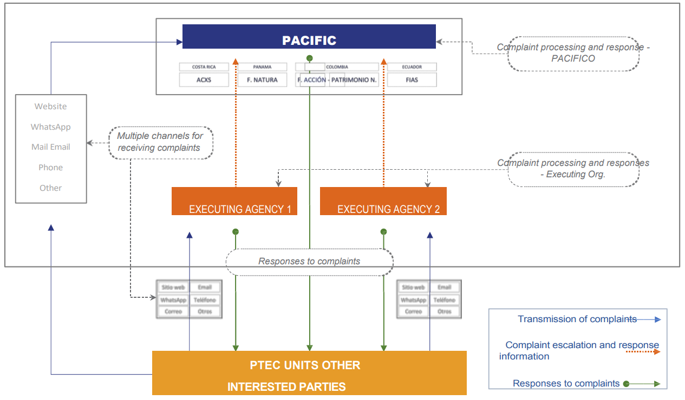
The MGQ can be used from the following levels of PACIFICO operation: directly (a stakeholder can send PACIFICO a complaint); through the implementing organization (using the MGQ that organization implements); through the PACIFICO focal points in the countries; and through the MGQs of the PACIFICO member Funds. If one of these levels is unable to respond to the complaint, it should be submitted to the other party that can be considered responsible for dealing with the complaint (i.e. if the implementing organization/member fund cannot resolve the matter directly, it should be escalated to PACIFICO, and if it is received by PACIFICO and they are unable to resolve the complaint due to them not being directly responsible, then it should be delegated to the implementing organisation). In the case that the inability to respond to the complaint is due to time constraints, the MGQ level that received the complaint should issue a partial response explaining this situation and within a reasonable period of time, and communicate this response to the complainant and to PACIFICO and implementing organization/member fund, as relevant.
PACIFICO MGQ Procedures
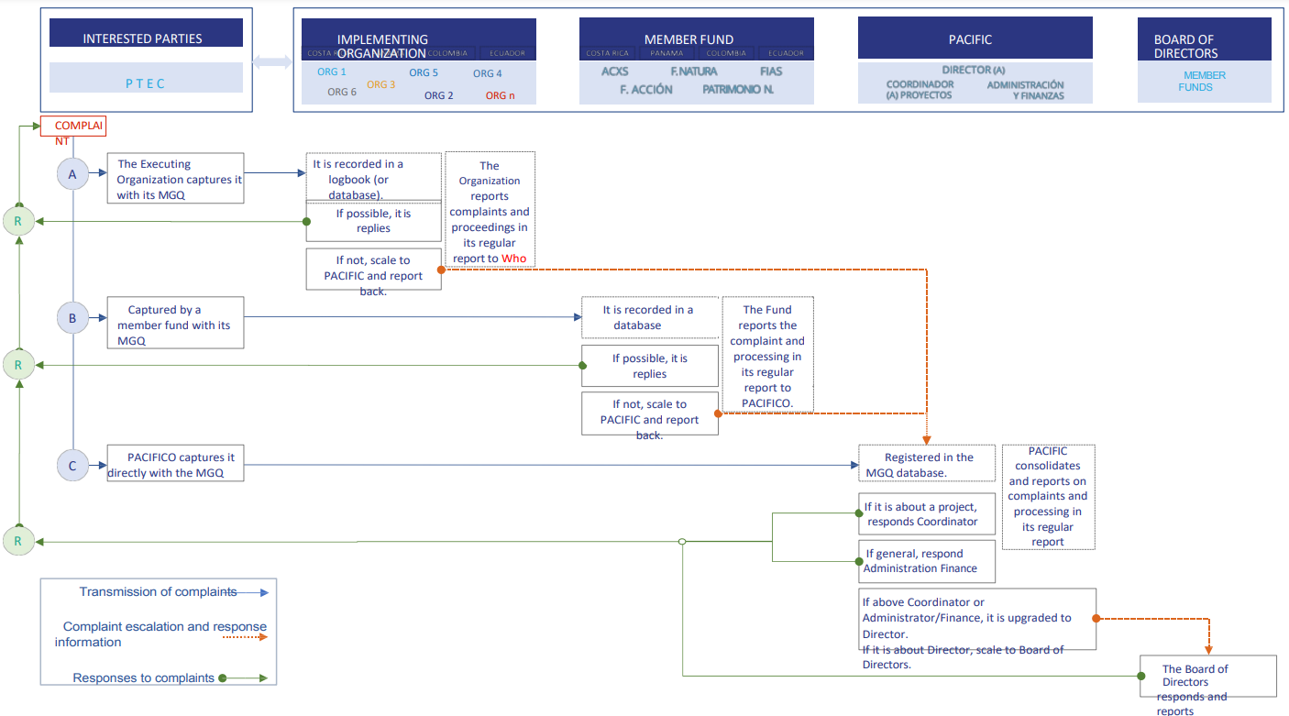

In cases where the grievance cannot be satisfactorily resolved through PACIFICO’s MGQ or the claimant does not consider the mechanism as adequate for the grievance, the next higher level could be used. Complainants could still revert to the CI Ethics Hotline if, for some reason, PACIFICO's MGQ is considered inadequate to deal with the grievance in question.
The following figure shows the different tiers of the AGM system that would apply to the project.
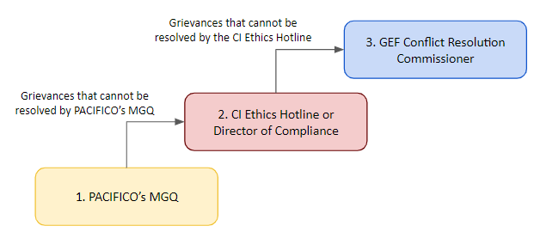
The AGM Manager is responsible for all activities and processes related to project-level grievances. The Ethics Hotline, which can be used for anonymous grievances, is managed by Navex's Ethics Point. Ethics Hotline is Safe Harbor Certified through the United States Department of Commerce and is available worldwide. Another alternative is to file a claim with the Director of Compliance (DOC) who is responsible for the CI Accountability and Grievance Mechanism and who can be reached at: Director of Compliance, Conservation International 2011 Crystal Drive, Suite 600 Arlington, VA 22202, USA. This information must be contained in the project-level AGM and disseminated to all project stakeholders.
Details referring to the CI Ethics Hotline have mainly been sourced from the document provided under the following link: https://www.conservation.org/docs/default-source/gef-documents/20151115-accountability-and-grievance-mechanism.pdf?sfvrsn=92633125_2.
Step 1: Registration of complaint
PACIFICO’s MGQ offers a range of different access channels:
- a section on the PACIFICO website where complaints can be submitted;
- a dedicated WhatsApp number;
- the postal address of PACIFICO's headquarters in Panama;
- a dedicated email address;
- a telephone number where complaints are received;
- physical mailboxes in the MPAs where there are PACIFIC projects (mailboxes that will be managed by those responsible for those projects);
- other effective and low-cost channels.
PACIFICO’s MGQ can be used from the following levels of PACIFICO operation: directly (a stakeholder can send PACIFICO a complaint); through the implementing organization (using the MGQ that the organization implements); through the PACIFICO focal points in the countries; and through the MGQs of the PACIFICO member Funds.
The MGQ allows for the receipt and processing of complaints in a confidential manner, guaranteeing the receipt and processing of anonymous complaints in cases where the complainant does not wish to identify themselves. In its reports, PACIFICO undertakes to maintain the confidentiality of the complainants.
The project-level AGM to be developed in early stages of project implementation should equally offer several different access points, including through the project website. Information needs to be provided in Spanish to all stakeholders on how to access the project-level AGM, including an online and paper form and a direct contact for the AGM Manager. Information on how to access the CI Ethics Hotline and contact details for the Director of Compliance and the GEF Conflict Resolution Commissioner should also be communicated. Where stakeholder events are carried out as part of project implementation, these events should be used to remind participants of the existing AGM and ensure awareness of how it can be accessed and used, including the possibility to speak directly to the AGM Manager at any time, as needed.
The CI Ethics Hotline is accessible via https://secure.ethicspoint.com/domain/media/en/gui/10680/index.html. The portal offers to register a concern either online or by phone. For online registration of concerns, the complainant is asked to choose from a category of topics to which complaints might be related, distinguishing between
- Accounting, Auditing and Financial Reporting;
- Business Integrity;
- Environment, Health and Safety;
- HR, Diversity and Workplace Respect;
- Misuse, Misappropriation of Corporate/Donor Assets; and
- Project Grievance
For a registration of a concern by phone the complainant first needs to provide information on the country from which the complaint is made before a toll-free number is provided that can be used. Oral grievances will be entered into the registry (CI’s Global Grievance Database) and then dealt with like grievances registered online. Independently from whether the complainant registers a grievance online or orally, there is always the possibility to select whether the grievance is to be considered confidential and whether it should be registered anonymously or not.
When a grievance is registered online, the system confirms the submitted report. Before submission, the complainant needs to generate a password to access all communication around the grievance from now onwards. In the case of grievances registered orally, those would be transferred to the project's AGM Manager who should get access to the CI Global Grievance Database, which registers all of the relevant information and can manage the process. Documents that become available in the course of the process (e.g. the result to the eligibility assessment) can also be accessed through the follow up option in the system (see below).
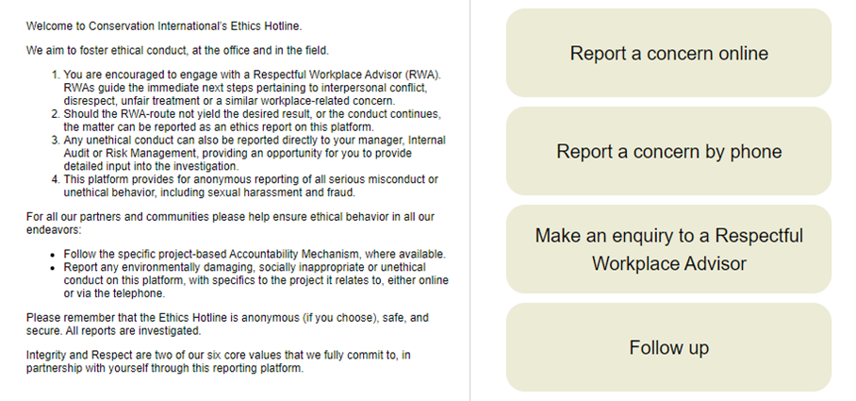
The entire CI Ethics Hotline portal is located on the NAVEX Ethics Point secure server, i.e. it is not part of the CI Website or intranet. NAVEX Global, Inc., an American-based company, provides compliance management software solutions and for CI ensures that all information entered into the CI Ethics Hotline is secure and can be treated confidentially if the complainant prefers that.
Through the CI Ethics Hotline, it is ensured that “no employee or any other person will be discharged, threatened, or discriminated against in any manner for reporting in good faith what they perceive to be wrongdoing, violations of law, or unethical conduct.” CI also spells out specifically that “Retaliation against any person who submitted a claim in good faith is subject to disciplinary action up to and including termination for cause and grantees or partners may be disqualified from submitting future funding proposals to Conservation International.”
Step 2: Eligibility assessment
Each grievance must be screened to understand whether any of the eligibility criteria listed under section II applies and thus a potential breach of CI’s environmental and social safeguards, principles, standards or procedures has occurred. Where this can be confirmed, the grievance is eligible to be dealt with.
Where it is concluded that the grievance does not meet any of the eligibility criteria, the claimant is informed within a reasonable time from the registration of the grievance and the information letter includes a clear explanation in appropriate language for why the grievance cannot be addressed under the AGM. To the extent possible, a suggestion is included for a different mechanism that may be more suitable to deal with the grievance (e.g. state systems, whistleblower mechanisms or international courts).
PACIFICO’s ESMS states that where the possible solution to the complaint exceeds the contractual scope of the organization, or the complaint refers to an issue involving more than one organization, the organization should escalate the complaint to PACIFICO and inform the complainant of this action. If PACIFICO cannot respond to the complainant, it will explain the reasons why the complaint is not appropriate. In any of these cases, the deadline previously established (25 working days) is maintained, although it may be extended.
Step 3: Verification and analysis
Once a grievance has been registered and its eligibility confirmed, it first needs to be verified to confirm it and then analyzed to establish the complexity of resolving it. The verification step can include different activities, depending on their suitability on a case-by-case basis. For example, where a complaint was registered anonymously, a follow-up with the complainant or another person involved in the case directly may not be adequate. Steps of verification could then include surveys among project team members or the involvement of an independent party, always ensuring that enquiries cannot be related back to the claimant. In other cases, site-visits, face-to-face meetings and virtual interviews can also be considered for verification.
Once verified, the root causes of the subject of the grievance are further assessed and possible solutions identified to ensure that issues of non-compliance with CI’s environmental and social safeguards are corrected. This step can equally include in‐country inspections, interviews of project‐affected people, and comprehensive information gathering to allow a factual determination of the issues raised and a reliable basis for any recommendations made.
PACIFICO’s ESMS does not describe how the organisation deals with verification and analysis of complaints. It will be necessary that PACIFICO makes adjustments to its MGQ to guarantee that grievances can be adequately verified and analysed.
Step 4: Identification of solution
This is a step in the process that can vary greatly depending on the grievance at hand. In very complex cases it may be necessary to involve additional experts with a particular background in this step. For example, if there was a grievance escalated from project-level on access restrictions to resources that the claimant considers having a right to access, it may be necessary to involve a legal expert to clarify the rights basis as part of this step.
In the case of PACIFICO, if the MGQ level (i.e. implementing organization/member fund) considers that it can respond to the complaint and resolve the matter directly within the established timeframe and without recourse to a higher instance (or escalate the complaint), it should respond to the complainant by explaining the actions and changes taken as a result of the complaint or, failing that, explaining the reasons why the complaint is not appropriate. In the latter case, the response should mention the possibility of filing an appeal directly with PACIFICO, if the person considers it appropriate. However, PACIFICO’s ESMS does not explain whether and when additional experts would be required in this step. It is recommended that PACIFICO specifies this in their MGQ.
Step 5: Communication of suggested solution, incl. timeline for implementation
At this point it is important to communicate with the claimant to ensure that the suggested way forward is considered satisfactory and adequate, incl. regarding the timeline for implementation. This timeline can vary considerably depending on the complexity of the case and steps involved in resolving it. The claimant should be informed of the need to confirm or reject the suggested solution within a certain number of days so that the process can be continued in due course.
PACIFICO responds within 25 days after receiving a complaint. The complainant receives a response explaining the actions and changes taken as a result of the complaint or, failing that, explaining the reasons why the complaint is not appropriate.
Step 6: Implementation of suggested solution
Where agreement is reached on the way forward, implementation of activities to address the grievance starts. Approaches to resolve grievances may include facilitating a consultative dialogue, promoting information sharing, undertaking joint fact‐finding, facilitating establishment of a mediation mechanism, and/or using other approaches to problem solving. Remedial actions involving a change in the project require approval from the Project Agency who will then inform the GEF Secretariat. The implementation process and milestones along the way need to be carefully documented. Who gets involved in implementation of the suggested solution is decided on a case-by-case basis depending on the specific needs of the case at hand.
PACIFICO’s MGQ adopts a culturally appropriate approach in relation to the communities in the PTEC intervention areas. This means that both the complaints process and the responses that are prepared and communicated, and the actions that may be taken as a result of this process, will be appropriate to the culture and context of the communities. The cultural appropriateness feature may result in responses by PACIFICO or implementing organizations being additionally supported and developed through face-to-face events in the communities. The MGQ is constructive to the extent that it privileges dialogue and consensus to solve the issues that cause complaints, as well as the learning derived from both the complaint and its solution.
Step 7: Documented and agreed closure of complaint
Once the implementation has been completed it is important to ensure that the complainant considers the grievance as adequately addressed and understands that the case will therefore be closed. A document that confirms how the grievance was dealt with and the outcomes achieved is therefore prepared and it is documented that the claimant agrees with the content of the document.
PACIFICO consolidates information on complaints and their respective processing and reports this information as part of its normal information and reporting obligations. However, PACIFICO does not specify how it is ensured that the complainant is satisfied with the response and that there is an agreed closure of a complaint. Therefore, PACIFICO should ensure that its MGQ contains information about this.
Institutional/organizational structure to handle grievances
For PACIFICO’s MGQ, when the complaint is about a PACIFICO project, the person in charge of answering it is the Project Coordinator. When the complaint is of a general nature, or about PACIFICO's finances and administration, the person in charge of Administration and Finance is the person in charge of responding to the complaint. If the complaint involves the Project Coordinator or the person in charge of Administration and Finance, the person in charge of ESMS escalates it to the PACIFICO Director. When the complaint is about the PACIFICO Director, the person in charge of the ESMS shall escalate it to the PACIFICO Board of Directors.
For the project-level AGM, grievances should be directed to the AGM Manager, who is responsible to follow up on complaints or to designate a person or panel to conduct, as needed, a thorough and objective review of any grievance that gets registered. Any designated person or panel that gets involved in dealing with registered anonymous grievances through the CI Ethics Point will report to the Senior Director of Compliance and Risk Management.
Documentation
PACIFICO’s MGQ allows for the receipt and processing of complaints in a confidential manner. As mentioned in the ESMS, the confidentiality of the complainant is of the utmost importance and must be guaranteed throughout the complaint-handling process. However, no further details are provided on how this confidentiality is ensured. It will be necessary for PACIFICO to include details on this in their MGQ.
In the case of the CI Ethics Point, grievances are maintained and managed within the Global Grievance Database housed by NAVEX on a secure platform that only allows the AGM Manager to view their entries. A claimant who wants to follow up on their grievance can log onto the portal using a login code, i.e. there is no need to reveal the grievant’s identity.
Level 3: GEF Conflict Resolution Commissioner
If a claimant is not satisfied with the response regarding a grievance that was considered to be eligible under the project-level AGM, the grievance may be escalated to the GEF Conflict Resolution Commissioner, a position specifically established for this purpose in the GEF Secretariat. The GEF Conflict Resolution Commissioner responds directly to the GEF CEO. For more information and steps involved in the process, please see https://www.thegef.org/projects-operations/conflict-resolution-commissioner.

SECTION VI: Monitoring and Reporting

When a grievance is confirmed as eligible, the AGM Manager needs to create a report summarizing the complaint, steps to resolve the issues, the parties’ decisions, and the parties’ agreement, if any. This report will be made available to all parties involved. From then on, the AGM Manager will monitor implementation of decisions. As part of the monitoring process all parties involved will be consulted and the AGM Manager will prepare monitoring reports on implementation of remedial actions and submit them to the involved parties. The conclusion of the process occurs after monitoring of remedial actions is completed and involves preparation of a final report by the person/panel involved in the resolution, which is then submitted to all parties concerned.
The project is expected to report on a quarterly basis (using the CI-GEF Quarterly Reporting template), progress made towards the implementation of the grievance mechanism, including the number of grievances received and the outcome of the grievance process.

On an annual basis and using the CI-GEF Project Implementation Report (PIR) template, the following CI-GEF’s minimum indicators are to be reported. The project can include other appropriate accountability and grievance indicators in addition to the CI-GEF/GCF’s indicators.

Indicator | Baseline | Target
- Number of times the Accountability and Grievance Mechanism is communicated/disseminated to stakeholders | 0 | 20 (4 per country)
- Percentage of conflict and complaint cases reported to the project’s Accountability and Grievance Mechanism that have been resolved | 0 | 100%

Person responsible for implementing and monitoring the AGM: | TBC
Budget Summary | Provide the total budget required and allocated for effective implementation of the AGM. Please also indicate the budget line in the project’s overall budget.

See paragraph 31 in UN OHCHR (2011) Guiding Principles on Business and Human Rights. Available from: https://www.ohchr.org/sites/default/files/Documents/Publications/GuidingPrinciplesBusinessHR_EN.pdf, accessed on 20 July 2023
Please see Fundación Pacífico’s Environmental and Social Management System (ESMS) (2023), page 37.
Information obtained from PACIFICO’s ESMS (2023). Section 2. PACIFICO’s Grievance Mechanism.

