CI-GCF/GEF AGENCIES
ENVIRONMENTAL AND SOCIAL SAFEGUARDS (ESS) SCREENING FORM

☐ Preliminary Screening (check if performed at GEF Project Identification Form (PIF) Stage or GCF Concept Note (CN) Stage | ☒ Second Screening (check if performed at GEF Project Preparation Grant (PPG) Stage or GCF Project Preparation Facility (PPF) Stage  Performed at PPG stage.

Guidance Notes
- This ESS Screening Form is guided by the CI-GEF/GCF Agencies’ Policy on Environmental and Social Safeguard Standards, which forms part of the CI-GCF/GEF Agencies Environmental and Social Management Framework (ESMF).
- The CI-GCF/GEF Agencies undertake environmental and social safeguard screening for every project or program to determine the risk categorization for the project, the ESS Standards triggered by the project, and the mitigation measures to be implemented by the project.
- ESS screenings are performed at (i) conceptual stage (Preliminary Screening) using the finalized versions of the PIF/PFD/CN; and (ii) proposal development stage i.e. PPG/PPF (Secondary Screening) using the project document when details of activities, project intervention areas and executing arrangements, among others, have been finalized. Additional screenings may be performed at any time when significant changes have emerged including but not limited to new proposed activities, changes in local/national context of project intervention areas, and where environmental and social risks have increased.
- The CI-GCF/GEF Agencies classify the project into one of three categories, depending on the type, location, sensitivity and scale of the project and the nature and magnitude of its potential environmental and social impacts. The descriptions of the categories and lists of types of projects identified in Appendix II of the CI-GCF/GEF’s ESMF. These descriptions are meant to serve as guidance and are not exhaustive.
- The CI-GCF/GEF Agencies do not fund projects that involve the construction or rehabilitation of large or complex dams, and resettlement of people. The CI-GCF/GEF Agencies cannot support projects that contradict CI’s mission and policies.
- The Executing Agency/Entity is responsible for fully completing and providing accurate responses to each question in this Screening Form, and to submit the completed Form to the CI-GCF/GEF Agencies in a timely manner.
- The CI-GCF/GEF Agencies is responsible for ensuring that the project complies with the CI-GCF/GEF Policy on Environmental and Social Safeguards, and will use the completed Screening Form to determine the mitigation measures for the Executing Agency/Entity to implement.
- In addition to preparing and implementing mitigation measures for the environmental and social safeguard standards triggered, the Executing Agency/Entity will also need to comply with CI-GEF/GCF’s policies on gender, stakeholder engagement and accountability and grievance mechanism. As such the Executing Agency/Entity will be required to prepare a Gender Assessment and Action Plan, a Stakeholder Engagement Plan, and an Accountability and Grievance Mechanism (see to ESMF for details).
- The Executing Agency/Entity is responsible for informing the CI-GCF/GEF Agencies in a timely manner, if at any time during the preparation and implementation of the project, the information provided in this Screening Form changes in a way that results in the risks of the project being increased.
- For additional information/clarification, please contact Ian Kissoon, Senior Director of ESMF, CI-GEF/GCF Agencies at ikissoon@conservation.org or your GEF/GCF Project Manager.

I. PROJECT INFORMATION
GCF/GEF Project ID: 11267 | Countries: Ecuador, Costa Rica, Colombia, and Panama
Project Title: Beyond 30x30: Securing resilience in the Eastern Tropical Pacific through enhanced transboundary cooperation
Name of the Executing Agency/Entity: Fundación Pacífico (Pacific Foundation)
Length of Project: 60 months | Anticipated Start date: XXX |  | Anticipated End date: XXX
GCF Results Area(s) / GEF Focal Area(s): International Waters
GCF/GEF Project Amount: $15,673,000 USD |  | Co-Financing Amount: $53,383,037 USD (TBC)
Project Objectives:
The objective of the Beyond 30x30 project is to ensure the long-term resilience and conservation of at least 31.2 million ha of the Eastern Tropical Pacific Marine Corridor area (Central ETP), a critical 200,000,000 ha subsection of the Eastern Tropical Pacific (ETP) located in the Pacific waters of Ecuador, Costa Rica, Colombia, and Panama. The project aims to achieve this objective by strengthening regional governance, coordinating blue economy investments and conservation efforts, and securing regional connectivity and improved management.
Project Components and Main Activities Proposed:
To achieve this objective, the project has been broken down into the following components:
- Component 1 – Strengthening CMAR governance and long-term sustainability: This component will strengthen regional capacity and coordination mechanisms and create enabling conditions leading to a more robust CMAR. While the CMAR governments have all endorsed a stronger CMAR organization, specifics on the new organization are currently under determination with the support of other donors. This includes the establishment of CMARs mechanism(e.g., permanent Secretariat), a Binding Agreement, and the Declaration of Biosphere Reserve. A nationally endorsed and operational regional CMAR will help ensure donors and governments that their investments will be well-spent and will not duplicate other investments in the region.
- Component 2 – Improving regional corridor management and climate resilience: This component seeks to improve the regional corridor management with two outcomes: increased climate resilience of the Central ETP MPAs and improved regional MPA connectivity and management. Activities focus on improving regional MPA connectivity by addressing climate change and increasing management effectiveness, eg. an updated CMAR Regional Action Plan will be developed by 2025, and a regional management effectiveness assessment tool will be developed and applied in the Central ETP.
- Component 3 – Promoting a regional blue economy: This component will support regional blue economy investment by promoting the adoption and implementation of blue economy actions and securing blue economy investment that will enhance sustainability in both fisheries and tourism sectors. Activities will focus on fishing businesses that are operating in the six multi use MPAs, tourism businesses that operate in both the six multiuse MPAs and the five no-take MPAs and transport operating in all MPAs.
- Component 4 – Strengthening Capacities for Regional Communications, Knowledge Management, and Learning: Readily available and transparent reports documenting progress toward programmatic and specific project goals will help attract additional regional investment. As a GEF International Waters (IW) project, all work will comply with IW focal area and IW:LEARN requirements. Activities focus on building monitoring and evaluation capacity as well as information sharing through participation in IW: Learn and regional and international exchanges.
Safeguard Screening Form Completed by: Sara Barrueco, Manuela Barisone, Monika Bertzky, Asesoramiento Ambiental Estratégico (AAE)
Date of Submission/Resubmission of Completed Form to CI-GEF/GEF:
First submission: 18th March 2024
Resubmission (final version): 31st May 2024
CI-GEF/GCF Comments:

II. PROJECT CONTEXT
Project Location
- Indicate where the project will take place AND provide a legible map highlighting the project intervention areas, towns/communities/indigenous territories, protected areas, and main rivers/watersheds):

The project will be implemented in and around 11 Protected Areas (PAs) in the Marine Corridor (Corredor Marino or CMAR) of the central Eastern Tropical Pacific Seascape, which is found in the Pacific waters and islands of Ecuador, Costa Rica, Colombia, and Panama, with a total area of around 62,500,000 ha. The following map shows the CMAR marine protected areas (MPAs), divided by country (or exclusive economic zone) as well as showing the main connectivity (migration) routes.
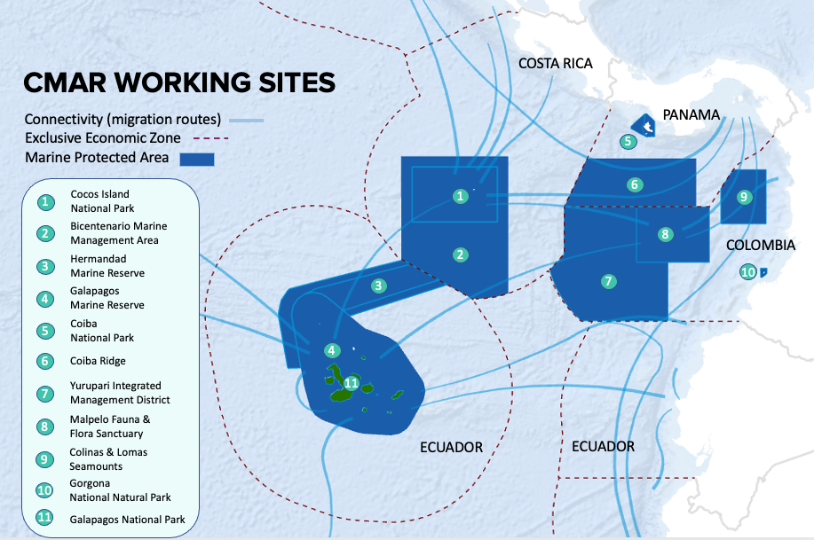
Figure 1. CMAR working sites
The 11 PAs can be divided into fully protected MPAs and multiple use areas (Figure 2), although fully protected MPAs might have small areas where use is still permitted.
The following table outlines the area (ha) of each CMAR fully protected MPAs, as well as the multiple use areas.
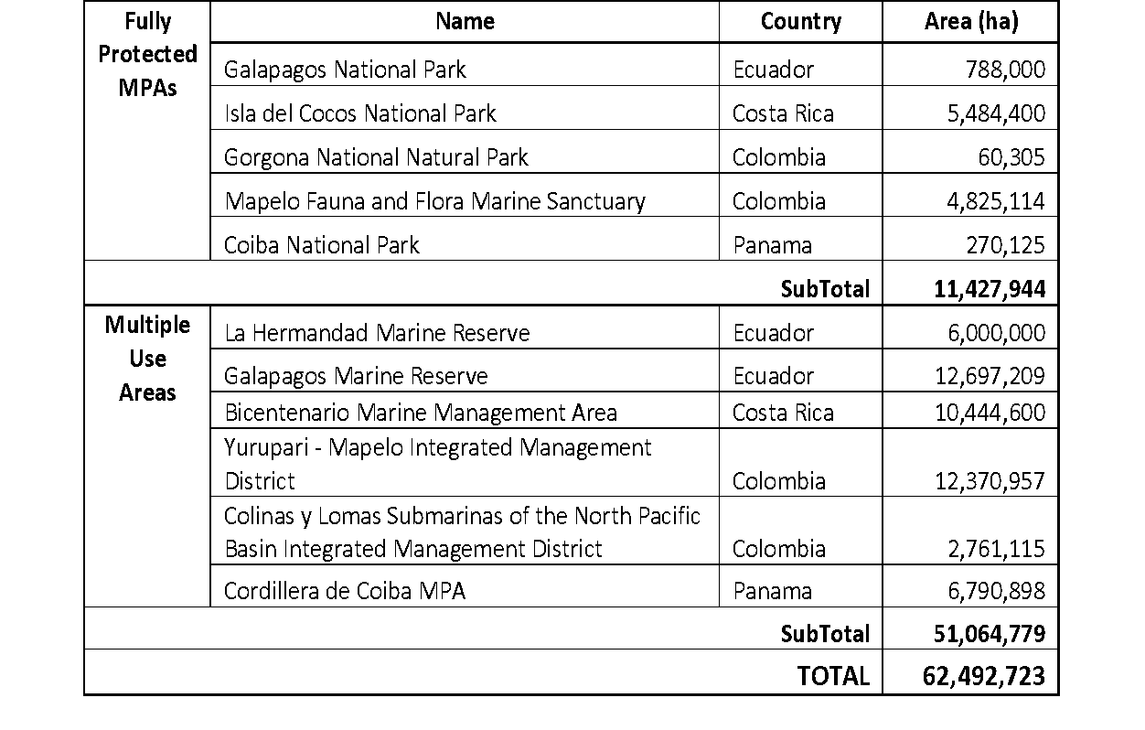
Figure 2. Fully protected and multiple use areas part of CMAR.
Due to the vastness of the PAs that make up the Central ETP, addressing the entirety of these areas is beyond the scope of any one project to address. Therefore, the Beyond 30x30 project proposes to directly impact the long-term resilience and conservation of at least 31,250,000 ha (50%) of the CMAR MPAs in the four countries including the five fully protected MPAs (with no-take zones) and the six multiuse areas, generating lessons learned and knowledge that can be replicated within the broader ETP and in other geographies. It intends to do this, through the following project components, associated outcomes, and outputs.
CMAR has not yet been officially delimited from a geographical or jurisdictional perspective. Based on current applicable legal frameworks, it is likely that the eventual delimitation of CMAR will only cover an area within the Exclusive Economic Zones (EEZs) of the respective member States, not the high seas pocket included in the proposed map (Figure 1). This is due to the absence of a regional or internationally agreed legal framework with the power to establish protected areas on the high seas (CMAR 2019).
With the exception of the Galapagos Archipelago islands, the CMAR project area is largely uninhabited by humans. Nonetheless, the MPAs in the region are recognised as an important economy for many communities along the Eastern Tropical Pacific Ocean (ETPO), and are transitory home and/or stop over sites for national governmental entities, tourists, researchers, and fishers. Among these communities or user groups are Afro-Colombian communities and possibly indigenous communities (to be confirmed in subsequent analysis).
Biological Context of Project Area
- Indicate global significance (e.g. biodiversity hotspot, Ramsar site, Key Biodiversity Area) of the project area.
- Identify endemic and IUCN Red Listed species.
- Describe the environmental conditions of the area including pollution, threats to biodiversity, and natural disasters.

With its 2.1 billion hectares (ha) spanning from Mexico to Peru, the Eastern Tropical Pacific (ETP) is one of the most biodiverse and productive ocean areas on Earth. The Eastern Tropical Marine Corridor is one of the world’s densest clusters of marine World Heritage Sites (NOAA n.d.). The Central ETP includes coastal sections of the Pacific Central American Coastal Large Marine Ecosystem (LME) that extend along the Pacific Coast from Mexico to Ecuador. Approximately 1.42% of this LME is protected, and includes 0.22% of the world’s coral reefs and 0.78% of the world’s seamounts. Much of the Pacific Central American Coastal LME is influenced by seasonal movements of the Inter-tropical Convergence Zone (Bakun et al. 1999). Extreme ocean depths are reached close to the coast due to a narrow and steep continental shelf. The area contains six marine ecoregions: Nicoya has a wide continental shelf and extensive coral area that serves as a fish breeding area; the Panama Bight is known for its extensive reefs, high productivity and an annual arrival of humpback whales; Cocos Island harbors the most diverse coral reef ecosystems of the ETP and is a popular diving destination; and the Northern, Eastern Galapagos, and Western Galapagos ecoregions are differentiated by their various water temperatures and habitats caused by ocean currents that circulate through the area (Sealey and Bustamante 1999).

Table 1: MPAs and their IUCN Category (Source: GEF (2023). GEF-8 Project Identification Form (PIF))
Area | Country | IUCN Category
Galapagos National Park | Ecuador | II
Isla del Coco National Park | Costa Rica | II
Gorgona National Natural Park | Colombia | II
Malpelo Fauna and Flora Marine Sanctuary | Colombia | IV
Coiba National Park | Panama | II
La Hermandad Marine Reserve | Ecuador | V
Galapagos Marine Reserve | Ecuador | V
Bicentenario Marine Management Area | Costa Rica | VI
Yurupari — Malpelo Integrated Management District | Colombia | Not Reported
Colinas y Lomas Submarinas de la cuenca del Pacífico Norte Integrated Management District | Colombia | VI
Cordillera de Coiba MPA | Panama | VI

The broader ETP region includes vast oceanic areas and is interconnected by a series of currents that provide a diverse and changing set of oceanographic conditions throughout the region that create high levels of productivity and biodiversity. The Central ETP plays a significant role in climate change mitigation and global biodiversity protection. The ocean currents pumping through the region attract enormous shark aggregations, the world’s largest biomass of reef fish, as well as iconic animals and highly migratory ocean life – e.g., tuna, turtles, sharks, rays, and whales – that travel within this area (Palacios et al. 2023). With its rich marine biodiversity, these waters provide livelihoods for coastal residents across the region through tourism and fishing, while providing a source of recreation and food for millions worldwide (GEF 2023).
The near-pristine island ecosystems of CMAR are highly connected with coastal areas and are protected by large scale oceanic MPAs. They are also highly biodiverse and include rare, threatened, and ecologically important species that are the building blocks of a healthy, productive ocean. Much of the project area has been isolated for thousands of years, and thus there are also endemic species in the area, especially in the Galapagos, Cocos, Gorgona, and Mapelo areas. However, this project will not work with these species directly (CI 2023).
Critically Endangered Species:
Cetaceans | Balaenoptera musculus | Blue Whale
Sea turtle | Eretmochelys imbricata | Hawksbill
Shark | Mustelus whitenyi | Humpback smoothound
Seabirds | Phoebastria irrorata | Waved albatross
Shark | Carcharhinus longimanus | Oceanic whitetip
Shark | Mustelus mento | Speckled smoothound
Shark | Sphyrna corona | Mallethead shark
Shark | Sphyrna lewini | Scalloped hammerhead
Shark | Sphyrna media | Scoophead shark
Shark | Sphyrna mokarran | Great hammerhead

Endangered Species:
Sea turtle | Chelonia mydas | Green turtle
Ray | Mobula birostris | Giant Manta Ray
Ray | Mobula mobular | Spinetail Devil Ray
Ray | Mobula tarapacana | Sicklefin Devilray
Ray | Mobula thurstoni | Bentfin Devilray
Shark | Alopias pelagicus | Pelagic thresher
Shark | Cetorhinus maximus | Basking shark
Shark | Ginglymostoma unami | Nurse shark
Shark | Isurus oxyrinchus | Shortfin mako
Shark | Isurus paucus | Longfin mako
Shark | Nasolamia velox | Whitenose shark
Shark | Rhincodon typus | Whale shark
Shark | Sphyrna tiburo | Bonnethead

Additional specific information about the biodiversity of each country’s MPAs is provided below:
Costa Rica: Cocos Island NP's seabed is praised by divers as the best in the world for observing large pelagic species such as sharks, rays, tuna and dolphins. The island holds various titles including Costa Rican Historical-Architectural Heritage and Protected Wetland of International Importance Ramsar. The Ramsar Wetlands Convention highlights "the marine area of Cocos Island and the existence of coral and fish species in great abundance. In addition, it has the most extensive and species-rich reef growth in the Eastern Pacific; it is a meeting place for pelagic (open sea) and reef (coastal water) animals” (CMAR Pacífico 2023b). The Bicentenario Marine Management Area has endemic island species, such as the cod grouper (Serranidae: Mycteroperca olfax), and other common species such as butterflyfish and angelfish, show a constant gene flow between these marine protected areas, despite being geographically separated by hundreds of kilometres (FAICO 2023).
Panama: Endemism in Coiba NP includes one subfamily, four genera, one subgenus, 66 species and 24 subspecies. Two species of wood-decomposing fungi (Aphyllophorales), Antrodiella reflexa and Macrohyporia pileata are reported as endemic to the NP. Among the endemic flora species, one genus and one species, Desmotes incomparabilis and two endemic species, Fleischmannia coibensis and Psychotria fosteri, can be mentioned within the vascular plants (Autoridad Nacional del Ambiente 2009). The Coiba ridge is also considered a biodiversity hotspot, home to endangered sea turtles, whales, sharks, and countless species of seabirds (Wyss Foundation 2023).
Colombia: Gorgona Island has abundant vegetation (86% of the island is covered) and high rainfall (6,900mm), which favours the presence of great biodiversity. The island is home to 159 migratory and resident birds, 35 terrestrial reptiles, 543 vascular plants, 2 freshwater fish, among others. Its marine area has 0.3 km2 of coral formations, it being the largest extension of hard corals in the Colombian Pacific. There are 25 hard corals, 24 echinoderms, 53 polychaetes, 525 molluscs, 159 crustaceans, 379 marine fish, 15 marine mammals, 6 marine reptiles, 86 macroalgae, among other species (CMAR Pacífico 2023a). Likewise, the Malpelo Sanctuary is a ‘reservoir' for biodiversity, particularly sharks, giant grouper and billfish and is one of the few places in the world where sightings of the short-nosed ragged-toothed shark, a deepwater shark, have been confirmed. Other biodiversity highlights include 17 marine mammal species, seven marine reptile species, 394 fish species and 340 species of mollusks. Known marine endemics include five fish species and two sea star species (UNESCO 2023). The Yuruparí-Malpelo District contains pelagic ecosystems and seabeds, with migratory animals such as tuna, goldfish and marine mammals, and includes some threathened species like the the hawksbill sea turtle (Eretmochelys imbricata) and the hammerhead (Sphyrna lewini) and whale (Rhincodon typus) sharks (PNNC 2023a). Colinas y Lomas Submarinas of the North Pacific is an area of high productivity that congregates medium pelagics such as billfish, sailfish, marlin, sierra wahoo and dorado, carbonate and non-carbonate sandy bottoms, as well as the bottlenose dolphin Tursiops truncatus that will be targets for conservation (MINAMBIENTE 2022).
Ecuador: The geographical and historical isolation of Galapagos has resulted in a high degree of biodiversity and endemism. More than 2900 marine species have been reported, of which 18.2% are endemic. More than 45 endemic bird species, 42 reptile species, 15 mammal species and 79 fish species live in Galapagos and coexist harmoniously with the local population. The Galapagos Islands also have a rich variety of endemic flora, reaching 500 species of vascular plants, bryophytes and algae (UNESCO 2015). The convergence and influence of currents in the Galapagos marine reserve has generated a unique marine and terrestrial biodiversity, with organisms from warm climates such as corals and reef fish, to penguins and fur seals from cold climates (DPNG 2014). In the Hermandad reserve, there is high biodiversity in terms of pelagic species with a vulnerable conservation status, such as the shark Hammerhead (S. Lewini), Thresher Shark (A. Pelagicus) and Silky Shark (C. Falciformis) and the Pacific Green Turtle (Chelonia Mydas), and therefore their protection requires immediate attention (Ministerio del Ambiente, Agua y Transición Ecológica 2022).
The increase in human population and development in the last decades has resulted in various negative impacts on the environment, including increased pollution on water bodies from agricultural runoff and urban waste, leading to habitat destruction and compromising ecosystem resilience as well as livelihoods. Unsustainable fishing is a main activity threatening this vast area, and bycatch is considered the most significant threat to the survival of marine megafauna, including species and populations of marine mammals, turtles, sharks and rays worldwide. Agricultural activity is also affecting certain bird species, such as the Witch-bird, which became extinct on the islands of San Cristóbal and Floreana and whose future is unpredictable on Santa Cruz. Marine ecosystems are also being severely affected by climate change. In fact, changes have been observed in the geographical distribution of marine species in all oceanic regions (Poloczanska et al. 2016). Small islands are increasingly affected by increases in temperature, the growing impacts of tropical cyclones, storm surges, droughts, changing precipitation patterns, sea level rise, coral bleaching and invasive species, all of which are already detectable across both natural and human systems. Climate change is predicted to increase sea levels, change ocean temperatures, alter oceanic currents around the Islands and change the amount and distribution of rainfall. These conditions, together with current human activity and pressure on the natural ecosystems, will result in accelerated species losses. The loss of the island’s biodiversity will directly impact the local communities as their livelihoods are primarily tourism, fisheries, and agriculture, all of which are dependent on these threatened natural resources (Larrea and Di Carlo 2011).
While the Central ETP continues to attract sustainability investment, the scale of solutions does not match the current magnitude of threats (GEF 2023).
Socio-economic Context of Project Area
- Describe the broad economic, social and cultural context of, and local communities living in, the area of the proposed project and identify disadvantaged groups present in the area. Include statistical information on the number of men, women, indigenous people, disadvantaged/vulnerable/disabled groups, economic/livelihood activity, household income.
Most of the inhabitants of the CMAR project area reside in the Galapagos Archipelago islands, although the other MPAs also constitute important resource areas for the surrounding population. Therefore, most project beneficiaries will primarily include people involved in economic activities in these areas, including workers involved in tourism and fishing activities. CMAR and MPAs management staff and researchers will also benefit from the project.
Economic activities and employment in the CMAR are highly dependent on the use of natural resources and ecological services of the MPAs. They are largely limited to the provision of services (tourism), the extraction of direct products (fishing), marine transportation or harvesting and jobs in processing industries. Some exceptions are found in the areas of influence, where there are job offers in the primary sectors oriented to agriculture and livestock. For artisanal extractive activities such as fishing, the use of natural resources is free. The only criterion for access to fishing resources is compliance with the established minimum regulations (i.e. fishing licences). Fishing resources are only limited by their availability and certain restrictions in protected areas and EEZs. In the CMAR region, national authorities regulate fishing through temporary closures, catch size limitations or fishing gear.
CMAR's area of influence (with the exception of the Galapagos Islands) is a region dominated by high unemployment, poor access to services and significant poverty, despite the fact that the fishing, tourism and maritime transport sectors earn high incomes. Therefore, there are needs and opportunities for the development of projects that favour the sustainable use of resources, improving the poverty conditions of the populations, giving more room for participation to the most vulnerable people and empowering women in local economies. Poverty levels in the intervention areas of the four countries are higher than the mean national levels, with the exception of the Galapagos Islands, where the situation is reversed.
Costa Rica:
The group of actors in Isla de Cocos NP (Figure 3) are the following:
- Tourists: There is a tourism plan and access areas are restricted for diving. Tourism can be considered low impact. Only small boats can enter the area for a duration of 1 week (strict control). Boats: there are yachts and sailboats that go to the island occasionally. Licences and registers exist.
- Rangers: A team of approximately 10 people.
- Ministry of public security: coastguard.
- Bomberos de Costa Rica (firefighting services) has a station on the island. There are also coast guards.
- NGOs such as FAICO, Costa Rica por Siempre, Misión Tiburón, INNOCEANA, Rewild, Fundación Bezos, Re-planet, Conservación Internacional.
- Education and research (University of Costa Rica).
Fishing is not allowed around the islands.
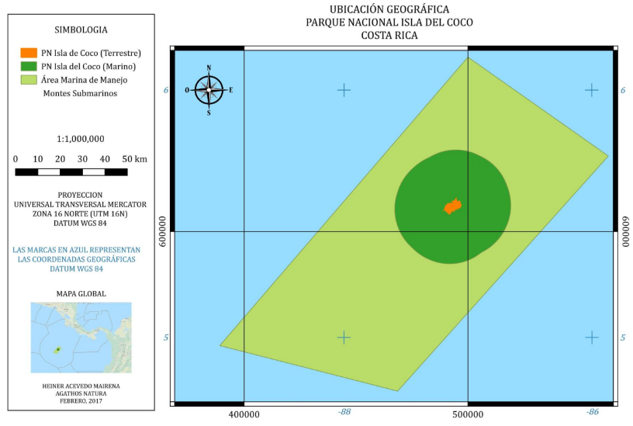
Figure 3: Cocos Island.

However, fishing is permitted in the Bicentenario Marine Management area (see Figure 4). There is only semi-industrial fishing (longline) in the area. There is no artisanal fishing on the island or in the Bicentenary Area (FAICO 2023). There are no IPs in the area.
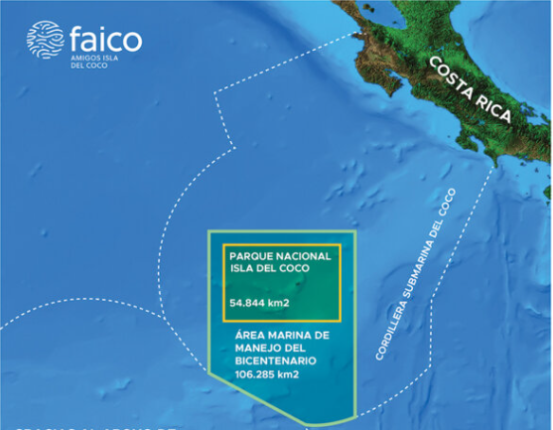
Figure 4. Bicentenario Marine Management Area. Source: FAICO 2023.
Panama:
From 1919 to 2004, the penal colony on Isla Coiba constituted the only local human population in the island. As of today, the prison is no longer operative, with the prisoners having been relocated to other facilities (Coiba NP 2023). Except for ranger control stations, the large island that is part of the NP is currently uninhabited. There are islets outside the NP that are also inhabited, such as Coibita, where there is a research station.
Although Isla Coiba is currently uninhabited, the island is accessed by people engaging in sport fishing and subsistence fishing by communities in the area of influence of Coiba NP (see Figure 5), as well as for other purposes such as sport diving, sport fishing, and marine mammal watching and research. Since Coiba NP has no communities or permanent resident population, the greatest sources of pressure come from the so-called area of influence of the protected area (Autoridad Nacional del Ambiente 2009).
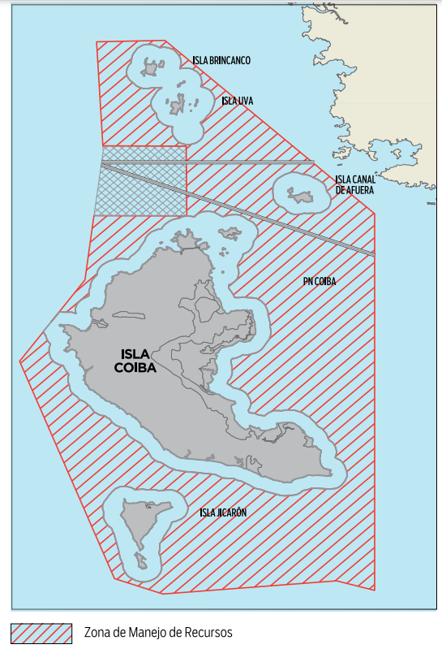
Figure 5. Resource Management Zone in Isla Coiba. Source: Mar Viva 2021.
The users of the Coiba NP are the following:
- Fisherfolk: Currently there are 14 fishing permits in force in Coiba NP, i.e. 12 artisanal vessels allowed to enter the area. There is a good relationship with these actors and they even report to the authorities when they identify illegal activities in the area. The Fisheries Management Plan establishes closed fishing seasons and objectives. There are no IPs in the area. There are 39 women and 161 men involved in artisanal fishing in Coiba.
- Tourism: There are tour operators, tourists and cruise ship staff (season is from February to March).
- Research organisations, such as Fundación Islas Secas and Coiba AIP, a public-private partnership working on research issues.
- Civil Society Organisations (CSOs), such as the Federation of Artisanal Fishermen of the Area of Influence of the Coiba National Park (FEPACOIBA) and UNESCO. FEPACOIBA works in a Special Marine Protected Area or Use Zone outside the NP and is granted special fishing permits. The Association’s activities are woman-led.
- NP Staff: There are 2 ranger stations and 12 rangers in total for the whole island.

The Coiba Ridge is a submerged MPA and is therefore uninhabited by humans. About two thirds of the ridge are designated as “no-take” areas to fully protect the unique biodiversity of the region, while the remaining portion excludes industrial fishing but continues to support the livelihoods of coastal communities in Panama (Wyss Foundation 2023).
Colombia:
None of the MPAs in Colombia are inhabited. The Gorgona National Natural Park is a hotspot for ecotourism activities; being, by tradition, one of the natural places with the highest daily or temporary visitation by nationals and foreigners (students, national and foreign divers, and other forms of leisure tourism).
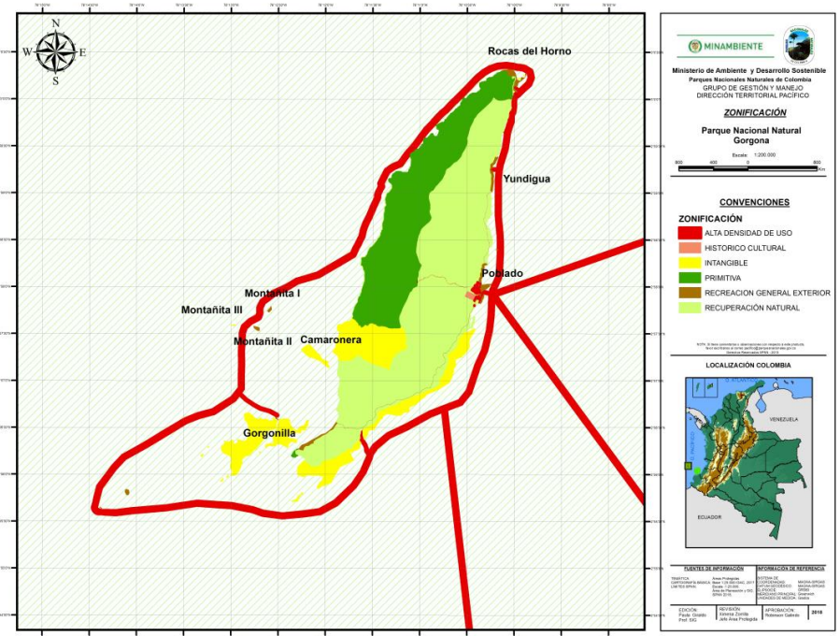
Figure 6. Zoning of NP Gorgona (red: high use areas; green: primitive areas; light green: area of natural recovery; yellow: no-use areas). Source: SIG DTPA-PNN/MINAMBIENTE 2018
The service providers present in the area, mainly in the municipality of Guapi, but also in Bazán and surrounding areas, are maritime transporters, restaurant and hotel personnel, diving instructors, handicrafts saleswomen/men and environmental guides or interpreters. These groups of actors are detailed in more detail below:
- Fisheries: Afro-Colombian communities living in coastal regions have a right of access to the Gorgona National Natural Park and area of influence for their fishing expeditions (eg. community of Bazán) (Vive Gorgona 2024). In addition, members of the indigenous organisations Eperara Siapidara can also be considered users of the park (MINAMBIENTE 2018). The Park has a process of permanent interaction with the community of Bazán, given their historical use of the Gorgona marine area, which has led to the establishment of the first use agreement in force (MINAMBIENTE 2018). The park is used as a rest area for fishing expeditions;
- Tourism: The municipalities of Guapi, Timbiqui, El Charco, La Tola, Mosquera and Olaya Herrera benefit from the development of ecotourism activities in the park, as the provision of ecotourism services generates approximately 25 direct jobs in these municipalities and purchases and contracting of services in these communities amounting to 700 million pesos per year;
- Educational activities;
- Academic and research groups, which develop research and monitoring projects.

The Mapelo Marine Sanctuary is the largest no-fishing zone in the Eastern Tropical Pacific and is widely recognized as one of the top diving sites in the world (certified divers need to be authorised by operators (boats)). There are no native communities or colonisation zones in this MPA, and the presence of humans is limited to the marines of the National Navy's control and surveillance post and the sporadic stay of scientific researchers (PNNC 2023b). Although, legally, the entire property is a no-take area, monitoring of illegal commercial and artisanal fishing is needed and depends on costly patrolling and law enforcement both in and around the sanctuary. Due to its size and remoteness, Malpelo Island cannot develop into a major tourist destination and will remain a niche destination for specialised, boat-based diving tourism. Overall, visitor numbers and group sizes are controlled in accordance with established limits. Research and Environmental Education is also active in the area, and tourists along with scientists and the rotating Navy personnel are the only regular visitors to Malpelo Island. It is undisputed that many, if not most, of the property's marine secrets remain to be discovered, suggesting a major potential for research in an almost pristine natural environment (UNESCO 2023). The information provided so far lists the community members involved in tourism as 6 women and 7 men (Ecotourism with Fundación Malpelo).
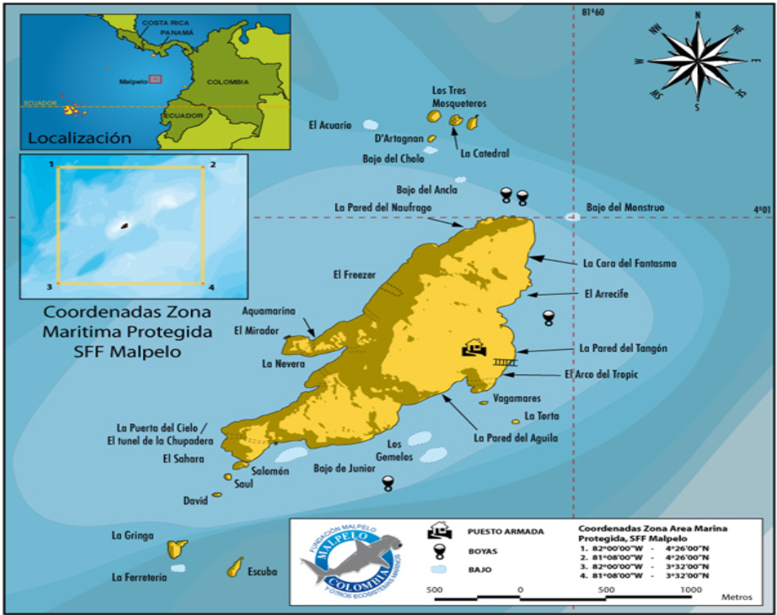
Figure 7. Malpelo island. Source: Malpelo Foundation.

In terms of multi-use areas, there is the Yurupari - Mapelo Integrated Management District, where the entire area is marine and does not contain any terrestrial land. Ecotourism is permitted, although national and foreign vessels visiting the protected area must first apply for entry permits to the Malpelo Fauna and Flora Sanctuary at the offices of PNNC in Bogotá (PNNC 2023a). On the other hand, the Colinas y Lomas Submarinas of the North Pacific is envisioned as an area suitable for sustainable fishing (MINAMBIENTE 2022).
The number of men and women living in these coastal communities is unknown, and whether these communities include IPs, or disadvantaged/vulnerable/disabled groups, will be determined in subsequent analysis.
Ecuador:
The Galapagos Marine reserve is a multiple-use area created to appropriately manage marine species of commercial interest and to conserve and protect its ecosystems with unique fauna and flora. This reserve surrounds the Galapagos Archipelago islands (see Figure 3). The most recent census in 2015 measured the Galapagos islands’ population at 25.244 (51,8% men and 48,2% women), with a growth rate of 1,8%. Most of the residents in the Galapagos Archipelago islands self-identify as mixed race or “mestizos” (85%), while 8% consider themselves to be indigenous. The rest of the population self-identify as white (3%), Afro-Ecuadorian (3%), Montubio (1%), or other (INEC 2015). It is still to be determined whether groups self-identifying as Indigenous Peoples (IPs) in the Galapago islands (i.e. the Salasacas community, whose members are mainly engaged in agricultural activities) may be adversely or positively affected by the project. This will have to be determined when final project activities and their locations are confirmed.
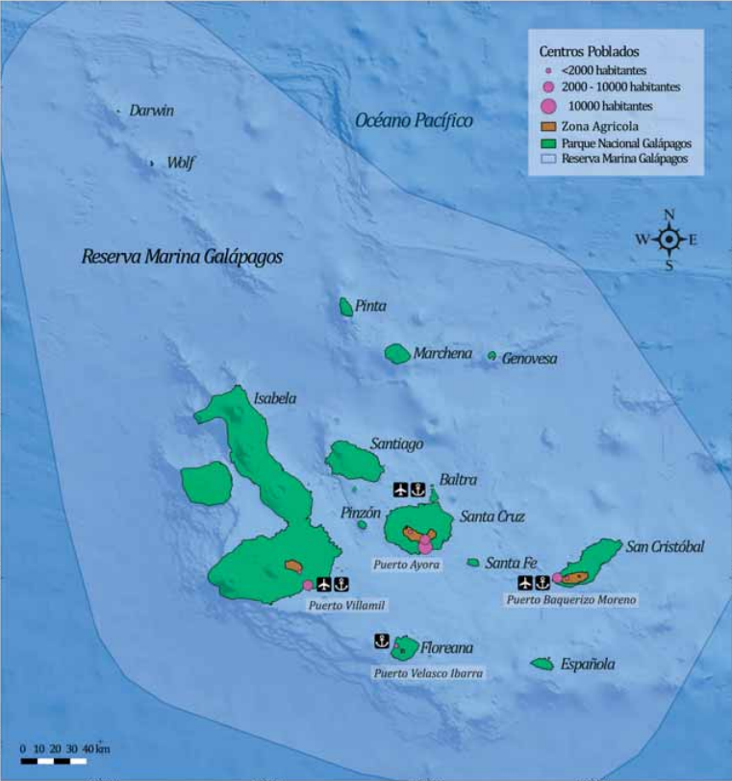
Figure 8. Galapagos protected areas. Source: DPNG 2014.
In the Galapagos Archipelago islands, most women work in services and sales occupations as well as other basic occupations such as cleaning, domestic services or agricultural, fishing, or mining activities. Other professions with a sizable proportion of female workers include administrative support (13,8%) and scientific and intellectual positions (13 %). On the other hand, most men work as tradesmen, craftsmen and in service and sales occupations. Other less prominent but still important occupations are basic occupations, plant and machinery operators (11%), and farmers and skilled workers (10%) (INEC 2010). The average monthly current household income in Galapagos is 1,901.3 dollars (INEC 2017).
In the National Park, 97% of the terrestrial area is fully protected, while 3% of the area is used by the population. There are also buffer zones for where resource use is permitted. In the marine area, there are no take zones and other areas where fishing is authorised. There are four main groups of actors present in the islands:
- Tourism: guilds, associations, cruise ships, and the hotel sector. The National Park has proven to be the main basis for the economic development of the province and an important source of foreign exchange for the country. The main economic activity in the archipelago is tourism, based on the conservation policies and actions implemented by the Galapagos National Park Directorate (DPNG) administration (DPNG 2014);
- Fisheries: fishing cooperatives. This is one of the largest user sectors. Only artisanal fishing is permitted (regulated through permits);
- Tour guides and interpreters, who are usually members of local communities. The NP provides them with training and certification for their activities;
- Science industry: researchers;
- Public and private entities;
- Governmental institutions: Galapagos National Park (Ministry of Environment - MAATE), Ministries of Defence, Production and Fisheries.

The Hermandad marine reserve is a marine corridor linking the Galapagos Marine Reserve with Costa Rica’s marine protected area (see Figure 9). Sustainable fishing is permitted in this corridor. The continental fishing sector, as the main user of the Ecuadorian Insular Exclusive Economic Zone, will maintain the use of key areas in the most productive zones of the region to develop its activity under a responsible management approach that promotes sustainable catches in the long term (Ministerio del Ambiente, Agua y Transición Ecológica 2022).
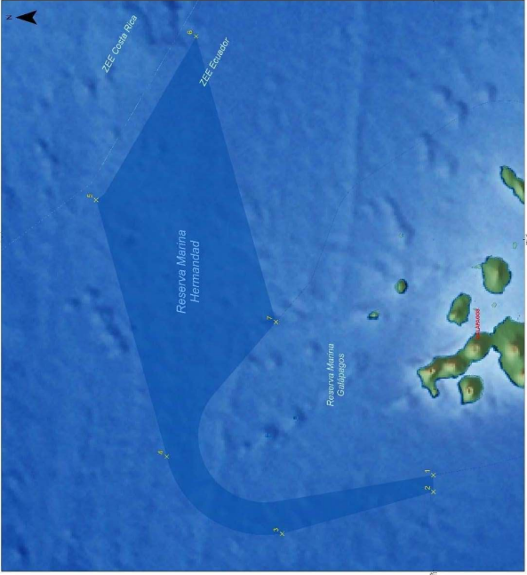
Figure 9. Hermandad Marine Reserve. Source: DPNG 2014.

- Describe how men and women access, use, manage and govern the natural resources that the project seeks to focus on. How could project activities affect or benefit women and men, and people with diverse gender identities where relevant?

The preliminary analysis of socioeconomic and sociocultural variables carried out in the CMAR pre-feasibility study (2016) shows that there are gender differences in access to resources and employment. In general, men are dedicated to extractive activities with demands for extended hours and greater requirements for physical strength, such as agriculture, livestock and fishing. This represents 25% of the EAP for men, compared to 1% for women. Women are primarily engaged in tourism and, to a lesser extent in small-scale fisheries and its supply chain, although they do play an important role in the commercialization of artisanal fishing, in the production of industrial fishing products, and in the service sector (hotels, gastronomy, food sales and small businesses). On the other hand, commerce and transportation services in the areas of influence are dominated by men (CMAR 2016). There are also women working for CMAR and as scientists in the area. A more significant proportion of men also work in small-scale fisheries. These gender differences have also been presented in additional analyses (e.g. ACD 2010).
Many of the communities living on the coast or in the islands depend on fishing as their primary source of income. A significant percentage of women work in the processing of fish in small factories or selling fish and seafood (prawns, in particular) in local markets, an activity that some of them depend solely on for their livelihoods. A closed seasons for fishing has been implemented during January and March of each year in some areas (e.g. Buenaventura, Colombia), which means that women receive less income; a situation that puts the food security and well-being of them and their families at risk (CMAR Pacífico 2015). As a possible solution to this situation, an agreement between WWF and the National Aquaculture and Fisheries Authority (AUNAP) in 2020 meant that 105 fisherwoman or platoneras were selected to participate in a seed capital programme, an initiative that opened up spaces for training on entrepreneurship and allowed them access to other products that they were able to market during the closed season (WWF 2020).
According to the report “USAID/South America Region Gender and Fisheries Analysis” (USAID 2023) for Colombia and Ecuador, a large percentage of women work in fish processing factories in suboptimal conditions, since they have an invisible role within value chains. Men occupy the majority of positions of authority in formal and informal decision-making bodies and in fishing companies, and women lack access to opportunities to improve their socioeconomic conditions.
In the South Pacific of Costa Rica, half of the artisanal and piangüero fishermen are women, but the fishermen's organizations are led by men (CMAR 2016).
In the report carried out by Vivienne Solis Rivera on "Fisheries and gender equality" for Costa Rica (2013), it is also stated that the work of women in activities related to natural resources is intense but little recognized and access to the spaces where they take restricted environmental and economic policy decisions.
As outlined in the PACA report of 2020, there is the misconception that activities such as fishing, tourism, environmental stewardship and aquaculture are predominantly associated with men. Consequently, the crucial contributions of women in these domains often go unrecognised.
In Panama's tourism sector, boat captains are men and few guides are women. Women participate in tourism-related activities, but women's roles and contributions in the whale watching supply chain are not visible.It is noteworthy that the migration that occurs in Panama is mainly carried out by women (CMAR 2016).
Information related to gender in the tourism or maritime transport sector for the project area is scarce or non-existent. The project could exacerbate situations of lower income for these communities if restrictions are supported without adequate mitigation measures or if new ones are established. Therefore, the project will further analyse women’s roles in project fisheries and tourism activities and ensure that they participate in and benefit from the project and that no additional workload is imposed through project activities (GEF 2023).
Management plans (outlined in Component 2) will be updated – or developed for those MPAs where no management plan exists – to acknowledge gender and intergenerational uses and inclusion as well as acknowledging the role of Afro-descendent and other coastal community MPA users where applicable. Components 3 and 4 have a strong gender focus and will work with male and female business owners providing blue economy focused technical expertise. Blue economy activities (outlined under Component 3) will be developed with women entrepreneur input. Activities in all blue economy work will include meetings with men and women in each sector to better understand their roles and limitations, and how the project can help improve women’s involvement. Exchanges (outlined in Component 4) will include exchanges of women’s groups so they can learn and share information from other women entrepreneurs and how they have overcome obstacles to their engagement. Meetings and exchanges with CMAR staff and researchers will be organised with input from women participants to help ensure their active participation in project activities (CI 2023).

- Describe the extent of gender-based violence (GBV) and Sexual Exploitation, Sexual Abuse and Sexual Harassment (SEAH). Are GBV and SEAH relatively high at the national and project level? Is the project planning to introduce activities that may perpetuate or exacerbate GBV and SEAH?

In Colombia and Ecuador, the incidence of gender-based violence (GBV) and workplace harassment is assumed to be significant, but limited information is available (USAID 2023). In Colombia, the percentage of women who have suffered violence is significant: 70.8% (psychological), 40.1% (physical), 33.3% (economic), 12% (sexual), 74.7% (some violence). However, this is not only a gendered problem, as a considerable number of men have also been victims of violence: 79.1% (psychological), 27.9% (physical), 27.2% (economic), 1.3% (sexual), 79.4% (some violence) (Data on Pacific coast of Colombia; ENDS Colombia 2015). In Galapagos, 60.6 percent of women over 15 years of age at the national level indicate that they have experienced some type of violence (physical, psychological, sexual). Psychological violence, as in the rest of Ecuador, is the most recurrent form of violence in the province of Galapagos with 49.9%. In the case of patrimonial violence, 2 out of 10 women have experienced it in the province.
In Panamá (NP Coiba) GBV exists but it is still taboo. Alcohol is a trigger and lack of education and access to information does not help (MARVIVA’s interview 2023). Women’s deaths at the hands of their intimate partner or former partner in Panamá is estimated to be 5% . Femicide or feminicide, most recent data available in Panamá: 1.1% (CEPAL 2022).
Costa Rica has various policies and laws to protect women and girls exposed to GBV and SEAH. None of these measures, however, cover the specificities of those who live in coastal areas or engage in small-scale artisanal fishing (International Collective in Support of Fishworkers-ICSF 2022). Women’s deaths at the hands of their intimate partner or former partner in Costa Rica is estimated to be 5%. Femicide or feminicide, most recent data available in Costa Rica: 7% (CEPAL 2022).
Moreover, both narcotrafficking and human trafficking are known to occur in the project area (particularly around Galapagos), while information on the links between tourism and SEAH are now being documented. In Ecuador, 72,1% of causes of sentences against women are in relation to narcotrafficking. This figure is high when compared to the prosecutions of male detainees, as only 32% were arrested for drug crimes. One reason for the discrepancy is that women are forced to commit crimes under threat (INEC 2022; CIDH 2023).
During the PPG phase, the project will include considerations on GBV and SEAH as part of the accountability data available for MPAs or sectoral policies. The findings of these studies will be used to guide the development of activities within each component to ensure that the project in no way perpetuates or exacerbates these practices (CI 2023).
For more information on gender, please see the separate deliverable: Gender Mainstreaming Plan (GMP).
Institutional Capacity
- Describe the institutional experience in implementing environmental and social safeguards, gender and stakeholder engagement.
- Indicate the number of staff dedicated (part/full-time) to safeguards, gender and stakeholder engagement.
- Describe the capacity of the above staff (are they subject experts such as gender specialist or have they been trained in safeguards, gender and stakeholder engagement). (The EA/EE will be required to complete an ESMF capacity self-assessment during the PPG/PPF stage).

Fundación Pacífico currently has in place an Environmental and Social Monitoring System (ESMS), designed to comply with the requirements of the German Development Bank (KfW). This system was approved and adopted in October 2023, and its use wil start in full with the implementation of KfW and FFEM-funded projects.
Pacifico’s ESMS includes provisions to deploy Pacifico’s Gender Policy. It also includes a Gender Action Plan (SAS 9 and its appendixes). As with the ESSMS in general, the gender policy and tools will start implementation with the above mentioned projects. However, due to the recent development of the ESMS, there are currently no staff members appointed to supervise the ESMS, including its gender policy.
Regarding stakeholder consultation, Pacifico’s experience lies in the consultation process with the CMAR Secretariat and the representatives of CMAR member authorities in Costa Rica, Panamá, Colombia and Ecuador. Stakeholder engagement has been led by board members in each country.
Given the lack of experience of Pacifico’s staff in E&S safeguards implementation and the very recent ESMS, hiring safeguards experts/training staff will be essential so that they have the knowledge and capacity needed to identify and manage E&S risks and impacts. This includes stakeholder engagement, including stakeholder mapping, identification of those who are more vulnerable or disadvantaged within an specific context, and the design and implementation of Stakeholder Engagement Plans (SEP).
The budget contemplated for the project includes a gender focal point. To optimise resources, one option could be that this role can be covered by someone who specialises both in gender and safeguards. If this is not possible, then at least one of the national support consultants hired for the project should be a specialist in safeguards. This has been reflected in the project’s budget.
No additional resources from Pacifico are expected to be needed as the project’s budget should cover them.
Pacifico needs to ensure that there is enough staff to apply the ESMS by the time of the implementation of the CMAR project, and that they are trained and/or have the capacity to assess E&S risks and impacts and implement mitigation measures. Since activities will depend on the context and capacities of each country, activities might vary and therefore good communication and organisation between countries must be a priority. Moreover, adequate coordination needs to be prioritised to ensure that activities happening both at the national and regional levels are harmonised and their implementation is successful.

Additional Information
- Describe any risks or factors that may affect or contribute to the project implementing safeguard measures/plans.

Risks or factors include disinterest or opposition of rights holders/stakeholders to participate in engagement as part of the project or lack of institutional capacity to implement the mitigation measures. Insufficient legal and institutional /capacity frameworks to support transboundary coordination to protect the central ETP is considered a risk. Moreover, the extent to which the four countries can coordinate in the implementation of activities can also present its own challenges. It is necessary to know if each country will be responsible for the implementation of different activities, if the activities will partly overlap, or if all activities will be jointly implemented, and what capacities will be in place to ensure a successful implementation. Conflicts of interest between countries and how this could affect the project should also be taken into account.

III. ESMF EXCLUSIONS
This section will help the CI-GEF/GCF Agencies to determine whether they can support a project. Please provide accurate answers and details including supporting documents, where requested. If you answered “Yes” to any of the questions (i-xiii) then the CI-GEF/GCF Agencies cannot support the project.

Will the project: | Yes | No
- Contravene major international and regional conventions on environmental issues? | ☐ | ☒
- Propose to create or facilitate significant degradation and/or conversion of natural habitats of any type (forests, wetlands, grasslands, coastal/marine ecosystems, etc.) including those that are legally protected, officially proposed for protection, identified by authoritative sources for their high conservation value, recognized as protected by traditional local communities, or have significant negative socioeconomic and cultural impacts that cannot be cost-effectively avoided, minimized, mitigated and/or offset? | ☐ | ☒
- Involve adverse impacts on critical natural habitats, including forests that are critical natural habitats, including from the procurement of natural resource commodities, except for adverse impacts on a limited scale that result from conservation actions that achieve a net gain of the biodiversity values associated with the critical natural habitat? | ☐ | ☒
- Propose to carry out unsustainable harvesting of natural resources -animals, plants, timber and/or non-timber forest products (NTFPs)- or the establishment of forest plantations in critical natural habitats? | ☐ | ☒
- Propose the introduction of alien species that can potentially become invasive and harmful to the environment, unless there is a mitigation plan to avoid this from happening? | ☐ | ☒
- Involve involuntary resettlement, land acquisition, and/or the taking of shelter and other assets belonging to local communities, individuals or Indigenous Peoples? | ☐ | ☒
- Contravene major international and regional conventions on human rights, including rights specific to indigenous peoples? | ☐ | ☒
- Propose activities that result in the exploitation of and access to outsiders to the lands and territories of indigenous peoples in voluntary isolation and in initial contact? | ☐ | ☒
- Propose the use and/or procurement of materials deemed illegal under host country laws or regulations or international conventions and agreements, or subject to international phase-outs or bans, such as:  a. ozone depleting substances, polychlorinated biphenyls (PCBs) and other specific, hazardous pharmaceuticals, pesticides/herbicides or chemicals; and  b. wildlife or products regulated under the Convention on International Trade in Endangered Species or Wild Fauna and Flora (CITES)? | ☐ | ☒
- Propose the use and/or procurement of pesticides and hazardous materials that are unlawful under national or international laws, the generation of wastes and effluents, and emissions of short- and long-lived climate pollutants? | ☐ | ☒
- Involves the removal, alteration or disturbance of any non-replicable or critical cultural heritage, or the use of any intangible cultural heritage without the Free, Prior and Informed Consent of the communities who it belongs to? | ☐ | ☒

IV. SIMPLIFIED APPROVAL PROCESS (GCF Projects ONLY)
Questions XIV through XXII are ONLY for GCF Projects pursuing the Simplified Approval Process (SAP). If you answer “Yes” to any of the questions below, your project will undergo further review to determine eligibility for the Simplified Approval Process.

Will the project: | Yes | No
- Involve associated facilities and require further due diligence of such associated facilities? | ☐ | ☐
- Involve trans-boundary impacts including those that would require further due diligence and notification to downstream riparian states? | ☐ | ☐
- Adversely affect working conditions and health and safety of workers or potentially employ vulnerable categories of workers including women or child labor? | ☐ | ☐
- Generate hazardous waste and pollutants including pesticides and contaminate lands that would require further studies on management, minimization and control and compliance to the country and applicable international quality standards? | ☐ | ☐
- Involve the construction, maintenance, and rehabilitation of critical infrastructure (i.e. dams, water impoundments, coastal and river bank infrastructure) that would require further technical assessment and safety studies? | ☐ | ☐
- Involve the resettlement and dispossession, land acquisition, and economic displacement of persons and communities? | ☐ | ☐
- Be located in protected areas and areas of ecological significance including critical habitats, key biodiversity areas and internationally recognized conservation sites? | ☐ | ☐
- Affect Indigenous Peoples that would require further due diligence, free, prior and informed consent (FPIC) and documentation of development plans? | ☐ | ☐
- Be located in areas that considered to have archeological (prehistoric), paleontological, historical, cultural, artistic, and religious values or contains features considered as critical cultural heritage? | ☐ | ☐

V. ENVIRONMENTAL AND SOCIAL SAFEGUARDS (ESS) SCREENING
This section will help the CI-GEF/GCF Agencies to determine the category of the project and the ESS Standards triggered by the project. Please provide accurate answers and details including supporting documents, where requested.

ESS1: Environmental and Social Impact Assessment
Will the project potentially:
- cause significant adverse environmental and social impacts (which may affect an area broader than the project area) that are sensitive, diverse, or unprecedented?
- cause adverse environmental and social impacts (which are site-specific and few if any of them are irreversible) on human populations or environmentally or socially important areas?
☒ NO (to all of the above)
☐ TO BE DETERMINED
☐ YES (to any of the above)
It is not expected that the project will cause significant adverse environmental and social impacts, or adverse envionmental and social impacts on human populations or environmentally or socially important areas in addition to those risks already covered in ESS 2, 3 and 4 below.
Stakeholder engagement: It has been found that governments' communication with the marketers and artisanal fisheries representatives to inform them of important information (i.e. new regulations etc.) has not been very strong until now (CMAR Pacífico 2015). Project management will have to ensure that all rights holders and stakeholders possibly affected by activities or new measures imposed as part of/supported by the project are duly informed. Moreover, efforts should be made to ensure the participation of affected rights holders and stakeholders in relevant decision-making processes and other project initiatives (e.g. as part of Output 1.1.2: National commissions and regional working groups established/strengthened and regulated, and Output 1.2.1: Implementation of a financial sustainability strategy that aligns existing and new donors for CMAR and its associated instruments; in the design of activities under Components 2 and 3 that could affect the communities, i.e working groups; and to participate in and benefit from IW: Learn and regional and international exchanges under Component 4). Likewise, when providing capacity-building (i.e. as part of Output 1.1.3: Strengthened capacity of CMAR (CMAR secretariat, ministerial committee, regional technical committee, national commissions, regional technical working groups, MPA managers on regional marine management and other relevant stakeholders)), it will be important to guarantee that gender and inclusivity is ensured so that the interests of all community users in relevant activities in relation to governance are considered. Finally, communication of relevant information should be done in an adequate and timely manner, i.e. the Communication Strategy to be developed under Component 4 will need to include appropriate guidance and strategies for engagement with women, marginalised groups and communities of users of the MPAs as a whole to ensure better buy-in and adoption of sustainability practices.

- Has a full or limited ESIA that covers the proposed project already been completed?
☒ NO
☐ YES (If Yes, answer the following)
- Is the assessment a: ☐ A FULL ESIA ☐ A LIMITED ESIA | Yes | No
- Does the assessment meet its terms of reference, both procedurally and substantively? | ☐ | ☐
- 3. Does the assessment provide a satisfactory assessment of the proposed project? | ☐ | ☐
- 5. Does the assessment describe specific environmental and social management measures (e.g., avoidance, minimization, mitigation, compensation, monitoring, and capacity development measures)? | ☐ | ☐
- 6. Does the assessment identify capacity needs of the institutions responsible for implementing environmental and social management issues? | ☐ | ☐
- 7. Was the assessment developed through a consultative process with key stakeholder & rightsholder engagement, including issues related to gender mainstreaming and Indigenous Peoples? | ☐ | ☐
- 8. Does the assessment assess the adequacy of the cost of and financing arrangements for environmental and social management issues? | ☐ | ☐
For any “no” answers, describe below how the issue has been or will be resolved or addressed.
ESS 2: Protection of Natural Habitats and Biodiversity Conservation
Will the project:
(a) involve adverse impacts on Critical Habitats, including forests that are Critical Habitats, including from the procurement of natural resource commodities, except for adverse impacts on a limited scale that result from conservation actions that achieve a Net Gain of the Biodiversity values associated with the Critical Habitat?
(b) contravene applicable international environmental treaties or agreements?
(c) involved the utilization of genetic resources?
(d) introduce or use potentially invasive alien species?
(e) affect species identified as threatened at the local and/or global levels?
(f) implement habitat restoration activities?

☐ NO (to all of the above)
☐ TO BE DETERMINED (TBD)
☒ YES (to any of the above)
The project will implement habitat restoration activities under Component 2. However, these and the other activities envisaged as part of the project are not expected to have any adverse impacts on natural habitats and biodiversity conservation. Under Component 2, i) a Climate Action Plan will be developed, which will include climate change adaptation activities (Output 2.1.1), and i) a regional management effectiveness assessment tool will be implemented (Output 2.2.1), which will include restoration activities. For example, activities such as the use of "assisted evolution" techniques (e.g., inoculating corals with stress-resistant algae or microbes to reduce vulnerability to bleaching; use of portable thermal management systems for corals; etc.). Although it is expected that these activities will only have positive impacts, they ought to be designed and implemented in a way that guarantees the safety of natural habitats and biodiversity.
Likewise, Components 1 and 4 are not expected to have any environmental impacts since they focus on strengthening governance and communication and knowledge management. However, blue economy initiatives will be implemented in the fisheries, tourism and transportsectors under Component 3, and it will need to be ensured that these do not involve any adverse impacts on natural habitats and biodiversity conservation.

ESS 3: Resettlement, Physical and Economic Displacement
Will the project
(a) involve the voluntary or involuntary resettlement of people? Resettlement including relocation or loss of shelter.
(b) restrict land use and access?
(c) cause economic displacement of people? Economic displacement, including the loss of access to natural resources that lead directly or indirectly to the loss of traditional/subsistence livelihoods, including assets,
social capital, cultural identity, among other impacts.

☐ NO (to all of the above)
☐ TO BE DETERMINED (TBD)
☒ YES (to any of the above)
Under Component 2, key interventions aligned with the CMAR regional action plan will be implemented in at least five Central ETP MPAs. This includes activities part of Output 2.2.2., under which the restoration of degraded habitats and the implementation of fishing exclusion zones in key migration areas is being considered. Areas under restoration are likely less accessible for resource users.
Other potential adaptation actions being considered under this component are using temporary closures during bleaching episodes to reduce additional stress on corals; eliminating the use of destructive fishing/harvesting practices and destructive landings; improving fisheries management to protect spawning and nursery areas and limit the extraction of herbivorous fish and predators; relocating corals affected by bleaching; facilitating distribution shifts to track changes in climatically suitable areas (such as restoring tidal connectivity); creation of artificial reefs designed to prohibit illegal trawling; and introduction of new habitats in the marine environment. All these measures could result in access restrictions for the local communities who depend on fishing for their livelihoods.
In addition to these measures, there are several research and monitoring activities being considered also under Component 2 (e.g. development/updating of biodiversity inventories, development of studies to determine the relative variation of the three main ocean currents as a consequence of climate change, studies on the increase in sea surface temperature, monitoring of ecologically essential species and behavioral analysis, monitoring of migratory species, etc. as well as a general increase in research and monitoring to better understand the effects of climate change in the CMAR area), which could also potentially lead access to some areas being temporarily restricted.
For example, Afro-Colombian communities currently have rights of access to the Gorgona National Natural Park for their small-scale fisheries activities, on which they depend for their livelihoods. Although the project intends to protect the rights of access of the communities living in and around the MPAs, these activities could result in some form of restrictions of access. Moreover, an increase in connectivity between MPAs would likely mean the creation and/or expansion of corridors and protected areas, which might result in further access restrictions.
Mangrove restoration is not expected to cause access restrictions since it would take place in protected areas where access is currently not permitted, although this will have to be confirmed once the adaptation activities have been fully identified and developed.
Additionally, possible activities as part of the blue business plans (Component 3) could cause economic displacement for these communities due to a limitation in their rights of access and the subsequent reduction in food and other resources. These activities might include the enforcement of regulations to ensure sustainability (such as closures, permitted sizes and quantities), banning of certain fishing methods, the protection of certain fish species, new and more sustainable fishing practices (e.g.cultivation of native marine species in floating cages or marine facilities for human consumption), the strengthening of zoning in Marine Protected Areas (MPAs) to improve control and surveillance, and marine ecotourism (e.g. development of guided tours for marine life sightings) and training of tourism service providers to guarantee the sustainability of their actions.
Additionally, since the CMAR area has not yet been officially delimited from a geographical or jurisdictional perspective, this can give rise to confusion over the boundaries within which fishing is permitted as well as potential tensions and conflict between authorities and the population and among citizens of the different countries part of CMAR as a result.
If any access restrictions are identified/confirmed, mitigation measures will need to be identified, including the development of a Process Framework.

ESS 4 : Indigenous Peoples
Will the project:
- work in lands or territories traditionally owned, customarily used, or occupied by indigenous peoples?
- cause impacts on land and natural resources, including restrictions on land use or loss of access to natural resources, subject to traditional ownership or under customary use or occupation, or the location of a project or program on such land or the commercial development of such natural resources?
- cause relocation of Indigenous Peoples from land and natural resources subject to traditional ownership, or under customary use or occupation?
- cause significant impacts on an Indigenous People’s cultural heritage that is material to the identity and/or cultural, ceremonial, or spiritual aspects of the affected Indigenous People's lives, or the use of such cultural heritage for commercial purposes?
- include the commercial development of lands and natural resources central to Indigenous Peoples’ identity and livelihood, or commercial use of Indigenous Peoples’ Cultural Heritage?
- restrict the access of Indigenous Peoples to parks and protected areas?
- Work in territories where there is Indigenous Peoples in voluntary isolation or could result in undesired contact with IPs?

☐ NO (to all of the above)
☐ TO BE DETERMINED (TBD)
☒ YES (to any of the above)
The project will take place in areas that are occupied by groups that self-identify as Indigenous Peoples (IPs), who could benefit from or be impacted by project activities. These include members of the indigenous organisations Eperara Siapidara in Colombia (Gorgona National Park) and Salasacas in Ecuador (Galapagos). Additionally, Afro-Colombian communities also inhabit the CMAR area. These communities are predominantly involved in the fishing and tourism sectors and could therefore be impacted by project activities.
The CI GEF (2020) definition of the term “Indigenous Peoples” is used in a generic sense to refer to a distinct social and cultural group possessing the following characteristics, in varying degrees: (a) Self-identification as members of a distinct indigenous social and cultural group and recognition of this identity by others; (b) Collective attachment to geographically distinct habitats, ancestral territories, or areas of seasonal use or occupation as well as to the natural resources in these areas; (c) Customary cultural, economic, social, or political systems that are distinct or separate from those of the mainstream society or culture; and, (d) A distinct language or dialect (existing now or in the past), often different from the official language or languages of the country or region in which they reside. According to this definition, then, it is possible that some of the groups that could benefit from and/or be impacted by the project can be considered to be Indigenous Peoples, in which case ESS4 would be triggered.
There is the possibility that activities as part of the project (those under Components 2 and 3) could cause access restrictions for some of these groups (please see ESS3 above). As explained in ESS3, the final set of activities to be implemented and their locations are yet to be established, and therefore it is not possible to confirm if IPs could be affected by these activities. It is not expected that the project will cause relocation of IPs. Likewise, the project does not take place in an area where there are IPs in voluntary isolation and where undesired contact with IPs could be a risk.
Since this ESS can be considered triggered, an effective consultation process with the affected IP communities will need to be conducted to fully identify their views and to seek their free, prior and informed consent (FPIC) for those activities affecting them. Moreover, an Indigenous Peoples Planning Framework (IPPF)/Indigenous Peoples Plan (IPP) describing measures to avoid possible adverse impacts will also be need.

ESS 5: Resource Efficiency and Pollution Prevention
Will the project:
- promote the trade in or use of any substances listed under the Stockholm Convention on Persistent Organic Pollutants, or other chemicals or hazardous materials subject to international bans, restrictions or phaseouts due to high toxicity to living organisms, environmental persistence, potential for bioaccumulation, or potential depletion of the ozone layer, consistent with relevant international treaties and agreements?
- generate wastes and effluents, and emissions of short- and long-lived climate pollutants?
- involve pest management measures, Integrated Pest Management or Integrated Management of Vectors and Intermediate Hosts?
- procure pesticides?
- use energy, water and other resources and material inputs, where significant water consumption is involved and would cause adverse impacts on communities, other water users, and the environment?

☒ NO (to all of the above)
☐ TO BE DETERMINED (TBD)
☐ YES (to any of the above)
It is not expected that the project will have the risks (a)-(e) stated above. However, it will need to be ensured that activities as part of the project, particularly those included in the Climate Action Plan (Component 2) and blue economy business plans (Component 3), do not cause any inadvertent pollution or inefficient use of resources; for example, it will need to be ensured that blue economy activities as part of the tourism sector do not result in an increase in water consumption. This could be done by including energy and resource efficiency and pollution avoidance considerations in these plans.

ESS 6: Cultural Heritage
Will the project implement activities that affect cultural heritage (both tangible and/or intangible), including archaeological, paleontological, historical, architectural, and sacred sites including graveyards, burial sites, and sites with unique natural values?

☒ NO
☐ TO BE DETERMINED (TBD)
☐ YES
It is not expected that the project will include activities that could affect tangible cultural heritage; however, it is not possible to confirm at this point that there are no cultural heritage artefacts where potentially disruptive activities could take place (e.g. restriction of access to sacred sites including graveyards and burial sites or historical and paleontological sites due to restoration from EbA actions under Component 2), since the location for these activities is yet to be established. For example, petroglyphs from the Tumaco Tolita society can be found in Gorgona (PNNC n.d.), and the Galapagos Islands were declared a World Heritage Site due to, in part, their representative examples of important stages in the earth's history, including evidence of life, geological processes creating geological landforms or significant geomorphic or physiographic features. It is not expected that activities could affect this cultural heritage, but this will need to be confirmed once it is known where the activities under this component will take place and an analysis has been carried out to ensure that any possible tangible cultural heritage is protected.
With regards to intangible cultural heritage, it will need to be ensured that activities under Component 3 do not have a negative effect on this type of cultural heritage. Any activities that try and change behaviour of people, such as the introduction of practices that are believed to be more sustainable, should consider that possible artisanal fishing techniques, i.e. collection of mussels, catching of crabs, etc. could fall under traditional knowledge and might thus be considered as intangible heritage. Any activities that aim to introduce practices that depart from these traditional styles (i.e. implementation of sustainable fishing methods under blue economy plans and associated capacity building, as well as capacity building for tourism service providers to guarantee the sustainability of their actions) must consider the traditional knowledge and practices in place and evaluate whether more modern practices will indeed be more sustainable. Ideally, this should be discussed with the local communities applying traditional knowledge and practices, ensuring that this knowledge is appreciated and that any change in practices is developed in a participatory manner.

ESS 7: Labor and Working Conditions
Does the EA/EE have in place the necessary policies, procedures, systems and capabilities to ensure that:
- the fundamental rights of workers, consistent with the International Labour Organization’s (ILO) Declaration on the Fundamental Principles and Rights at Work are respected and protected?
- written labor management procedures are established in accordance with applicable national laws?
- workers are provided with clear and understandable documentation of employment terms and conditions, including their rights under national law to hours of work, wages, overtime, compensation and benefits?
- workers are provided regular and timely payment of wages; adequate periods of rest, holiday, sick, maternity, paternity, and family leave; and written notice of termination and severance payments, as required under national laws and the labor management procedures?
- decisions relating to any aspect of the employment relationship, including recruitment, hiring and treatment of workers, are made based on the principles of non-discrimination, equal opportunity and fair treatment, and not on the basis of personal characteristics unrelated to inherent job requirements?
- appropriate measures are in place to prevent harassment, intimidation, and exploitation, and to protect vulnerable workers, including but not limited to women, children of working age, migrants and persons with disabilities?
- workers who participate, or seek to participate, in workers’ organizations and collective bargaining, do so without interference, are not discriminated or retaliated against, and are provided with information needed for meaningful negotiation in a timely manner?
- forced labor and child labor are not used in connection with the project or program?
- occupational health and safety (OHS) measures are applied to establish and maintain a safe and healthy working environment, including supply chain workers?
- workers are informed of applicable grievance and conflict resolution systems provided at the workplace level?
- workers may use these mechanisms without retribution, and the grievance and conflict resolution systems does not impede access to other judicial or administrative remedies available under the law or through existing arbitration procedures, or substitute for grievance systems provided through collective agreements?

☐ NO (to any of the above)
☐ TO BE DETERMINED (TBD)
☒ YES (to all of the above)
It is expected that Fundación Pacífico (EA) will have the necessary policies, procedures, systems and capabilities in place to avoid the risks (a) - (k) mentioned above. Fundación Pacífico’s ESMS contains a standard on labour and working conditions, which is based on World Bank’s guidance (ESS2: Labor and Working Conditions). The objectives of the standard are i) to promote health and safety in PACIFICO's activities and projects, ii) to promote fair treatment, non-discrimination and equal opportunity in such activities and projects, and iii) avoid forced labor of any kind and child labor (under 14 years of age). The requirements of PACIFICO’s standard and that of the World Bank, as well as the provisions of the national labor laws in all Pacifico countries and those included in Pacifico’s governance documents (Manual de Puestos, Manual de Políticas y Procedimientos), ensure (a) to (k) above are covered.
Nonetheless, it is important to note that where the project creates employment opportunities it must be ensured that these meet ILO standards. This includes activities under Components 2 and 3. For example, where the implementation of Blue Economy Plans leads to new employment opportunities, it would be important that these are safe and fair for all, i.e they are equally available for women and men, working conditions meet international OHS standards, include fair remuneration and employment benefits, etc. Pacifico’s ESMS is aligned with the 10 Fundamental Conventions of the ILO and therefore it is expected that these will be met.
Regarding (j) and (k): At the moment, no one has been informed about the grievance mechanism yet. Therefore, Pacifico needs to ensure that all stakeholders and workers are duly informed and that the mechanism guarantees point (k) above once implementation starts.

ESS 8: Community Health, Safety and Security
Please complete the following Risk Assessment Tool to determine community health, safety and security risks and their mitigation measures. Guidance on how to complete the Tool can be found in Appendix IX of the ESMF (Version 7). Try to identify risks in a way that recognizes diversity, disadvantaged groups that might be disproportionately affected or affected in different ways to others. For example, elderly and people with disabilities will be more impacted by natural hazards, or women having more exposure to accidents from having less access to Personal Protective Equipment (PPE).

Some of the CHSS risks may include but are not limited to:
- Natural hazards/disasters such as flooding, drought, wildfires, volcanic eruptions, earthquakes, typhoons and hurricanes;
- Climate change and ecosystem service stress such as increased temperatures;
- Exposure to Hazardous Materials such pesticides and banned chemicals;
- Exposure to communicable/vector-borne disease such as Ebola, COVID-19, and Malaria;
- Security related risk such as working in areas of conflict or post-conflict or with illegal activities (e.g. poaching, growing illicit crops), context with ongoing human rights violations, human-wildlife conflict, frequent and violent protests/demonstrations, working with armed rangers;
- Safety related risks such as failure of structural elements or infrastructure built by the project, lack of PPE; and
- Gender-Based Violence (GBV) and Sexual Exploitation, Abuse and Harassment (SEAH).

Community Health, Safety and Security Threat | Likelihood | Impact | Risk | Risk Rating | Mitigation Measures
- Physical injury or harm and impact on project activities as a result of changing weather patterns due to seasonal El Niño/La Niña resulting in natural hazards/disasters occuring in project MPAs and/or in close proximity to these areas | 3 | 4 | medium | 12 | Seasonal natural hazards as a result of this will need to be considered and included in the design of planned activities. The development of a climate vulnerability analysis (as part of Output 2.1.1.) partly addresses this risk. Additional measures include making use/sharing climate prediction models as well as weather alerts and warnings with relevant personnel/actors; using protective equipment and other safety measures for workers; choosing activities more resilient to these hazards for the adaptation and blue economy plans; or suspending a/o adapting programming accordingly.
- Physical injury or harm due to unsafe working conditions | 2 | 3 | low | 6 | It is possible that port infrastructure resilient to adverse conditions will be built. Were this to be the case, project management will need to ensure that working conditions are safe for workers. This can be done by ensuring that workers are aware of possible unsafe practices, that they are provided with adequate PPE and that training is provided, if needed. However, these infrastructure works would be small-scale and therefore the likelihood of possible accidents is low.
- Contraction or transmission of COVID-19 or other transmittable diseases as a result of coming together in presence in a larger group of people | 3 | 3 | low | 9 | Implement officially recommended measures as applicable/relevant as and when in-presence events are planned
- Tensions and/or violence with local population due to an increase in law enforcement operations | 3 | 3 | low | 9 | Training of law enforcement personnel on human rights and rights of local resource users that may depend on certain marine resources; appropriate behaviour and use of force; etc.
- Tensions and/or violence with local population due to confusion over boundaries / disagreement over enforcement measures | 3 | 3 | low | 9 | Ensuring that all rights holders and stakeholders are provided with clear and timely information over new/existing boundaries within which fishing is permitted; Ensuring that resource users are compensated for possible impacts resulting from access restrictions.
- Decrease in security for communities and project personnel (including risk of SEAH) due to narcotrafficking using marine routes | 3 | 4 | medium | 12 | Enforcing security measures; MPA control. It will be important that the project i) does not improve the enabling conditions for illicit activities to take place (e.g. by creating new areas with restricted access that might not patrolled and which could be potentially used by drug traffickers), and ii) increases accidental encounters between organised criminal groups and local resource users, fisherfolks and tour operators (e.g. if indeed the routes they can take are reduced due to more limitations and patrolling, traffickers may go around certain areas and encounter other stakeholders).
Total |  |  |  | Medium
Average |  |  |  | N/A
Overall risk rating to project-affected communities |  |  |  | Medium

ESS 9: Private Sector Direct Investments and Financial Intermediaries
Will the project make either direct investments in private sector firms or Endowment Funds, or channels funds through Financial Intermediaries (FIs)?

☐ NO
☐ TO BE DETERMINED (TBD)
☒ YES (to any of the above)
The project will be sub-granting to small and medium enterprises (SMEs) to implement business plans.

ESS 10: Climate Risk and Related Disasters
Please refer to guiding questions in Appendix A to help answer the questions below:

Describe the climate projections for the country or region, or if possible, for the specific location of the project for the next 30 years from the start date of the project.
Climatic changes in the eastern tropical Pacific are controlled by the El Niño-Southern Oscillation (ENSO), a recurring ocean-and-atmosphere pattern that warms and cools the eastern tropical Pacific through El Niño and La Niña events, respectively, and that lasts from one to three years. However, there is low agreement on how (or if) climate change will influence the behaviour of ENSO and other long-term climate patterns (Hoegh-Guldberg et al. 2014). In fact, tropical waters at the heart of ENSO are not behaving exactly as climate scientists expected they would in a warming world, with potentially major implications for weather phenomena around the world.
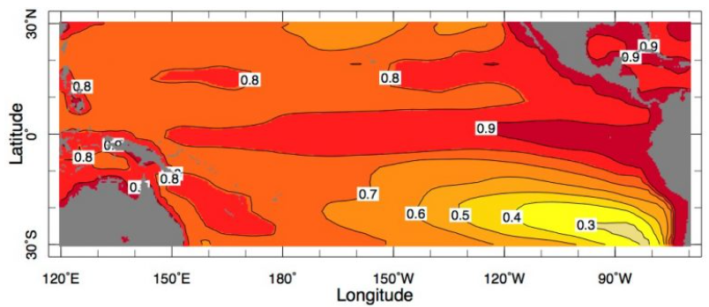
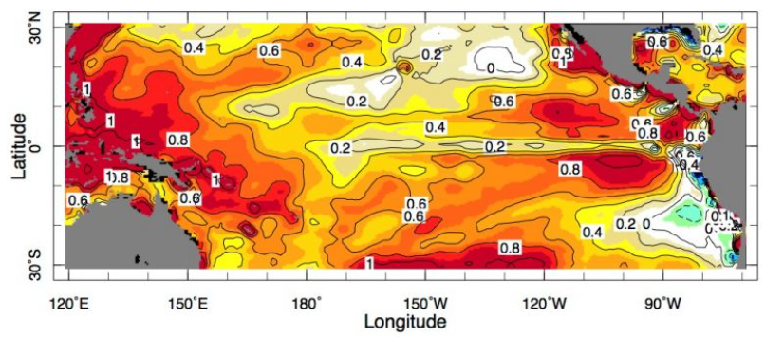
Figure 10. The tropical Pacific Ocean (Australia and South/Central America in gray, left and right). Top map shows what climate models say sea-surface temperatures should be doing in response to rising greenhouse gases, including pronounced warming of waters along the equator. Bottom map shows what the waters are actually doing; the equatorial waters are remaining relatively cool (Source: Seager et al. 2019; Krajick 2019).
Climate models (see figure 10 above) indicate that ENSO is virtually certain to continue to be a major driver of oceanic variability over the coming century, and a superposition of a warming ocean on future ENSO activity means that temperatures within Equatorial Upwelling Systems (EUS) sub-regions are projected to continue to warm significantly, shifting towards an “El Niño-like” state (Hoegh-Guldberg et al. 2014). However, the opposite is occurring. The western tropical Pacific has warmed dramatically, as predicted, but unusually persistent upwelling of cool subsurface water has led to a slight drop in average sea surface temperature over much of the eastern tropical Pacific. In fact, in the last 30 years, the accumulation of satellite and buoy data on sea surface temperatures has supported the notion that the eastern tropical Pacific is cooling (Henson 2023, Lindsey 2016).
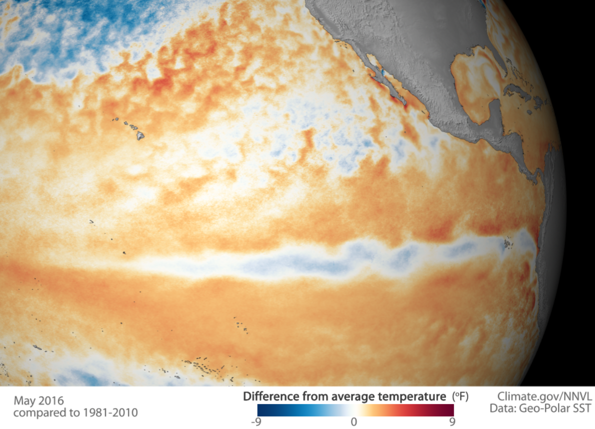
Figure 11. 2016 difference from average temperature in the Pacific (from 1981 - 2010). Redder colours indicate where average monthly sea surface temperatures in May 2016 were warmer than the 1981-2010 average, while blue colours indicate where sea surface temperatures were cooler than average. Temperatures across most of the western tropical Pacific were still warmer than average, but a narrow band of cooler-than-average surface water had emerged at the equator in the eastern half of the basin. Source: NOAA/Lindsey 2016.
This anomaly seems to primarily affect the ocean surrounding the islands in the equator line, in particular the Galapagos Archipelago. However, studies on the Islands of San Cristobal, Santa Cruz, and Isabela show that there is a wetting and warming trend across the region. Precipitation is projected to increase between 20 and 70% and temperature may even increase up to 2.5 °C, in comparison with the last four decades. However, these future estimates may be constrained by the ability of General Circulation Models (GCMs) to represent climate change in the equatorial Pacific, since in the case of the Galapagos region, major discrepancies have been reported between GCMs and observed tropical Pacific sea surface temperature trends (Paltán et al. 2021). As previously mentioned, the projected warmer and wetter future contradicts the recent cooler and drying trends, which are more representative of a “La Niña-like” state.
The rest of the CMAR project area seems to show less uncertain warming trends, albeit lower than predicted by climate models. Higher temperatures worsen many types of disasters, including storms, heat waves, floods, and droughts, ocean acidification, and sea level rise. The Intertropical Convergence Zone (ITCZ), which shifts latitudinally with climate patterns, makes the marine and coastal ecosystems of the MPAs in the ETPO particularly vulnerable to climate change impacts. Warming surface waters, particularly during intense El Niño events, result in lower primary production and a general decline in biological activity (Enright et al. 2021). Projected increases in sea temperature mean that heat stress will continue to increase and ultimately irreversibly degrade marine ecosystems such as coral reefs. Moreover, a substantial risk exists with respect to the synergistic interactions between sea temperature and declining pH, especially as to how they influence a large number of key biological processes (Hoegh-Guldberg et al. 2014).
It is unknown whether the factors that are now pushing the tropical Pacific toward a La Niña-like state will eventually get overwhelmed by longer-term global warming, leading to the El Niño-like outcome that models have long projected. This means that making decisions based on projections of future climate becomes harder as there is significant debate on climate projections in the eastern tropical Pacific at the moment.
Describe the relevant potential hazards (e.g. heavy rainfall leading to flood, low rainfall leading to drought, temperature changes which could lead to heat waves, sea-level rise, or changes in other extreme events such as hurricanes and cyclone) that could prevent the project from achieving its objectives and/or outputs.
Due to the conditions outlined above, the CMAR region is also susceptible to natural disasters including earthquakes, hurricanes, and intense storms. According to NASA, in a typical year, the Eastern Pacific (from the coast of the Americas to 140° West longitude) sees 15 named storms, eight hurricanes, and four major hurricanes. Due to prevailing westerly trade winds, most storms in the eastern Pacific move westward and rarely make landfall (NASA Earth Observatory 2021). Extreme weather and droughts have also been experienced and are expected to continue.
These events are not expected to substantially affect the project or prevent the project from achieving its objectives and/or outputs as long as climate variability and possible effects of ENSO are embedded in activity design. Attention will need to be paid to these potential hazards and ensure that project activities have protective measures in place to ensure that they succeed in the face of these climatic variabilities. The project should ensure that activity design accounts for these hazards and continue to monitor climate trends across the region as they could influence activities undertaken in climate action plans and MPA management effectiveness in Component 2 and blue economy fisheries work in Component 3. For example, when designing more sustainable fishing methods under Component 3, it will be important to ensure that these methods are resilient to likely future climate change events. For some activities, these potential hazards are already being considered. For example, in workshops on Component 2 with CMAR, country representatives and working groups, it was noted that the main climate hazards that the Climate Adaptation Plan should address are: ENSO, sea temperature rise, sea level rise and ocean acidification, and therefore it is expected that the activities contained within this plan will help reduce the likelihood of related climate risks in the future.

Describe the current and projected exposures, vulnerabilities, and adaptive capacities (e.g. technical, institutional, financial) and how these could prevent the project from achieving its objectives and/or outputs.
Currently, the CMAR region lacks a regional entity that is capable of guiding regional marine conservation investment. This project is founded on the premise that such an agency can be identified and trained with needed skills within the term of this GEF project (CI 2023). While CMAR already has a set of guiding documents, these need be revised and broadened to reflect the organization’s evolution into a more formal regional entity while new bylaws and procedures will need to be developed and approved by the four governments. An important objective of Component 1 is to strengthen a regional entity capable of attracting and managing large sum and multi-year investment. The project intends to work with the four governments to strengthen regional governance by broadening CMAR’s mandate and increasing the institution’s capacity and global profile (CI-GEF 2024).

What mitigation measures have been identified and incorporated into the design of the project/planned for the implementation phase to reduce the likelihood and/or consequences of risks or to respond to consequences so as to ensure that the project achieves its objectives and/or outputs?
Climate scenario coping strategies will be included in project MPA management plans and blue economy initiatives (Components 2 and 3). As part of Outcome 2.1, an updated CMAR Regional Action Plan will be developed by 2025 (currently supported by the World Bank), and the project will be used as a guide for the development of a Regional Climate Action Plan that will establish actions, metrics, and goals that will be implemented and measured across the CMAR MPAs. Output 3.1 will include the development of a Blue Economy Strategy in alignment with the Climate Action Plan. These plans will help inform the development of best practices while helping to secure the sustainability and viability of MPA and blue economy initiatives (CI-GEF 2024).

If one or more risks are accepted, please provide a justification.
Known risks are considered minor to moderate and could easily be addressed following good practice standards and mitigation measures.

Appendix A. Climate risk and related disaster assessment tool (adapted from FAO).
The checklist below presents some guiding questions on hazards, exposure, vulnerability and adaptive capacity (see definitions in Appendix XI of the ESMF Version 7) for completing the climate screening section of the Safeguard Screening Form:
Existing Hazards Guiding Questions: | Yes | No | TBD
Observed climate and weather hazards in the project area:
Extreme temperature (heat/cold) | ☒ | ☐ | ☐
Extreme precipitation and flooding | ☒ | ☐ | ☐
Agricultural Droughts and/or dry spells | ☒ | ☐ | ☐
Storms (Tropical storms, snowstorms, hailstorms, dust storms, etc.) | ☒ | ☐ | ☐
Winds (Typhoons, Cyclones, Hurricanes, Tornadoes, Harmattan) | ☒ | ☐ | ☐
Sea level rise (from global warming and storm surges) | ☐ | ☒ | ☐
Other natural hazards observed in the project area:
Earthquakes | ☒ | ☐ | ☐
Tsunamis | ☒ | ☐ | ☐
Volcanic eruptions | ☒ | ☐ | ☐
Landslides or avalanches | ☐ | ☐ | ☒
Wildfires | ☐ | ☐ | ☒
Salinization | ☒ | ☐ | ☐
Ocean acidification | ☒ | ☐ | ☐
Projected Hazards Guiding Questions | Yes | No | N/A
Do future climate scenarios foresee an incremental increase of potential hazards and climate change compared to the baseline that may affect the project over its lifetime?
Extreme temperature | ☒ | ☐ | ☐
Extreme precipitation and flooding | ☒ | ☐ | ☐
Agricultural Droughts and/or dry spells | ☐ | ☒ | ☐
Change in temperature | ☒ | ☐ | ☐
Change in rainfall | ☒ | ☐ | ☐
Exposure Guiding Questions | Yes | No | N/A
Is the project located in high exposure areas?
Low-lying areas (valleys or coastal zones) | ☒ | ☐ | ☐
Arid and semi-arid zones | ☐ | ☒ | ☐
Mountains zones and permafrost areas | ☐ | ☒ | ☐
Are the agricultural systems (crops, livestock, fisheries, forests) targeted by the project affected by climate related hazards?
Is crop productivity affected by rainfall variability, changes in temperature or pests and diseases? | ☐ | ☒ | ☐
Is livestock productivity affected by rainfall variability, changes in temperature or parasites and diseases? | ☐ | ☒ | ☐
Is fisheries productivity affected by ocean acidification, changes in sea temperature or variation of water salinity? | ☒ | ☐ | ☐
Is forest productivity affected by wildfires, diseases, rainfall variability or changes in temperature? | ☒ | ☐ | ☐
Is any stage of the agricultural value chain (production, storage, processing and marketing) affected by climate related hazards? | ☒ | ☐ | ☐
Vulnerability Guiding Questions | Yes | No | TBD
Is the target population in the project area living below the poverty line? | ☐ | ☒ | ☐
Are the livelihoods of the target population sensitive to climate change? | ☒ | ☐ | ☐
Is the target population income exclusively from agriculture? | ☐ | ☒ | ☐
Is the population migrating due to food insecurity as a consequence of climate change? | ☐ | ☒ | ☐
Is the project targeting sensitive groups (indigenous people or other marginalized groups) that are likely to be affected by climate change? | ☐ | ☐ | ☒
Is climate change affecting certain groups more than others in the project area? | ☒ | ☐ | ☐
Adaptive Capacity Guiding Questions: | Yes | No | TBD
Does the target population have access to climate information? | ☐ | ☐ | ☒
Are there any early warning systems in the project area to anticipate and respond to climate-related events and disasters or climate-driven pests and diseases? | ☐ | ☐ | ☒
Does the government or other institutions support the target population/communities with the necessary social and economic resources to prepare for or respond to climate-related events? | ☐ | ☐ | ☒
Is the target population carrying out self-adaptation? | ☐ | ☐ | ☒
Do policies exist that make financial credit, loans and agricultural insurance available? | ☐ | ☒ | ☐
Project Modulation of Risks Guiding Questions: | Yes | No | TBD
- Policies and planning
Does the project support the integration of climate into national policies and planning? | ☒ | ☐ | ☐
Does the project support the increased use of climate data and information in national long term and strategic planning? | ☒ | ☐ | ☐
- Capacity building, training and outreach
Would the project invest in institutional development and capacity-building for national institutions involved in climate related activities? | ☒ | ☐ | ☐
Would the project invest in increased information and dissemination of climate-related information to target groups? | ☒ | ☐ | ☐
Does the project have opportunities to strengthen rural and indigenous climate risk management capabilities? | ☒ | ☐ | ☐
Does the project support the capacity of target groups to utilize and apply climate services at the farm level? | ☐ | ☒ | ☐
- Data gathering, monitoring and information management
Will the project support the infrastructure and technology necessary to monitor climate variables and collect data required from climate impact assessment and modelling? | ☒ | ☐ | ☐
Will the project support the national institutions to develop the skills required to monitor and collect climate related information? | ☒ | ☐ | ☐
Will the project support development of databases and repositories of climate information? | ☒ | ☐ | ☐
- Mitigation
Will the project invest in measures that will reduce or mitigate emissions of GHGs from the energy sector? | ☐ | ☒ | ☐
Will the project invest in measures to reduce or mitigate emissions of GHGs from livestock or agricultural production (e.g. rice production) | ☐ | ☒ | ☐
Will the project invest in measures to reduce or mitigation emissions of GHGs through reforestation or land use change? | ☐ | ☒ | ☐
Will the project invest in renewable energy and green technologies? | ☐ | ☐ | ☒
Will the project invest in other measures to reduce or mitigate GHG emissions? | ☐ | ☐ | ☒
- Adaptation
Will the project invest in climate smart agriculture activities? | ☐ | ☒ | ☐
Will the project promote climate resilient practices for crops, livestock and fisheries? | ☒ | ☐ | ☐
Will the project promote sustainable natural resources management? | ☒ | ☐ | ☐
Does the project support Nature-based Solutions for climate change and disaster risk reduction? | ☒ | ☐ | ☐
Will the project invest in agricultural insurance? | ☐ | ☒ | ☐

References

Alianza para la Conservación y el Desarrollo (ACD).(2010). Diagnóstico Socioeconómico y Ambiental de 10 comunidades del Área de Influencia del Parque Nacional Coiba.
Autoridad Nacional del Ambiente (2009). Coiba National Park Management Plan.
Bakun, A., J. Csirke, D. Lluch-Belda & R. Steer-Ruiz. (1999). The Pacific Central American Coastal LME, pp. 268-280. In K. Sherman & Q. Tang (eds.). Large Marine Ecosystems of the Pacific Rim. Assessment, Sustainability, and Management. Blackwell Science, Oxford.
CEPAL. (2022). Observatorio de Igualdad de Género de América Latina y el Caribe. Mapas de País: Panamá; Costa Rica. Available at: https://oig.cepal.org/es/paises (accessed February 2024).
CMAR Pacífico. (2015). Corredor Marino del Pacífico Este Tropical (video). Available at: https://www.youtube.com/watch?v=VUF-WG1Uzp8&t=710s (accessed 5th October 2023).
Corredor Marino del Pacífico Este (CMAR). (2016). Estudio de prefactibilidad y formulación de un proyecto para la adecuada gestión del CMAR.
CMAR. (2019). Plan de acción 2019-2024. San José, Costa Rica.
CMAR Pacífico. (2023a). Parque Nacional Natural Gorgona. Available at:
https://www.cmarpacifico.org/donde-trabajamos/areas-nucleo/parque-nacional-natural-gorgona (accessed 18th October 2023).
CMAR Pacífico. (2023b). Parque Nacional Isla de Coco. Available at:
https://www.cmarpacifico.org/donde-trabajamos/areas-nucleo/parque-nacional-isla-del-coco (accessed 18th October 2023).
CI-GEF. (2024). GEF Project Document. Beyond 30x30: Securing resilience in the Eastern Tropical Pacific through enhanced transboundary cooperation. Colombia, Costa Rica, Ecuador, Panama / LAC. Version March 1, 2024
Coiba National Park. (2023). Penal Colony of Isla Coiba. Available at:
http://www.coibanationalpark.com/prison.html (accessed 12th October 2023).
Comisión Interamericana de Derechos Humanos (CIDH). (2023). Mujeres Privadas de Libertad en las Américas.

Conservation International (CI). (2023). CI-GCF/GEF Agencies. Environmental and Social Safeguards (ESS) Screening Form: Preliminary Screening. Beyond 30x30: Securing resilience in the Eastern Tropical Pacific through enhanced transboundary cooperation. Commented version, 24th March 2023.
Enright, S.R.; Meneses-Orellana, R.; and Keith, Inti. (2021). The Eastern Tropical Pacific Marine Corridor (CMAR): The Emergence of a Voluntary Regional Cooperation Mechanism for the Conservation and Sustainable Use of Marine Biodiversity Within a Fragmented Regional Ocean Governance Landscape. Front. Mar. Sci., 02 June 2021. Sec. Marine Affairs and Polic. Volume 8 - 2021.
Dirección del Parque Nacional Galápagos (DPNG). (2014). Plan de Manejo de las Áreas Protegidas de Galápagos para el Buen Vivir. Puerto Ayora, Galápagos, Ecuador.
ENDS Colombia. (2015). Encuesta Nacional de Demografía y Salud. Tomo 2.
Equipo Regional de Océanos de CI (CIAFD). (2024). GEF CMAR: Insumos y sugerencias para PRODOC por componentes. Febrero 2024.
FAICO. (2023). Área Marina de Manejo del Bicentenario. Available at:
https://www.cocosisland.org/area-marina-manejo-montes-submarinos-isla-del-coco/#:~:text=El%20%C3%81rea%20Marina%20de%20Manejo,Ejecutivo%20N%C2%B0%2043368%2DMINAE (accessed 20th October 2023).
GEF (2023). GEF-8 Project Identification Form (PIF): Beyond 30x30: Securing resilience in the Eastern Tropical Pacific through enhanced transboundary cooperation.
Hoegh-Guldberg, O., R. Cai, E.S. Poloczanska, P.G. Brewer, S. Sundby, K. Hilmi, V.J. Fabry, and S. Jung. (2014). The Ocean. In: Climate Change 2014: Impacts, Adaptation, and Vulnerability. Part B: Regional Aspects. Contribution of Working Group II to the Fifth Assessment Report of the Intergovernmental Panel on Climate Change (IPCC). [Barros, V.R., C.B. Field, D.J. Dokken, M.D. Mastrandrea, K.J. Mach, T.E. Bilir, M. Chatterjee, K.L. Ebi, Y.O. Estrada, R.C. Genova, B. Girma, E.S. Kissel, A.N. Levy, S. MacCracken, P.R. Mastrandrea, and L.L.White (eds.)]. Cambridge University Press, Cambridge, United Kingdom and New York, NY, USA, pp. 1655-1731.
Henson, Bob. (2023). A mystery in the Pacific is complicating climate projections. Available at:
https://yaleclimateconnections.org/2023/04/a-mystery-in-the-pacific-is-complicating-climate-projections/ (accessed 19th October 2023).
Krajick, Kevin. (2019). Part of the Pacific Ocean Is Not Warming as Expected. Why?. State of the Planet. Climate, Earth Sciences. Columbia Climate School. . Available at:
https://news.climate.columbia.edu/2019/06/24/pacific-ocean-cold-tongue/ (accessed 19th October 2023).
Instituto Ecuatoriano de Estadísticas y Censos (INEC). (2010). Fascículo Provincial Galápagos. Resultados del Censo de Población y Vivienda en el Ecuador 2010. Available at:
https://www.ecuadorencifras.gob.ec/wp-content/descargas/Manu-lateral/Resultados-provinciales/galapagos.pdf (accessed 3rd October 2023).
INEC. (2015). Principales resultados Censo de Población y Vivienda Galápagos 2015. Censo de Población y Vivienda Galápagos. Available at:
https://www.ecuadorencifras.gob.ec/documentos/web-inec/Poblacion_y_Demografia/CPV_Galapagos_2015/Presentacion_CPVG15.pdf (accessed 3rd October 2023).
INEC. (2017). Memoria Estadística Galápagos. Available at:
https://www.ecuadorencifras.gob.ec/documentos/web-inec/Bibliotecas/Libros/Memoria_Estadistica_Galapagos_2017.pdf (accessed 4th October 2023).
INEC. (2022). Datos del Censo Penitenciario 2022.
Larrea, I. and Di Carlo, G. (2011). Climate Change Vulnerability Assessment of the Galápagos Islands. WWF and Conservation International, USA
Lindsey, Rebecca. (2016). As El Niño weakens, cool surface waters emerge in eastern tropical Pacific. NOAA. Available at:
https://www.climate.gov/news-features/featured-images/el-ni%C3%B1o-weakens-cool-surface-waters-emerge-eastern-tropical-pacific (accessed 19th October 2023).
Mar Viva. (2023). Interview AAE-MARVIVA Panamá on Gender Issues. 2023.12.05
Mar Viva. (2021). Zonificación Parque Nacional Coiba.
MINAMBIENTE. (2018). Management Plan. National Natural Park Gorgona 2018-2023.
MINAMBIENTE. (2022). Resolución Nº 0671: “Por medio de la cual se declara, reserva, delimita y alindera como Distrito Nacional de Manejo Integrado Colinas y Lomas Submarinas de la Cuenca Pacífico Norte, un área ubicada en el extremo norte del territorio marítimo de Colombia sobre la Cuenca del Pacífico”. 28 de junio de 2022. República de Colombia.
Ministerio del Ambiente, Agua y Transición Ecológica de Ecuador. (2022). Management Plan: Hermandad Marine Reserve.
NASA Earth Observatory. (2021). Early Storm in the Eastern Pacific. Available at: https://earthobservatory.nasa.gov/images/148298/early-storm-in-the-eastern-pacific (accessed 18th October 2023).
National Oceanic and Atmospheric Administration (NOAA) (n.d.). Eastern Tropical Pacific Seascape Project. Available at: https://sanctuaries.noaa.gov/management/international/mpa_epacific.html (accessed 18th October 2023).
PACA (2020). Towards Joint Integrated, Ecosystem-based Management of the Pacific Central American.
Palacios D., Felix F., Montecinos Y., Najera E., Kelez S., Samaniego J.,Velásquez P., Zapata L, Lancaster M., Friedlaender A.S., Castro C.A., Quintana E., Bermúdez-Rivas C., Cazas JJ., Villamil Echeverri C., Rojas Bracho L.,Sepúlveda M., Medrano-Gonzales L., Santillan L., Aguilar Arakaki R., Pineda, L., Reisinger R., and Johnson C.M. (2023). Corredor Azul del Pacífico Oriental: Oportunidades y acciones para la protección de ballenas migratorias. Informe técnico. Fondo Mundial para la Naturaleza (WWF).
Paltán, H.A., Benitez, F.L., Rosero, P. et al. (2021). Climate and sea surface trends in the Galapagos Islands. Sci Rep 11, 14465.
Parques Nacionales Naturales de Colombia (PNNC). (2023a). Distrito Nacional de Manejo Integrado Yuruparí – Malpelo. Available at:
https://www.parquesnacionales.gov.co/nuestros-parques/dmi-yurupari-malpelo/#1681508222362-1db9e9a9-7c6f (accessed 19th October 2023).
PNNC. (2023b). Santuario de Fauna y Flora Malpelo. Available at:
https://old.parquesnacionales.gov.co/portal/es/ecoturismo/parques/region-pacifico/santuario-de-flora-y-fauna-malpelo/ (accessed 19th October 2023).
PNNC. (n.d.). Actividades Ecoturísticas: Gorgona. Available at: https://old.parquesnacionales.gov.co/portal/es/ecoturismo/parques/region-pacifico/parque-nacional-natural-gorgona/actividades/ (accessed 14th March 2024).

Poloczanska, E. S., Burrows, M. T., Brown, C. J., Molinos, J. G., Halpern, B. S., HoeghGuldberg, O., Kappel, C. V., Moore, P. J., Richardson, A. J., Schoeman, D. S. & Sydeman, W. J. (2016). Responses of marine organisms to climate change across oceans. Frontiers in Marine Science 3, 1–21.
Seager, R., Cane, M., Henderson, N. et al. (2019). Strengthening tropical Pacific zonal sea surface temperature gradient consistent with rising greenhouse gases. Nature Climate Change. 9, 517–522 (2019).
Solis Rivera, V. (2013). Fisheries and gender equality. Available at: https://womensmajorgroup.org/wp-content/uploads/2014/05/Fisheries_and_gender_equality.pdf (accessed 20th October 2023).
Sullivan Sealey, K. & G. Bustamante. (1999). Setting geographic priorities for marine conservation in Latin America and the Caribbean. The Nature Conservancy, Arlington, Virginia.
The Guardian. (2021). Latin American countries join reserves to create vast marine protected area. Available at: https://www.theguardian.com/environment/2021/nov/02/four-latin-american-countries-join-protected-marine-reserves-to-create-mega-mpa (accessed 20th October 2023).
UNESCO. (2015). Reserva de la Biosfera Archipiélago de Colón - Galápagos (Ecuador). Available at: https://es.unesco.org/biosphere/lac/galapagos#:~:text=M%C3%A1s%20de%2045%20especies%20de,plantas%20vasculares%2C%20bri%C3%B3fitas%20y%20algas (accessed 20th October 2023).
UNESCO. (2023). Malpelo Fauna and Flora Sanctuary. Available at: https://whc.unesco.org/en/list/1216/ (accessed 19th October 2023).
USAID (2023). Usaid/South America Region Gender and Fisheries Analysis. Available at: https://banyanglobal.com/wp-content/uploads/2023/07/USAID-South-America-Region-Gender-and-Fisheries-Analysis.pdf (accessed 20th October 2023).
Vive Gorgona. (2024). Turismo Sostenible. Available at: https://islagorgona.co/turismo-sostenible/ (accessed 14th March 2024).
Wyss Foundation. (2023). Cordillera de Coiba Marine Protected Area (Panama). Available at: https://www.wysscampaign.org/project-list/2021/8/17/cordillera-de-coiba-marine-protected-area-panama (accessed 17th October 2023).
WWF. (2020). Un impulso para las Platoneras de Buenaventura en la temporada de veda. Available at: https://www.wwf.org.co/?362790/Un-impulso-para-las-Platoneras-de-Buenaventura-en-la-temporada-de-veda (accessed 5th October 2023).

The Central ETP is used hereafter to refer to the geographic area of the Exclusive Economic Zones in the ETP region of Ecuador, Costa Rica, Colombia, and Panama. This area includes the ETP Marine Corridor, CMAR. The Central ETP includes the CMAR Marine Protected Areas (MPAs). CMAR is used to refer to the collaboration platform between the four countries in Central ETP.
As it is the case for the Galapagos National Park, as indicated during the kick-off meeting with officials from the Ecuadorian Government. (Source: Initial meeting: Ecuador - PRODOC GEF CMAR. Meeting between Conservation International (CI), Asesoramiento Ambiental Estratégico (AAE), and local Focal Points from the Government of Ecuador. 13th October 2023).
This, according to Heileman, S. 2012. XIV-48 Pacific Central American coastal: LME# 11. Large marine ecosystems of the world. National Oceanic and Atmospheric Administration, Silver Spring, Maryland. Accessed online April 8th at https://iwlearn.net/resolveuid/3910fbfb-e29e-4ca0-87bd-dc690d81ed88. However, the percentage of protection within this LME has likely increased above the reported 1.42% given the recent expansions of oceanic MPAs in the Central Pacific. Some of these MPAs fall completely or partially within the PACA LME.
As confirmed by government officials in Costa Rica in the first kick-off meeting with AAE as part of the project. Source: Initial meeting: Panama - PRODOC GEF CMAR. Meeting between Conservation International (CI), Asesoramiento Ambiental Estratégico (AAE), and local Focal Points from the Government of Costa Rica (SINAC). 19th October 2023.
Idem.
As confirmed by government officials in Panama in the first kick-off meeting with AAE as part of the project. Source: Initial meeting: Panama - PRODOC GEF CMAR. Meeting between Conservation International (CI), Asesoramiento Ambiental Estratégico (AAE), and local Focal Points from the Government of Panama. 12th October 2023.
As confirmed by government officials in Ecuador in the first kick-off meeting with AAE as part of the project. Source: Initial meeting: Ecuador - PRODOC GEF CMAR. Meeting between Conservation International (CI), Asesoramiento Ambiental Estratégico (AAE), and local Focal Points from the Government of Ecuador. 13th October 2023.
Idem.
Associated facilities are those that are not funded as part of the project, and that would not have been constructed or expanded if the project did not exist and without which the project would not be viable.
Critical Habitat means a Habitat with high Biodiversity value, including (i) Habitats of significant importance to Critically Endangered or Endangered species, as listed on the International Union for the Conservation of Nature (IUCN) Red List of threatened species or equivalent national approaches, (ii) Habitats of significant importance to endemic or restricted-range species, (iii) Habitats supporting globally or nationally significant concentrations of migratory or congregatory species, (iv) highly threatened or unique ecosystems, and (v) ecological functions or characteristics that are needed to maintain the viability of the Biodiversity values described in (i) to (iv).
These are activities that have been suggested by AAE to the CMAR countries as possible adaptation measures to be carried out under Component 2 (please see the “matriz medidas propuestas de adaptación”).
Idem. Please see the “matriz medidas propuestas de adaptación” that was shared by AAE.
According to CI Policy on Indigenous Peoples, “CI identifies indigenous peoples in specific geographic areas by the presence, in varying degrees, of: a) Close attachment to ancestral and traditional or customary territories and the natural resources in them; b) Customary social and political institutions; c) Economic systems oriented to subsistence production; d) An indigenous language, often different from the predominant language; and f) Self-identification and identification by others as members of a distinct cultural group”.
The Indigenous People of Salasaka belong to the Kichwa indigenous nationality of the Sierra of Ecuador. Its main town is located in the province of Tungurahua, in the Andes. They emigrated to the Galapagos Islands in the 1950s, and from that moment on they created a large community (see here, and here). Although they are IPs, they do not necessarily have a strong a link with the resources of this territory (sea, fisheries, etc.), as, for example, the Afro-descendant communities of the Colombian coast could have.
Cultural Heritage means both tangible and intangible cultural heritage, including movable or immovable objects, sites, structures, natural features and landscapes that have archaeological, paleontological, historical, architectural, religious, aesthetic, or other cultural significance, located in urban or rural settings, above ground, underground or underwater; as well as practices, representations, expressions, knowledge, or skills – as well as the instruments, objects, artefacts and cultural spaces associated therewith – that communities, groups, and in some cases individuals, recognize as part of their heritage, as transmitted from generation to generation and constantly recreated by them in response to nature and a shared history
Please note that, although agricultural droughts are expected to increase in the future, this will not affect marine areas and therefore it is not very relevant for the CMAR project.
This does not apply as the project will not include activities in relation to agricultural systems such as crops and livestock.
Idem.
Although the CMAR area has significant poverty (for example, in 7 out of the 9 communities within the area of influence in Colombia, at least 65% of the inhabitants are considered to live in poverty, see CMAR (2016)) it is not considered to be below poverty line levels as defined by the World Bank as $2.15 per person per day (source).
It is still to be determined whether Indigenous Peoples could be affected by the project (please see ESS4 above).
Please note that this box has been ticked "yes" since Output 2.1.1. will include a climate change assessment (i.e. vulnerability assessment) but it will not include modelling. This will be done by the IKI Save the Blue Five project.

