Maury Mutual Water

Annual Water
Quality Report for 2025
STATE ID #52100D
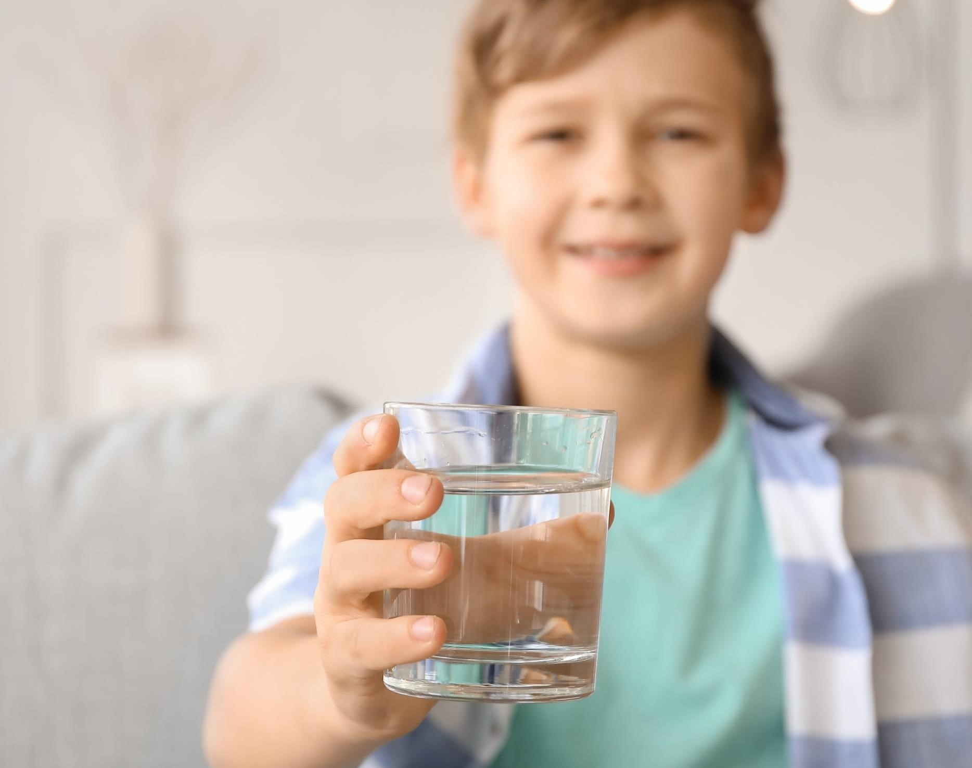

A Message from Your Operator

Dear Community,

This is your annual report about your drinking water quality. Having clean, safe water is one of the most important services we provide, and we want you to be as informed as possible about your drinking water.

This report is intended to provide peace of mind and confidence in your drinking water. Here we explain where your water comes from, the results of the sampling that we have performed, and what we are doing to protect you and your family. We are proud to report that the water we provide to you has met all federal and state requirements in 2025.

If upon reading this report, you have any questions, or don’t feel that peace of mind, please reach out. You may contact us at (206)-751-5325 and Hornick556@gmail.com.

Sincerely,

Skylar Hornick

About Your Water
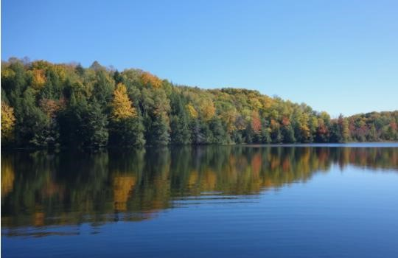
Where Your Drinking Water
Comes From
MMWC collects water from two groundwater sources: springs (S01) and a deep well (S02). Both sources are located on an 18acre parcel along Luana Beach Road. Spring water is drawn from a shallow, unconfined aquifer, and gravity fed to the springhouse. Chlorine is added to safeguard against pathogenic organisms. Water from the springs requires no filtration or additional treatment. Well water is pumped from 260
feet below grade (25 feet below mean sea level). This deep aquifer contains elevated levels of iron and manganese. To make the water more palatable, these secondary contaminants are oxidized with chlorine and then removed via greensand filtration.
Finished water from both sources is pumped to the storage tank on 63rd Ave SW through a shared pipe. MMWC's lower system is gravity fed from the tank on 63rd Ave SW. Water for the upper system is pumped from 63rd Ave SW to the storage tank on 59th Ave SW & 248th St. The upper system is gravity fed from this tank.
The springs are MMWC's primary, and preferred source of water. The well provides service reliability during peak demand, and when the springs need to be taken offline for maintenance and/or repair.

We Protect the Source
Making the water safe to drink starts by protecting the place it comes from. We work with state scientists to take samples of water at its source to look for possible pollutants. This is called a Source Water Assessment. Not all testing may be required to be done every year, still water quality monitoring is done in compliance with state and federal regulations.

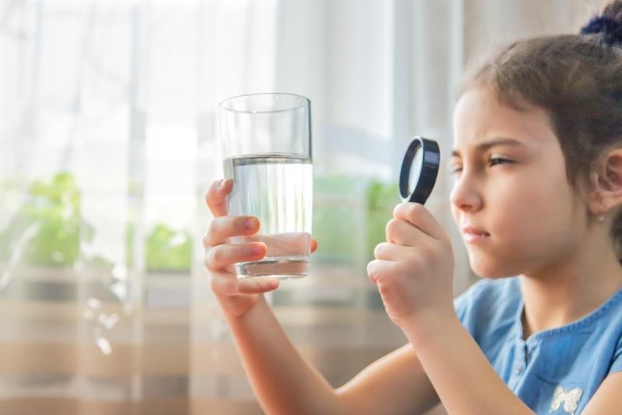
What Is in Your Drinking Water
The sources of drinking water (both tap water and bottled water) include rivers, lakes, streams, ponds, reservoirs, springs, and wells. As water travels over the surface of the land or through the ground, it dissolves naturally occurring minerals and, in some cases, radioactive material, and can pick up substances resulting from the presence of animals or from human activity.
Contaminants that may be present in source water include:
Microbial contaminants, such as viruses and bacteria, may come from sewage treatment plants, septic systems, agricultural livestock operations, and wildlife.
Inorganic contaminants, such as salts and metals, can be naturally occurring or result from urban stormwater runoff, industrial or domestic wastewater discharges, oil and gas production, mining, or farming.
Pesticides and herbicides, which may come from a variety of sources such as agriculture, urban stormwater runoff, and residential uses.
Organic chemical contaminants, including synthetic and volatile organic chemicals, are byproducts of industrial processes and petroleum production, and can also come from gas stations, urban stormwater runoff, and septic systems.
Radioactive contaminants, which can be naturally occurring or be the result of oil and gas production and mining activities.

In order to ensure that tap water is safe to drink, the Environmental Protection Agency (EPA) prescribes regulations which limit the amount of certain contaminants in water provided by public water systems. The Food and Drug Administration (FDA) regulations establish limits for contaminants in bottled water which must provide the same protection for public health. Drinking water, including bottled water, may reasonably be expected to contain at least small amounts of some contaminants. The presence of contaminants does not necessarily indicate that water poses a health risk. More information about contaminants and potential health effects can be obtained by calling the EPA’s Safe Drinking Water Hotline (1-800-426-4791).

Sampling and Testing
Our water is tested for more than 100 contaminants for which state and federal standards have been set. We’re looking for bacteria, metals, and chemicals to make sure the water continues to be safe to drink.

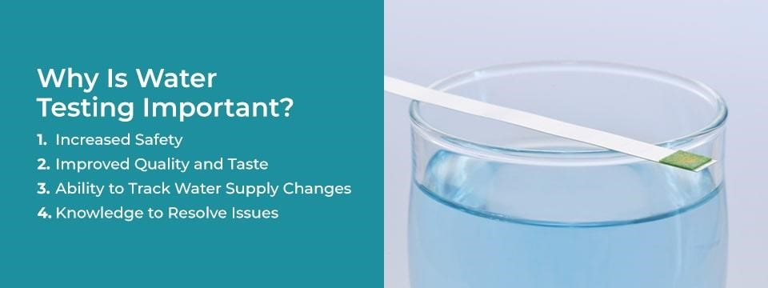

Bacteria
We look for bacteria regularly, as required by law, and there are 3 locations in the water system where we take samples for analysis. More thorough testing, evaluation, and action is required if bacteria is found in even a small percentage of tests.

Disinfection by-products (Trihalomethane (THM) or Haloacetic Acids (HAA))
One time per three years we look for byproducts of the disinfection process. When chlorine, the disinfectant we use to protect against the water of bacteria and viruses, starts to break down in the water, it can form new compounds. These compounds, trihalomethanes (THM) and haloacetic acid (HAA), have been known to cause cancer at high levels. The legal limit for drinking water is 80 parts per billion and 60 parts per billion respectively. We test for these compounds at one location in the water system.

Lead and Copper
We take water samples from 5 different homes in our system every 3 years to test them for lead and copper.

Stay Informed About Your Water

Governance
Company business is conducted and managed by the Board of Trustees: Steve Hunter, Paul Gilland, Richard Foulkes and Scott Harrison. The Board meets monthly. If you wish to have an item placed on the agenda or have any questions regarding company business and/or policy, please contact the Board using the contact information provided on the last page.

Projects
Infrastructure projects are important to maintain the safe flow of water to your home for your family. When there is something to repair it is a good opportunity to make upgrades but being preventive and thinking ahead is the best practice. Two projects in the works are the Springhouse renovations and replacing a section of the 2-1/2” transmission line from sources to the 63rd Ave storage tank.

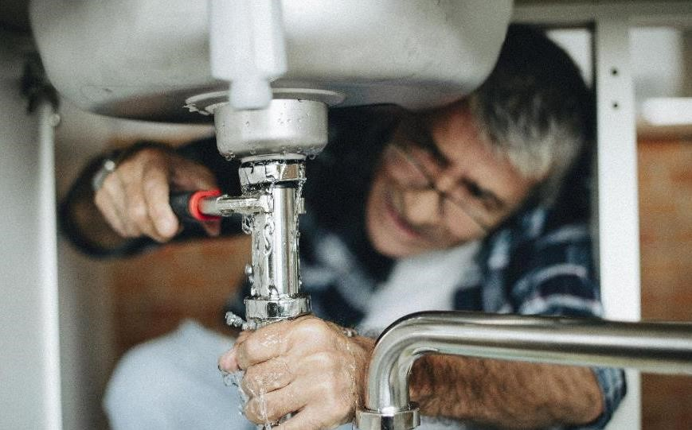
Your Role in Water Quality
Check Your Home or
Business’ Plumbing for

Lead and Copper
We work hard to provide high quality water when it arrives on your property. Once the water we provide passes through the meter on your property, however, it is exposed to a whole new environment in your home that we have no control over. But you do.

Some of the things that can change the water quality on your property include your plumbing and pipe material, how long you go without running the water, and whether or how you connect outdoor hoses to your home’s water supply. Lead can cause serious health problems, especially for pregnant women and young children. Lead in drinking water is primarily from materials and components associated with service lines and home plumbing. Maury Mutual Water is responsible for providing high quality drinking water and removing lead pipes but cannot control the variety of materials used in plumbing components in your home. You share the responsibility for protecting yourself and your family from the lead in your home plumbing. You can take responsibility by identifying and removing lead materials within your home plumbing and taking steps to reduce your family's risk. Before drinking tap water, flush your pipes for several minutes by running your tap, taking a shower, doing laundry or a load of dishes. You can also use a filter certified by an American National Standards Institute accredited certifier to reduce lead in drinking water. If you are concerned about lead in your water and wish to have your water tested, contact us. Information on lead in drinking water, testing methods, and steps you can take to minimize exposure is available at http://www.epa.gov/safewater/lead (opens in a new window).

Run Water After Vacation
Another factor that affects water quality in your home is how “stale” the water is. When you leave your home or business for a long time, as you may when you take a vacation, the water in the pipes and plumbing doesn’t move. When water has been sitting in the pipes for days, bacteria can grow, and if you have lead or copper plumbing, those metals can start to seep into the water. The best thing to do when you get back from being away after a long time is to run the water on full blast for 30 seconds to two minutes before using it for drinking or cooking. And always use cold water for cooking, to draw in fresh water from the outside.

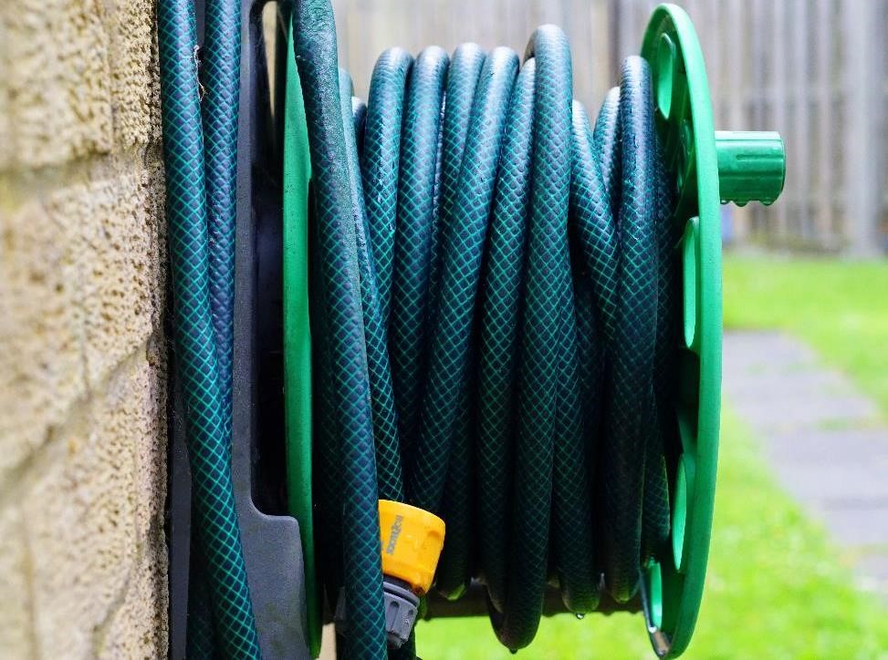
Safely Connect Outdoor
Hoses
A third factor that can influence water quality in your home is connections to your water outside your home. The outdoor spigot connection to a hose provides a potential way for pollutants to enter your plumbing. If you use the hose to spray chemicals on your yard by connecting the nozzle to a spray bottle, or if you have a sprinkler system connected, there is the potential for chemicals from the bottle or the lawn to be accidentally sucked back into your internal plumbing. To prevent this from happening, we recommend (and in some states it is the law) that you have a device installed to prevent that from happening.

Looking Out for Special Populations
Some people may be more vulnerable to contaminants in drinking water than the general population. Immunocompromised persons such as persons with cancer undergoing chemotherapy, persons who have undergone organ transplants, people with HIV/AIDS or other immune system disorders, some elderly, and infants can be particularly at risk from infections.
These people should seek advice about drinking water from their health care providers.
EPA/CDC guidelines on appropriate means to lessen the risk of infection by Cryptosporidium and other microbial contaminants are available from the Safe Drinking Water Hotline (1-800-4264791).



Table of Water Data for 2025
The samples were taken in 2025 unless noted otherwise.

Lead and Copper – Testing is done every 3 years. Most recent tests were done in 2022.
Samples are collected at customer faucets. The number of homes monitored is based on population served by the system. Specific EPA-mandated criteria are used to select the homes
Primary  Inorganic  Contaminant | Year Taken | EPA’s AL | No. of  homes sampled | 90% of customers’ homes  were less than | Violation | Source
Lead (ppb) | 2022 | 15 | 5 | 1.05 | NO | Corrosion of household plumbing; Erosion of natural deposits
Copper (ppb) | 2022 | 1.3 | 5 | .3650 | NO | Corrosion of household plumbing;  Erosion of natural deposits; Leaching from wood preservatives
Lead & Copper: In Washington State, lead in drinking water comes primarily from materials and components used in household plumbing. The more time water has been sitting in pipes, the more dissolved metals, such as lead, it may contain. Elevated levels of lead can cause serious health
problems, especially in pregnant women and young children. To help reduce potential exposure to lead: for any drinking water tap that has not been used for 6 hours or more, flush water through the tap until the water is noticeably colder before using for drinking or cooking. You can use the flushed water for watering plants, washing dishes, or general cleaning. Only use water from the cold water tap for drinking, cooking, and especially for making baby formula. Hot water is likely to contain higher levels of lead. If you are concerned about lead in your water, you may wish to have your water tested.

Information on lead in drinking water is available from EPA’s Safe Drinking Water Hotline at 1-800-426-4791 or online at: http://www.epa.gov/safewater/lead.

Organic Chemicals & Contaminants:
MMWC tested its water sources for 14 different herbicides and 31 pesticides in 2018, as well as 58 different volatile organic chemicals (VOC's) in 2020. There were no detections of any of these contaminants. VOCs are by-products of industrial processes and petroleum production and can also come from gasoline stations and dry-cleaning facilities. The Department of Health has granted monitoring waivers for any further organics monitoring. Waiver eligibility is based on the sources' susceptibility ratings, water quality history, and from information gathered from across the state.
Disinfectant & Disinfection By-Products
The Department of Health requires that MMWC maintain a minimum chlorine residual of 0.3 ppm at entry to distribution and 0.2 ppm chlorine residual throughout the system. Residuals are measured during daily inspections at least 5 days per week.
Disinfectant | Tested | MRDL | MRDLG | YOUR WATER | Compliant Y/N | Typical Source of Contaminant in Drinking Water
Free Chlorine (ppm)  at entry to distribution system | Daily | 4 | 4 | 0.69 (average chlorine  residual at entry to distribution) | Y | Water additive used to kill microbes; oxidant used in iron and manganese removal  process
Disinfection Byproduct | Year Tested | MRDL | MRDLG | YOUR WATER | Compliant Y/N | Typical Source of  Contaminant in Drinking Water
Total  Trihalomethanes,  TTHM (ppb) | 2024 | 80 | N/A | 6.75 | Y | By-product of drinking water disinfection
Halo acetic Acids, HAA (ppb) | 2024 | 60 | N/A | None detected | Y | By-product of drinking water disinfection

Primary Inorganic Contaminants Detected in Your Drinking Water
Inorganic Contaminant  (units) | Springs/S  01  (date  tested) | Well/S02  (date  tested) | MCL | MCLG | Compliant | Typical Source of Contaminant in Drinking  Water
Arsenic (ppb) | <1.0  (10/2019) | <1.0  (8/2013) | 0 | 0 | Y | Erosion of natural deposits; Runoff from orchards; Runoff from glass and electronics production wastes
Asbestos (MFL) | <0.12  (10/2019), sample  collected in distribution | <0.12  (10/2019), sample  collected in distribution | 7 | 7 | Y | Decay of asbestos cement water mains; Erosion of natural deposits
Nitrate (ppm) | 0.20  (09/20245) | 0.20  (8/2022) | 10 | 10 | Y | Runoff from fertilizer use; leaching from septic tanks; erosion of natural deposits
Arsenic: Your drinking remains far below EPA's revised drinking water standard for arsenic. The Department of Health requires the following information for reporting between 5 - 10 ppb arsenic. We are providing it as additional information: “There is a small chance that some people who drink water containing low levels of arsenic for many years could develop circulatory disease, cancer, or other health problems. Most types of cancer and circulatory diseases are due to factors other than exposure to arsenic. EPA's standard balances the current understanding of arsenic's health effects against the costs of removing arsenic from drinking water.”
Asbestos: A portion of Maury Mutual’s distribution systems consists of asbestos cement water mains. Routine samples are collected to detect the onset of decay. Maury Mutual’s asbestos cement pipes have shown no sign of decay. Some people who drink water containing asbestos in excess of the MCL over many years may have an increased risk of developing benign intestinal polyps.
Nitrate: Nitrate in drinking water at levels above 10 ppm is a health risk for infants of less than six months of age. High nitrate levels in drinking water can cause blue baby syndrome. Nitrate levels may rise quickly for short periods of time because of rainfall or agricultural activity. If you are caring for an infant, you should ask for advice from your health care provider.

Secondary Inorganic Contaminants Detected in Your Drinking Water
Inorganic  Contaminant  (units) | Springs/S  01  (year  tested) | Well/S02  (year  tested) | SMCL | Compliant? (Y/N) Source | Typical Source of  Contaminant in  Drinking Water
Iron (ppm) | 0.21  (2025) | 0.23  (2025) | 0.3 | Y | Leaching from natural deposits; industrial wastes
Manganese (ppm) | 0.019 (2025) | 0.021 (2025) | 0.05 | Y | Leaching from natural deposits
Chloride (ppm) | 12.1  (2024) | 14.3  (2024) | 250 | Y | Runoff/leaching from natural deposits;  seawater influence
Sodium (ppm) | 6.8  (2019) | 9.8  (2022) | N/A | Y | Erosion of natural deposits; seawater influence
Hardness (ppm) | 92.0  (2019) | 72  (2022) | N/A | Y | Erosion of natural deposits
Iron & Manganese: Water from the Springs/S01 is naturally low in iron and manganese, and is not treated. The opposite is true of water from the Well/S02. Raw/pre-treatment water samples from the Well/ S02 contained 1.23 mg/L of iron and 0.086 mg/L of manganese, both exceeding the Secondary Maximum Contamination Level (SMCL). The results posted in Table 3 for the Well/S02 are post-treatment results. The SMCL for iron and manganese are not based on health effects as primary MCL’s are, but based on aesthetic cosmetic effects. Left untreated, water from the Well/S02 would likely have noticeable odor and taste issues, as well as stain clothes and/or plumbing fixtures.

Chloride & Sodium: Given the Well/S02’s proximity to the north shore of Maury Island, and the pump draws from below mean sea level, an increase in chloride levels could indicate saltwater intrusion. This has not been the case. The EPA identifies 20 ppm of sodium as a level of concern for customers who must restrict their dietary intake.

Hardness: Hardness is the amount of dissolved calcium and magnesium there is in water. Harness is not considered a health concern, but a nuisance. Hard water can cause mineral build in plumbing, water heaters/fixtures, and poor performance of soaps and detergents.
0-75 ppm = "soft" water
75-150 ppm = "moderately hard”
150-300 ppm = “hard"
>300 ppm = "very hard”
NTU - Nephelometric Turbidity Units: Turbidity is measured with an instrument called a nephelometer. Measurements are given in nephelometric turbidity units.

Radioactive Contaminants:
Analyze Name (Units) | Springs/S01 (year tested) | Well/S02 (year tested) | SMCL | Complia nt?  (Y/N)  Source | Typical Source of Contaminant in Drinking Water
Radium 228 (pCi/L) | 0.0825  (10/2024) | 0.2840 (5/2025) | 5 | Y | Erosion of natural deposits
Gross Alpha (pCi/L) | <3.0000  (10/2024) | <3.0000  (5/2025) | 15 | Y | Erosion of natural deposits
Radium:
Some people who drink water containing radium 226 or 228 in excess of the MCL over many years may have an increased risk of getting cancer.
Gross Alpha:
Certain minerals are radioactive and may emit a form of radiation known as alpha radiation. Some people who drink water containing alpha emitters in excess of the MCL over many years may have an increased risk of getting cancer.

Definitions
ACRONYMS | DEFINITIONS
MCLG | Maximum Contaminant Level Goal: The level of a contaminant in drinking water below which there is no known or expected risk to health. MCLGs allow for a margin of safety.
MCL | Maximum Contaminant Level: The highest level of a contaminant that is allowed in drinking water. MCLs are set as close to the MCLGs as feasible using the best available treatment technology.
TT | Treatment Technique: A required process intended to reduce the level of a contaminant in drinking water.
AL | Action Level: The concentration of a contaminant which, if exceeded, triggers treatment or other requirements which a water system must follow.
MRDLG | Maximum Residual Disinfectant Level Goal: This is the lowest amount of cleaning chemical drinking water should have, because it is the lowest amount needed to make sure bacteria and viruses can’t live.
MRDL | Maximum Residual Disinfectant Level: The highest level of disinfectant allowed in drinking water. There is convincing evidence that addition of a disinfectant is necessary for control of microbial contaminants.
Level 1  Assessment | A Level 1 assessment is a study of the water system to identify potential problems and determine (if possible) why total coliform bacteria have been found in our water system.
Level 2  Assessment | A Level 2 assessment is a very detailed study of the water system to identify potential problems and determine (if possible) why an E. coli MCL violation has occurred and/or why total coliform bacteria have been found in our water system on multiple occasions.
mg/L | Number of milligrams in one liter of water
pCi/L | Picocuries per liter (a measure of radioactivity)
NA | Not applicable
ND | Not detected
NR | Monitoring not required, but recommended
NTU | Nephelometric Turbidity Units: Turbidity is measured with an instrument called a nephelometer. Measurements are given in nephelometric turbidity units.
PPM | Part Per Million= 1 drop of water in a hot tub
PPB | Part Per Billion = 1 drop of water in an Olympic size swimming pool
PPT | Part Per Trillion (ppt) = 1 drop of water in a lake that’s 6 square acres

Leak Detection:
It is recommended that members occasionally check for unnoticed leaks. This is easily done with service meter inspections. Most meters have low flow indicators. After ensuring no water is being used on the premises, inspect the meter. All dials, spinners and sweep hands should be still. Any movement represents a leak. Another method is to track meter activity over periods of nonuse: overnight, or while away from home. Simply record the number on the meter register after all water use has stopped, and again prior to any water use. Any change represents lost water. Your conservation efforts are greatly appreciated.

Contact Information:
Topic | Mailing address | Email | Telephone
Billing | Maury Mutual Water Co.  PO Box 633  Vashon, WA 98070 | accounts@maurymutual.org  (Web site: http:// maurymutual.org/) | (206)259-0496
Company business, policy issues, questions/ comments for the Board | Maury Mutual Water Co.  PO Box 633  Vashon, WA 98070 | accounts@maurymutual.org  (Web site: http:// maurymutual.org/)
Emergencies, water quality, general information | Skylar Hornick  Maury Mutual Water Co.  PO Box 633  Vashon, WA 98070 | Hornick556@gmail.com | (206)751-5325


Additional Resources
Information on lead in drinking water: www.epa.gov/safewater/lead (opens in a new window)
- Requirements of the Water Quality Report (also known as the Consumer Confidence Report): http://www.epa.gov/sites/default/files/201405/documents/guide_qrg_ccr_2011.pdf (opens in a new window)
The Safe Drinking Water Act: www.epa.gov/sdwa (opens in a new window) CDC Guide to Understanding your CCR: http://www.cdc.gov/healthywater/drinking/public/understanding_ccr.html (opens in a new window)
American Water Works Association: http://www.awwa.org (opens in a new window)
Water Environment Federation: http://www.wef.org (opens in a new window)
Groundwater Information: https://waterdata.usgs.gov/nwis and http://www.epa.gov/ground-waterand-drinking-water/ (opens in a new window)
- Washington state health department: 360-236-4700 https://doh.wa.gov/

This report was prepared by Skylar Hornick, System Operator

