Guide Dogs Toys Guidelines for Puppy Raisers
Purpose
Play is an important part of every puppy’s development. The right toys help guide dog pups learn, explore and use their energy in positive ways. Toys also help build good chewing habits and prevent boredom.
Choosing suitable toys keeps pups safe, supports their development, and helps them learn to make good choices about what is (and isn’t) okay to chew.

1. Why Choosing Suitable Toys Matters
- Safety first: Unsafe toys can cause choking or intestinal blockages if swallowed.
- Healthy habits: Some toys can encourage rough play or unwanted chewing behaviours.
- Training consistency: Using appropriate toys helps pups learn to distinguish between their toys and household or children’s items.
- Development: Toys that encourage thinking and problem-solving build confidence and resilience.

2. What to Look for in a Toy
When choosing toys, always consider durability, safety and purpose.
A good toy for a guide dog pup should:
- Be made of natural rubber, high quality nylon, non-toxic food-grade plastic or silocone, or fabric.
- Be strong and durable enough to withstand chewing.
- Have no small removable parts such as ears, button eyes or tails.
- Be appropriately sized — large enough that the pup cannot fit the whole toy in its mouth.
- Be easy to clean and made from non-toxic materials.
- Provide either chewing satisfaction or mental enrichment, not just noise or novelty.
If you’re unsure whether a toy is appropriate, check with your Puppy Development Advisor (PDA) before giving it to your pup.

3. Approved Toy Types
Toys that Do Not Require Supervision *Noting all toys should be checked regularly for damage
These are durable, safe options suitable for independent play:
- KONG brand: Classic, Extreme, Dental, Ball, Tire, or Goodie Bone.
- Nylabone/Tasty Bone: Only the original or synthetic-flavour varieties (no added meat, cheese or peanut butter flavours).
- Tuffy Toys: Only types with thick black stitching (no plush or soft fabric versions).
- Outward Hound range
Always inspect toys regularly and replace them when worn or damaged.

Toys that Require Supervision
These toys can be used while you’re present and should be removed afterward:
- Toys for teething puppies (under 5 months) that are softer and designed for small jaws.
- Soft, plush, or fabric toys (including stuffed animals). Supervise the pup closely when introducing soft toys. Remove when broken and stuffing is exposed.
- Enrichment toys like LickiMats, puzzle feeders, or homemade toys (e.g., plastic bottles, towel rolls, frozen feeders).
- Any DIY enrichment activities, such as sniffing games or digging boxes.
Supervised toys are great for mental stimulation but should never be left with the pup unsupervised.

4. Toys Not Permitted
To protect pups’ health and training outcomes, the following toys are not allowed:
- Rope toys or toys with strings or tassels.
- Toys with small squeakers, small parts, or easily chewed-off sections.
- Children’s toys or household items (e.g., socks, slippers, old shoes).
These items can be swallowed or confuse the pup about what items are appropriate to chew.

5. General Toy Guidelines
- Inspect toys daily. Remove and discard any that are damaged, broken, or too small.
- Rotate toys every few days to keep playtime interesting and stimulating.
- Use toys as part of enrichment and positive training, not just for entertainment.
- Clean toys regularly, especially those used with food.
- Monitor feeding-based toys (like KONGs or puzzles) to ensure the pup doesn’t overeat — reduce meal portions accordingly.
- Ask your PDA if unsure about any toy or enrichment activity.

6. Enrichment Ideas
Provide mental and sensory variety by including:
- Food-based puzzles (e.g., frozen KONGs, wobbler feeders, outward hound puzzle toys).
- Scent games (hide kibble or toys for the pup to find).
- DIY activities like towel rolls or “sniff and seek” mats — always supervised.

Summary
Safe and appropriate toys:
Support healthy development and positive behaviour
Encourages learning through play
Keeps pups happy, healthy and ready for their future as guide dogs
If in doubt — check with your Puppy Development Advisor before giving any new toy.

Recommended Toy Gallery
Toys that Do Not require supervision*:
*Noting all toys should be checked regularly for damage
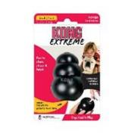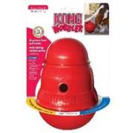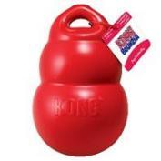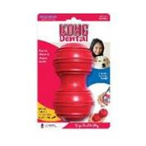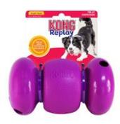

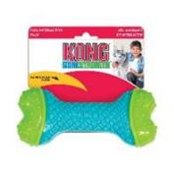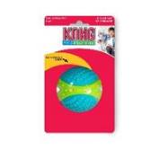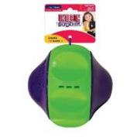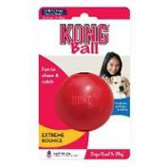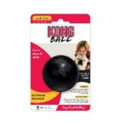

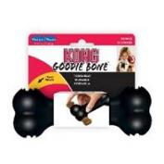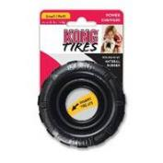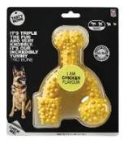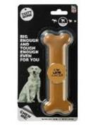

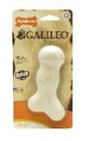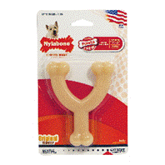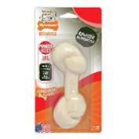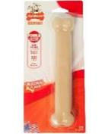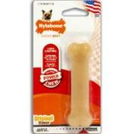
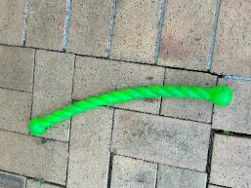
Kong safestix
Tuffy Toy Range:
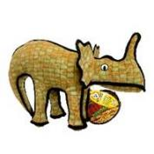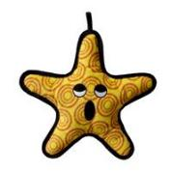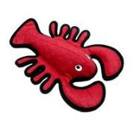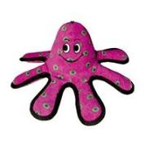
Toys that require supervision:
These toys are recommended for pups up to 5 months of age. They are good for small jaws and teething.

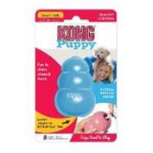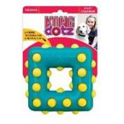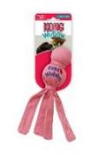
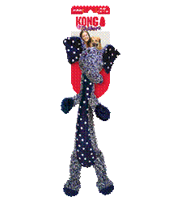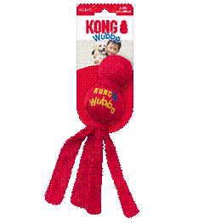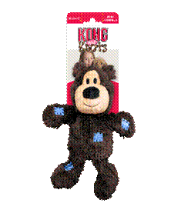

5 months plus:

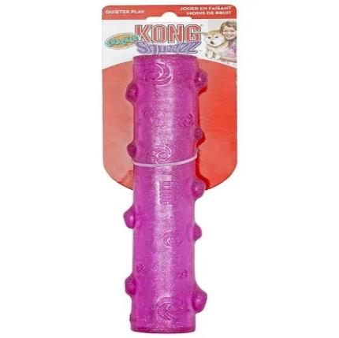
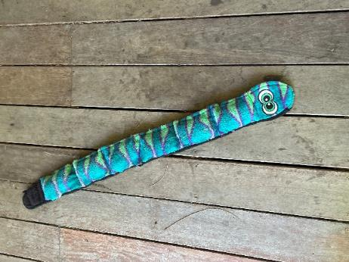
Outward hound invincible

Examples of broken toys that should be removed
Picture description: The below images show dog toys that have parts broken or missing and should be discarded for safety reasons.
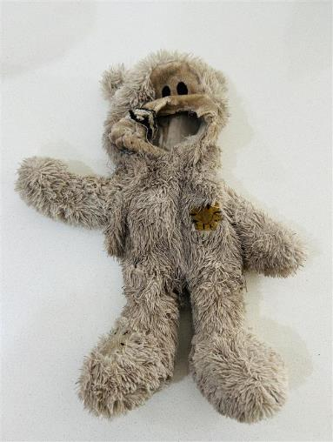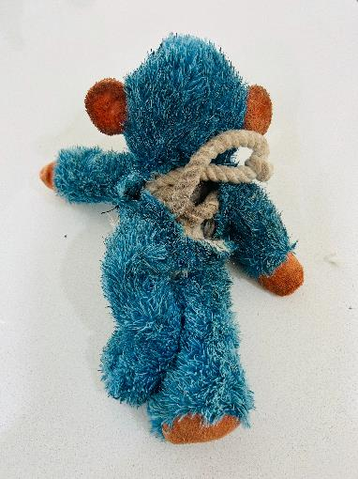
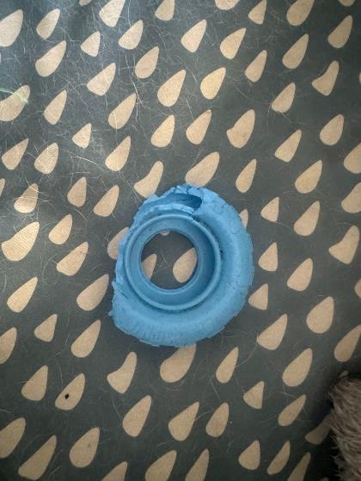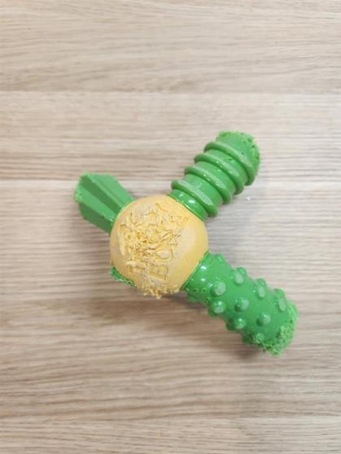

Puppy Enrichment Ideas

What is Enrichment and Why is it Important?
Enrichment means giving your pup activities that stimulate their mind, use up energy, and allow natural behaviors. It keeps them happy and entertained—and gives you a chance to try something fun together! Without enough mental stimulation, pups can get bored and develop unwanted habits like counter surfing, stealing items, digging, or chewing walls.
Every pup is different. Some are satisfied with short training sessions and a walk, while others need extra activities to keep their brains busy. Below are ideas for enrichment activities. Some require supervision for safety—these are clearly noted. Always remove supervised items when not in use.

Helpful Tips
- Rotate toys: Swap toys every few days to keep things exciting.
- Allow the pup time to work it out. If you notice the pup struggling, show them how it works. Be patient—age and focus matter.
- Boost motivation: Use enrichment as a meal replacement or add tasty treats like cooked chicken.
- Watch portions: Many activities use food. Adjust daily rations so your pup stays healthy.
- Check durability: Even tough toys wear out. Inspect regularly.
- Unsure about an item? Ask your Puppy Development Advisor before giving it to your pup.

Purchased Enrichment

Frozen KONG Toys (Classic, Dental, Ball, Tire, Goodie Bone)
Prep time: 10 minutes + overnight freeze
Materials: Kong toy, kibble, carrot, apple, or cooked chicken

Instructions
- Soak kibble until it forms a paste. Mix in small pieces of carrot, apple, or chicken.
- Stuff the mixture into the toy holes.
- Freeze overnight.
- Clean after each use.
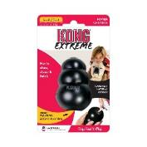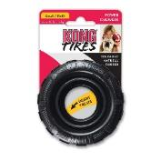
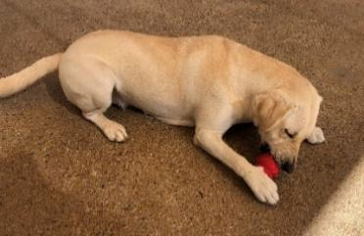

LickiMat
Prep time: 10 minutes + overnight freeze
Materials: LickiMat, food (chicken, carrot, apple, kibble), blender, freezer

Instructions
- Shred chicken, carrot, or apple into tiny pieces.
- Soak kibble in water until it forms a paste.
- Spread food on the mat. Add water if needed to help it stick.
- Freeze overnight.
- Place on the floor for your pup to lick. Remove if they start chewing the mat.
- Clean after each use.

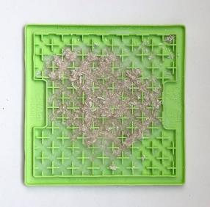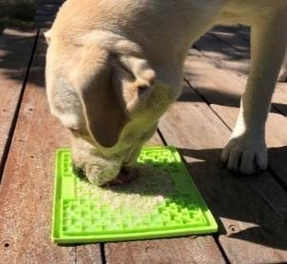

Puzzle Toys
Prep time: 10 minutes (+ optional freezing)
Materials: Puzzle toy (no loose parts), food

Instructions
- Fill puzzle with food as per instructions.
- Optional: Freeze to make it harder.
- Let your pup work it out.
- Remove and clean when finished or if they lose interest.

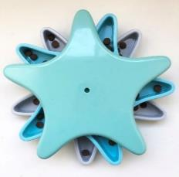 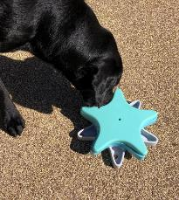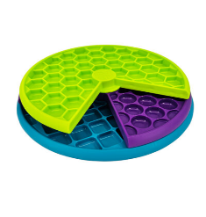Outward hound

Homemade Enrichment (No Supervision Needed)

Pupsicle Stick
Time to make: 10 minutes + overnight freeze
Materials: PVC pipe (20cm), cling wrap, rubber bands, kibble
Instructions:
- Soak kibble until soft.
- Cover one end of the PVC pipe with cling wrap and secure with a rubber band.
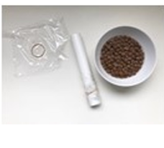
- Fill pipe with kibble, pressing down to pack it in.
- Seal the other end.
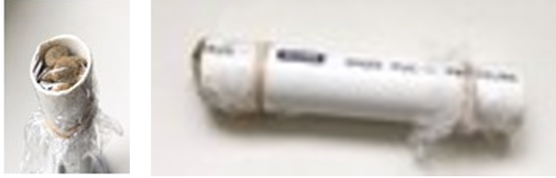
- Freeze overnight.
- Remove from pipe and give to pup as a meal replacement.

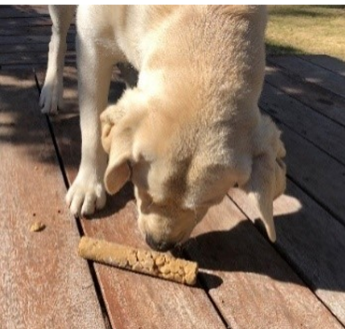

Shell Digger
Prep time: 5 minutes
Materials: Kiddie pool, sand/dirt or water, toys, kibble, carrot, apple

Instructions
- Fill pool with sand or water
- For Sand: Hide toys or kibble for your pup to find.
- Water: Scatter waterproof toys or food for them to retrieve.

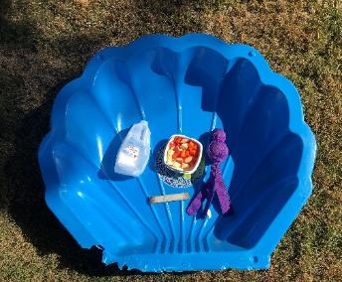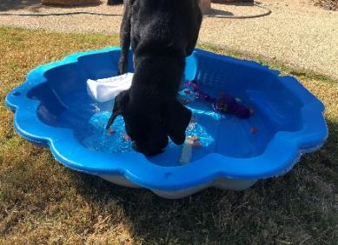

Sniff, Roll & Crunch
Time to make: 5 minutes
Tools needed: None
Materials: A large towel
Food: Kibble, carrot or apple
Use / longevity: Multipleuses (towel only)
Instructions:
- Lay the towel on a flat surface and fold lengthways down the middle
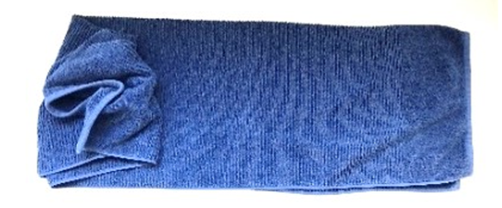
- Scatter food along the length of the towel then roll it up to resemble a cylinder
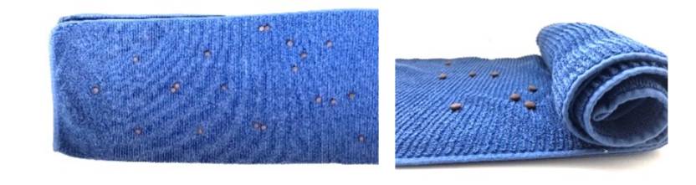
- Place the towel in front of the pup and allow them to unroill the towel to get the treats
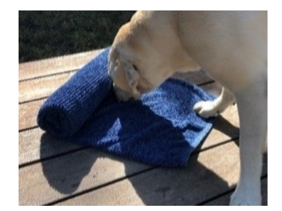
- Remove from pup when all the treats are gone. Wash towel between uses

Bottle Roulette
Time to make: 20 minutes
Tools needed: drill, file
Materials: Clean plastic bottles – lids, labels and rings removed
A length of wood, bamboo or dowel on which to hang the bottles
Food: Kibble, carrot or apple
Use / longevity: Multiple uses (bottles only)
Instructions
- Drill two holes opposite each other in each bottle, in such a way that the bottle will hang upright when it is threaded onto the rod. Use the file to file down any rough edges and rinse the bottles.
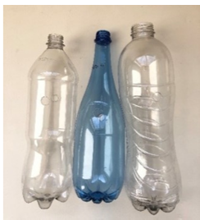
- When dry, thread the wood, bamboo or dowel through the holes and place a small amount of food in each.
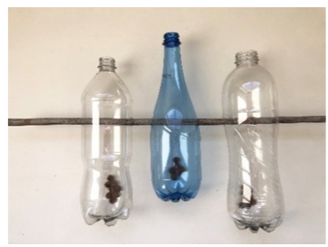
- Hang the toy securely so that the bottles sit off the ground but within the pup’s reach. Allow the pup to paw the bottles to extract the food.
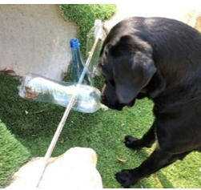

Ball Buster
Time to make: 5 minutes
Tools needed: None
Materials: A clean plastic bottle with a wide neck and body
A collection of balls just narrower than the neck of the bottle so that they will go in, but not come out easily.
Food: Kibble, carrot or apple
Use / longevity: Multiple uses (bottles and balls only)
Instructions:
- Remove the lid from the bottle and insert the balls. You may need to use a utensil to push them in if it’s a very tight fit.
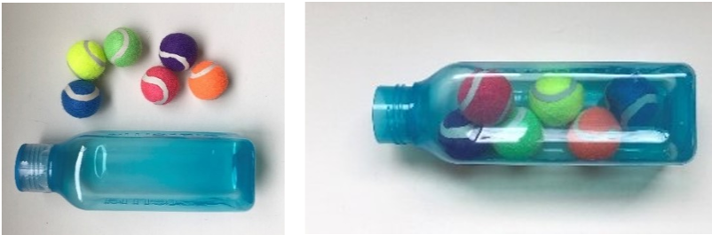
- Place the treats inside the bottles and give to the pup. Once the food has all been extracted remove from the pup and put in a safe place.
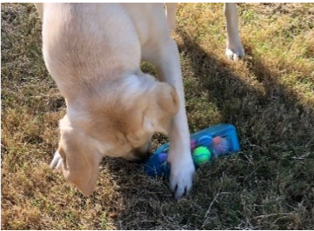

Jarbles
Time to make: 20 minutes
Tools needed: drill, file
Materials: Large plastic jar (the pup should not be able to put their whole jaw around the jar as this is a choking hazard).
Toilet rolls – 3 is usually enough depending on the size of the jar.
Food: Kibble, carrot or apple
Use / longevity: Multiple uses (jar only)
Instructions:
- Clean the jar thoroughly, removing any remaining food, the label, and plastic ring below the lid.
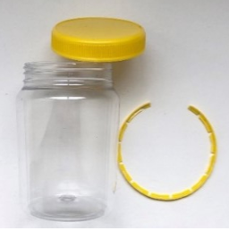
- Use a drill to make kibble-sized holes along the curved surface of the jar. File down any rough edges using the file. NB: the larger and more numerous the holes, the easier it will be to get the treats out.
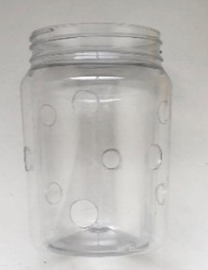
- Place enough toilet rolls in the jar to fill up the space.
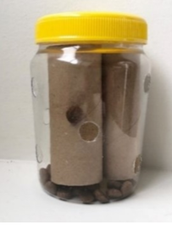
- Add a small amount of kibble, diced apple or carrot and secure the lid.
- Give the jarbles to the pup and supervise play. Remove from pup when all the food has been extracted.
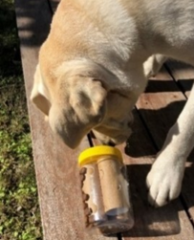
- Clean the jar and replace toilet rolls after each use.

Plumber’s Helper
Time to make: 30 minutes
Tools needed: Drill, saw, file
Materials: PVC piping cut into various lengths (the pipe diameter should be wider than the pup’s jaw).
PVC plumbing connections
Food: Kibble, carrot or apple
Optional: PVC caps to increase difficulty.
Use / longevity: Multiple uses
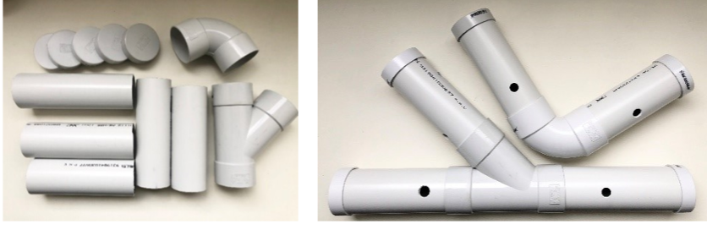
Instructions:
- Drill various sized holes, at least kibble-sized into the piping and, if desired, caps. File down any rough edges. NB: the larger and more numerous the holes, the easier it will be for the pup to remove the treats.
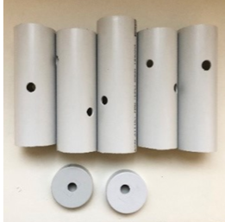
- Assemble the toy using the joint pieces to join the pipes.
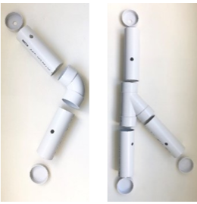
- Add treats and place caps on the ends if desired. Give to pup and remove once all treats have been extracted.
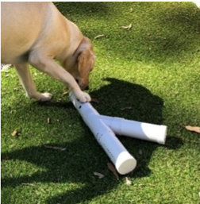
- Clean after each use.

Guide Dogs Toy Guidelines for Pups with Crown Extensions
Protecting dental health while supporting welfare and play needs

Purpose
Some pups receive crown extensions to protect narrow-based canine teeth. These extensions are fragile and can easily break if a pup chews hard or unsuitable objects.
However, play and chewing are essential for a pup’s welfare, development, and mental stimulation.
This policy provides guidance to help you choose safe, suitable toys that protect your pup’s teeth and overall wellbeing.

1. Suitable Toys
Choose toys that are soft, flexible and low-impact on teeth. You should be able to depress or bend the rubber when squeezing between your fingers. These help the pup engage in play without risking damage to the crown extensions.
Recommended options:
- Soft rubber toys that can be gently compressed (e.g. KONG Puppy or KONG Classic for softer chewers).
- Flexible food-dispensing toys (e.g. rubber treat balls or wobblers).
- Soft fabric or fleece tug toys, used under supervision only.
- LickiMats and snuffle mats for gentle enrichment and mental stimulation.
- Frozen enrichment using KONGs or soft silicone moulds with soaked kibble or pureed food.
Rotate toys regularly to maintain interest and prevent overuse of any single item.

2. Toys Not Appropriate
Avoid any toys that are hard, abrasive or rigid, as these may chip, loosen or fracture the crown extensions.
Not permitted:
- Hard nylon or plastic chew toys (e.g. Nylabone, Tasty Bone).
- Real or synthetic bones, antlers, or hooves.
- Rope toys (fibres can catch on extensions).
- Hard rubber balls (e.g. solid KONG Extreme or tennis balls).
- Sticks, rawhide or compressed chews.
- Any toy the pup must bite down on firmly or that encourages strong tugging.
These items pose a high risk of damaging the crown extensions and should not be used.

3. Supervised Soft Toys
Soft toys can provide comfort and enrichment but must be managed carefully.
If a soft or fabric toy is used:
- Supervise at all times to prevent tearing and ingestion.
- Allow gentle mouthing only — stop play if the pup begins to chew or bite firmly.
- Remove the toy after play and store it out of reach.
- Inspect daily for damage and replace immediately if torn or fraying.
Supervised soft play helps the pup express natural behaviour while protecting their teeth.

4. General Care and Welfare
- Maintain daily play and enrichment sessions to support the pup’s mental wellbeing.
- Provide additional enrichment through training, gentle games, and scent-based activities.
- Avoid frustration — ensure the pup still has regular opportunities to chew and play safely.
- If you notice any damage to a crown extension or tooth, contact your Puppy Development Advisor and veterinarian immediately.

Summary
Pups with crown extensions can still enjoy a full, enriching play routine when given soft, flexible and supervised toys.
The goal is to balance dental safety with welfare and development needs through thoughtful toy selection, supervision, and variety.
When in doubt, always consult your Puppy Development Advisor before introducing a new toy or enrichment activity.

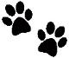
Enrichment for Pups
with Crown extensions

It might seem like your pup can’t do much while wearing crown extensions, but don’t worry, there are still plenty of ways to keep them happy and enriched. Chewing is a natural behaviour that provides important enrichment, so we want to make sure they continue to enjoy that same level of stimulation, even if the items they can safely chew have changed.
Here are a few fun activities you can do with your pup while they have crown extensions:
Toy Hides
Hide your pups favourite toy in the house or garden and encourage them to use their sight or smell to find the toy. Repeat the game in different areas to keep it interesting
Lickimat
*Supervision required
Soak kibble in water until it turns into a paste. Smear onto a lickimat and freeze. Pup will enjoy licking this and it is a cool treat on a hot day
Kong wobbler
Add dry kibble into the Kong wobbler and encourage the pup to push it around to get the treats out. Monitor this activity to ensure the pup is not using its mouth/teeth to pick the item up as this could cause a break on the tooth.
Treat bobbing
Use a shallow splash pool and pop some yummy treats into the water such as kibble, carrot or apple. Pup will bob its head in the water for the treats
DIY Snuffle box
*Supervision required
Use a large box and fill with random household objects like bottles, cardboard, utensils, plastic cups and sprinkle kibble inside. Closely supervise to ensure pup does not pick up or chew any hard objects.
Exploration walks
Pup would benefit from extra exploration walks – using the 5m long line to provide them the opportunity to sniff on their daily walk. Speak to your PDA for further guidance on this type of walk
One on one play time
One on one play can be a great way to build your relationship with your pup. Use a suitable toy for their crown extensions to gently play with pup without tugging on the toy. Playing tug could cause damage to the extensions however, sliding the toy along the floor with pup chasing and catching can be a great game. They can then be encouraged to chew before asking for a ‘give’ and play again.

We recommend incorporating 3 activities per day, ideally rotating through different activities.

