Implementation Guidelines for
Students Startup and Innovation Policy (SSIP 2.0)

Step 1:
Apply for Proof of Concept (PoC)/Prototype Development Support:
- Visit https://www.guiitarstartupcouncil.org/ and apply for Startup Support or
- https://bit.ly/guiitar
Resources:
- PPT: https://docs.google.com/presentation/d/1GMm0mKRIC1y0V3vBN5q_aM1W6Fv3k4kz/edit?usp=drive_link&ouid=106640023809987366179&rtpof=true&sd=true

- Concept Note: https://docs.google.com/document/d/1nlb0TPmIw5gWBXi6_h5-IUd37Z7bodBQ/edit?usp=drive_link&ouid=106640023809987366179&rtpof=true&sd=true

- Phase-wise Project Cost: https://docs.google.com/spreadsheets/d/1du8jAa_4l7g5Sb6i2Bu8v7d6mygrkJ6p/edit?usp=drive_link&ouid=106640023809987366179&rtpof=true&sd=true
Step 2:
- Meeting with GUIITAR Council for mentorship
- Documents uploading on Google Drive
Step 3:
- Invite for Presentation before Technical Committee and University Level Startup Committee
- Approval/Reject/Deferred by the Committee
- A sanction Letter issued to the Approved idea
- Students whose idea differed were invited again for Presentation before the Committee
Step 4:
- Submit Acceptance of project funding letter
- Team leader nomination for fund disbursement letter
- Submit a reasonable rate certificate and pre-approval of purchase
Step 5:
1. Advance fund disbursement to the team leader bank account
2. Submit Utilization Certificate
Step 6:
1. Submit Mentoring Report
Step 7:
- Submit a reasonable rate certificate and pre-approval of purchase for the next phase
- Advance fund disbursement to Team Leader Bank Account
- Submit Utilization Certificate
Step 8:
1. Attend Review Meetings every 15 days

Step 9: Minimum Viable Product
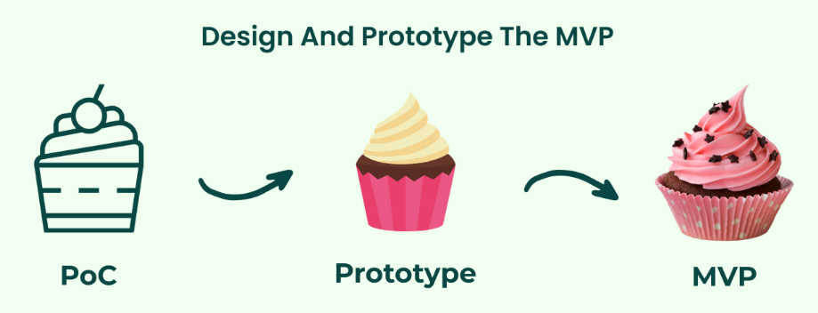
- Build and test MVP
- Calculate the cost of MVP
- Launch MVP with minimum features
- Analysis and Iterate

Step 10: Startup
- Company Registration
- DIPP Recognition

