DRAFT
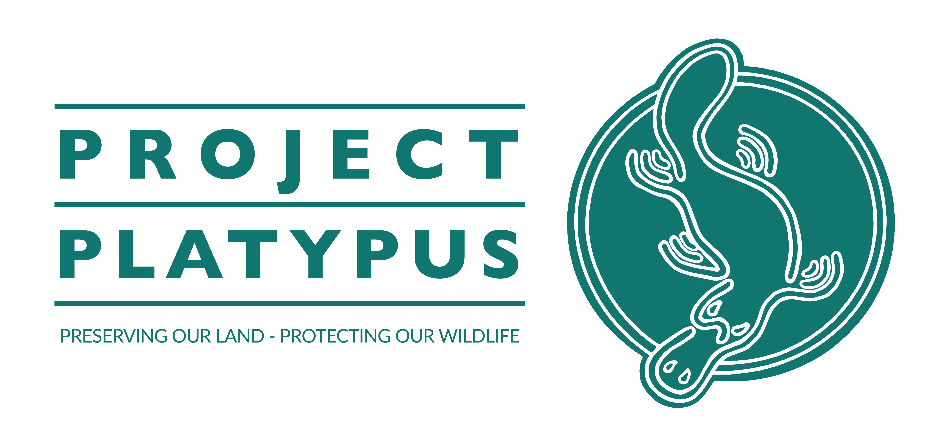

​

​

Yes, I would like to support the work of Project Platypus
You can make your donation to Project Platypus using the DONATE NOW button on our web site: www.platypus.org.au
Or if you prefer to make your donation directly by credit card or EFT, you can use this form and send it to admin@platypus.org.au

Donation by EFT:
Project Platypus Public Fund, CBA BSB 063-528 Account 101 74 538

Please mark your EFT ‘Donation’, add your full name & send form to admin@platypus.org.au

I’d like to make a tax-deductible gift of:
$1000 $2500 $5000 $10,000 Another amount____________
Please circle

Name
Street
Town/suburb | Postcode
Email address
Telephone
Would you like your donation to remain anonymous? Yes No
Can we send you our quarterly Landcare newsletter – Down to Earth? Yes No
Donations over $2 are tax deductible. Project Platypus is a Deductible Gift Recipient (ABN: 59 631 244 284) and is registered as a Charitable Institution.
PROJECT PLATYPUS
9 Ormston Rd, Stawell | manager@platypus.org.au | www.platypus.org.au

