Town Clerk
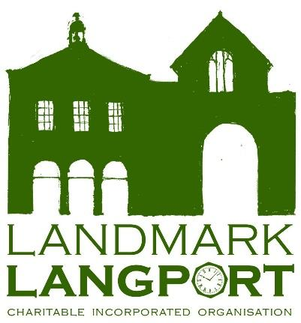
Langport Town Council
Langport Town Hall
Bow Street
TA10 9PR

11th June 2024

Dear Town Clerk.

Following our letter of 2nd April 2024, I am writing to you as a very valued, long-term tenant of Landmark Langport.

Landmark Langport Trustees have made some positive progress within the Town Hall. The RSPB have now moved into the recently renovated ground floor as long-term tenants. Walter’s Garden is proving to be a huge success and is becoming increasingly popular with the community with more than 25 regular volunteers working on the garden and veg boxes being shared with Langport Cares Foodbank. We have seen an increase in bookings in both Ridgway Hall and the Town Hall. We have also recently invited the Langport Business Group to hold their meeting in the Town Hall which will give us a great opportunity to network with our local business community.

The trustees recognise that although we have made some small wins our primary issue remains having regular and reliable income streams to secure a stable future for the building.

Following a recent meeting of the trustees they have agreed an appropriate rent rise for the Langport Town Council would be a 15% increase. Taking your rent from £3,500 to £4,025. There is also a small monthly charge of £50 for the shed spaces currently on the courtyard to the rear of the Town Hall building.

We hope to see you at the up coming event ‘Birthday Day’ which Landmark Langport are hosting in the Town Gardens on 21st July. The trustees also plan to host drinks in the garden once the weather settles, date to follow…

Please don’t hesitate to get in touch should you wish to discuss this matter further.

Kind regards,

Alice Mounter
On behalf of Landmark Langport Trustees

Langport Town Hall | Bow Street | Langport | Somerset | TA10 9PR | Tel: 07395 465233

