Report title: A report responding to correspondence received from Somerset Council with regards to the emptying of Litter and Dog waste bins
Report Author: Gerard Tucker –Town Clerk
Date: 22nd August 2024
Recommendation: That consideration is given to the additional financial commitment required to manage the waste bins in Langport

BACKGROUND

Somerset Council informed that it was reviewing the devolution of responsibilities in various departments, including the management of litter and dog waste bins collections. Councillors confirmed the location of the bins at a meeting on 20th August, including the town garden, Northmoor and Memorial Field.

REPORT
If the estimate of the regularity of the bin emptying is correct and the responsibility for bins on other land is not upheld, then Langport Town Council can expect a large invoice.
Table 1
Location | What 3 Words | Type | Responsibility | Empties  annual | Expected cost £
Eastover Recreation Ground | upholding.magical.stack | Litter | LTC | 52 | 378.56
Memorial Field – Social Club | kite.consults.towers | Litter | LTC | 52 | 378.56
Whatley – by River Parrett | orbited.teardrop.forklift | Dog | LTC | 52 | 378.56
Cocklemoor | every.bearable.curries | Dog | LTC | 156+ | 1,135.68
Cocklemoor | describe.finest.topics | Dog | LTC | 156+ | 1,135.68
Cocklemoor | briefer.yummy.gosh | Litter | LTC | 156+ | 1,135.68
Cocklemoor | increment.amuse.spearing | Dog | LTC | 156+ | 1,135.68
Cocklemoor | turkeys.verse.firework | Litter | LTC | 156+ | 1,135.68
Cocklemoor | lecturing.relies.dorm | Dog | LTC | 156+ | 1,135.68
Cheapside – by Bakery | players.flushed.skippers | Litter | LTC | 156+ | 1,135.68
North Street Moor* | weekends.rationing.redefined | Dog | Langport Commoners | 52 | 378.56
Rear of Town Hall* | trickle.charcoal.chess | Litter | Landmark Langport | 52 | 378.56
Rear of Town Hall* | foods.trickles.wishing | Dog | Landmark Langport | 52 | 378.56
 |  |  | Total | 1,248 | £9,085.44
*Confirmed by Somerset Council that these bins will be charged to the respective organisations

The bins on Cocklemoor are emptied during the summer holidays (six weeks) on five days per week. If this is factored in, the additional cost equates to £3,057.60 (7 bins – emptied an extra twice per week x 30 days x £7.28) 7 x 2 x 30 x £7.28 = £3,057.60. Should Langport Town Council accept the costs of emptying the bins in Langport, without passing some of the costs on to third parties, then the worst-case scenario is an additional financial commitment of £12,143.04 + VAT per annum.

Total current capacity

The type of bin used throughout the town are either steel dog waste bins, or relatively small litter bins with limited capacity.
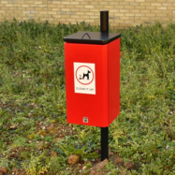 40 ltr 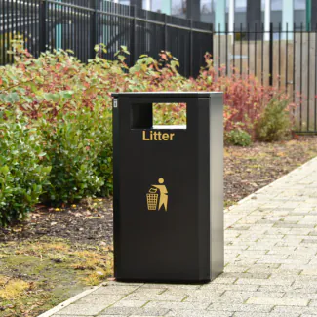120ltr 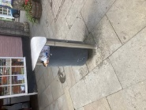 60ltr
There are five of these on There are two of these on This one is located
Cocklemoor Cocklemoor by The Little Bakery

Total capacity of all the bins that Langport Town Council may be charged to maintain is 800 ltrs which when divided by the total anticipated cost equates to £15.17 per ltr.

Alternative solutions for consideration
Current location of town centre bins
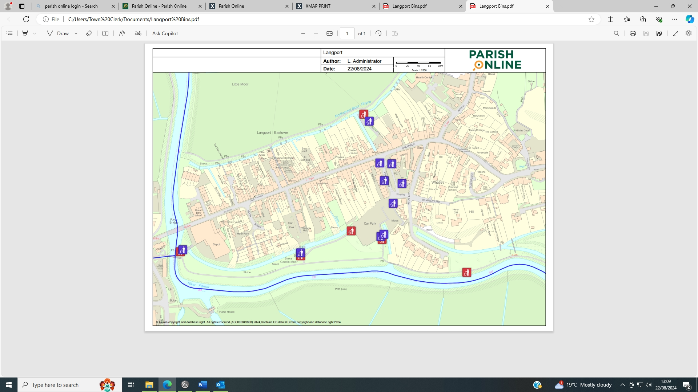

If all the bins listed in Table 1 were removed, with the exception of the bin by The Little Bakery and replaced by larger dual-purpose bins at four specific locations –three on Cocklemoor (Back Water, Ridgway and Bow Bridge) and The Memorial Field, the capacity would increase to 896 ltrs.

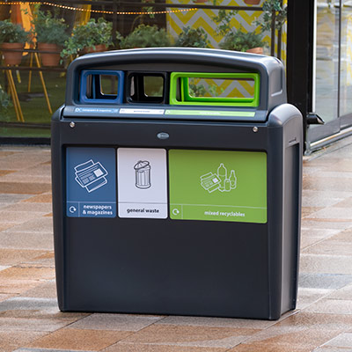 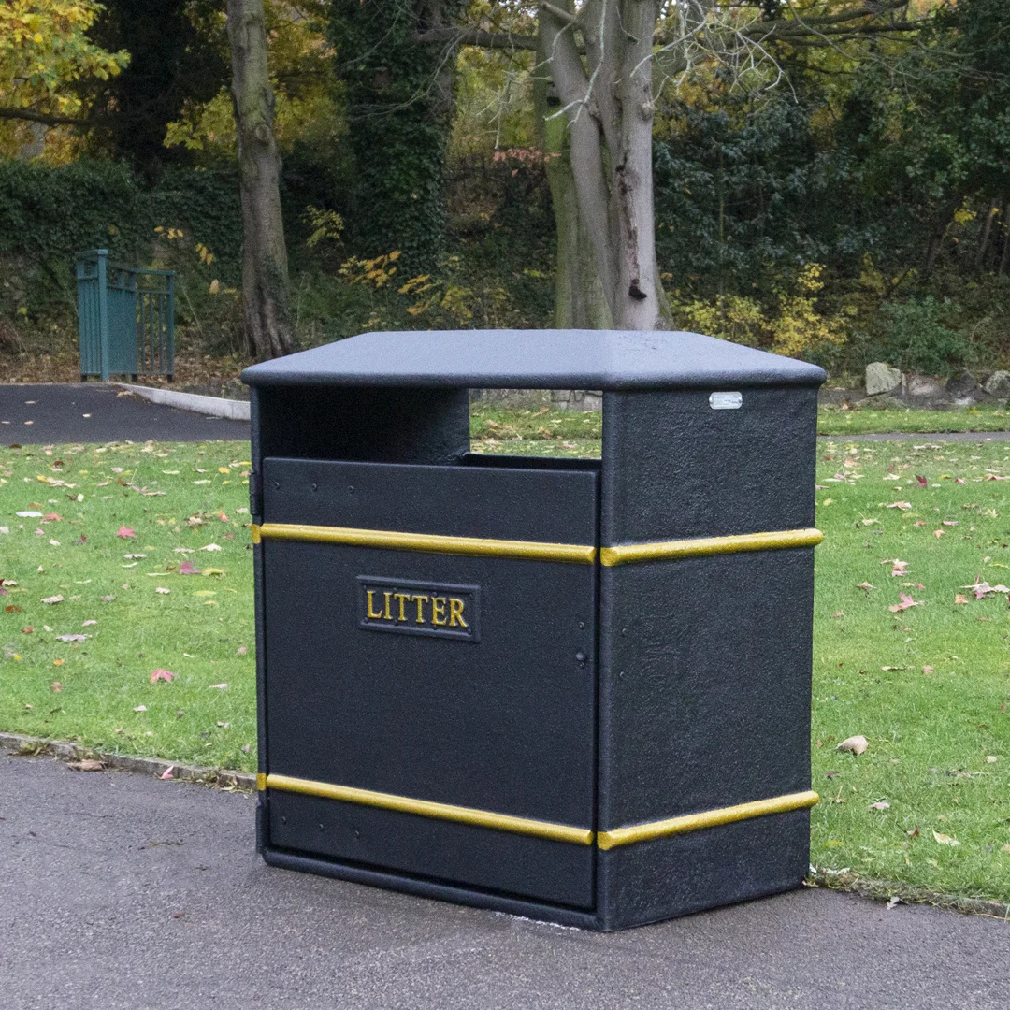£548.26 + VAT 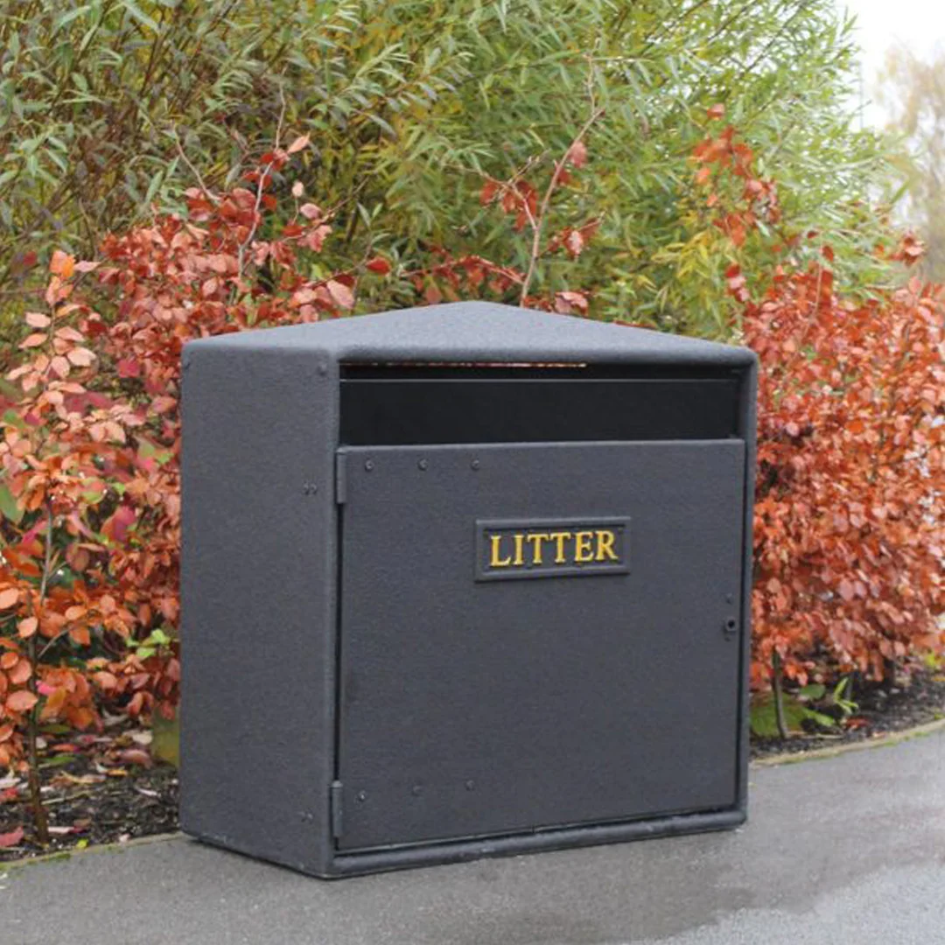 £483.85 + VAT
154 ltrs 224 ltrs
Importantly, the number of bins to be emptied is reduced to five, from the original thirteen. On the assumption that the larger bins are emptied twice per week and the bin by The Little Bakery is emptied three times per week the collection costs are reduced to £5,139.68 +VAT. This equates to £5.38 per ltr. To be factored in, is the £1,935.40 purchase cost of four new dual-purpose bins, which on the assumption they would last five years makes the revised cost per annum (including depreciation) of £5.90 per ltr.

RECOMMENDATION

By removing all of the existing bins (with the exception of the bin located by The Little Bakery) and replacing with larger dual-purpose bins, there is a significant saving to be made. Of concern is that there would no longer be a bin at Whatley by the river. It is presumed that each dog walker would be walking past at least one bin and would carry the dog waste to the next available bin.

It is recommended that Langport Town Council is presented with this report, yet withholds making any decisions until the detail is forthcoming from Somerset Council on the actual costs incurred.

FINANCIAL

It is understood that Somerset Council are considering a charge of £7.28 per bin per collection. It is believed that currently the Cocklemoor bins are emptied three days per week and the others weekly. The worst-case scenario is that Langport Town Council could expect to be charged £12,143.04 for the emptying of bins. If the bins are removed and replaced by five larger capacity bins, retaining the bin by The Little Bakery, the cost per annum is reduced to £5,139.68. Even with a depreciation of £500 per annum on the new bins, the saving per annum is still more than £7,500.

Current bins located on land owned or managed by LTC | Current capacity of all bins located on LTC owned land | Cost per annum per litre | Additional costs – removal of bins | Total current costs (TBC)
10 | 940 litres | £14.13 | Unknown | £12,143.04
Suggested number of bins to be located on LTC owned land | Suggested capacity of all bins located on LTC owned land | Cost per annum per litre (inc depreciation) | Additional costs – Installation of new bins | Anticipated costs if larger bins purchased
5 | 956 litres | £5.24 | Estimate £500 | £5,139.68  + Installation and depreciation

