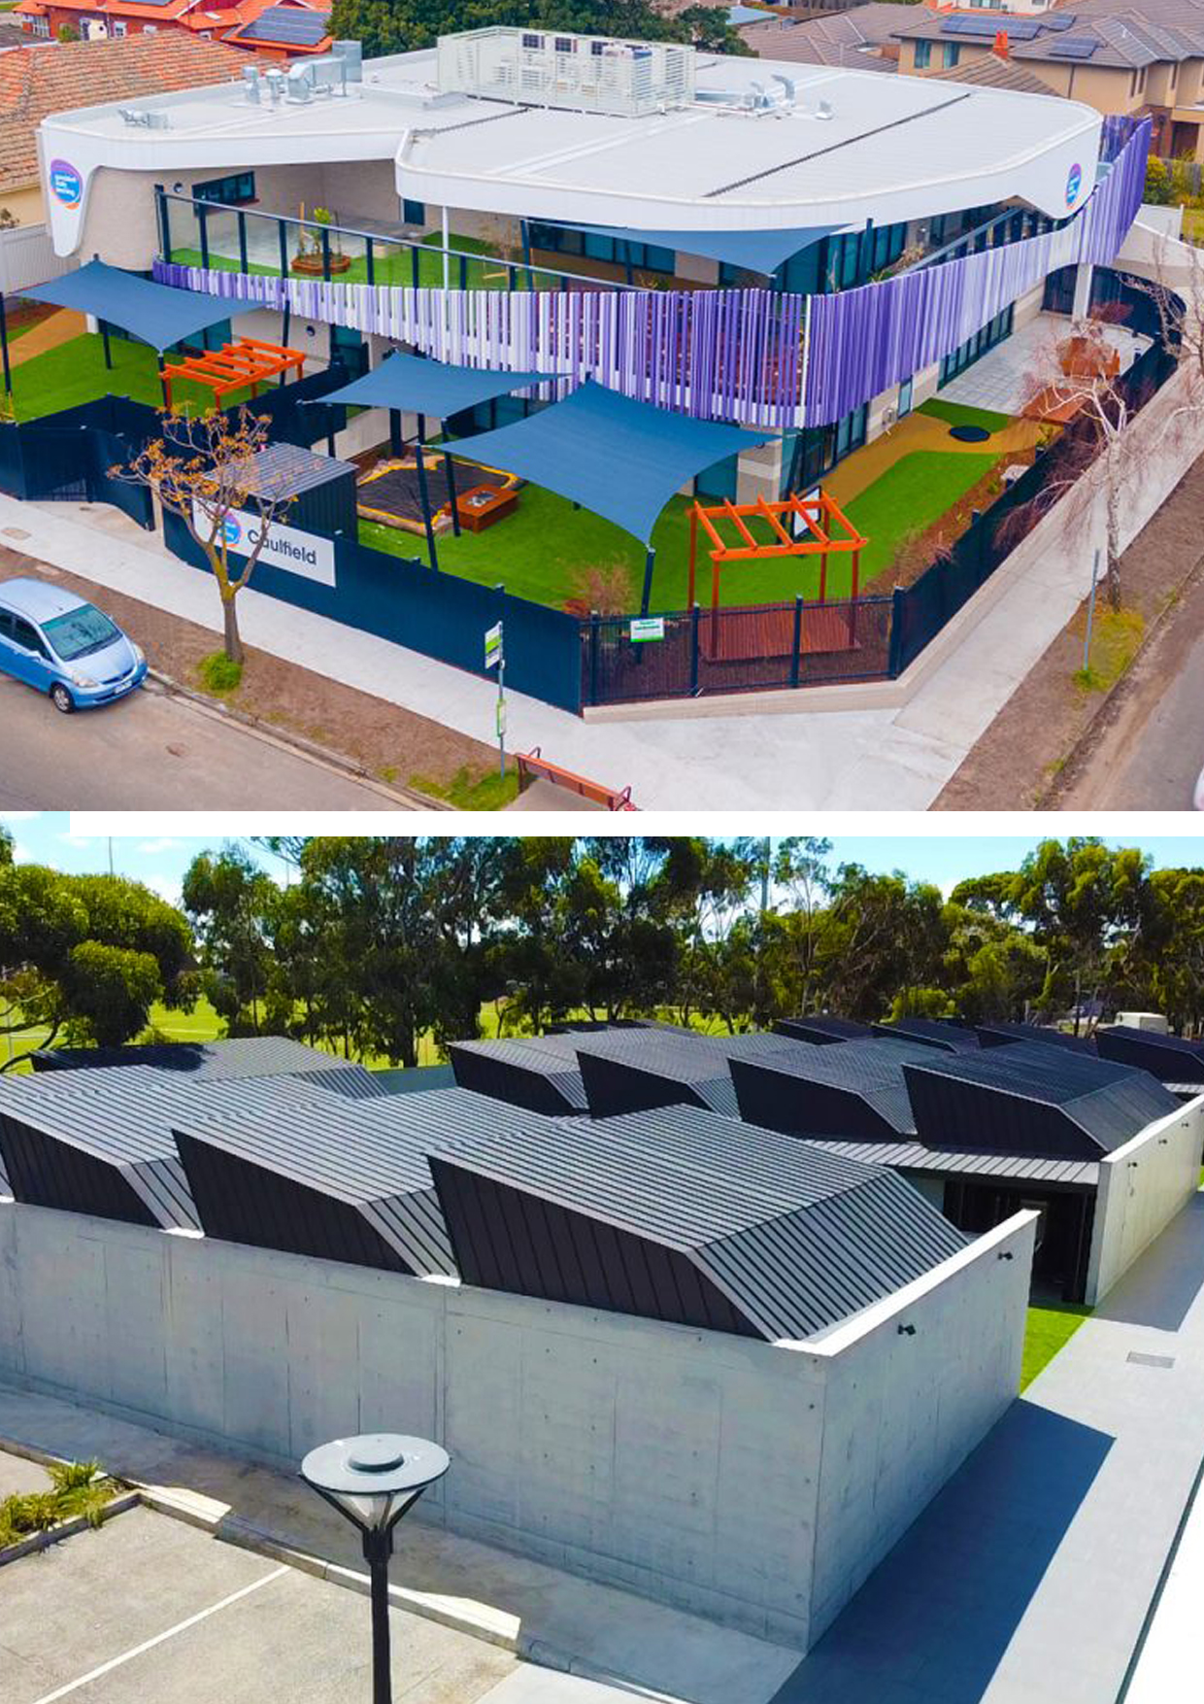

Amnicon Constructions

Statement Prepared By:

Amnicon Constructions Pty Ltd
Unit 5, 276 Kororoit Creek Road
Williamstown, VIC. 3016
amnicon.com.au

CAPABILITY
STATEMENT.

June 2024

TABLE OF CONTENTS

Page 03
Page 05
Page 07
Page 12
Page 15
Page 17
Page 18
Page 19
Page 20
Page 21

01 Company Profile
02 Our Team
03 Scope of Work & Methodology
04 Completed Projects
05 Projects in Progress
06 Management Systems
07 Quality, Environmental & Safety Systems
08 Accreditation & Insurance
09 Amnicon in the Community
10 Company References

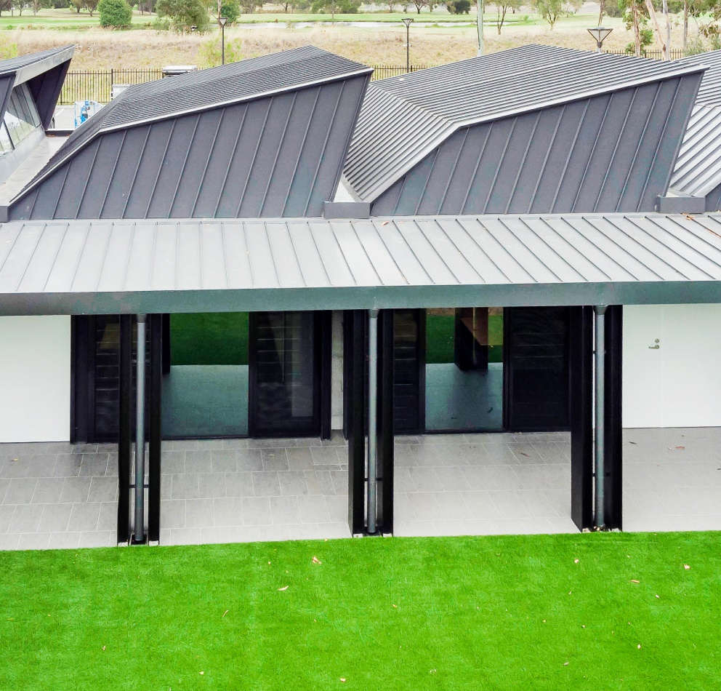

_{1.0}

Company Profile

_{EXECUTIVE SUMMARY}
Amnicon Constructions was originally established in 2017, situated in Melbourne, Victoria. Presently, we have evolved into thriving enterprises operating successfully within the VIC region. Our progress and expansion have been self-financed and astutely overseen.  _{History}  Although new, our management team and employees are highly experienced with many successful projects completed. Since 2017, AmniCon has been growing exponentially and praised by its clients due to the honesty and transparency instilled in its culture. We have specialized in commercial projects such as education centres, community centres, childcare centres and mosques.  _{Experience}  As our organization grows, we have strategically enlisted and provided backing to our delivery teams with adept and resilient leaders. These leaders have garnered notice from fresh clienteles and consequently, new market domains, consistently enlarging our collection of educational undertakings and broadening our affiliations. By leveraging our array of projects and the strategic enlistment of seasoned construction experts, we are empowered to successfully execute endeavours spanning various market sectors.  _{Culture}  We uphold a robust sense of familial camaraderie in all our undertakings. We've had the privilege of observing the evolution and advancement of our personnel. This encompasses individuals who started with us as apprentices, experiencing personal and vocational development as they transitioned from trade positions to managerial roles. | During the initial stages, our tasks primarily encompassed educational as well as multi-purpose and multi-unit development projects. Over time, these endeavours evolved into more demanding undertakings as our effective strategies yielded positive outcomes. A multitude of our earliest clients continue to engage in project discussions with us up to the present, encompassing both private and public educational ventures. This enduring connection is upheld by our unwavering dedication and a steadfast track record of surpassing client anticipations.  _{Experience}  Central to our recruitment philosophy is a fundamental aim: to ensure a seamless cultural alignment. Personal dispositions are regarded as equally vital as professional experience. We recognize the distinction between knowledge and wisdom, and this guides our personnel selection process.

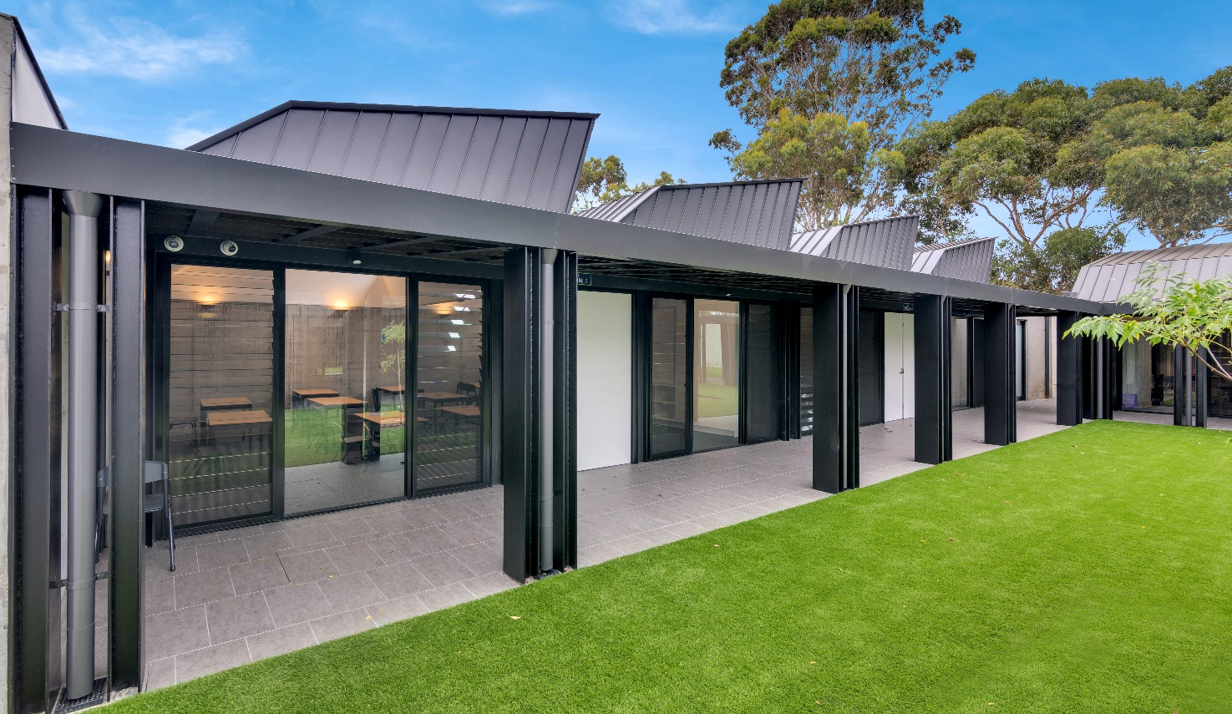

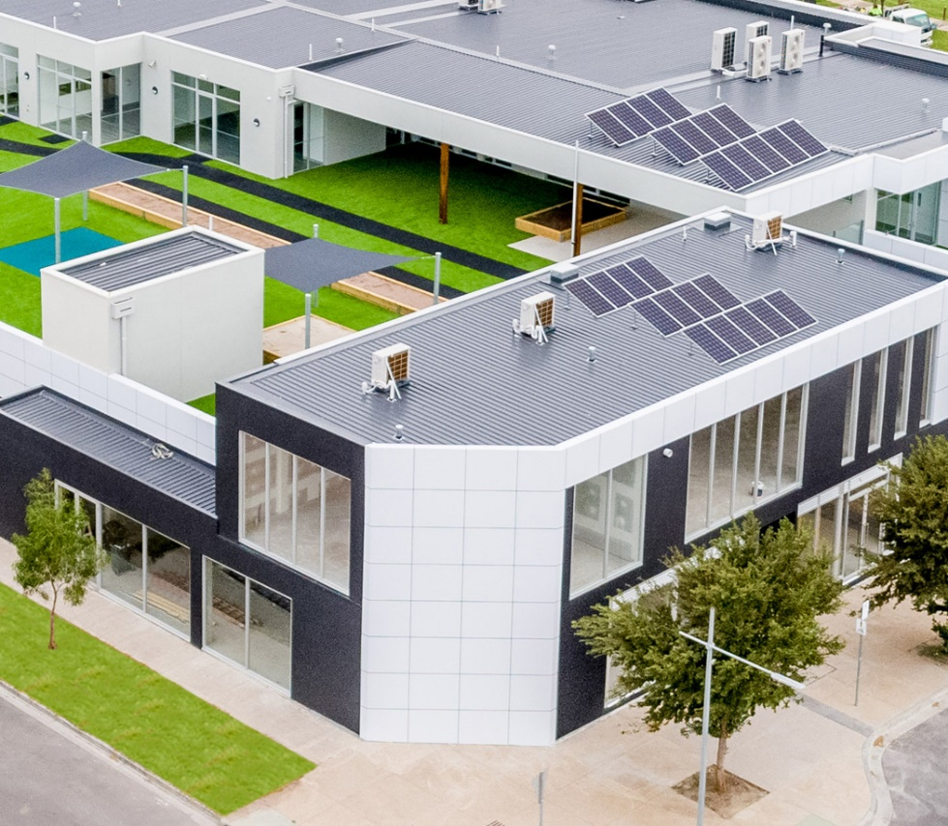

_{2.0}

Our Team

_{EXPERIENCE & EXPERTISE}
Adaptability is our strength. Our compact company structure allows us unrivalled scope to respond quickly and effectively to diverse project requirements.  _{Estimating Manager}  Our dedicated and commercially astute team of experienced estimators ensure accurate pricing of all projects undertaken. With less assumptions and more measurement of actual costs, our clients can rely on our estimations to be both true, fair and competitive.  _{Project Managers}  We take the time to understand our client's needs. Our working relationships are collaborative and congenial. We are experts at identifying issues unique to particular  _{Contracts Administration}  Strong site coordination, strict budget management, and thorough reporting procedures are our standard framework for every project. Quality is assured by seamless information flow between our team, sub-contractors and consultants. Meticulous document management systems ensure that RFIs, VQs, progress claims, cash flow, insurance compliance and all contractual obligations are implemented to the highest professional standards.  _{Site Supervisors}  Our Site Managers are carefully selected. We require them to be on top of all aspects of site works, coordinate construction programs, and manage accurate, timely communications up and down the line. Our track record of site safety speaks for itself. We do everything in our power to ensure incident-free sites and engage a third party to independently audit the safety of every project periodically. Our industrial relations record is outstanding. | projects, designing and implementing delivery strategies that help avoid problems before they occur. Amnicon Constructions implements rigorous OH&S management consistently across all sites, with high standards independently verified through performance, audits, and an excellent record over many years. With this in mind, project managers are carefully delegated to their projects.  _{Sub Contractors}  First class quality relies on more than just inspecting work and using good tradesmen. Amnicon Constructions nourishes strong relationships with consultants and sub-contractors. We ensure the quality of our projects by using a loyal team of skilled sub-contractors who understand our construction language.  _{Account Manager}  Our Account Manager plays a key role in overseeing the mountain of data generated in the MIS backend systems. Effective cloud-based tools are utilised that serve as the primary point of contact for clients, ensuring project details are well understood and effectively communicated to internal teams. Throughout the project lifecycle, our Account Manager monitors progress, address concerns, and identify opportunities for streamlining internal processes.

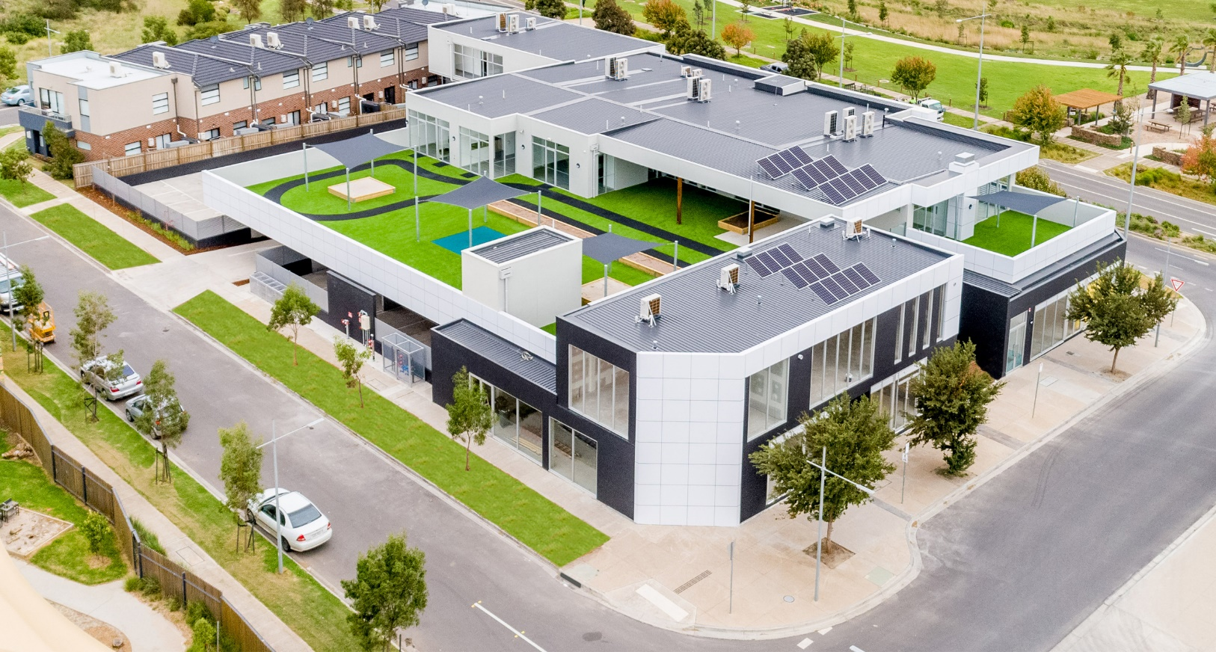

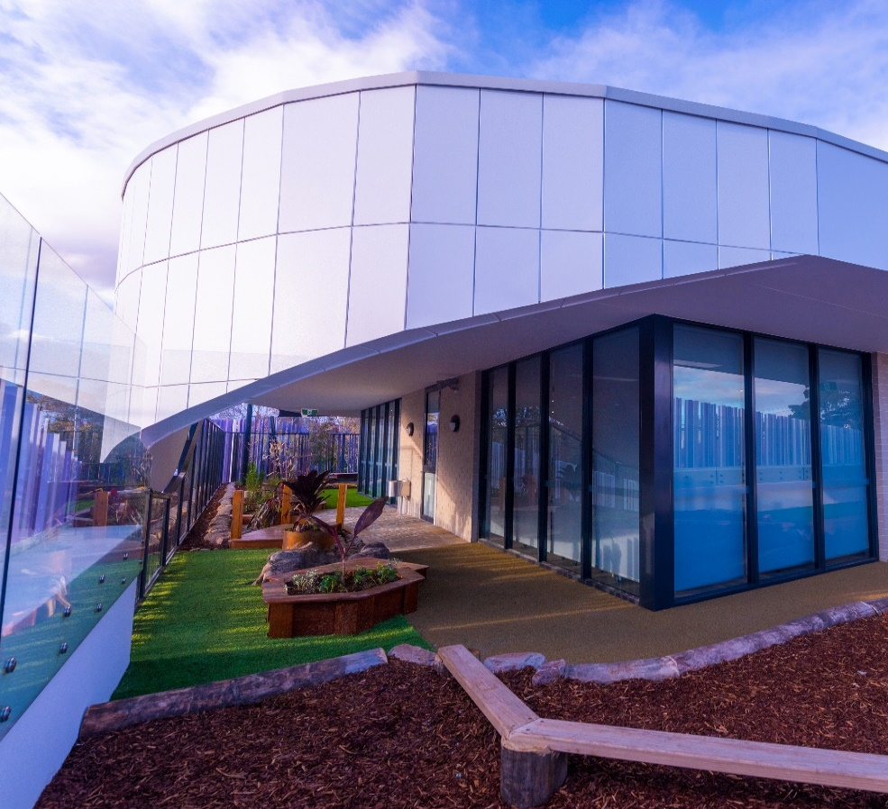

_{3.0}

Scope of Work & Methodology

_{Scope of Work}  Amnicon Constructions understand that the AIA Multi -Purpose project is being delivered in order to provide greatly improved educational services for their students within the existing schooling facilities located in Coburg Victoria. The Multi-Purpose facility is intended to be a central hub for the students, designed to offer educational necessities found in all modern & contemporary educational building.  This project will include the following works:  - Classrooms, Quiet Rooms, Staff, Boardroom  - _{Playground, Courtyards}  - _{Toilets, Kitchens}  - _{Reception / Administration}  - _{New Carpark}  - _{Landscaping to Perimeter}  _{Methodology}  During our lead in time, we reviewed & continue to review all quotations that are received, and we endeavour to select competent trade contractors to complete each trade element. Key project features will be given careful attention in terms of subcontractor selection. Amnicon Constructions will ensure the selected contractors have the necessary experience in similar type and size projects, availability and capability, which are the optimum criteria to be met for selection. Careful consideration will be given to lead times. Preference will be given to trade contractors within the local catchment area who have a proven track record in time management and completing work to a high standard on similar projects and/or recent work on other projects, that demands a superior level of finish.  The project will commence with site preparation, including cut and fill works to formation level and set down of underground services works. This will be followed by the pouring of the main ground slab, construction of wall framing, lower roof frame, upper roof frame and finally the roof cover.  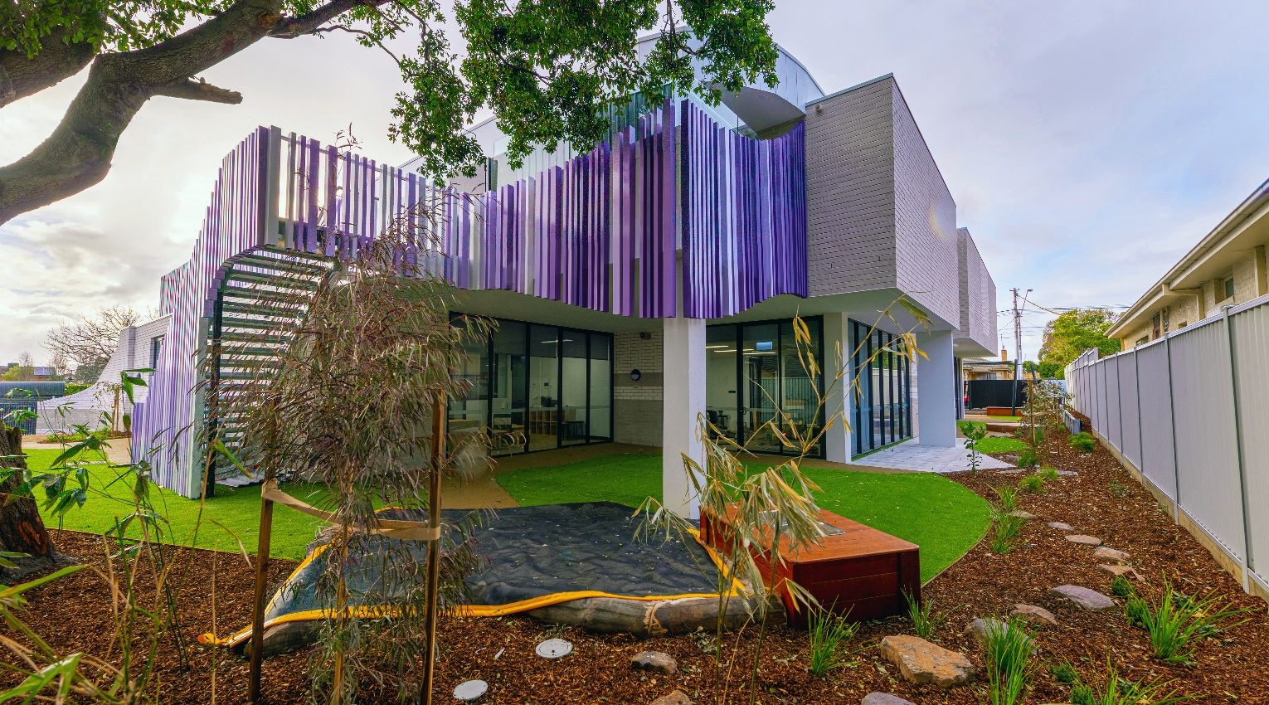 | _{Scope of Work}  Amnicon Constructions has successfully completed a similar educational building project and will utilise such expertise to deliver this project to the highest of standards. Careful choice of subcontractors, as well as great attention to security and safety standards will ensure the success of this project. Amnicon Constructions have the highest standards (FSA Accreditation) as well as a proven safety record to enable successful completion of this project.  Our on-site methodology is derived from our experience on similar projects, the provided plan set and on how we perceive the sequence of the works. Prior to any works commencing on site, appointed Amnicon Constructions staff will discuss with all project stakeholders (Client and Consultants) the parameters that must be adhered to.  _{horology}  External framing, cladding and windows will be completed to bring the project to a lockup stage to enable the rough in of services. Wall and ceiling lining will take place followed by joinery and fixing of doors.  All sub-contractors and staff will undergo a site-specific Safety Induction prior to commencement of their respective work area, and Safe Work Method Statements being carefully completed, implemented, and regularly reviewed by the trade contractors and site project team.  We note that weather (high winds) may be a concern. Once the building has a roof, the next priority will be getting it sealed. i.e., getting wall cladding & windows in. Once the building is sealed and weathertight, then fit-out type activities can commence. Wall and ceiling lining will take place followed by joinery, fixing of doors and painting. Floor coverings & fit off of services will then be completed to get the building to its final stages. Landscaping works will be delivered with priority once other trades near completion and space on site allows for appropriate and safe access.  _{West Community Centre project.}

Building defects & completion of external works are to be done before practical completion. Amnicon Constructions is committed to building long-term relationships with clients (both principals and consultants) through the successful delivery of projects. Amnicon Constructions has the skilled team of construction professionals available and ready to focus their attention on this multi-purpose educational facility. Lookman Elkurdi, our Company Director overseeing all construction matters will be involved throughout all stages of the works and available to the Australian International Academy & Elevli Plus Architects as required.  Our team will work collaboratively with the Australian International Academy & Elevli Plus Architects and all project stakeholders and our skilled consultants. Site meetings with key stakeholders will be held regularly with our Project Team and Construction Manager. This will be critical for us to ensure our working relationship with the Australian International Academy & Elevli Plus Architects to  enable the completion of works by the proposed timeframe. The success of this project will be assured because of the way we communicate through the building process to achieve the agreed program whilst delivering a high-quality product.  In summary, Amnicon Constructions will provide an exemplary level of cooperation, planning, communication and skills, focussed on delivering a quality outcome for AIA.  _{Site Establishment}  Upon appointment Amnicon Constructions will hold a start-up meeting to converse with all project stakeholders and to introduce our proposed team. The start-up meeting will also be used to reconfirm the objectives of the AIA project, risks and approvals processes. | The agenda for the start of works will include the following:  - _{Introduction of participants}  - _{Overview of the project}  - Development of a communications framework  - Identification of key concerns and risks  - Development of acceptable solutions to Client concerns  Our Site Establishment Plan will be submitted to the superintendent for review and approval before being implemented.  In addition, we will prepare and submit for approval the following:  - _{Environmental Management Plans}  - Occupational Health and Safety Management Plans  - _{Quality Assurance Plans}  _{Site Setup}  Once site possession is granted, Amnicon Constructions will complete a thorough photographic report of all areas and services pathways where construction work will occur. This report will be issued to the superintendent to confirm the existing conditions of the surrounds. The report will be used to help ensure the immediate areas surrounding site are returned in the same condition.  _{Temporary Service & Power}  In order to provide the site with appropriate services requirements, temporary services and power will be required. Reticulated power and lighting installations will comply in all respects with the requirements of the OH&S Regulations, Electricity Supply Authority and the Code of  Practice for Temporary Electrical Installations on Building and Construction Sites. All General-Purpose Outlets (GPO’s) shall be provided with earth leakage protection.

_{Traffic Control}  Although the site is reasonably isolated, we understand that disruption to the residents must be kept to a minimum during the construction phase. Traffic management will be put in place to minimise this disruption.  _{Amenities}  Amnicon Constructions will set-up amenities in an agreed area on site for this project. A designated area will be utilised within the fenced area for our site bins and storage.  _{Commissioning}  Commissioning is an integral part of the project delivery. The commissioning, and more specifically the management of the overall commissioning process has in Amnicon’s extensive experience proven to be absolutely critical to achieving a successful outcome on a project.  The projects comprehensive commissioning requirements will be managed by our project team. Our Project Manager and Site Manager will ensure that the subcontractors commissioning plans meet the requirements of the essential and emergency services requirements as well as GWCC operational requirements and constraints. These procedures have proven effective on recent projects.  _{We will Do the Following:}  - Initial scoping of the works to ensure all subcontractor services packages are fully inclusive and compliant with the contract,  - Programming the services procurement to ensure long lead time items, trusses, plant, glazing and the like, are ordered in line with installations requirements,  - Managing and co-ordinating the procurement and installation phases to ensure, compliance of all building services with the requirements of the project documents and authority standards. | _{Traffic Control}  - Early preparation of a project commissioning plan to ensure as-built compliance meets the design and operational requirements,  - Coordination and approval of services shutdowns, augmentation works and upgrades,  - Checking and reviewing the building service installations and subcontractor works through a combination of visual inspections, audits & checklists,  - Progressive and final testing commissioning of all service installations,  - Reviewing and submitting all drawings and Operations and Maintenance Manuals,  As part of the commissioning and handover of the project, Amnicon Constructions will develop a commissioning plan for all key services. The commissioning plan will cover items such as:  - Testing of Fire Services & Monitoring System  - Building Management System Testing  - Testing and Authority Approval of Switchboards  - Supply of As-Builts and Manuals  - Consultant Defect Inspection and Review  Our project team and the management of the services subcontractors will be on site at all times during Client Commissioning. If any issues arise our team can immediately respond.  _{Completion & Quality Assurance}  Our Quality Assurance processes includes comprehensive Inspections and Test Plans throughout all stages of each sub trades work. The outcome of our QA Processes is the completion of all defects as the project approaches completion. Our Site Manager will be conducting frequent Quality inspections as each scope of work/area is approaching completion. Defects lists are issued to all relevant trades. Completion of these defects is vigorously monitored and pursued.

_{Responsibilities Matrix}
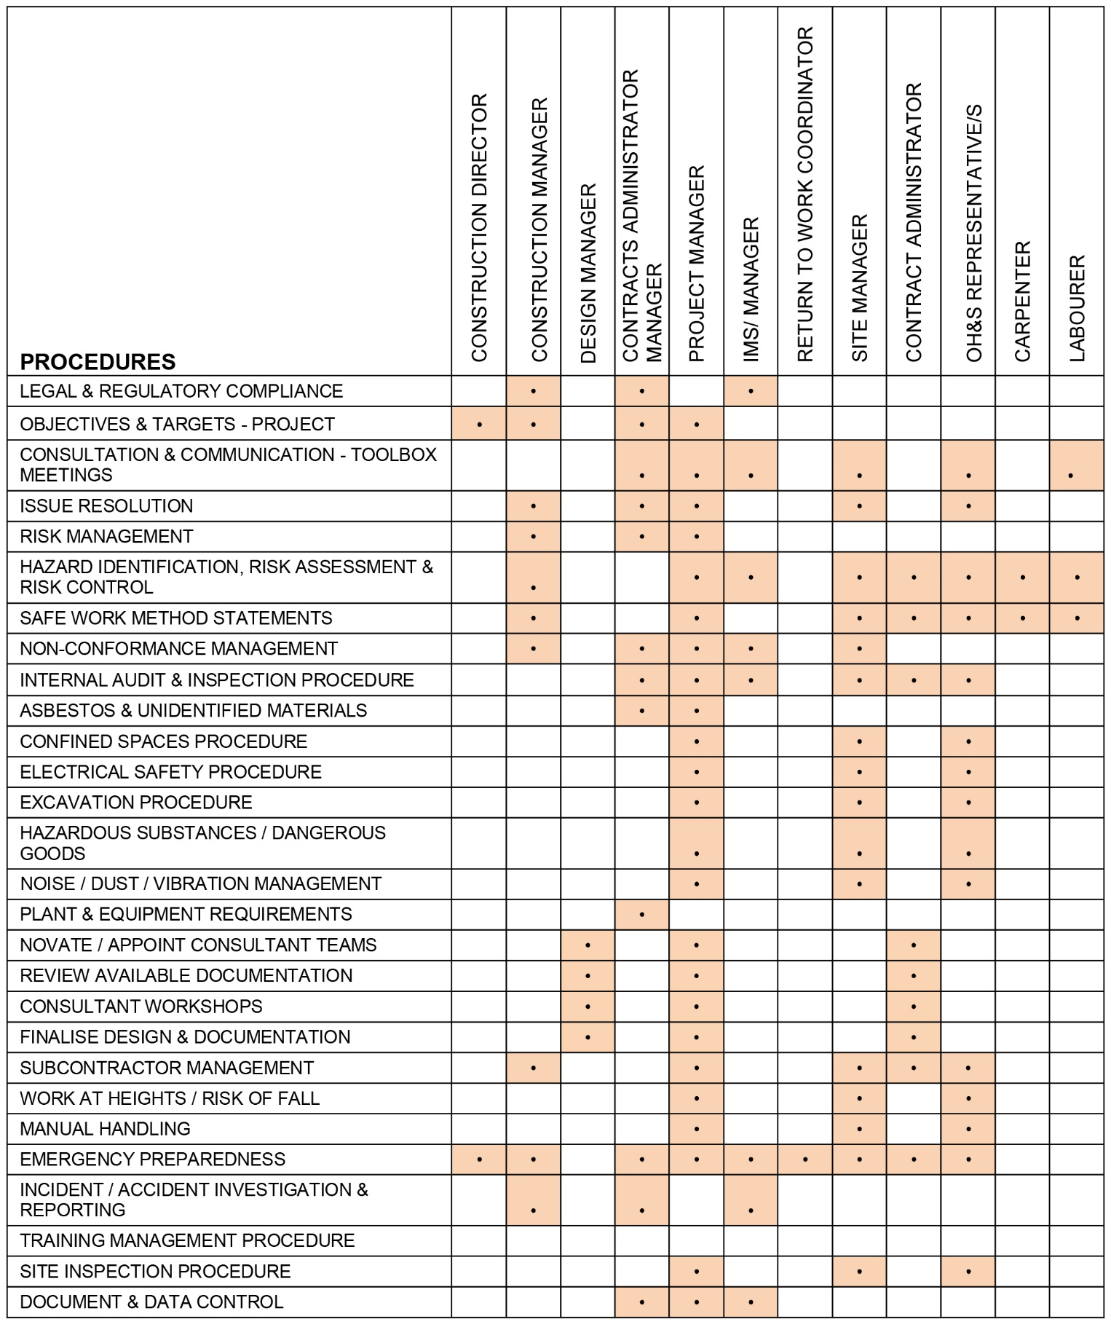



_{4.0}

Completed Projects

_{Project} | _{AIC Education Centre} | 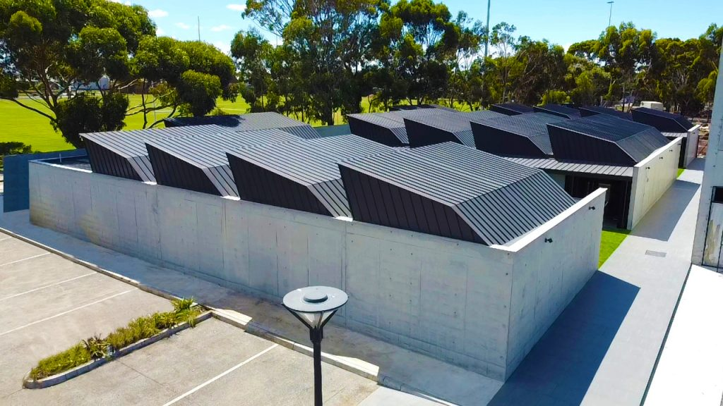
_{Sum} | _{$3.5 Mil}
_{Duration} | _{2 Yrs. Completed Feb 2021}
_{Location} | _{Newport, Victoria}
_{Procurement} | _{Fixed Lump Sum}
_{Project Summary}
Education facilities including, classrooms, quiet rooms, toilets, staff offices & courtyard.

_{Project} | _{Mixed-Use Development} | 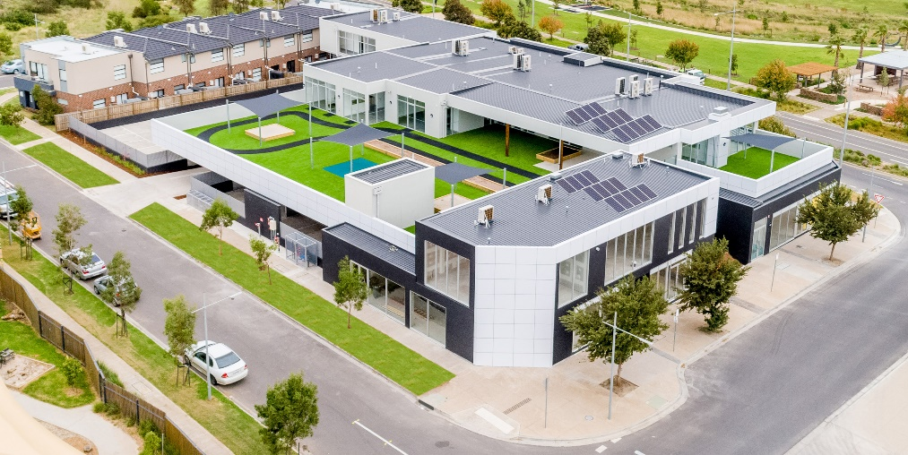
_{Sum} | _{$5 Mil}
_{Duration} | _{1.5 Yrs. Completed April 2021}
_{Location} | _{Epping, Victoria}
_{Procurement} | _{Fixed Lump Sum}
_{Project Summary}
This project included a Childcare Centre, Retails Offices & Medical Facilities

_{Project} | _{Goodstart Childcare Centre} | 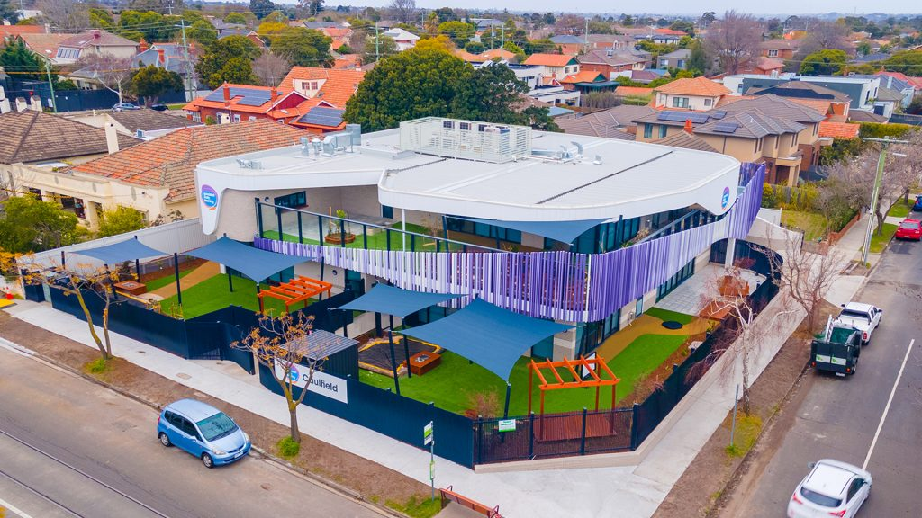
_{Sum} | _{$4.5 Mil}
_{Duration} | _{1.5 Yrs. Completed Aug 2021}
_{Location} | _{Caulfield, Victoria}
_{Procurement} | _{Fixed Lump Sum}
_{Project Summary}
This is a state-of-the-art Multi Story Childcare Facility for Goodstart, which caters for 120 children.

_{Project} | _{Brookfield Childcare Centre} | 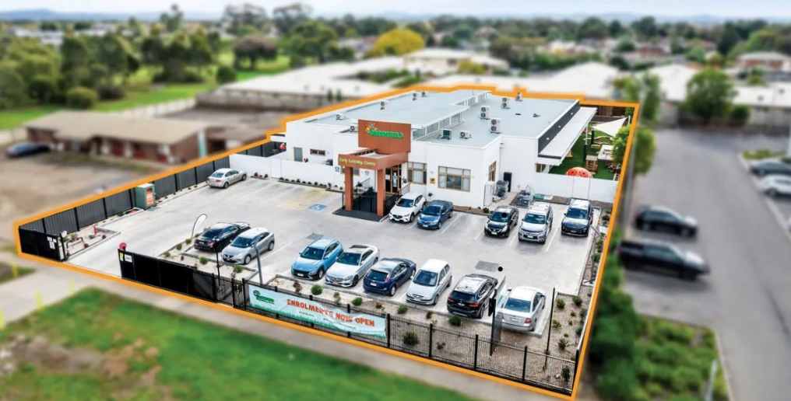
_{Sum} | _{$4.1 Mil}
_{Duration} | _{2 Years, Completed in 2023}
_{Location} | _{Brookfield, Victoria}
_{Procurement} | _{Fixed Lump Sum}
_{Project Summary}
This is a single-story childcare centre in Brookfield which caters for 117 children.

_{Project} | Hume City Council - Gladstone Park Tennis Pavilion | 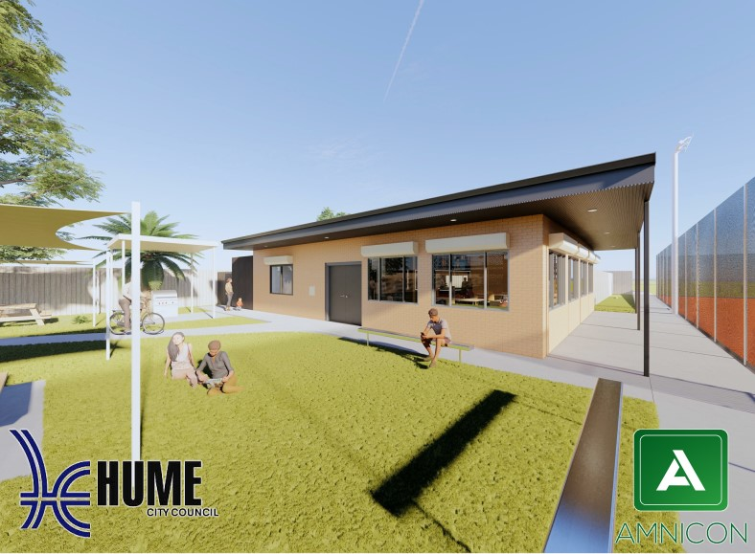
_{Sum} | _{$525,000.00}
_{Duration} | 10 Months, Completed March 2024
_{Location} | _{Gladstone Park, Victoria}
_{Procurement} | _{Fixed Lump Sum}
_{Project Summary}
This project involves the renovation of an existing
Tennis Pavilion into modern sporting facility for
the Gladstone Park Tennis Club.

_{Project} | _{AIA School Canteen & Canopy} | 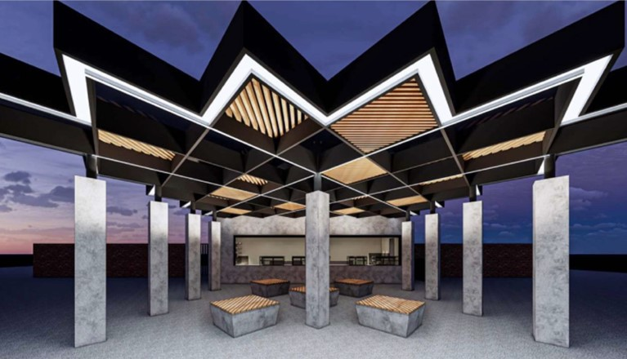
_{Sum} | _{$1.7 Mil}
_{Duration} | 12 months, Completed in June 2024
_{Location} | _{Coburg, Victoria, 12 Months}
_{Procurement} | _{Fixed Lump Sum}
_{Project Summary}
This project involves the construction of a school canteen which includes a modern pavilion style canopy.

_{Project} | _{Truganina Warehouse} | 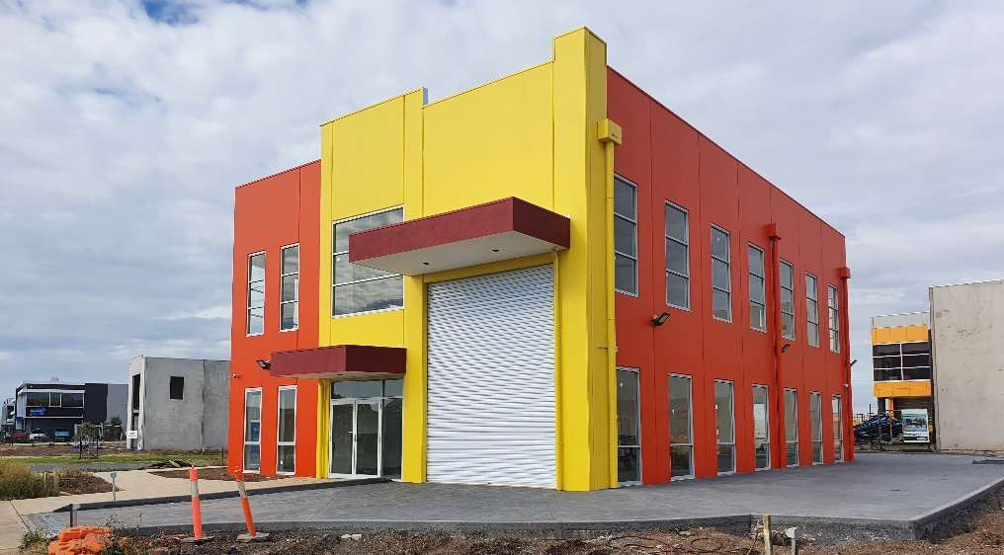
_{Sum} | _{$880,000.00}
_{Duration} | _{1 Year, Completed Feb 2021}
_{Location} | _{Truganina, Victoria}
_{Procurement} | _{Fixed Lump Sum}
_{Project Summary}
This is a commercial warehousing building consisting of mezzanine, modern office, mini kitchenette & toilets.

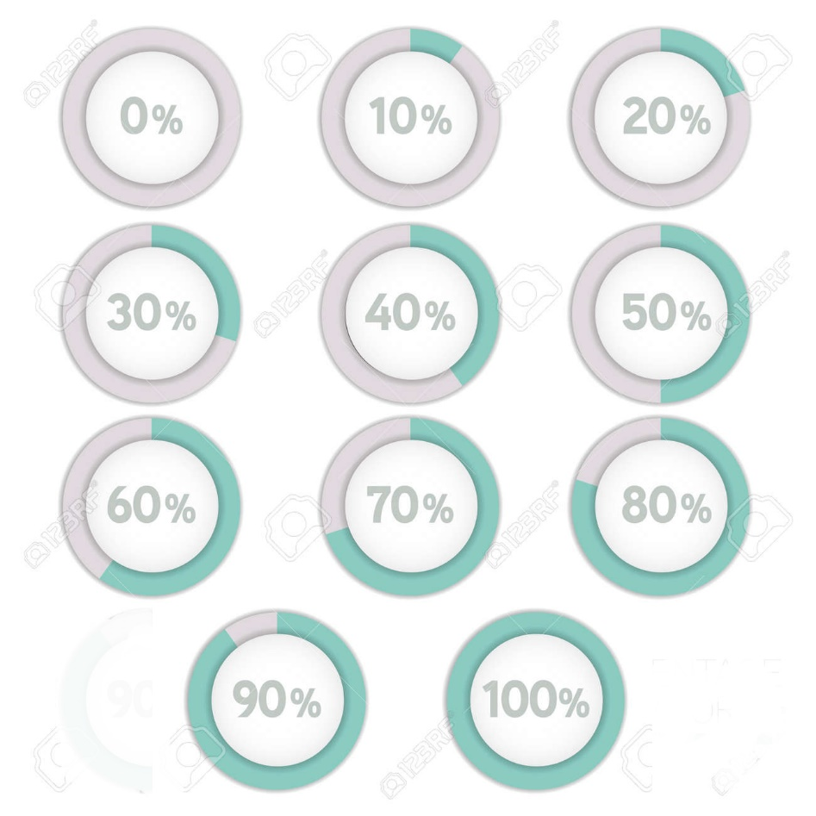

_{5.0}

Projects in Progress

_{Project} | _{Community Swimming Pool} | 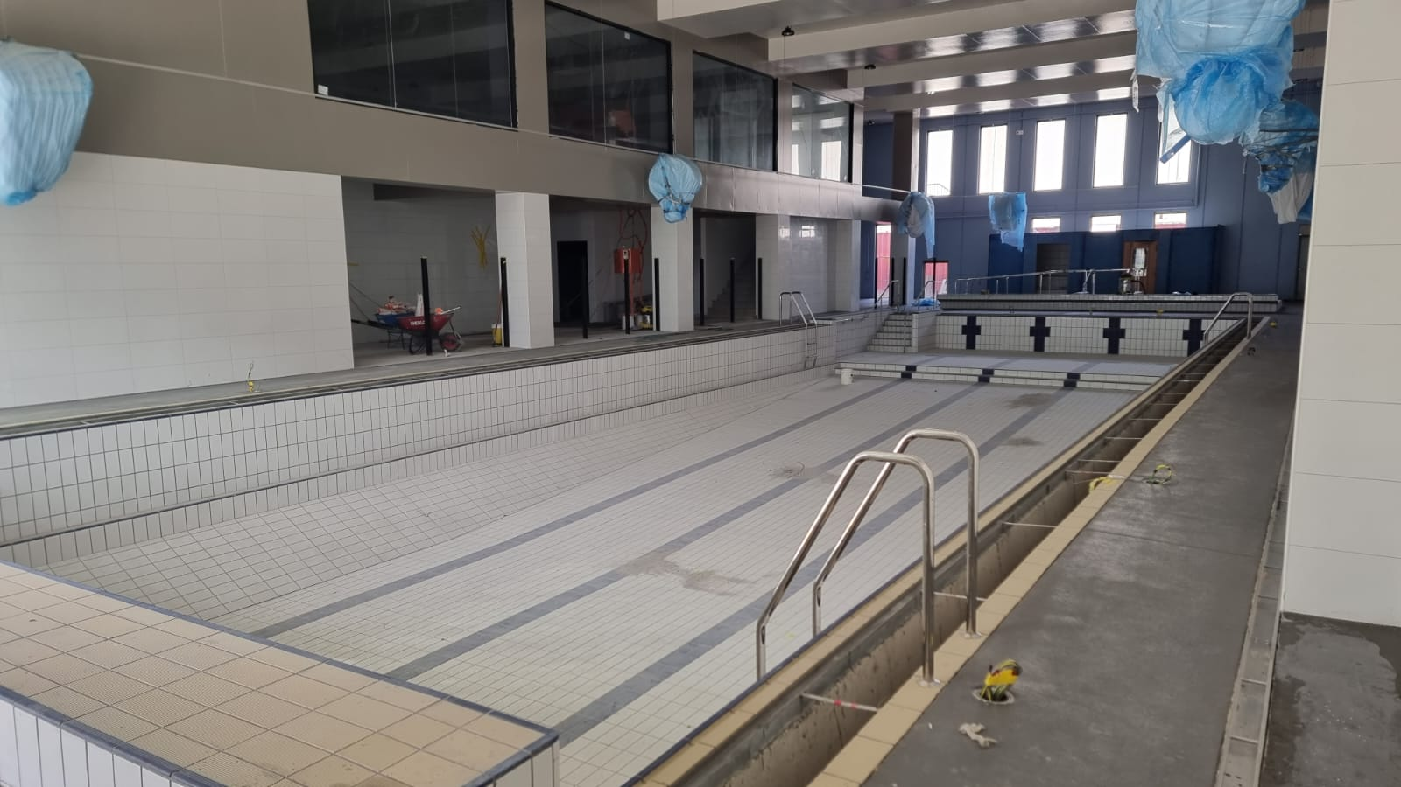
_{Sum} | _{$6.5 Mil}
_{Duration} | _{Started Q3 2021, 36 Months}
_{Location} | _{Broadmeadows, Victoria}
_{Procurement} | _{Fixed Lump Sum}
_{Project Summary}
This is a community-based project, consists of 3 stories, a 25 Meter Olympic Swimming Pool, Mezzanine Gymnasium and a third level Multi-Purpose-Hall. The project is 98% complete. Hand over date in November 2024

_{Project} | Bendigo Mosque – Community Centre | 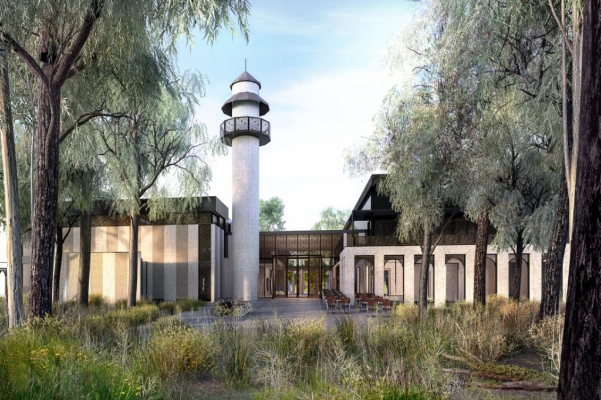
_{Sum} | _{$6.1 Mil}
_{Duration} | _{Started Q2 2023, 18 Months}
_{Location} | _{East Bendigo, Victoria}
_{Procurement} | _{Fixed Lump Sum}
_{Project Summary}
This is a community-based project involving the building of a prayer facility, as well as a sports centre for the community. This project is being done in stages and current working Minaret.

_{Project} | AIA – Multi Purpose Hall / Secondary Classrooms | 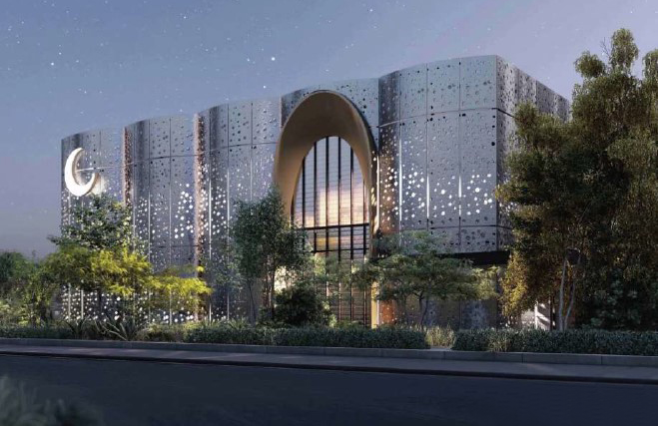
_{Sum} | _{$8.9 Mil}
_{Duration} | _{Started Q1 2024, 24 Months}
_{Location} | _{Coburg North, Victoria}
_{Procurement} | _{Fixed Lump Sum}
_{Project Summary}
This is a modern contemporary educational building which seamlessly integrates traditional Islamic architectural elements with cutting-edge design using elegant, geometric patterns reflecting intricate Islamic architecture.

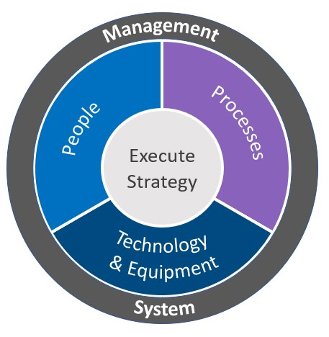

_{6.0}

Management Systems

Amnicon Constructions always seeks excellence in the field of commercial construction, leveraging the prowess of Management Information Systems (MIS) to navigate the complexities of its projects with finesse. Central to this approach is the adept utilization of specialized tools like Microsoft Project, which empowers the company to meticulously plan, schedule, and monitor project milestones. By employing this software, we can meticulously allocate resources, set realistic timelines, and proactively identify potential bottlenecks, thereby ensuring projects stay on track and within budget.  Moreover, the company harnesses the capabilities of database software, which serves as the cornerstone for efficient data management. Through customized databases, Amnicon Constructions systematically catalogues information pertaining to suppliers, subcontractors, projects specifications and regulatory | requirements. This repository of structured data not only expedites the decision-making process but also enhances the accuracy of project estimations, leading to well-informed choices that mitigate risks and optimize resource utilization.  Amnicon Constructions adopts cloud-based systems for enhanced collaboration and data access. Cloud platforms enable real-time information sharing among teams, ensuring stakeholders stay informed about project progress. This digital framework improves communication, facilitates quick adaptation to changes, and fosters a cohesive project environment. Teamed with MIS tools like Microsoft Project and databases, these cloud systems bolster Amnicon's capacity to deliver innovative, efficient, and precise commercial construction projects. Community Centre project.



_{7.0}

Quality, Environmental & Safety Systems

Amnicon Constructions relies on leading processes to support all stakeholders. These processes encompass our internal IMS (Information Management System) and Cloud base implementation throughout our operations. Our solid understanding of HSEQ systems attests to our unwavering dedication to health, safety, quality, and environmental performance. Regular internal and third-party audits across projects and offices underscore our commitment to compliance and understanding.  Amnicon's commitment & well-established policies and procedures reinforce our diligent planning within our integrated management systems. Our project teams prioritize recycling, material reuse, and waste management enhancements. Our goal is to minimize landfill waste, addressing construction's potential pollution through strategic procurement and waste segregation. | Each project employs a tailored management plan to address site-specific concerns accurately. With a reputation for quality, we meticulously plan inspections, hold points, and works. Our tools support and monitor diverse disciplines, ensuring quality assurance compliance and continual best practices across teams and projects. Setting measurable objectives and targets drives continuous improvement and a pursuit of construction excellence.  Amnicon provides staff training to enhance skills, knowledge, and quality awareness. Non-conformance identification, investigation, and reporting drive proactive prevention. Our vision is to foster growth, sustainability, and innovation, nurturing enduring client relationships.



_{8.0}

Workcover Insurance

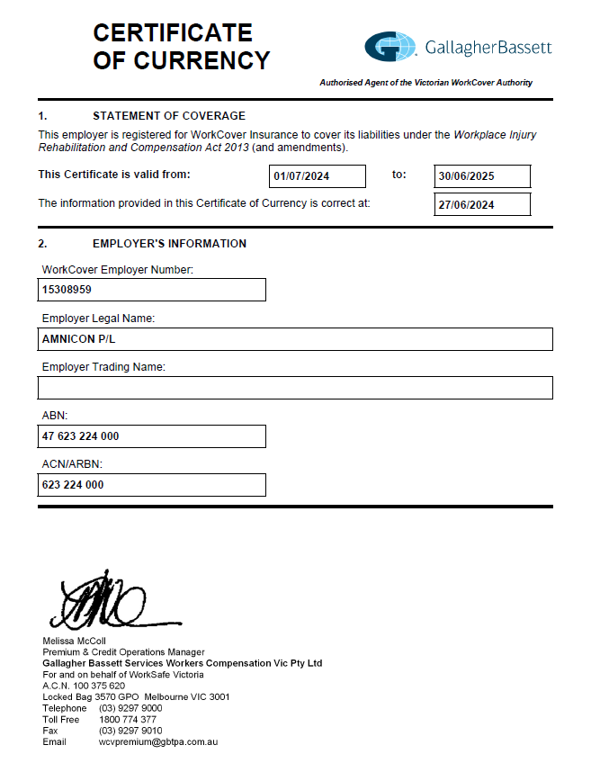

Construction Insurance

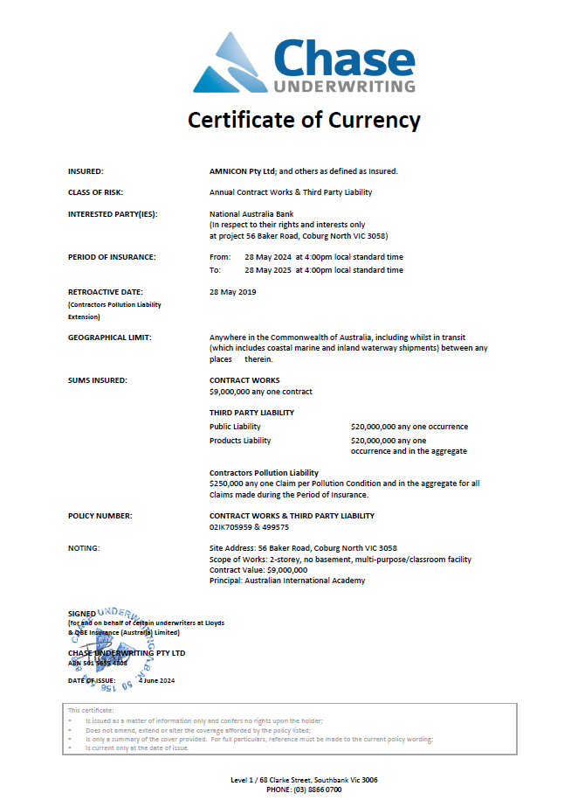



_{9.0}

AmniCon in the Community

_{Scope of Work}  We actively support our communities and staff. Our organisation has been involved in several community groups over the years, many of these clubs and associations are personal passions of our staff and we are  proud to support them with their enthusiasm outside of their professional activities.  We have contributed in areas such as:  - Local Charity Groups (Human Appeal)  - Local Sports Clubs (Newport Storms Soccer Club)  - _{Australian Islamic Centre}  - _{Australian Islamic Mission}  - _{Bendigo Islamic Centre} | _{Scope of Work}  Our commitment to these groups includes both financial support and also time commitments and the use of our expertise to support them in their endeavours. Centre project.



_{10.0}

Company References

_{Scope of Work}  When it comes to forging successful partnerships and embarking on new ventures, Amnicon Constructions stands ready to provide a network of references that speak to our proven track record and expertise. Our esteemed references, comprising satisfied clients and collaborators, are readily available to vouch for or recommend our capabilities and commitment. These references encompass the spectrum of our projects, showcasing our dedication to quality, efficiency, and innovation. | _{Scope of Work}  Upon request, we gladly connect prospective clients with our references, allowing them to gain firsthand insights into our work ethic and results. We believe in transparency and trust in our engagement process, and after references are contacted, we ensure an open dialogue with new clients, discussing their unique project needs, aligning expectations, and formulating a tailored approach that upholds the standards our references attest to. project.

