Explorer Mindset in Action

A GUIDE FOR EDUCATORS & STUDENTS

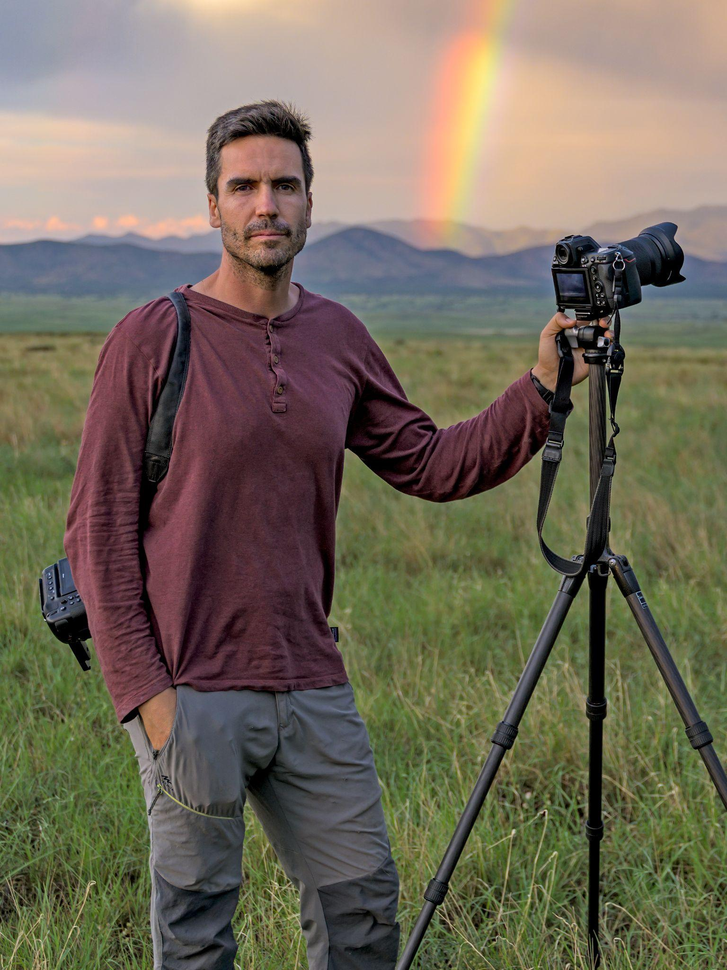
Meet Explorer Jaime Rojo

Jaime Rojo is a photographer and a strong advocate of wilderness conservation and large-landscape connectivity. His goal is to capture images that can ultimately become tools for the creation of new protected areas. He is an International League of Conservation Photographers Senior Fellow, a trustee of the WILD Foundation, and the recipient of honors in competitions such as World Press Photo and Wildlife Photographer of the Year.

Fifty years after the startling discovery that monarch butterflies spend winters in the forests of Mexico, Chasing Monarchs will reveal this winged wonder of the insect world in new ways with never-before-seen visuals. Tag along with conservationists and citizen scientists who are helping this species avoid catastrophic threats, all through Jaime’s beautiful photos and videos.

TOPICS COVERED IN THIS SHOW INCLUDE: Photography, Entomology, Climate Change, Conservation

WHAT IS THE EXPLORER MINDSET?

The Explorer Mindset is a series of attributes, shared values, and commitments that define what it means to be a National Geographic Explorer. We believe that every person has the potential to develop that same Explorer Mindset that drives Explorers to inquire, seek knowledge, and think critically and creatively to solve the world’s most pressing problems. This competency-based framework identifies and codifies the Attitudes, Skills, and Knowledge that are indicators of the Explorer Mindset:
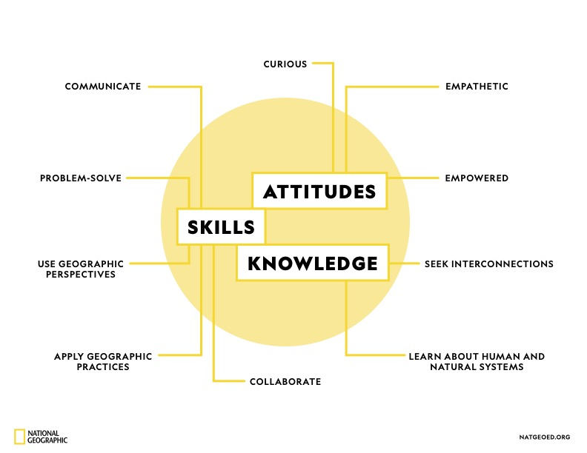

The Explorer Mindset Learning Framework is aligned to and cross-walked against at least 12 global frameworks, including the US Geography, NGSS Science, and C3 Framework for Social Studies Standards, ESRI’s Geographic Approach; OECD, WEF, Asia Society, World Savvy, and The Nature Conservancy’s global competencies; and National Geographic Education’s Globally Inclusive Design Principles.

SIX QUESTIONS: An Interview with Jaime Rojo

What first sparked your interest in your field?
I’ve been fascinated by wildlife and the wonders of migration since an early age. During my childhood in Spain, I watched in awe as cranes and geese arrived in the winters. I had an obsessive interest in nature, and I kept these detailed field journals full of notes and sketches. But the truth is that I wasn’t very good at drawing and it caused me a lot of frustration. Photography came into my life as a way to record and share my nature observations with friends and families.
What’s the scariest experience you ever had in the field?
Only once have I had a scary encounter with wildlife. It was many years ago, while backpacking with my then-girlfriend in Denali National Park, Alaska. We were strolling through beautiful rolling hills of tundra, covered in moss and blueberries, when in the distance I spotted a huge male grizzly. It was our first time in bear country. We continued on our path, keeping an eye on him, but the bear started to follow us. We completely changed direction, and he did the same. There was nowhere to hide and nobody around, so we sped up, but he kept following us, curious, and closer each time. We found a mound with a rocky outcrop and climbed up. Eventually, the grizzly lost interest in us and went away. That night camping in the open tundra wasn’t exactly pleasant.

Who was the best teacher or mentor you ever had?
My first mentor was the most unusual man, a Mexican artist and photographer whom I met through a family connection. He was the classical genius: brilliant in his field but frugal with words, ambiguous with his advice, and without many social skills. His view of nature, photography, and conservation, and particularly his drive forward, were very influential for me. I learned a lot working with him, and I like to believe that he also learned some.
Can you tell us about a memorable mistake you made & how you recovered from it?
Oh boy, the list is long, but there is one that stands out. I knew from an early age that I wanted to become a professional photographer, but I wasn’t brave enough to take the leap of faith, so I delayed the decision too long and lost some valuable momentum. But I recovered from it by working really hard and by approaching the business with a more mature strategy. When I look back, I often wonder how my career would have been if I had followed my instincts in my early twenties and made some reckless decisions! Who knows.
What advice do you have for young explorers?
Follow your dreams, but don’t be a reckless romantic. To make a living as a photographer these days, you have to be as good a businessperson as an artist. And this is a reality that is hard to cope with when all you want is to be out there making pictures.
Do you have any recommended reading for those who want to explore further in your field?
A Wild Life: A Visual Biography of Photographer Michael Nichols, by Melissa Harris. There are not many great biographies about National Geographic photographers and this is one of my favorites.
(See more recommendations from Jaime in “Further Resources” at the end of this guide!)

BEFORE & AT THE SHOW: Learn about the Explorer Mindset and Look for Examples

We recommend providing this list to students in advance or discussing the attributes in class. At the show, remind students to look for examples in the Explorer’s story & work!

ATTITUDES: Explorers Wonder About the World
CURIOUS - Explorers engage with the world around them. Explorers observe, document, and ask questions about where things are and why they are there.
EMPATHETIC - Explorers care about other people, cultural resources, and the environment. They are respectful and committed to making the world a better place. They value and understand their own and others’ points of view, acknowledging differences.
EMPOWERED - Explorers recognize their ability to protect people, cultural resources, and the environment. Explorers are leaders who utilize their knowledge, confidence, means, and ability to take action and make a difference.

SKILLS: Explorers Learn By Doing
USE GEOGRAPHIC PERSPECTIVES - Explorers use perspectives (including geological, ecological, historical, economical, political, cultural and spatial perspectives) at different scales (local, regional, and global) as they observe, analyze, visualize, and model spatial patterns, processes, and change over time of the human and natural systems.

APPLY GEOGRAPHIC PRACTICES - Explorers use practices such as mapping, inquiry, and citizen science to explore geographic questions, investigate, examine, assess problems. Explorers think critically as they create new insights and understanding.
COLLABORATE - Explorers engage with the communities in which they work, including a wide variety of partners and stakeholders on their team.
PROBLEM SOLVE - Explorers seek solutions to problems to protect and sustain the wonder of our world. Explorers are capable decision-makers, able to identify alternatives and weigh trade-offs to make well-reasoned decisions based on factual knowledge. Explorers pursue bold ideas and persist in the face of challenges.
​​COMMUNICATE - Explorers are storytellers who communicate about their work through a variety of methods (scientific, academic, and narrative) and media. Explorers communicate to inspire others to protect and sustain the wonder of our world.

KNOWLEDGE: Explorers Build Geographic Knowledge
LEARN ABOUT HUMAN AND NATURAL SYSTEMS - Explorers become informed as they study the physical properties of the planet, the human and natural systems spread across it, and the diverse creatures we share our world with.

SEEK INTERCONNECTIONS - Explorers strive to recognize and understand the intricate and interconnected systems of the changing planet we live on. They examine how humans coexist and interact with the environment and the ways places and people impact each other.

AFTER THE SHOW: Questions to Guide Discussion About the Explorer Mindset in Action

CURIOSITY -
How does this curiosity show up in this Explorer’s journey?
What are you curious about & how might this spark your own journey of exploration?
EMPATHY -
Can you identify examples of empathy in this Explorer’s work?
Why do you think empathy is important to exploration and discovery?
EMPOWERMENT -
How has this Explorer taken action to make the world a better place?
What steps could you take to make a difference?
USE OF GEOGRAPHIC PERSPECTIVES -
Can you identify the various perspectives and scales that this Explorer uses in their work?
How might exploring something at the local scale differ from exploring it on a global scale?
How might an historical perspective change provide different insights from an economic perspective?

APPLICATION OF GEOGRAPHIC PRACTICES -
Where has this Explorer applied geographic practices in their work?
How might you employ geographic practices like map making or critical thinking to explore and investigate?
COLLABORATION -
How does collaboration help to make this Explorer’s work successful?
If you could put together your own ‘dream team’ of collaborators, who would be on it?
PROBLEM SOLVING -
Describe a moment when this Explorer faced a problem. How did they tackle it?
Describe a time when you have faced a tough challenge. What did you do? What decisions did you make?
How does facing problems help us to develop persistence? Why might persistence help an Explorer?
​​COMMUNICATION -
What methods of storytelling were used in the show that you saw?
Did you have a favorite moment in the show? What made it stand out?
If you told a story about your own discovery, what methods might you use to capture your audience’s imagination?

LEARNING ABOUT HUMAN AND NATURAL SYSTEMS -

What human and/or natural systems were explored in the show that you saw?

How did this Explorer map, record, or analyze these systems as part of their work?

What human or natural systems can you identify that are part of your own environment?

SEEKING INTERCONNECTIONS -

What interconnections can you describe in this Explorer’s area of study?

How do those interconnections impact their work?

What interconnected systems impact your everyday life and environment?

ACTIVITY SHEET (pages 10 - 15 below)

Teachers may want to either print the following activity sheet or use it to guide discussion.

Each section is meant to lead students through an understanding of how a National Geographic Explorer works. In section 2, learners will have an opportunity to follow the Geo-Inquiry Process, which consists of five phases: ASK, COLLECT, VISUALIZE, CREATE, and ACT.

For more about how to use the Geo-Inquiry Process with your learners, visit: https://education.nationalgeographic.org/resource/geo-inquiry-resources/

1. Explorers Learn About the World
What is your Explorer’s name and where is he/she from? | Provide a brief (1-2 sentences) description of your Explorer’s work.
Name:  Birthplace or Place of Residence: | What:  How:  Where:

2. Explorers Are Curious
Mark what interests you most about the Explorer’s work.
ASKING QUESTIONS  I am curious about:  ▢ The Explorer’s work location and why it’s important.  ▢ The Explorer’s question(s) and problem(s).  ▢ How the human and natural worlds are affected by the problem. | COLLECTING INFORMATION  I am curious about:  ▢ The data gathered and method of collecting it.  ▢ The Explorer’s involvement in communities.  ▢ Other team members that work with the Explorer. | VISUALIZING INFORMATION  I am curious about:  ▢ How the Explorer organizes collected data.  ▢ How the Explorer makes sense of collected data.  ▢ How the Explorer uses maps and graphs. | CREATING STORIES TO INSPIRE CHANGE  I am curious about:  ▢ How the Explorer creates stories to share their work.  ▢ How the Explorer shares their stories.  ▢ How the Explorer’s stories inspire others to act. | ACT  I am curious about:  ▢ How the Explorer will solve their question(s) and problem(s).  ▢ How the Explorer works with others to solve their question(s) and problem(s).  ▢ What motivates the Explorer to take action.
In the space below, share WHICH area initially sparked the most curiosity and WHY.

3. Explorers Seek Understanding
Complete the following statements based on what you saw in your Explorer’s show:
I’m fascinated by ….

For me, the most important aspect of my Explorer’s work is …

I now understand why my Explorer …

I think my Explorer’s work is impactful because …

I was inspired by …

If I was an Explorer, I think I would …

4: Explorers Stop and Think
Reflect on your Explorer’s presentation and share one area of his/her work towards which you feel most connected. Draw a picture or symbol or write a word or phrase that best represents this area of work and be prepared to circle up and share your WHY with your classmates.
National Geographic Explorers work with communities and invite others to join their cause. How could you become involved in your Explorer’s work?

5: Explorers Impact Others

PART 1: Complete each statement below by marking the box that best represents the impact of your Explorer’s work at the local, regional, and global level(s).

My Explorer impacts the local community…
▢ a little. ▢ somewhat. ▢ a lot.
My Explorer impacts surrounding regions…
▢ a little. ▢ somewhat. ▢ a lot.
My Explorer impacts other countries or global areas…
▢ a little. ▢ somewhat. ▢ a lot.
What area (local, regional, global) does your Explorer impact the most and WHY?

PART 2: Think about what you heard during the show. Now, read each “I CAN” statement below and write “yes” or “no” and provide an example that shows your understanding of the statement.

“I Can” Statements | Yes or No | Example
I can identify where my Explorer works.
I can explain how my Explorer’s work is connected to an issue in my community, regionally or globally.
I can summarize the factors that control and affect my Explorer’s work.
I can perceive the financial impact of the problem that my Explorer is researching.
I can explain past events that have affected my Explorer’s work.
I can understand the impact that humans have on my Explorer’s area of focus.
I can explain how landscape has an effect on my Explorer’s work and/or the problem they’re trying to solve.

For more information on this Explorer’s field and related areas of study, visit these recommended resources:

Jaime Recommends:

- My friend British photographer Matthew Maran has a great podcast, The Matthew Maran Podcast, in which he interviews many of the best photographers of our generation.
- Films – Incredible Animal Journeys, from National Geographic
- Websites
    - The Photo Society
    - International League of Conservation Photographers

Additional Resources:
- VIDEO - Forest of The Monarchs (4:30 mins)
- "Every Tree Used to be Blanketed by Them" (an article from The Guardian)

CREATIVE COMMONS LICENSE

