Explorer Mindset in Action

A GUIDE FOR EDUCATORS & STUDENTS
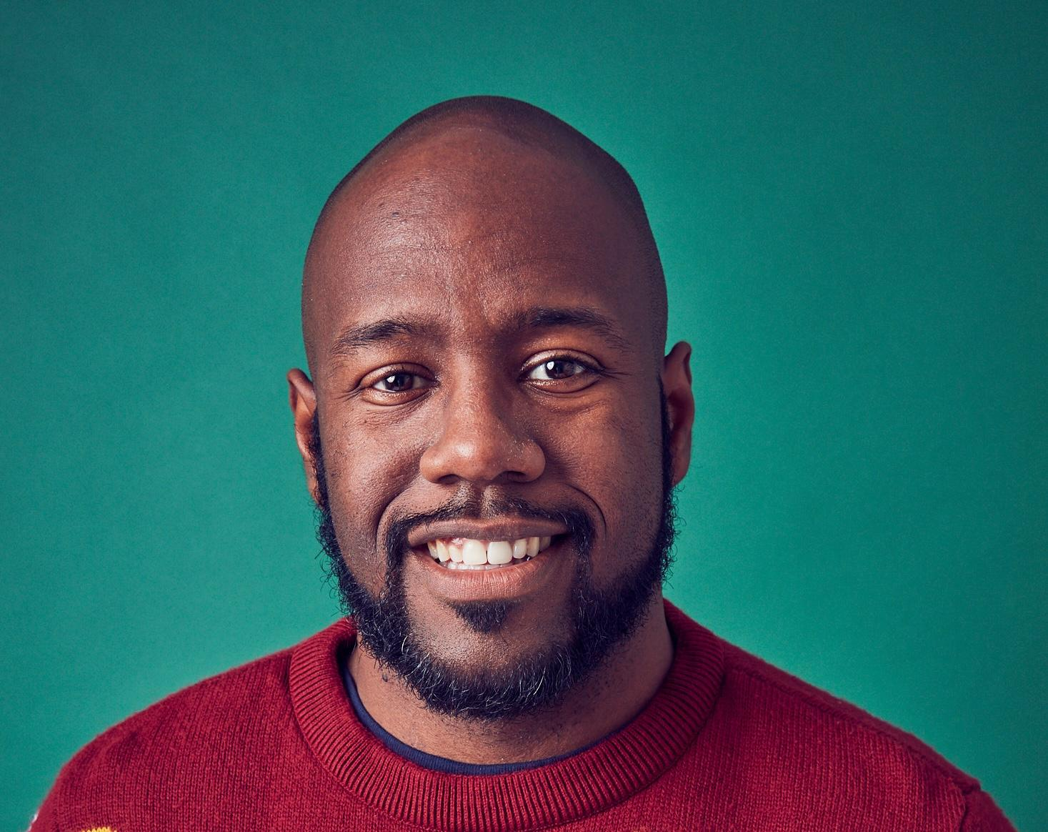
Meet Explorer Chris Schell

Chris Schell is an urban ecologist, professor, Afrofuturist, father, and published author. His research at the University of California, Berkeley, investigates how carnivores—coyotes, foxes, and raccoons—adapt to life in cities. This transdisciplinary work aims to disentangle how environmental injustices have structured our urban ecosystems and how we can harness those lessons to build more just, biodiverse, and resilient cities. He is a Cal Academy Fellow and board member and was a member of the 2021 Grist 50.

In his National Geographic Live show, Uncovering Our Concrete Jungle, we’ll join Chris on assignment to discover the unexpected story of how American history has shaped urban wildlife.

TOPICS COVERED IN THIS SHOW INCLUDE: Urban Ecology, Conservation, Environmental Justice

WHAT IS THE EXPLORER MINDSET?

The Explorer Mindset is a series of attributes, shared values, and commitments that define what it means to be a National Geographic Explorer. We believe that every person has the potential to develop that same Explorer Mindset that drives Explorers to inquire, seek knowledge, and think critically and creatively to solve the world’s most pressing problems. This competency-based framework identifies and codifies the Attitudes, Skills, and Knowledge that are indicators of the Explorer Mindset:
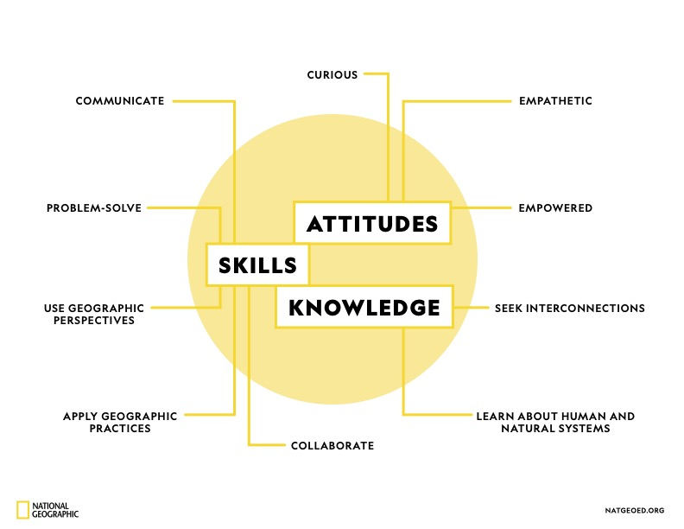
The Explorer Mindset Learning Framework is aligned to and cross-walked against at least 12 global frameworks, including the US Geography, NGSS Science, and C3 Framework for Social Studies Standards, ESRI’s Geographic Approach; OECD, WEF, Asia Society, World Savvy, and The Nature Conservancy’s global competencies; and National Geographic Education’s Globally Inclusive Design Principles.

FIVE QUESTIONS: An Interview with Chris Schell
What first sparked your interest in your field?
Coyotes have a knack for getting into unexpected places. The flashpoint that sparked my interest in urban ecology was one of those stories – in April 2007, a coyote sauntered into a Quiznos in downtown Chicago, right on East Adams Street in the loop. People eating and making sandwiches all stopped, and slowly walked out of the restaurant, while the coyote hopped into the drink cooler and fell asleep – for almost an hour! I instantly became obsessed with WHY that individual decided to enter a busy restaurant, where an entire population of others chose to stay away. Why do some animals decide to take on risks when others avoid them? As fate would have it, two years later I would start my PhD at the University of Chicago – a few miles away from the Quiznos coyote – to investigate how human disturbance shapes coyote parents, their offspring, and their willingness to take risks.
Who’s the best teacher or mentor you ever had?
Dr. Julie Young – one of most accomplished, brilliant carnivore ecologists I have ever had the pleasure of knowing – was influential in my growth as a scientist. Despite the countless demands on Dr. Young’s time, she always invested time in my growth. She helped build my confidence when I was uncertain, was beyond patient but insistent in cultivating greatness, and steadfast in her belief in me. Her work and care ethics were foundational to who I am as a scientist, and her deep knowledge of coyotes and other carnivores helped me to succeed in this field. Without question, I am a better scientist because of her guidance. Real talk: she continues to guide me, even today as a faculty member.
What’s the strangest/scariest/most exciting experience you ever had in the field?
Wildlife collaring – whether you’re a rookie or a veteran – frequently evokes feelings of wonder and awe. Sort of like the inspiring scenes of Laura Dern and Julianne Moore treating a Triceratops or T-rex infant in the Jurassic Park films. Random or unexpected events can quickly transform those feelings to angst. On a routine capture night at 2am in a Denver green space, my postdoc mentor (Dr. Stewart Breck) and I were conducting health checks on a captured coyote in 2017, when headlights in the distance flashed on and slowly moved toward us. A nearby police vehicle was moving toward us.
My heart raced: despite jumping through all the regulatory hoops to gain permits and approvals, it didn’t abate my concerns. Would the bright lights suddenly wake the sedated animal, jeopardizing the animal’s (and our) safety? Would the officer be skeptical of what we were doing, and shut it down mid-processing? As a Black man and young father, intrusive thoughts of Trayvon Martin and Michael Brown were just underneath the surface. I firmly placed my hands on the coyote, using his heartbeat to help calm mine. Angst quickly turned to joy when the officer exited his car to ask how he could help, ensuring that other officers blocked off passage for us to complete our work. The experience affirmed my belief that local peoples on the ground are eager to work together to build a better future.
What is the weirdest/most helpful thing you’ve packed for an expedition?
Garden supplies, hands down, have been the most helpful things I’ve packed for fieldwork. Yes, I work in cities, so it’s not completely intuitive why I would need them. But the green habitat fragments we work in constantly go through cycles of growth, and grass or vegetation waving in the breeze is the Kryptonite of wildlife camera trapping. Tall grasses and overgrowth lead to literally thousands of “false positive” images – photos taken of nothing, because the motion sensors were triggered by blowing grass. Sheers, weedwhackers, and garden shovels help us to lightly cultivate the landscape for the perfect shot – without the legion of grass-blowing images. These tools are the ultimate time-savers: less false positives mean we have more memory on our SD cards for wildlife, less time spent tagging empty photos, and more happiness to spread all around.
What advice do you have for young explorers?
The observations you make of the world around you are profound – and extremely valuable. Do not discount what you see and what you can do, no matter how simple or plain it may seem. Some of the most ground-breaking discoveries in science are the most basic – and those observations have the power to change both your external and internal world. Cherish your time in nature and it will lead you to community and connection greater than you can ever imagine.
BEFORE & AT THE SHOW: Learn about the Explorer Mindset and Look for Examples
We recommend providing this list to students in advance or discussing the attributes in class. At the show, remind students to look for examples in the Explorer’s story & work!

ATTITUDES: Explorers Wonder About the World
CURIOUS - Explorers engage with the world around them. Explorers observe, document, and ask questions about where things are and why they are there.
EMPATHETIC - Explorers care about other people, cultural resources, and the environment. They are respectful and committed to making the world a better place. They value and understand their own and others’ points of view, acknowledging differences.
EMPOWERED - Explorers recognize their ability to protect people, cultural resources, and the environment. Explorers are leaders who utilize their knowledge, confidence, means, and ability to take action and make a difference.
SKILLS: Explorers Learn By Doing
USE GEOGRAPHIC PERSPECTIVES - Explorers use perspectives (including geological, ecological, historical, economical, political, cultural and spatial perspectives) at different scales (local, regional, and global) as they observe, analyze, visualize, and model spatial patterns, processes, and change over time of the human and natural systems.
APPLY GEOGRAPHIC PRACTICES - Explorers use practices such as mapping, inquiry, and citizen science to explore geographic questions, investigate, examine, assess problems. Explorers think critically as they create new insights and understanding.
COLLABORATE - Explorers engage with the communities in which they work, including a wide variety of partners and stakeholders on their team.
PROBLEM SOLVE - Explorers seek solutions to problems to protect and sustain the wonder of our world. Explorers are capable decision-makers, able to identify alternatives and weigh trade-offs to make well-reasoned decisions based on factual knowledge. Explorers pursue bold ideas and persist in the face of challenges.
​​COMMUNICATE - Explorers are storytellers who communicate about their work through a variety of methods (scientific, academic, and narrative) and media. Explorers communicate to inspire others to protect and sustain the wonder of our world.
KNOWLEDGE: Explorers Build Geographic Knowledge
LEARN ABOUT HUMAN AND NATURAL SYSTEMS - Explorers become informed as they study the physical properties of the planet, the human and natural systems spread across it, and the diverse creatures we share our world with.
SEEK INTERCONNECTIONS - Explorers strive to recognize and understand the intricate and interconnected systems of the changing planet we live on. They examine how humans coexist and interact with the environment and the ways places and people impact each other.
AFTER THE SHOW: Questions to Guide Discussion About the Explorer Mindset in Action
CURIOSITY -
How does this curiosity show up in this Explorer’s journey?
What are you curious about & how might this spark your own journey of exploration?
EMPATHY -
Can you identify examples of empathy in this Explorer’s work?
Why do you think empathy is important to exploration and discovery?
EMPOWERMENT -
How has this Explorer taken action to make the world a better place?
What steps could you take to make a difference?
USE OF GEOGRAPHIC PERSPECTIVES -
Can you identify the various perspectives and scales that this Explorer uses in their work?
How might exploring something at the local scale differ from exploring it on a global scale?
How might an historical perspective change provide different insights from an economic perspective?
APPLICATION OF GEOGRAPHIC PRACTICES -
Where has this Explorer applied geographic practices in their work?
How might you employ geographic practices like map making or critical thinking to explore and investigate?
COLLABORATION -
How does collaboration help to make this Explorer’s work successful?
If you could put together your own ‘dream team’ of collaborators, who would be on it?
PROBLEM SOLVING -
Describe a moment when this Explorer faced a problem. How did they tackle it?
Describe a time when you have faced a tough challenge. What did you do? What decisions did you make?
How does facing problems help us to develop persistence? Why might persistence help an Explorer?
​​COMMUNICATION -
What methods of storytelling were used in the show that you saw?
Did you have a favorite moment in the show? What made it stand out?
If you told a story about your own discovery, what methods might you use to capture your audience’s imagination?
LEARNING ABOUT HUMAN AND NATURAL SYSTEMS -
What human and/or natural systems were explored in the show that you saw?
How did this Explorer map, record, or analyze these systems as part of their work?
What human or natural systems can you identify that are part of your own environment?
SEEKING INTERCONNECTIONS -
What interconnections can you describe in this Explorer’s area of study?
How do those interconnections impact their work?
What interconnected systems impact your everyday life and environment?
ACTIVITY SHEET (pages 9 - 14 below)
Teachers may want to either print the following activity sheet or use it to guide discussion.
Each section is meant to lead students through an understanding of how a National Geographic Explorer works. In section 2, learners will have an opportunity to follow the Geo-Inquiry Process, which consists of five phases: ASK, COLLECT, VISUALIZE, CREATE, and ACT.
For more about how to use the Geo-Inquiry Process with your learners, visit: https://education.nationalgeographic.org/resource/geo-inquiry-resources/

1. Explorers Learn About the World
What is your Explorer’s name and where is he/she from? | Provide a brief (1-2 sentences) description of your Explorer’s work.
Name:  Birthplace or Place of Residence: | What:  How:  Where:

2. Explorers Are Curious
Mark what interests you most about the Explorer’s work.
ASKING QUESTIONS  I am curious about:  ▢ The Explorer’s work location and why it’s important.  ▢ The Explorer’s question(s) and problem(s).  ▢ How the human and natural worlds are affected by the problem. | COLLECTING INFORMATION  I am curious about:  ▢ The data gathered and method of collecting it.  ▢ The Explorer’s involvement in communities.  ▢ Other team members that work with the Explorer. | VISUALIZING INFORMATION  I am curious about:  ▢ How the Explorer organizes collected data.  ▢ How the Explorer makes sense of collected data.  ▢ How the Explorer uses maps and graphs. | CREATING STORIES TO INSPIRE CHANGE  I am curious about:  ▢ How the Explorer creates stories to share their work.  ▢ How the Explorer shares their stories.  ▢ How the Explorer’s stories inspire others to act. | ACT  I am curious about:  ▢ How the Explorer will solve their question(s) and problem(s).  ▢ How the Explorer works with others to solve their question(s) and problem(s).  ▢ What motivates the Explorer to take action.
In the space below, share WHICH area initially sparked the most curiosity and WHY.

3. Explorers Seek Understanding
Complete the following statements based on what you saw in your Explorer’s show:
I’m fascinated by ….

For me, the most important aspect of my Explorer’s work is …

I now understand why my Explorer …

I think my Explorer’s work is impactful because …

I was inspired by …

If I was an Explorer, I think I would …

4: Explorers Stop and Think
Reflect on your Explorer’s presentation and share one area of his/her work towards which you feel most connected. Draw a picture or symbol or write a word or phrase that best represents this area of work and be prepared to circle up and share your WHY with your classmates.
National Geographic Explorers work with communities and invite others to join their cause. How could you become involved in your Explorer’s work?

5: Explorers Impact Others

PART 1: Complete each statement below by marking the box that best represents the impact of your Explorer’s work at the local, regional, and global level(s).

My Explorer impacts the local community…
▢ a little. ▢ somewhat. ▢ a lot.
My Explorer impacts surrounding regions…
▢ a little. ▢ somewhat. ▢ a lot.
My Explorer impacts other countries or global areas…
▢ a little. ▢ somewhat. ▢ a lot.
What area (local, regional, global) does your Explorer impact the most and WHY?

PART 2: Think about what you heard during the show. Now, read each “I CAN” statement below and write “yes” or “no” and provide an example that shows your understanding of the statement.

“I Can” Statements | Yes or No | Example
I can identify where my Explorer works.
I can explain how my Explorer’s work is connected to an issue in my community, regionally or globally.
I can summarize the factors that control and affect my Explorer’s work.
I can perceive the financial impact of the problem that my Explorer is researching.
I can explain past events that have affected my Explorer’s work.
I can understand the impact that humans have on my Explorer’s area of focus.
I can explain how landscape has an effect on my Explorer’s work and/or the problem they’re trying to solve.

For more information on this Explorer’s field & related areas of study, visit these resources:
Read:
- Braiding Sweetgrass by Dr. Robin Wall Kimmerer
- Wild Life by Dr. Rae Wynn-Grant
- The Home Place by Dr. J. Drew Lanham
- An Immense World by Ed Yong

Visit these websites:
- The Schell Lab
- National Park Service – Urban Ecology Research Learning Alliance (UERLA)
Check out these videos, films, and podcasts:
- The 4 C’s of Urban Ecology
- Human Footprint – “The Urban Jungle” (S1 Ep5)
- Science Forward – Urban Ecology
- RadioLab Podcast
- Hoppers (Disney - 2026)
- Jurassic Park Series
- All That Breathes (2022)
- Wild London (2026)
- Science Friday (NPR)
- The Wild Podcast
- Going Wild Podcast

General Resources for Educators, from National Geographic Education:
- Explorer Mindset in Action Guide
- Conducting Powerful Conversations
- Exploring Multiple Perspectives
CREATIVE COMMONS LICENSE

