**Finding IP Address for JTD-793v2 using USB-to-Serial-Serial-to-RJ45 with PuTTY**

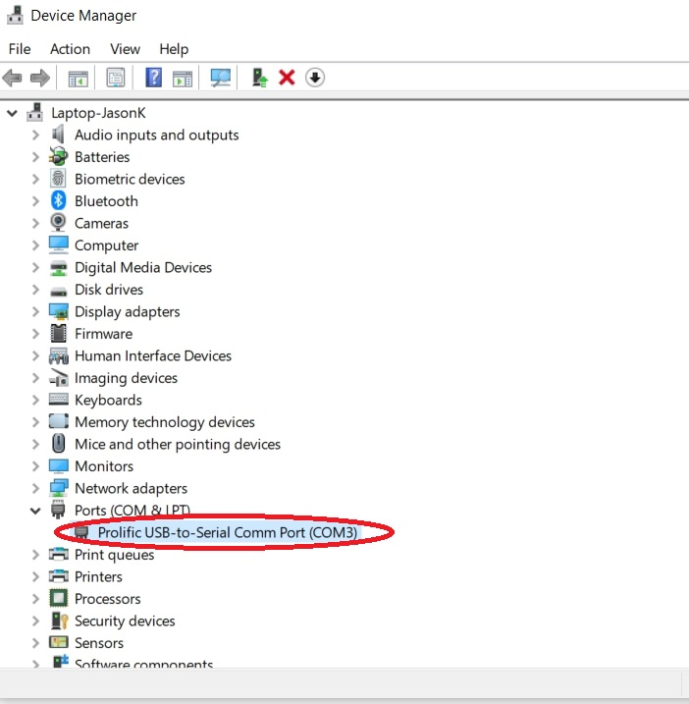

**When plugging in USB-to-Serial-Serial-to-RJ45, make sure that your computer reads the port in the Device Manager**

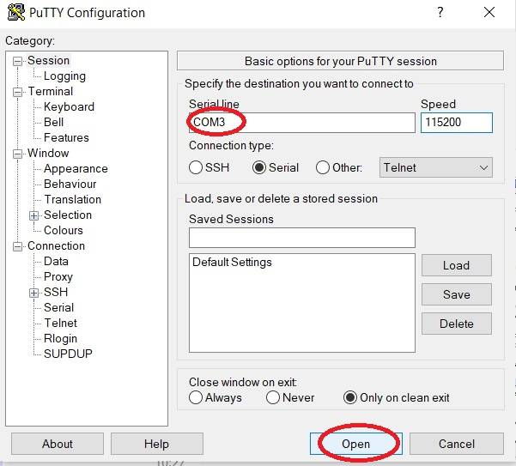

Open up **PuTTY** > Make sure the serial line is the same as the port listed on the device manager > hit **Open**



PuTTY command prompt will open up and ask for a **Username** and **Password**.

**Username**: Jtechdigitalconsole

**Password**: JTD@793v2

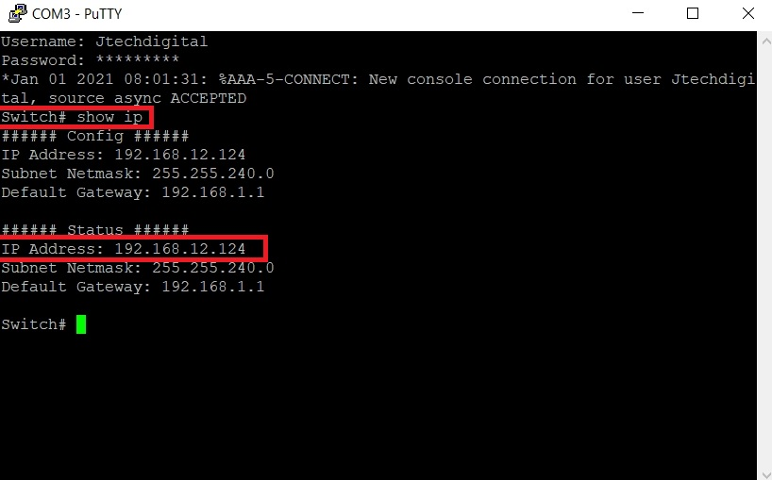

Type "**Show IP**" to find the IP address of the network switch. Close PuTTY