Dick White Academy (DWA) Safeguarding Policy

Dick White Academy (DWA) Safeguarding Policy

Safeguarding Policy

Introduction

DWA is committed to safeguarding and promoting the welfare of learners and expects all staff and learners to share this commitment. We aim to create a vigilant culture and promote the welfare of children and vulnerable adults as defined in the Children’s Act 1989 and the Protection of Vulnerable Adults Scheme 2004. It is the duty of DWA staff to play an active role in this. DWA is committed to provide a secure environment for learners, where learners feel and are kept safe. Wherever possible, we teach learners how to recognise when they are at risk, and exactly how to get help when they need it.

Safeguarding

What is Safeguarding?
For the purpose of this policy, safeguarding is:
- The protection of children and adults with additional needs from maltreatment
- Preventing impairment of health and development, ensuring circumstances consistent with the provision of safe and effective care to ensure best possible life chances
- Taking action to enable children and adults with additional needs to have the best outcomes
- Additionally, DWA recognises its duty in a wider context to safeguard all learners
Child Protection Child protection refers to the processes undertaken to protect children identified as suffering or being at risk of suffering significant harm.
The term ‘Child’ includes everyone under the age of 18. It should be noted that this policy also includes all adults who could be defined as ‘vulnerable’
Safeguarding is everyone’s responsibility. DWA’s Learner Safeguarding and Child Protection Policy applies to all of our learners, in particular learners who are children and adults with additional needs. This policy considers contextual safeguarding by taking into account environmental factors in a learner’s life, that might be a threat to their safety and or welfare (Working Together to Safeguard Children (2023) and in Keeping Children Safe in Education 2024 key objectives of the policy are to:
- Promote a safe environment for all of our learners to learn and achieve
- Actively promote the welfare of learners
- Identify any learners who may be experiencing abuse or harm in the workplace, at home, or in relationships
- Take appropriate action to ensure learners safety (Child and Adult Protection)
DWA is committed to ensure that every learner has the right to learn, free from fear and safe from abuse. This policy has been developed in accordance with the principles established by the Children Act 1989 and 2004 and related guidance.

Policy statement

All staff at DWA have a duty to identify any learners who may be experiencing abuse or harm in the workplace, at home, through on-line computer networks or in relationships, and take appropriate action in accordance with this guidance. DWA includes in these procedures, reporting and dealing with allegations of abuse against members of staff
- DWA acknowledges that education staff have a crucial role to play in helping identify welfare concerns and indicators of possible abuse or neglect at an early stage
- It is not the responsibility of any member of staff at DWA to investigate suspected cases of abuse. Instead, all cases should be referred to the DWA Designated Safeguarding Lead (DSL) or the DWA Designated Safeguarding Officer (DSO) in her absence, who will decide on the appropriateness of making a referral to outside agencies (Children’s Services, Police, Adult Services). Where appropriate, the DSL will make relevant inquiries within DWA
- DWA wants all learners to feel confident that their concerns will be taken seriously and that disclosure to any member of staff will be treated in a sensitive manner
- All children regardless of age, gender, ability, culture, race, language, religion, or sexual identity, have equal rights of protection
Those at Risk

Children and adults can experience abuse in a variety of settings, including in the workplace, within the family home, within a personal relationship, in the community, and while using online computer networks and phones.
Children’s legislation and adult guidance outline the following categories of abuse:
- Physical abuse may involve hitting, shaking, throwing, poisoning, burning or scalding, drowning, suffocating, or otherwise causing physical harm. Physical harm may also be caused when a parent or carer fabricates the symptoms of, or deliberately induces, illness in a child
- Emotional abuse may involve conveying to someone that they are worthless, unloved, or inadequate. It may involve serious bullying (including cyberbullying), causing people to frequently feel frightened in danger, or the exploitation or corruption of children or adults with additional needs. Some level of emotional abuse is involved in all types of abuse though it may occur in isolation
- Sexual abuse involves forcing or enticing a child or vulnerable adult to take part in sexual activities. These activities may involve physical contact, including assault by penetration (for example, rape or oral sex) or non-penetrative acts such as masturbation, kissing, rubbing and touching outside of clothing. They may also include non-contact activities, such as viewing, or the production of, sexual images, or grooming a child or vulnerable person in preparation for abuse (including via the internet). Adult males do not solely perpetrate sexual abuse, women can also commit acts of sexual abuse, as can other children and young people
- Neglect is the persistent failure to meet an individual’s basic physical and/or psychological needs, likely to result in the serious impairment of their health or development. Neglect may occur during pregnancy as a result of maternal substance abuse, or may involve a parent or carer failing to provide adequate food, clothing or shelter
- Discriminatory abuse includes behaviour towards another person that is racist, sexist, based on a person’s disability and other forms of harassment
- Financial or material abuse is stealing possessions or money from a child or vulnerable adult and bullying to force them to hand over their own money and/or possessions
- Institutional abuse/poor practice is inappropriate, disrespectful, or insufficient care

Staff responsibilities

The Board of DWA is committed to ensuring that DWA fulfils its duties in relation to safeguarding and protecting children, and adults with additional needs. All safeguarding policies will be reviewed on an annual (minimum) basis by the Board, which has responsibility for the oversight of DWA safeguarding and child protection systems. The Board will receive monthly reports on safeguarding activities and systems.

Board Member with overall responsibility for Safeguarding: Prof. Dick White- Director- DWR Ltd
DSL: Ali Heywood- DWA Principal
DSO: Kriss Graham- DWA Administrator, Kelly Winstanley- Head of Teaching & Assessment, Sally Petts- Head of Compliance, Lauren Lawton- Head of Operations

The Principal shall be the Designated Safeguarding Lead (DSL), with special responsibility for safeguarding and child protection systems, paying special attention to children and adults with additional needs. To carry out this role effectively, the DSL will undertake appropriate and specific training to provide them with the knowledge and skills required to carry out this role. The DSL’s training will be updated formally every two years, but their knowledge and skills will be updated through a variety of methods, e.g. bulletins, conferences, local meetings and other training at regular intervals, at least annually, to keep up with any developments relevant to their role.
The DSOs will deputise in the absence of the DSL. The DSOs will also be available to liaise with and make referral decisions alongside the DSL.
The Designated Safeguarding Lead is responsible for:
- Liaising with the Board over matters relating to Safeguarding and Protecting Children and Adults with Additional Needs
- Maintaining a confidential recording system for safeguarding and child protection concerns
- Ensuring the Board considers the DWA Learner Safeguarding and Child Protection Policy annually
- Lead responsibility for ensuring that DWA carries out its duties in relation to safeguarding all learners
- Informing the Board of how DWA and its staff have complied with the policy. A quarterly report of how duties have been discharged, including (but not limited to) the training that staff have undertaken.
- Overseeing the liaison between agencies, such as the police/children’s services in connection with any allegations against staff. This will not involve undertaking any form of investigation, but will ensure good communication between the parties and provide information to assist enquiries
- Undertaking ongoing training in relation to safeguarding
- Ensuring that parents and or carers of learners under the age of 18 are aware of DWA Learner Safeguarding and Child Protection Policy
- To ensure that all staff receive awareness training in safeguarding and protecting children and adults with additional needs, and are aware of DWA procedures and policies in relation to this
- Ensuring that DWA deals with allegations in accordance with these procedures
- To resolve any inter-agency issues
- To ensure that DWA liaises with workplace employers and relevant external agencies, so that appropriate safeguarding procedures are in place
All members of staff have a responsibility to:
- Identify and recognise children and adults with additional needs, who may be in need of extra help who are suffering, or are likely to suffer significant harm
- Provide help for children and adults with additional needs where appropriate
- Be aware of and take appropriate action to raise concerns regarding poor or unsafe practice or potential failures in the DWA safeguarding arrangements
- Where appropriate, contribute towards, read and adhere to DWA’s policies
- Respond and refer any concerns about children and/or adults in accordance with this policy
- Maintain an attitude of ‘it could happen here’ where safeguarding is concerned and to always act in the best interests of the learner

Monitoring IT usage

All IT usage on DWA servers is monitored on an ongoing basis. We regard the following activities to be inappropriate and disciplinary action may be taken as detailed below:
- Engaging in cyberbullying in any of its forms.
- Using, transmitting, receiving or seeking inappropriate offensive, vulgar, suggestive, obscene, abusive, harassing, threatening, defamatory (harming another person’s reputation by lies), disparaging or misleading language or materials.
- Sending, receiving, soliciting, printing, copying or replying to text or images or messages that disparage others based on their age, disability, gender reassignment, marriage and civil partnership, pregnancy and maternity, race religion and belief, sex, sexual orientation.
- The promotion of hate or views that are in opposition to the fundamental British values of democracy, the rule of law, individual liberty, mutual respect for those with different faiths and beliefs including calls for the death of members of the armed forces.
- Revealing personal information, such as the home address, telephone number or financial data of another person, or yourself.
- Engaging in illegal activities, or encouraging others to do so, including breaching copyright law.
- Engaging in private commercial activity.
- Any activity which may damage the organisation’s or others’ personal property.
This list is neither comprehensive nor exhaustive. Each student is expected to adhere to the Learner Code of Conduct, which may prohibit the use of certain communication technology in the classroom/workshop e.g. mobile phones. Learners may be requested to switch off their devices and place them in a visible location. Any behaviour deemed inappropriate will be dealt with in accordance with the Organisation’s Disciplinary Policy.

Safeguarding and Confidentiality

- Passwords should not be shared with other learners.
- Learners should refrain from uploading data which may contain a virus or is corrupted.
- Learners should report any misuse to their Course Director or a member of the Support Team.
- Unless authorised to do so, learners are prohibited from using email to transmit confidential information to outside parties.
- Learners may not access, send, receive, solicit, print, copy or reply to confidential or proprietary information about DWA, its Learners, its employees or other business associates.
- Learners who are concerned about online safety, including grooming and radicalisation, should speak to a member of staff, who in turn will contact the Designated Safeguarding Lead.

Breaching these Guidelines may result in access to the network being denied or withdrawn. In addition, it may lead to disciplinary action, which may result in exclusion from the programme. All Learners are reminded that it is an offence to alter, delete, damage or intentionally disrupt any computer system with malicious intent. Should it be found that illegal use is being made of the organisation’s computers then it also reserves the right to inform other authorities such as the police.

Actions

What to do if you are concerned that a learner is being abused or harmed:
- All staff at DWA are expected to take seriously the duty to be aware of, and respond to, concerns regarding learners who are, or may be, experiencing abuse and harm in any part of their lives. These concerns are to be passed on to the Designated Safeguarding Lead
- Where the learner is not a child or adult with additional needs, the learner will need to agree to the passing on of this information. The only exception to this is if the concerned member of staff considers the learner to be at risk of serious harm or danger

If a learner informs you that they are experiencing abuse:
- Respond calmly and listen carefully to what the learner is telling you.
- Explain as early as possible that you cannot keep total confidentiality on such matters, and that you may need to speak to the Designated Safeguarding Lead and/or Officer
- If the learner then decides not to continue talking to you, offer them advice about confidential helplines
- Advise the learner to find a quiet area to speak where they can avoid interruption. Do not deter the learner by asking them to call back later
- Encourage the learner to Tell, Explain or Describe (TED) as clearly as possible, but do not ask leading questions
- Record what the learner has told you or ask them to write it down themselves (if you think this is appropriate under the circumstances). This is because they may not want to tell anyone again what they have shared with you. Record times, locations and any other relevant facts. Do not include your own opinions or views about the disclosure, although you can describe the manner or state of the learner when they present themselves to you.
- Ensure the learner is safe at work. Try to ascertain how safe they will be if they leave the workplace or return home
- Respect confidentiality and do not discuss the disclosure with anyone other than the Designated Safeguarding Lead / Officer. It may be appropriate to talk to your line manager in some circumstances, but you do not automatically need to do so. Be clear with the learner about who you are speaking to and when. Keep the learner informed of what is happening as a result of their disclosure and ascertain their wishes and feelings where possible
- Where a learner has made a disclosure of abuse, or a staff member has concerns about abuse, no contact should be made with the learner’s parents or carers without consultation with the Designated Safeguarding Lead
- You may have concerns that a learner is experiencing abuse because of their behaviour, changes in their presentation, or that they are missing from work. Contact the Designated Safeguarding Lead / Officer to discuss your concerns
- A learner may disclose information that leads to concerns that another child and or adult with additional needs is experiencing abuse. You need to inform the learner that you will need to tell the DSL / DSO
- The DSL / DSO may need to contact you to request information about a learner. This is because DWA may need to contribute information to Children’s Services for an assessment or child protection investigation. The DSL will ensure that DWA is adhering to the government Information Sharing Guidance and will discuss with you what to inform the learner. Wherever possible, we will be as open as possible with the learner
- If you continue to be concerned about a learner after you have informed the DSL/DSO, contact the DSL/DSO again to let them know and request feedback
- In the event that you have only raised your concern to the DSO, you continue to feel concerned about the learner, and you feel that the DSO has not followed the concern up appropriately, you may contact the DSL directly. If you feel the DSL is not following up your concern appropriately then you may raise your concern further to the Board.
Supporting Learners at Risk

Statistically young people or adults with identified needs e.g. behavioural difficulties and/or disabilities are more vulnerable to abuse. DWA staff who work with young people or adults will need to be sensitive to signs of abuse.
The DSL will make a referral to children’s social care, if it is believed that a learner is suffering or is at risk of suffering significant harm. The learner (subject to their age and understanding) and the parents will be told that a referral is being made, unless to do so would increase the risk to the child.
Looked After Children (LAC). The most common reason for children becoming looked after is abuse or neglect. Upon enrolment DWA ensures that appropriate staff have, information about learners looked after status and care arrangements. The DSL will keep details of the learner’s social worker and the name and contact details of the local authority’s head for children in care.

Staff Training

At induction, all staff must read and store a copy of a mandatory list of policies and documents, these include this Safeguarding Policy, and the Prevent Policy
All staff must undertake on-line child protection training within one week of starting at DWA. No staff member will be allowed to interact with students unaccompanied until this training has been completed. In-house training on safeguarding children and adults with additional needs is provided for all new staff and is ongoing throughout employment, and at least annually. On-line Safeguarding training needs to be repeated every two years. This includes Safeguarding in FE e learning, Prevent in FE e-learning and where relevant safeguarding and safer recruitment e learning.
All staff must sign today they have read section 1 of KCSIE every September prior to the start of the new academic year.

Further awareness raising of the Safeguarding policy and what is required of all staff is undertaken at regular intervals including at:
- 1-2-1 monthly reviews
- Annual staff appraisals / development reviews
- Monthly staff newsletters
- Regular emails form the DSL.
Promoting and gaining Commitment to the Policy

DWA will ensure that this Safeguarding Policy is promoted via the following activities. This is not an exhaustive list, as other mechanisms will be used as and when the situation arises.
- Staff Training
- Email
- Intranet section on safeguarding and prevent, and what it means for staff and learners
- Visible media in and around office and employer locations
- Learning resources for all apprentices and other learners
- Learner reviews – carried out on an 8-weekly basis.
We will ensure that we measure the commitment within DWA to this Safeguarding policy by:
- Monitoring the outcomes from online and interactive training for both staff and learners
- All Staff and Apprentices will be asked to sign that they have seen and understood relevant training
- Managers will produce evidence (e.g. meeting notes) of 1-2-1 reviews, that this policy has been discussed
- Monitoring of learner review documentation
- Monitoring specific responses to safeguarding and prevent in learner and employer surveys
- Through our use of mock audits and quality checks.

Keeping records

Confidential chronology records will be securely held for all concerns relating to abuse. They should be passed to the Designated Safeguarding Lead/Officer and kept in the confidential store. The referring member of staff should keep no other records, including electronic records, which should be deleted upon referral.

Seeking Help - All apprentices

If either the apprentice or the employer has any concerns regarding any safeguarding issue, then they should get in touch with their instructor or main named contact at DWA as soon as possible.
If their Course Director or contact is unavailable, or it is not appropriate to contact them, then they can contact the DWA as follows:

Telephone: 01638 572889

Email: ali.heywood@dickwhiteacademy.ac.uk (DSL) or kriss.graham@dickwhiteacademy.ac.uk (DSO)
Kelly.winstanley@dickwhiteacademy.ac.uk (DSO)
Sally.petts@dickwhiteacademy.ac.uk (DSO)
Lauren.lawton@dickwhiteacademy.ac.uk (DSO)

In addition to contacting us, there are two charities who have out of hours support:
Vetlife- for concerns about all those who work in the veterinary industry 27/7 0303 040 255
Samaritans 116123.
We can also signpost you to several helpful organisations - we have collated contact details of organisations such as Anxiety UK, Mind, CALM, and Young Minds.
If the concern remains unresolved by the training provider, then the apprentice or employer should contact the ESFA Apprenticeship Service Support on 0800 150 600 or helpdesk@manage-apprenticeships.service.co.uk

Signed:
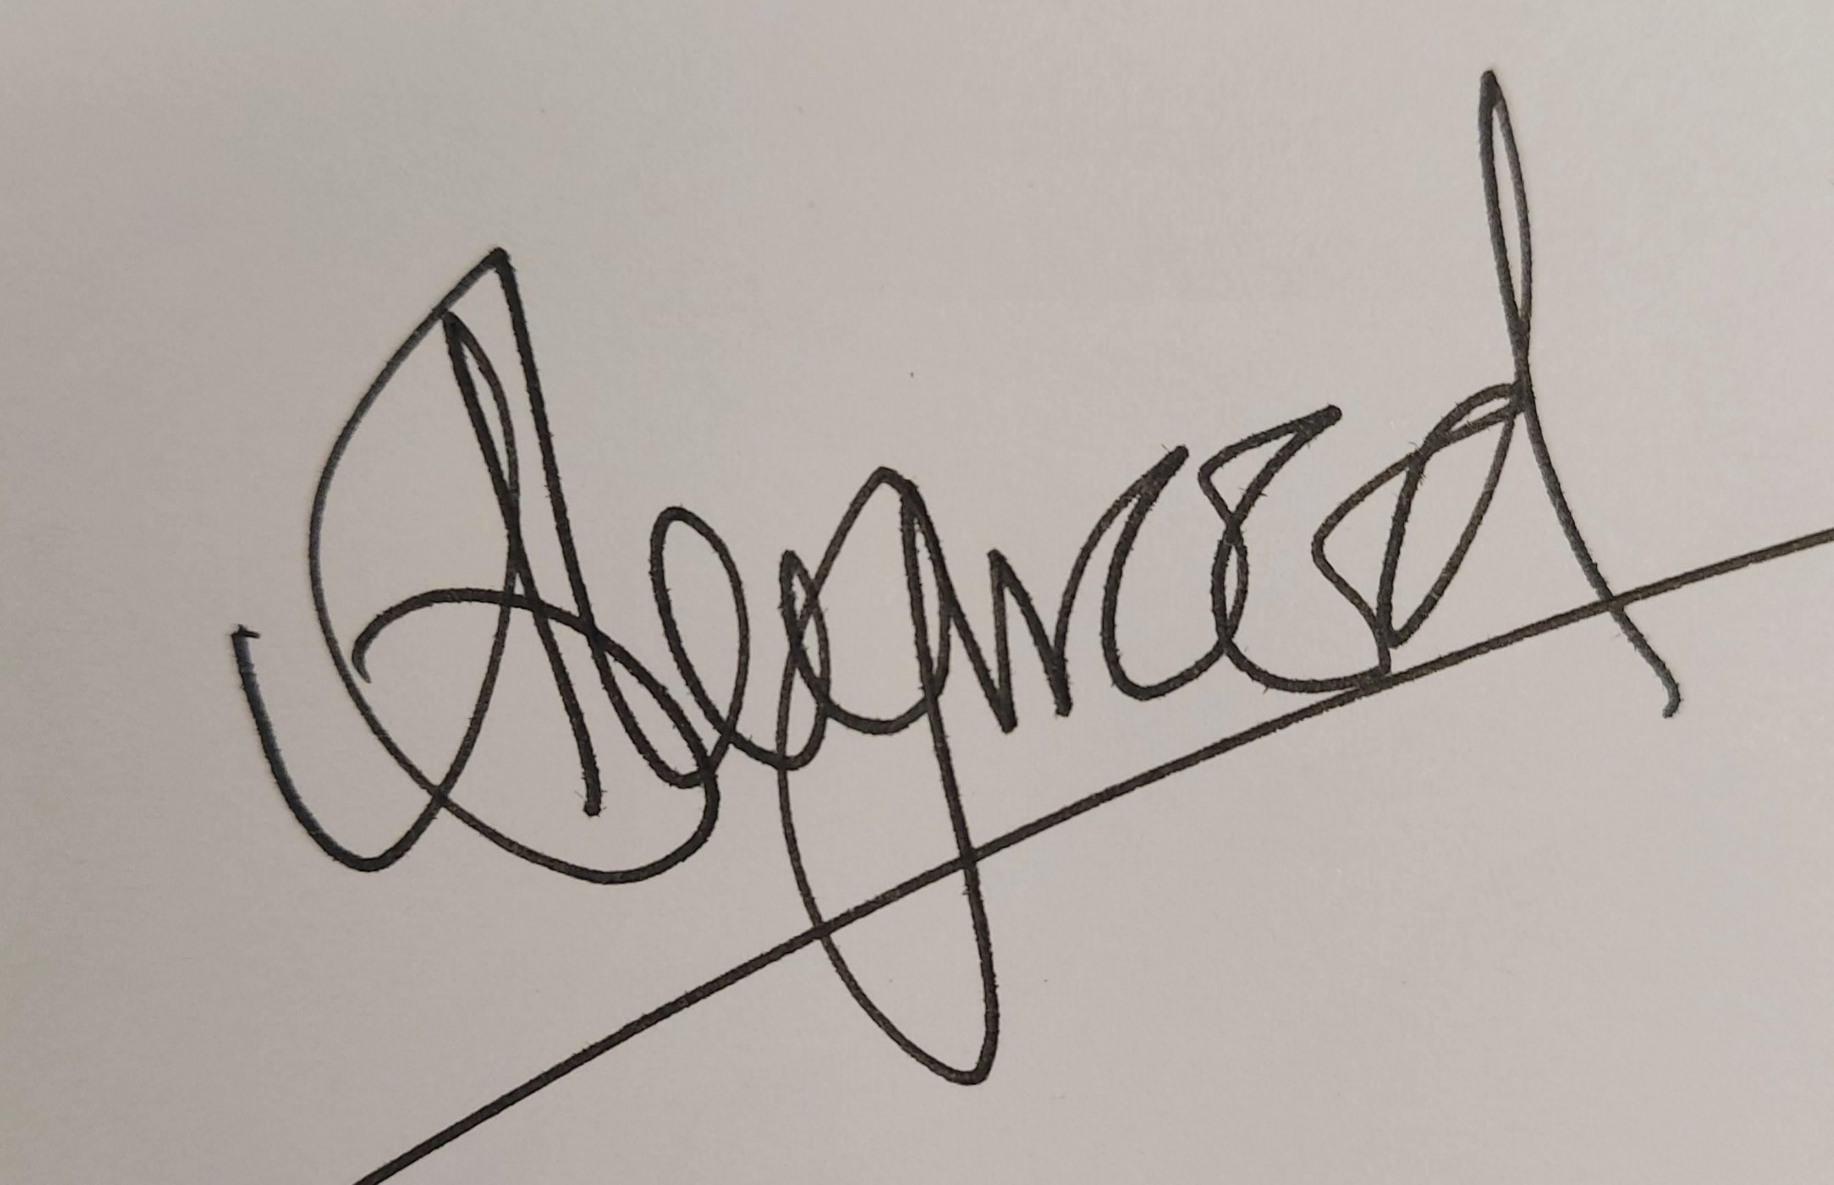

Position: Principal

Date: 14/02/2025

Effective from: 14/02/2025

Next review: February 2024

