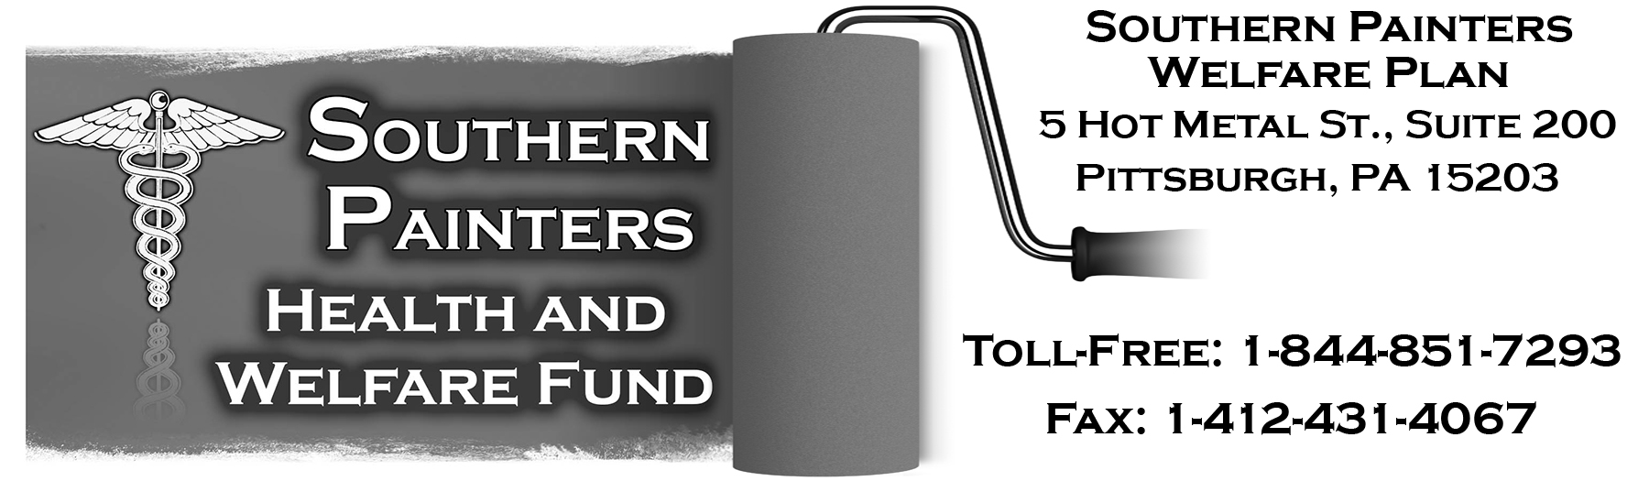
SOUTHERN PAINTERS WELFARE PLAN (“PLAN”)

NOTICE TO PARTICIPANTS OF END OF COVID-19 PUBLIC HEALTH EMERGENCY PERIOD AND OUTBREAK PERIOD AND AFFECTED BENEFIT MODIFICATIONS

JUNE 1, 2023

As Plan Sponsor, we would like to advise you of the following changes for the Southern Painters Welfare Plan (“Plan”), effective as noted.

COVID-19 Public Health Emergency Period (“PHE Period”) Ending May 11, 2023 – Impact on Related Coverage Effective July 1, 2023

During COVID-19 Public Health Emergency Period

The Plan has been providing enhanced benefits in response to the PHE Period declared in early 2020 and related federal legislation, which include the following:

- Coverage of COVID-19 diagnostic testing and related items and services, for both Network and Out-of-Network providers, without cost-sharing, prior authorization, or medical management;

- Coverage of qualifying COVID-19 preventive services and vaccines, for both Network and Out-of-Network providers, at 100% without cost-sharing or prior authorization; and

- Coverage of over the counter (“OTC”) COVID-19 tests for at home diagnostic testing, purchased on or after January 15, 2022, for up to eight (8) OTC COVID-19 tests per participant per month, free if purchased from a Network provider, and with reimbursement limited to the lesser of $12 or actual cost if purchased from an Out-of-Network provider.

Notices explaining these benefits in greater detail were provided to participants.

Effective July 1, 2023 Due to End of COVID-19 Public Health Emergency Period

It was recently announced that the PHE Period will end on May 11, 2023. As a result, the Plan will end the enhanced COVID-19 related coverage described above effective July 1, 2023. The Plan’s standard coverage provisions will govern the extent to which these services or items are covered which is generally as follows:

- Medically necessary COVID-19 diagnostic testing and related items and services will be covered for Network Providers only, at the standard benefit levels which include cost-sharing provisions and any applicable prior authorization and medical management;

- Qualifying COVID-19 preventive services and vaccines will be covered for Network providers only, at 100% without cost-sharing or prior authorization, to the extent provided under the preventive care guidelines; and

- OTC COVID-19 tests will no longer be covered.

Related Outbreak Period Ending July 10, 2023 – Impact on Deadline Extensions

During “Outbreak Period”

Certain deadlines under federal laws (ERISA and the Internal Revenue Code) were suspended for up to one year during the “Outbreak Period”, which began on March 1, 2020, and was scheduled to end 60 days after the end of the COVID-19 National Emergency Period (“NE Period”). This includes deadlines related to special enrollment periods, COBRA, and the claims and appeal procedures. Notices explaining the extension were provided to affected individuals.

After “Outbreak Period” Ends

It was recently announced that the NE Period was also expected to end on May 11, 2023, with the “Outbreak Period” ending 60 days later. This means the “Outbreak Period” will end on July 10, 2023, for the Plan.

All Plan-related deadlines that arise after the Outbreak Period ends will be governed by the normal rules that apply. All Plan-related deadlines that arise during the Outbreak Period and are still in suspension under the special relief as of the end date (because the suspension period has not yet reached the one year maximum), will resume running at that time.

If you have questions concerning this Notice or changes described in it, please contact the Plan Office.

Your receipt of this Notice does not certify that you are eligible for benefits under the Plan. You must satisfy the Plan’s eligibility requirements to be covered. This Notice is only a summary of the changes and does not replace or modify the Plan. If you have questions, please contact the Plan Office.

BOARD OF TRUSTEES

