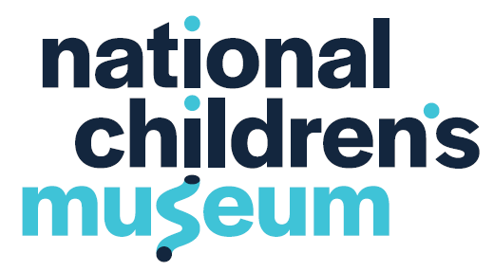

**Media Contact:** FOR IMMEDIATE RELEASE

Meredith Hamme October 6, 2022

mhamme@nationalchildrensmuseum.org

(202) 844-2486

**National Children’s Museum Welcomes New Trustees**

WASHINGTON – National Children’s Museum, a nationally-recognized cultural institution dedicated to STEAM and play-based learning in downtown Washington, D.C., is pleased to announce the appointments of three new Trustees to its board: **Elizabeth “Liz” Bonner** (Hill-Snowdon Foundation), **Robb Micek** (American Beverage Association), and **Tereasa Surratt** (Ogilvy).

“Since reopening in September 2021, National Children’s Museum has served more than 150,000 visitors in our new home, and engaged thousands more families and educators across the globe through digital initiatives. As a Congressionally-designated institution, a talented and committed Board of Trustees is essential to the Museum’s continued success and growth,” said Crystal R. Bowyer, President and CEO of National Children’s Museum. “Our new Trustees bring decades of experience in their fields, as well as impressive leadership records in the community. We are thrilled to welcome these three amazing leaders at a moment when the Museum is poised to make an incredible impact toward our mission to inspire children to care about and change the world.”

**Elizabeth “Liz” Bonner** is the President of the Board of the Hill-Snowdon Foundation, a family foundation based in Washington, D.C., that supports community organizing around racial and economic justice issues. In 2004, Ms. Bonner opened Nusta Spa, a full-service LEED-certified day spa in downtown D.C. She owned and operated Nusta until 2017, before selling the spa to her business partner. Previously, Ms. Bonner worked in corporate communications and investor relations in San Francisco. Ms. Bonner is an active member of the Washington, D.C., community, and co-chairs the Anti Racist Practice Group for Parents at St. Patrick’s Episcopal Day School, where she also serves as a volunteer for the Annual Fund and the Fund-a-Scholar IDEALS program. She lives in Washington, D.C., with her husband and nine-year-old son.

**Robert “Robb” Micek** is the Executive Vice President and Chief Financial Officer for American Beverage Association (ABA). In his role, Mr. Micek leads ABA’s Finance and Administration department and oversees all facets of the association’s financial and office-related operations. Prior to his role at ABA, Mr. Micek held top financial oversight positions for ISACA, American Society of Plastic Surgeons, and the University of Illinois Hospital & Health Sciences System in Chicago. He has significant experience in the areas of finance, accounting, taxes, investments, treasury, strategy, operations, M&A, marketing, human resources, technology, procurement, membership, and facilities. Mr. Micek has served as a member of a number of national and international non-profit organizations and is currently serving as the Non Profit Financial Professional Director on the Board of The Electrochemical Society. He splits his time between Washington, D.C., and Chicago, where he lives with his wife and together raised their three children.

**Tereasa Surratt is** a Vice President, Group Creative Director and leads Experiential at Ogilvy. With work featured in WSJ, NYT, Dwell, HuffPost, HGTV, MTV, NPR, and Apple, and with 25 years of experience in advertising, Ms. Surratt has garnered the highest awards in the industry including several Cannes Lions and has been named "AdAge Woman to Watch” and “Top Influencer” by Crains. She has served on the creative advisory board of SOHO HOUSE Chicago and theJUGGL and has mentored design & advertising students at University for the Creative Arts, England, Chicago Portfolio School + SIUC School of Art & Design. Additionally, Ms. Surratt is a three-time author, including a children’s book, and co-owner of Camp Wandawega, a National Landmark hotel recognized on the “Best Hotels in the World” list by Travel & Leisure and USA Today. Ms. Surratt splits her time between Chicago and Wisconsin with her husband and daughter.

**###**

**About National Children’s Museum**

STEAM adventure awaits at National Children’s Museum, located in the heart of downtown Washington, D.C.! With a mission to inspire children to care about and change the world, the Museum sparks curiosity and ignites creativity for children under the age of twelve and their families. Through playful science, technology, engineering, arts, and math (STEAM) based exhibits, programs, and virtual offerings, the Museum reaches millions of people each year. Learn more and plan your visit at nationalchildrensmuseum.org.