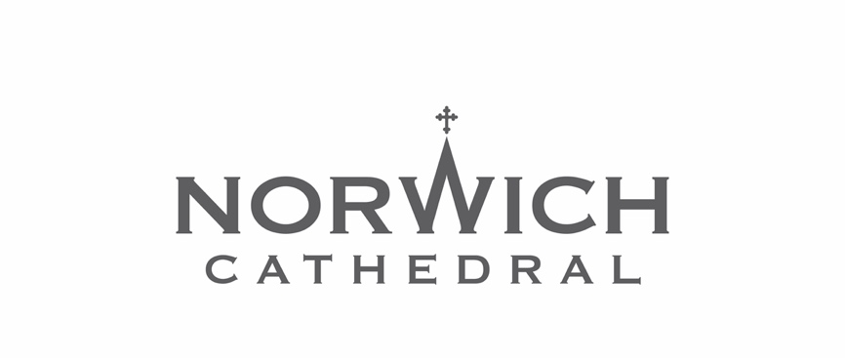

Alongside Norwich County Council, and other organisations across the County, Norwich Cathedral is working to ensure those vulnerable to domestic abuse know help is available and they need not suffer in silence.

The HEAR pledge

We pledge to break the silence around domestic abuse and HEAR, help and provide support in the workplace.

Help
Every employer has a duty to provide access to organisations who can help employees.

We will ensure staff and volunteers affected by domestic abuse are given access to the right specialist support and that information is made available for our visitors.

Educate
Every employer should ensure the right training is provided.

We will make sure the right training is provided to staff and volunteers to know what steps to take to support both colleagues and visitors

Awareness
Every employer has a responsibility to be aware of domestic abuse.

We will not tolerate domestic abuse in any form and will provide a supportive environment for staff, volunteers and visitors who experience such abuse.

Respond

Every employer should ensure the right policies are in place to respond to domestic abuse.
We will review our policies and processes and ensure they are implemented correctly.

The Dean and Chapter
May 2022
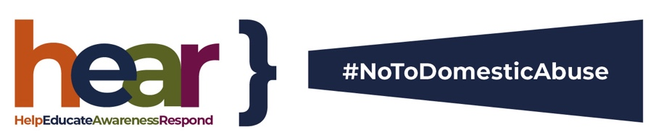

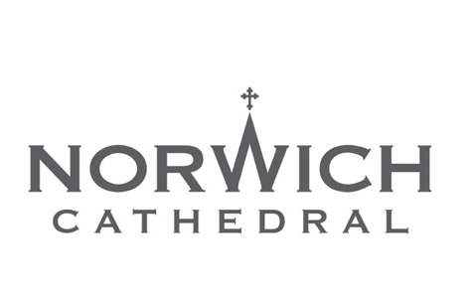
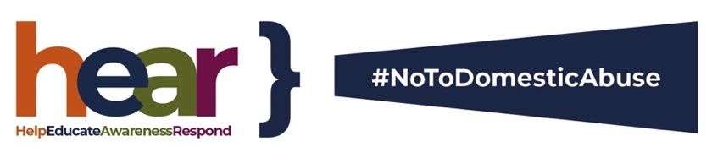

Nobody should live in fear of domestic abuse. Help is available.

How to get help

The police will always respond to emergency calls if you are in immediate danger and there are many organisations that can offer help and support.

If you are in immediate danger you should call 999. Police 101 is the non-emergency number.

Silent Solution
If you are calling from a mobile phone and speaking or making an immediate sound would put you in danger and you need immediate help, call 999 and stay on the line, then press 55 when prompted and the call will be transferred to the police, who will know it is an emergency call.

If you are calling from a landline, Silent Solution does not apply. If a 999 call is made and no one speaks and only background noise is heard and an operator does not know whether an emergency service is needed, you will be connected to a police call handler. Information about where you are calling from on a landline will be automatically available to call handlers to help provide a police response.

﻿Refuge - National Domestic Abuse Helpline 0808 2000 247
Phone (24/7) for confidential, non-judgmental information and expert support for women and children experiencing domestic abuse, including help to access refuge accommodation. With BSL Helpline option at www.nationaldahelpline.org.uk

﻿Respect - Men’s Advice Line 0808 801 0327
Monday-Friday 9am-8pm or info@mensadviceline.org.uk
provides support for male victims of domestic abuse.

﻿GALOP - LGBT+ Domestic Abuse Helpline 0800 999 5428
Monday to Friday 10am – 5pm, Wednesday and Thursday 10am – 8:00pm
help@galop.org.uk
For LGBT+ people who have or who are experiencing domestic abuse and for people supporting a survivor of domestic abuse; friends, families and those working with a survivor.
To speak to someone at Norwich Cathedral please contact either
Canon Andy Bryant, Named Person for Safeguarding: 01603 218331 or
Marie-Lyse Numuhoza, Safeguarding Friend: 07398 639 931

