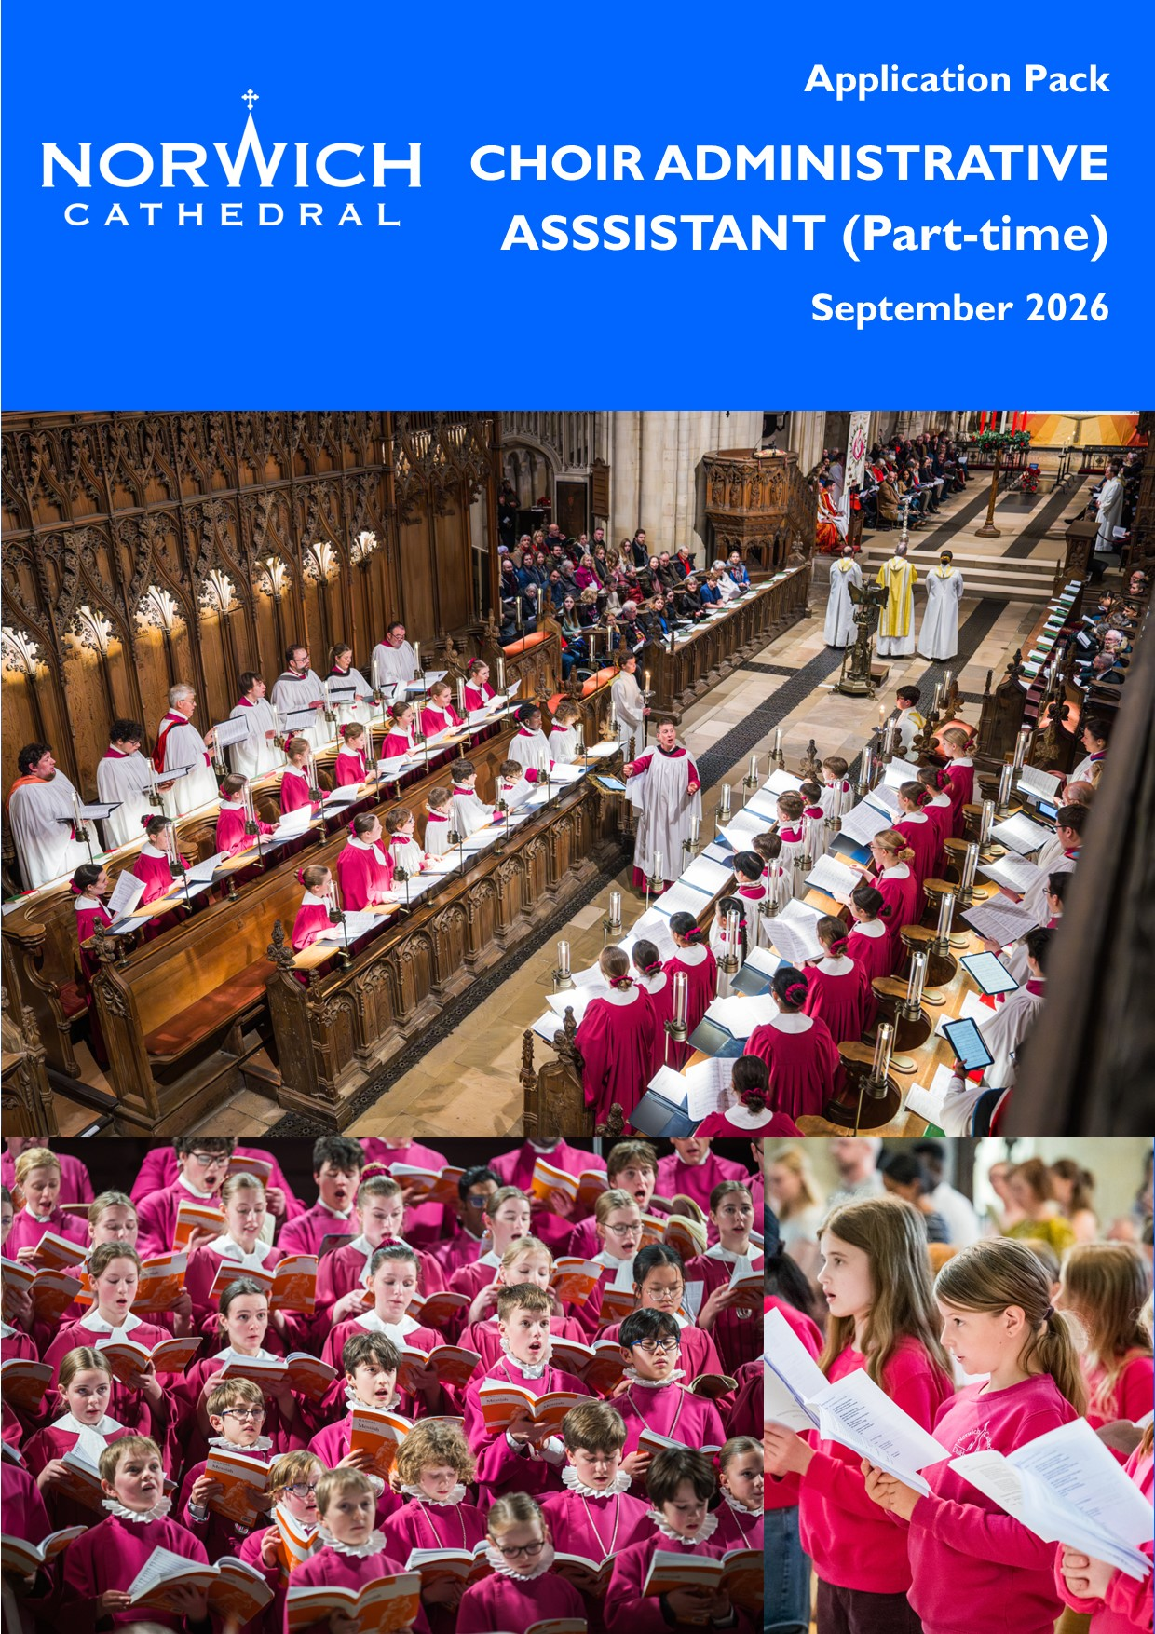



September 2026

Dear Applicant
Choir Administrative Assistant (Part-Time)
Thank you for your interest in the post of part-time Choir Administrative Assistant at Norwich Cathedral. This part-time role is key in ensuring the efficient organisation and smooth-running of our Cathedral Choirs and busy music department.

As part of the application pack, I am pleased to enclose the following:

- General Information about Norwich Cathedral and the post
- Job Description
- Person Specification
- Terms and Conditions
- Staffing Structure
- Application Form
- Job Applicant Privacy Notice

The closing date for applications is noon on Wednesday 16 September 2026 with interviews to be held on Thursday 24 September 2026.

If you would like to discuss the post before you apply and/or visit, please do not hesitate to contact Mr Ashley Grote, Master of Music (masterofmusic@cathedral.org.uk) to make an appointment.

I look forward to receiving your completed application form in due course.

Yours sincerely
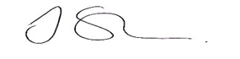
Dr Jan Sheldon
Acting Chapter Steward

Norwich Cathedral
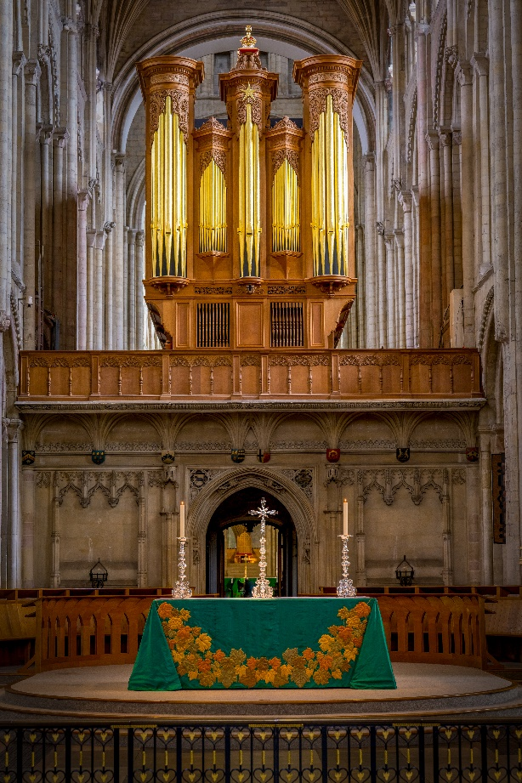
Background

Norwich Cathedral has stood for over 900 years as a place of Christian worship, learning and hospitality and the seat of the Bishop of Norwich. Throughout that time, it has welcomed visitors and pilgrims. Today it is one of the county’s leading visitor destinations, welcoming over 500,000 people each year. Special events, such as the ‘Dippy the dinosaur’ exhibition which drew over 234,000 visitors, have given the Cathedral a national reputation for embracing bold and thought-provoking visitor initiatives and ways of encountering the Christian faith.

Purpose
Norwich Cathedral is the Mother Church of the Diocese of Norwich, the focus for the Bishop’s ministry, and a place of Christian mission and discipleship.

Rooted in a daily rhythm of prayer and worship, it is a home of education, music, art, craftmanship and science, extending hospitality to all in the name of Almighty God.

Priorities
The Cathedral shares with the whole Diocese in seeking to be transformed by Christ, prayerfully, pastorally and prophetically by:

- Growing Faith: enabling all who share in the Cathedral’s life to deepen their encounter with the Gospel of Christ in prayer, worship and daily life.
- Engaging Visitors: growing visitor and pilgrim numbers, enabling all who come to be inspired by Norwich Cathedral and engage with it as a place of worship, learning and hospitality.
- Serving Communities: using the Cathedral’s strengths and partnerships to serve the common good, challenge social and environmental injustice, and inspire communities across Norwich, Norfolk and Waveney.

This mission is supported by these enabling priorities:

- Safeguarding – working together to make the Cathedral a safe place for all.
- Stewarding Resources – caring for the wellbeing of both people and planet, supporting and developing Cathedral staff and volunteers, while being financially sustainable.
- Caring for the Whole Cathedral Estate – conserving and enhancing the Cathedral and the wider Close as a place of beauty, heritage and hospitality.
Values
The Cathedral’s values are rooted in the Christian faith and shaped by its Benedictine heritage, especially as expressed in the three Benedictine vows:

- Stability (Stabilitas) – a commitment to being a place of sanctuary, support, trust and inclusion where safeguarding and the well-being of all is a priority
- Obedience (Obedientia) – a commitment to mutual respect, kindness, collaboration and listening well to one another
- Conversion of Life (Conversatio morum) – a commitment to spiritual growth, learning and creativity as a place that nurtures beauty, wonder, hope and curiosity

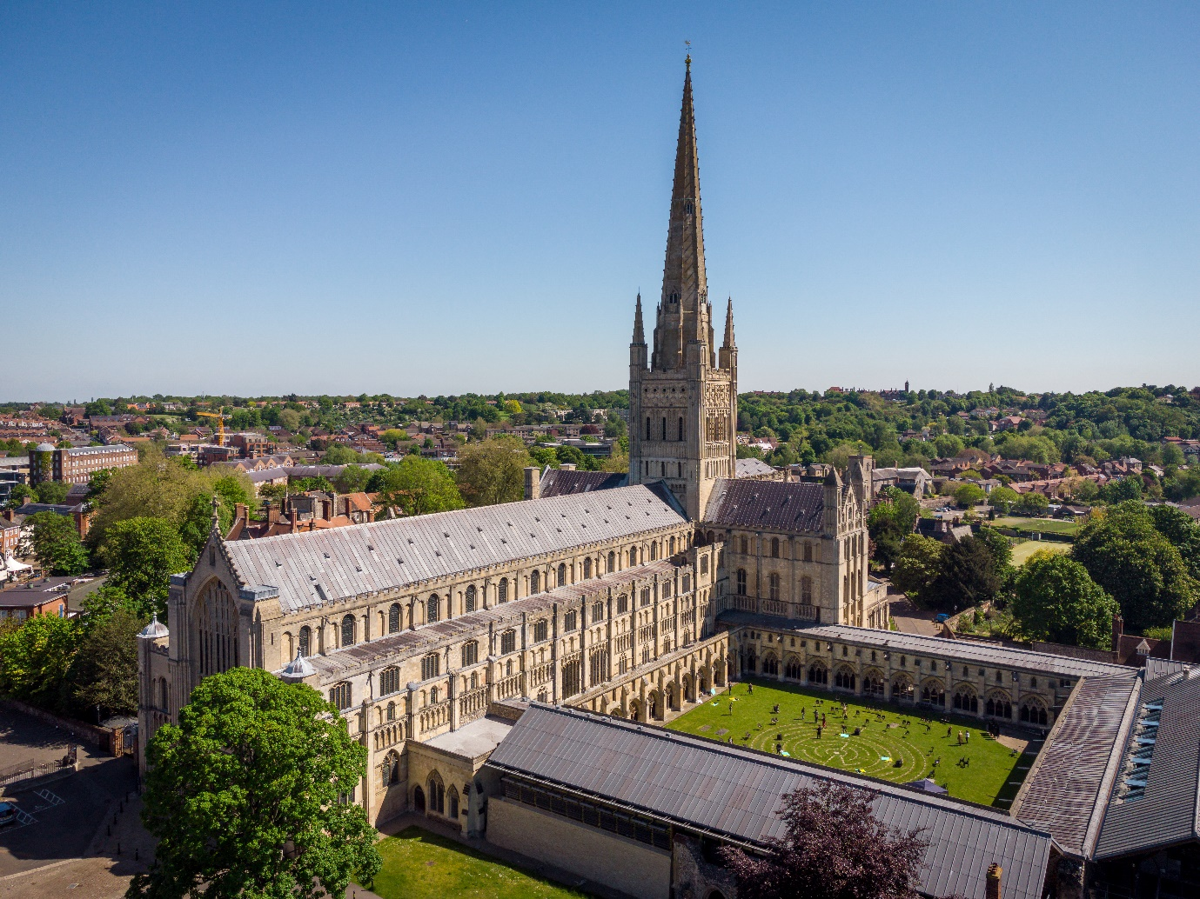

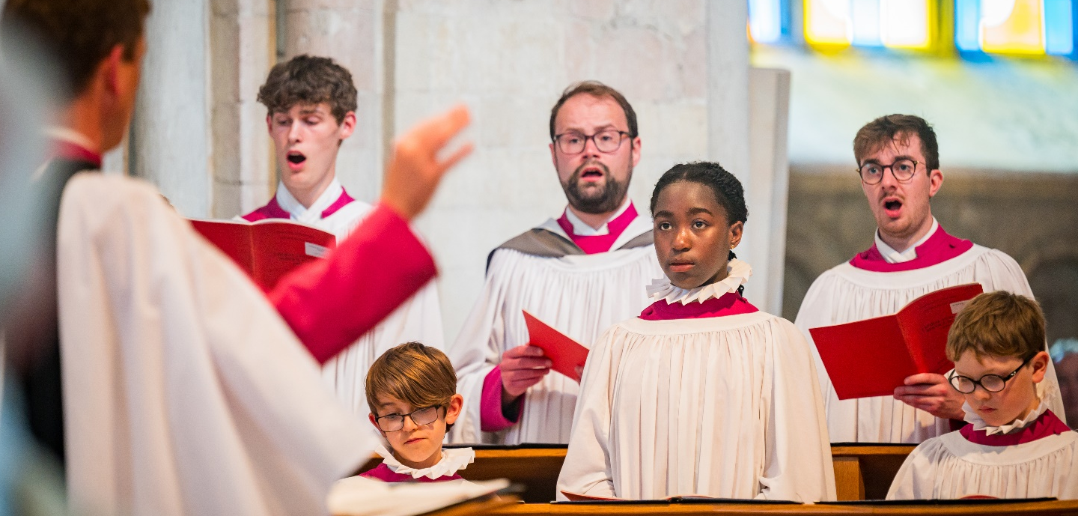

The Cathedral Music Department and Role of Choir Administrative Assistant

Norwich Cathedral has a flourishing Music Department, with the Cathedral Choir being regarded as one of the finest in the country. Over 100 children and young people and 65 adults regularly sing in the Cathedral’s different choirs. We are passionate about the role that music plays in worship, education and in inspiring those who visit us. We are committed to outstanding pastoral care and work hard to promote a positive safeguarding culture which creates a happy and safe environment for all those who sing here. The Cathedral Choir broadcasts frequently on BBC national radio, makes commercial recordings, gives concerts alongside internationally renowned soloists and tours abroad. That aside, we are also focused on giving as many children and young people the opportunity to learn and make music here, through our Children’s Choir, Senior Boys’ and Senior Girls’ Choirs, and in partnership projects with the Norfolk Music Hub.

The Choir Administrative Assistant plays a vital role in delivering all this, through efficient administration of routine and regular tasks that need to be done each week. Excellent communication skills are essential, both with colleagues internally and with those outside the organisation. The Music and Liturgy department is a small but closely knit team, and we are seeking someone who will come in with a positive, energetic and fun approach, with an eagerness to support the department in whatever way possible.

Overall responsibility for the Liturgy and Music at Norwich Cathedral lies with the Canon Precentor, Reverend Aidan Platten, who joined the Cathedral Chapter in September 2017.

The Organist and Master of Music is Ashley Grote, who has been in post since September 2012. He previously held posts as Assistant Director of Music at Gloucester Cathedral, Assistant Organist of Westminster Abbey and Organ Scholar of King’s College Cambridge. Ashley also conducts the Norwich Philharmonic Society Chorus and works regularly as a conductor and accompanist for the BBC Singers. The Assistant Master of Music and Organist is Graham Thorpe, and the Assistant Organist is Christopher Too. There is a full-time Music and Liturgy Administrator (Mrs Helen Morsia), with whom the part-time Choir Administrative Assistant shares an office.
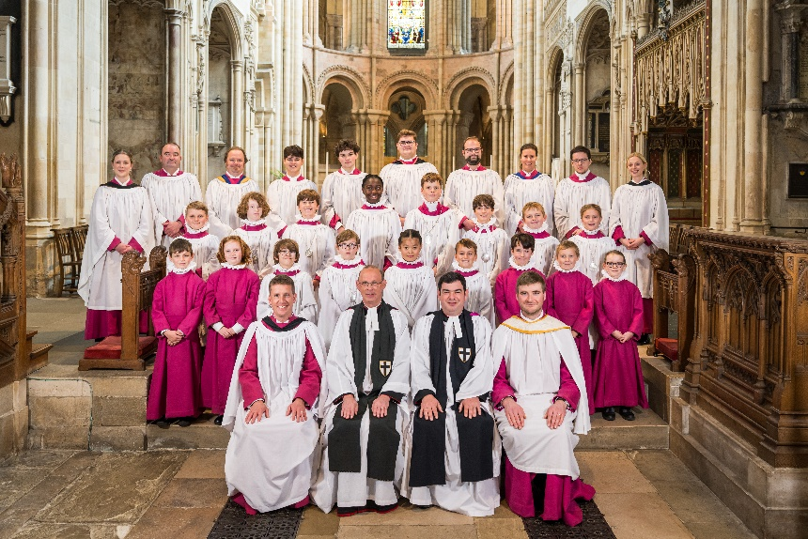
The Cathedral Choir comprises twenty choristers (boys and girls), who receive bursaries to attend Norwich School, which is sited within the Cathedral Close.

They sing alongside six Lay Clerks (salaried, professional adult singers) and six Choral Scholars, (who are either gap-year or post-graduate singers who typically spend 1-2 years here).

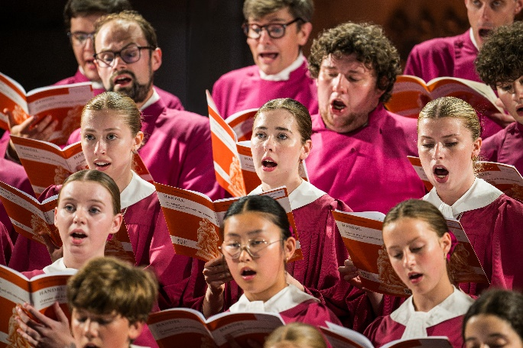
The Senior Girls’ Choir has 24 members, aged 11-18, drawn from schools across the area. They sing Evensong on Tuesdays during term-time, rehearse on Saturday mornings and participate in all the major Festivals and concerts that take place during the year.

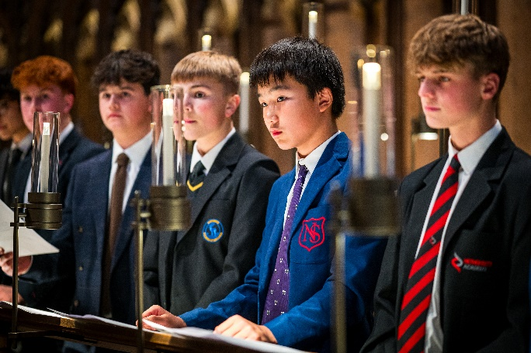
The Senior Boys’ Choir, started in 2024, is a group for secondary school aged boys with changing voices. They rehearse on Sundays during term time at 4.45pm, singing a service of Compline by Candlelight once a month.

The Cathedral Children’s Choir is a non-auditioned group for children in school years 2-6, who meet on a Saturday morning for 45 minutes and sing at various services and events throughout the year.

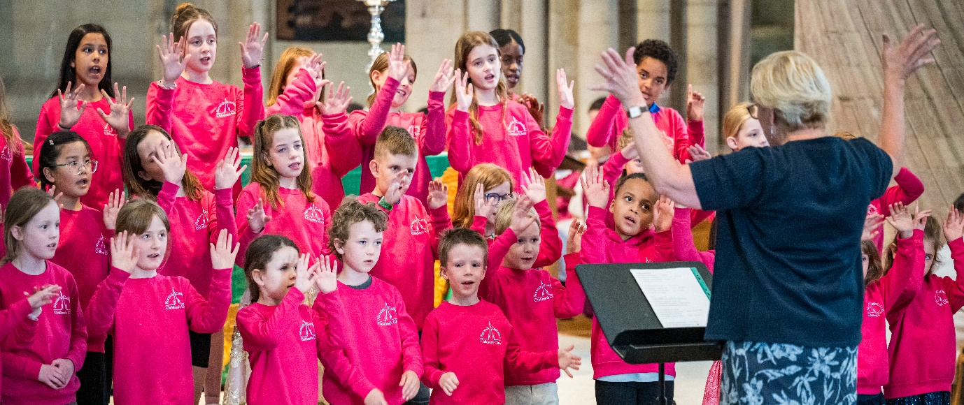

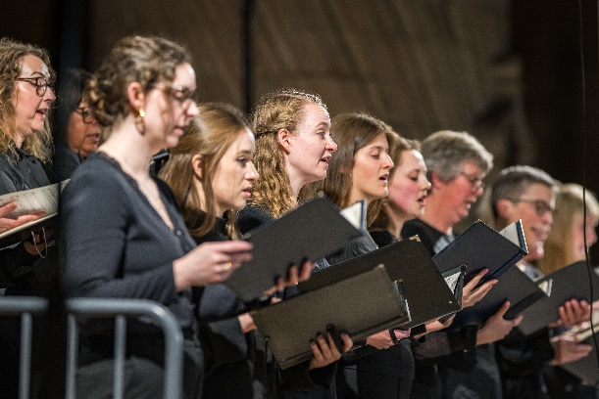
The Cathedral Chamber Choir is a group of around 50 excellent amateur singers, who rehearse on Thursday evenings, sing services in the absences of the Cathedral Choir and give concerts throughout the year. They are directed by Graham Thorpe, Assistant Master of Music.

How to Apply for this Vacancy

The successful candidate will need to demonstrate that they can be a positive ambassador for Norwich Cathedral and will have to quickly engage with the philosophy of the Dean and Chapter, appreciating and respecting the sensitivities of what being a Cathedral means. In this respect, some knowledge of the Church of England and a strong empathy with the Cathedral’s Benedictine ethos would be advantageous.

The Choir Administrative Assistant is line managed by the Master of Music (Mr Ashley Grote) and works closely with the Music and Liturgy Administrator (Mrs Helen Morsia).

Please complete the application form supplied. You can include not only experience gained in paid employment or self-employment, but also relevant experience and skills gained in voluntary work, domestic/family duties etc. Although we cannot consider a CV as an application, supporting materials will be accepted.

Applications should be addressed to Susan Bulpitt, Executive Assistant, Norwich Cathedral, 65 The Close, Norwich, NR1 4DH or by email to recruitment@cathedral.org.uk

The closing date for applications is: noon on Wednesday 16 September 2026.

Interviews

Interviews will take place on Thursday 24 September 2026. They will consist of a welcome and introduction to the Cathedral and the Liturgy and Music Department, a brief tour of the Cathedral, tests relevant to the post and a formal interview.

Candidates who are selected for interview will be notified by e-mail and/or telephone.
We receive many applications and are unfortunately not able to acknowledge them all. If you have not heard from us by noon on Monday 21 September 2026, please assume that you have not been successful with your application.

JOB DESCRIPTION
Job Title: Choir Administrative Assistant

Reporting to: The Dean and Chapter

Line Manager: Master of Music

Job Summary: To undertake the day-to-day administration relating to the Cathedral Choirs, and to support the smooth running of the Liturgy and Music Department

Specific Tasks:

- To support the Master of Music in all aspects of administration relating to all the Cathedral Choirs, undertaking any tasks relevant to the post as directed
- To be the administrative point of contact for all matters relating to the Cathedral Choirs, forming positive working relationships with members of the Music and Liturgy Department, and the wider Cathedral Team
- To be the first point of contact for Lay Clerks and Choral Scholars
- To be the first point of contact for prospective chorister parents and prospective Choral Scholars
- To maintain proper records, both computerised and manual, including databases and contact details for all choir members and parents
- To work with the Master of Music, in consultation with the Executive Assistant to ensure all adult members of the Cathedral Choirs and parent volunteers are safely recruited in accordance with the Cathedral’s Safeguarding Policies
- To assist the Master of Music with the production of the termly choir dates sheet and the weekly bulletin for chorister parents.
- Under the direction of the Master of Music to liaise with visiting singing teachers and with Norwich School to arrange timetabling of chorister, Choral Scholar and Lay Clerk vocal tuition
- To organise the Choral Scholar induction programme in consultation with the Master of Music, and the accommodation changeover in the Choral Scholar houses in consultation with the Estates Manager and Executive Assistant
- To assist the Music and Liturgy Administrator with any other administrative work within the Department
- To assist the Master of Music with the planning and administration of Choir Tours and any other Choir travel arrangements.

General:
- To support the Dean and Chapter at all times
- To adhere to good safeguarding practice, attending relevant training as directed
- To support the smooth running of the Chapter Office, sharing Reception cover as required
- To attend and participate in training courses as directed
- To adhere to HR policy contained in the Staff Handbook
- To take part in the Annual Appraisal/Review System
- To undertake any other reasonable tasks, relevant to the post

PERSON SPECIFICATION

Post: Choir Administrative Assistant

Essential Criteria
- Committed to supporting the mission, values and ministry of Norwich Cathedral
- Excellent organisational and administrative skills, with the ability to manage priorities effectively
- High level of accuracy and attention to detail
- Ability to plan, prioritise and manage workload proactively to meet deadlines
- Flexible and adaptable, with a positive and practical approach to responding to changing needs and priorities
- Educated to GCSE standard (or equivalent), including English Language and Mathematics
- Excellent verbal and written communication skills
- Strong interpersonal skills, with the ability to build positive relationships with clergy, staff, volunteers, congregation members and visitors
- Competent IT skills, including Microsoft Office applications (Word, Outlook, Excel and email)
- Willingness and ability to learn and use specialist IT systems and equipment as required
- Previous experience in an administrative, secretarial or office support role
- Experience of handling confidential and sensitive information with discretion, diplomacy and integrity
- Understanding of and commitment to maintaining appropriate confidentiality and professional boundaries
- Knowledge of general office procedures, including record management and filing systems (electronic and paper-based)
- Good telephone and reception skills, providing a welcoming and professional service
- Awareness of health and safety responsibilities within the workplace
- Ability to work effectively both independently and as part of a team
- Ability to interact appropriately and sensitively with people from a wide range of backgrounds and circumstances
- Calm, courteous and approachable manner, demonstrating sound judgement, trust-worthiness and discretion
- Positive, friendly and service-oriented attitude, with a sense of humour
- Flexible, proactive and willing to undertake a range of practical and administrative tasks as required
- Resilient, dependable and able to remain composed under pressure
Desirable Criteria
- Administration or IT-related qualifications; familiarity with administration systems, databases or online communication platforms
- Experience of maintaining records in accordance with data protection and safeguarding requirements
- Knowledge of the Church of England, its worship, structures and governance
- Experience of working within a listed building, heritage site or other unique environment

TERMS AND CONDITIONS

Post: Choir Administrative Assistant (part time)

Contract: Part Time, Permanent, Term-Time only (39 weeks per year) plus two weeks (41 weeks per year)

Salary: £7,535 per annum

Holidays: 23 working days’ paid holiday per year, together with all usual Bank and public holidays (pro-rata for part-time employees). Since this is a term time only post, holidays must be taken outside of terms. Holiday pay is included within the salary as detailed below.

Hours: The post is 12 hours per week during Choir Term Times (39 weeks per year). These hours are to be worked on regular set days (ideally 4 hours each day, 3 days per week). There is some flexibility as to the nominated exact days and times, within the Cathedral’s core office hours of 9 a.m. – 5 p.m. Monday to Friday, although the post must be undertaken Tuesday to Friday (Monday being the day off for the Master of Music).

An additional 24 hours will also be paid to cover preparation for the start and end of Choir Terms. This will be directed by the Master of Music as line manager.

To summarise:
This is 12 hours per week for 41 weeks per year = 492 hours
Plus 6.2 weeks holiday X 12 hours per week = 74.4 hours: Pro rata equivalent 74.4 x 41/52 = 59 hours

Since this is term time only, holiday pay is included as part of the salary. This will be paid in 12 equal monthly instalments across the year as above.

Probation: The post is subject to a probationary period of three months

Place of work: The usual place of work is the Chapter Office, Norwich Cathedral

Pension: Norwich Cathedral offers a pension scheme consistent with pension auto-enrolment.

Death in Service: On commencement of employment, staff become a member of the Staff Death in Service Benefits Scheme, which entitles nominee(s) to receive a lump sum of twice the employee’s annual salary at the date of death.

Medical: Successful candidates will be required to complete a medical questionnaire.
Smoking: The Cathedral operates a no smoking policy.

Equality, Diversity & Inclusion: The Cathedral values and actively strives to have a diverse and inclusive workforce in a working environment free from discrimination.

DBS: Norwich Cathedral is committed to safeguarding and promoting the welfare of children, young people and vulnerable adults, and all applicants must be willing to undergo screening appropriate to the post, including checks with past employers and an Enhanced check with the Disclosure and Barring Service. The successful candidate will also be expected to complete local and online Church of England safeguarding training; and keep such training professionally up to date.

Right to Work in the UK: You will be required to provide evidence of your right to work in the UK.

