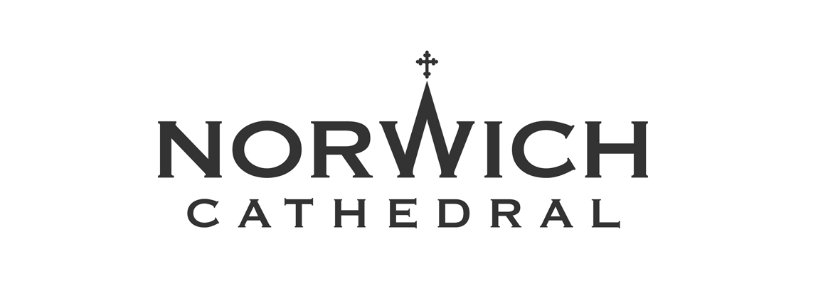

APPLICATION FORM
to be a volunteer at Norwich Cathedral

Thank you for your offer to help at Norwich Cathedral.
In order for us to process your application, please answer the following questions. Thank you.
Full Name:
(incl. title)
Address:

Date of birth:

Telephone no.:

Mobile:

Email:

Please provide contact details for two referees. (Referees should be adults who have known you for over two years and are not members of your family.)

- Name:
Address:

Tel. no.:
Email:

- Name:
Address:

Tel. no.:
Email:

Do you consider yourself to have a disability?

You do not need to give further details at this stage. However, if you are invited to attend for interview, please advise us of any specific arrangements or equipment which you require.

Please tell us where you heard about opportunities for volunteering at Norwich Cathedral.

Which volunteer role would you like to be considered for?
Please read the Volunteering Opportunities Booklet for details of volunteering roles. If you are uncertain about which role might suit you please write “to be decided”.

Please give some indication as to when and how frequently you are available.

Please use this space below to explain why you are interested in volunteering for the Cathedral and what skills and experience you are able to offer. There are a variety of roles available, please refer to the Volunteering Opportunities booklet for the skills required for each role.

Please also complete and return the Confidential Declaration form included in this application pack. Please note that you will be required to have a Disclosure and Barring Service check. The cost of this will be covered by the Cathedral.

Under the Data Protection Act, information is obtained and held by Norwich Cathedral as part of the volunteer application process. It is regarded as strictly confidential and will be stored securely. I consent for this information to be stored within the organisation’s manual and computerised filing systems.

Signed:

Date:

Please return this form to Mrs Sarah Jeffrey, The Chapter Office, 65 The Close, Norwich, NR1 4DH
Tel: 01603 218449 Email: volunteersadministrator@cathedral.org.uk Thank you.

For Office Use:
…./.…/…. Reference 1  …./.…/…. Reference 2  …./.…/…. Confidential Declaration  DBS required YES/NO …./.…/…. Date requested | …./.…/…. Passed to coordinator ………………………..  …./.…/…. Volunteer Database  …./.…/…. Trial period start date  …./.…/…. Trial period end date  …./…./…. Volunteers induction training

