Exciting opportunities
at Norwich Cathedral

Your chance to play a part in 900 years of history

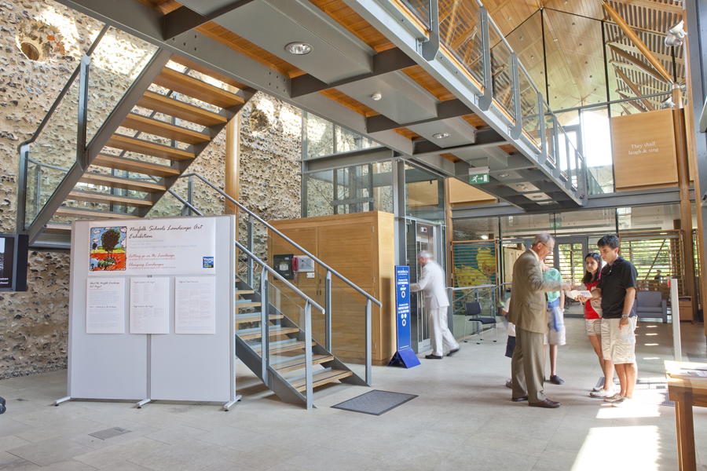

Volunteering at Norfolk’s
favourite building



Thank you for enquiring about volunteering at Norwich Cathedral.

Norwich Cathedral is a beautiful and inspiring building that draws thousands of visitors each year. Some come seeking to explore the history and the architecture, some for peace and space for reflection, others come seeking refreshments and relaxation and others come wanting to share in our worship or in other events.

Yet none of this would be possible without the support of our wonderful teams of volunteers, who together with our paid staff, ensure the Cathedral remains a place of welcome, learning and holiness for all who pass through its doors.

This booklet describes some of the different opportunities for volunteering at Norwich Cathedral, along with the training and minimum time commitment involved. In volunteering you will be offering your time and skills to the Cathedral. In return, the Cathedral and its staff will support you and give you appropriate training and encouragement.

Volunteers are welcome from all faiths and of no faith. All we ask is that you are willing to respect all that Norwich Cathedral stands for and be a good ambassador for the Cathedral to all our visitors.

To apply to be a volunteer, please complete the application form and confidential declaration sent out with this booklet and arrange for two references to be sent to us. We will then invite you to come to the Cathedral for an informal interview. To help you decide if you have chosen the right role, you will be given a taster session and then a three-month trial period for you to decide.

We look forward to hearing from you.

Liz Leaver
Canon Pastor
canonpastor@cathedral.org.uk
01603 218331

Volunteering at Norwich Cathedral

Hospitality has always been part of Norwich Cathedral. The original monastery was based on the Rule of St Benedict, which stressed the importance of treating all visitors as guests. The monks were encouraged to treat each visitor as if they were Jesus himself.

Our volunteers continue in that same Benedictine inspired tradition of hospitality, treating all visitors as guests, being attentive, helpful, caring and cheerful – even when things are busy.

All volunteers need to be reliable and punctual as their role is essential to the smooth running of the Cathedral. They need to be friendly, welcoming, enjoy meeting people and sensitive to and understanding of their differing needs. As ambassadors for the Cathedral, they need to be completely honest and trustworthy, treating all our guests with respect and dignity. At times the Cathedral can be a busy place, so it is important to be able to be flexible, coping with changing circumstances and not get flustered. It is important not to be easily distracted but able to stay focused on the needs of our guests.

We seek to be supportive of volunteers for whom English is a second or other language along with those with additional needs. However, we also recognise that volunteering roles can be demanding and so we may not always be able to offer the support that some may need.

Above all, what unites all our volunteers is an affection for Norwich Cathedral and enjoyment of working in this special and historic site.

We encourage everyone to apply for just one role initially but once you are settled with us then we would be happy to explore additional roles, should you request it.

Please note the availability of vacancies for different volunteer roles varies from time to time.

Welcomers
The Role | Offer all visitors a warm welcome.  Offer a free welcome booklet and give out Explorer Backpacks to children.  Offer directions around the Cathedral site and further afield in the city.  Be a source of information about events in the Cathedral and able to respond to a wide range of general questions about the Cathedral and the city.
Training | Learning is mainly through working alongside other volunteers plus an Introduction to Welcome training.  A free guided tour of the Cathedral.  Attend Induction Training (2hrs) and C1 Safeguarding training (2hrs)
Time Commitment | One 2 or 2.5hr shift per week.

Guides
The Role | Offer guided tours of the Cathedral, both free tours offered on the hour and pre-booked tours.  Available in the Cathedral to answer questions from visitors about the history and life of the Cathedral.
Training | Assigned a mentor to develop skills and confidence.  Attend six 2hr training sessions to develop your knowledge of the history and life of the Cathedral.  Undertake an assessed tour.  Attend Induction Training (2hrs) and C1 Safeguarding training (2hrs)
Time Commitment | One 2hr shift per week.

The Cathedral Gift Shop
The Role | Serve customers in the shop.  Comfortable with a computer linked till and credit card machine and handling money.  Assist with other shop related activities including light cleaning, stock counting, shelf-filling and pricing goods.  Be a source of information about events in the Cathedral and respond to a wide range of general questions about the Cathedral and the city. Open to those 16yrs & over.
Training | On the job training from the Retail Manager including introduction to the till and credit card machine.  A free guided tour of the Cathedral.  Attend Induction Training (2hrs); DBS clearance & C1 safeguarding training (2hrs).
Time Commitment | One half day shift per week.

Schools and Family Learning
The Role | Supporting learning programmes for over 10,000 primary and secondary aged children each year with subjects ranging from RE and History to Ethics and Science.  Supporting family learning days during school holidays.  Previous experience of teaching or working with children and young people is preferable.  Drama, storytelling and art and craft skills are advantageous.  Opportunities for those able to lead tours for international students.
Training | Training and support offered by the Schools & Family Learning team.  A manual is provided to support the different learning programmes.  A free guided tour of the Cathedral.  Attend a taster session (4 hrs) and then more observation as required.  Induction Training (2hrs); DBS clearance & C1 safeguarding training (2hrs).
Time Commitment | Flexible, but ideally one day per week.

The Herb Garden
The Role | Caring for the monastic herb garden which was established in 1997.  Mainly general weeding and pruning.  Some knowledge of gardening helpful especially knowledge of herbs and their uses.
Training | Learning is mainly through working alongside other volunteers.  A free guided tour of the Cathedral.  Attend Induction Training (2hrs) including  Basic Introduction to Safeguarding.
Time Commitment | Shifts as needed especially in growing season.
The Broderers
The Role | Helping repair Cathedral robes and textiles.  Help create new vestments and frontals for the Cathedral and other churches.  Help conserve existing textiles from the Cathedral and other churches.  A proven level of skill and/or experience is required, including showing three samples of work completed within the last three years.  Good eyesight, with or without glasses, is required along with good manual dexterity.  Work allocated is closely supervised by the Broderer’s Supervisor.
Training | Support and guidance are given by the Broderer’s Supervisor.  Attend Induction Training (2hrs) including  Basic Introduction to Safeguarding.
Time Commitment | 10am – 4pm on either Wednesday or Thursday each week.

The Cathedral Flower Guild
The Role | ARRANGING  Helping with staging flower displays in the Cathedral.  Previous experience of flowers arranging essential.  Usual arranging day is Friday.  WATERING  Assisting with watering flower arrangements during the week.  An ability to lift watering cans and push a wheelbarrow is essential.
Training | Support and guidance are given by members of the Guild Committee.  Attend Induction Training (2hrs) including basic introduction to Safeguarding.
Time  Commitment | On a rota offering support as available.
The Library
The Role | Supporting those studying at the Library and those borrowing books.  Helping with classification and care of the Collection.  Assisting with events in the Library.  Some familiarity with computers is helpful.  Book cleaning and other basic conservation tasks – this area involves manual handling and dexterity or craft skills are an advantage.
Training | Support and guidance are given by the Librarian.  A free guided tour of the Cathedral.  Attend Induction Training (2hrs) including  Basic Introduction to Safeguarding.
Time Commitment | A morning or afternoon each week.

The Sacristy
The Role | Helping with dusting/polishing within the Cathedral  N.B. Help is also needed with washing small linens used in the Cathedral’s worship – please speak to the Sacrist.
Training | Guidance and support offered by the Vergers’ team.  Attend Induction Training (2hrs) including  Basic Introduction to Safeguarding.
Time Commitment | Frequency to be agreed with the Sacrist.

Choir Coffee
The Role | Open to those who have worshipped at the Cathedral for six months or more.  Providing coffee for the Lay Clerks and Choral Scholars of the Choir on a Sunday morning prior to the 10.30 service.
Training | Learning is mainly through working alongside other volunteers.  Attend Induction Training (1.5hrs); DBS clearance & C1 safeguarding training (2hrs).
Time Commitment | On rota according to your availability.

Event Ushers
The Role | Giving support at events and concerts, usually evenings or weekends.  Helping welcome people, checking tickets, selling programmes and showing people to their seats.  Based at a Cathedral door to oversee comings and goings, including for emergency evacuations.  N.B. Whilst you will be able to hear the performance you may not be able to see the performers as you are on duty throughout.
Training | Learning is mainly through working alongside other volunteers.  DBS clearance  Attend Induction Training (2hrs) and C1 safeguarding training (2hrs).
Time Commitment | As need arises.

College of Chaplains
The Role | Open to Clergy and Readers with a Bishop’s Licence or permission to officiate or a similar role in another denomination.  Being a living icon of the presence of God within the Cathedral.  Available to talk with visitors especially those in need.  Offering a prayer on the hour each hour – script provided.
Training | Learning by shadowing another Chaplain.  Notes given on role.  A free guided tour of the Cathedral.  Attend Induction Training (2hrs).  DBS clearance and C1 training with the diocese
Time Commitment | A morning or afternoon as often as suits you.

Sunday School
The Role | Open to those who have worshipped at the Cathedral for six months or more.  Helping leading sessions, on a rota basis at the Sunday School which meets during the 10.30 Sunday Sung Eucharist during term times.  Attending termly planning meeting – usually after the 10.30 Sunday service;  Previous experience of working with children (4yrs-11yrs) helpful.
Training | Learning is mainly through working alongside other volunteers.  Attend Induction Training (2hrs).  DBS clearance and C1 safeguarding training (2hrs) for those 16yrs and over.
Time Commitment | On rota according to your availability.

Altar Server
The Role | Open to those who have worshipped at the Cathedral for six months or more.  Serving at Sunday Services - 10.30 am Sung Eucharist and 3.30pm Choral Evensong and at mid-week Festal Evensongs and other special services especially at major festivals.  Roles include Crucifer (carrying cross) Acolyte (carry candle) and serving at the Altar.  Previous experience helpful but not essential – open to young people (11+) and adults.
Training | Training is given by the Canon Precentor and the Head Server, as well as learning alongside other Servers.  Attend Induction Training (2hrs).  DBS clearance and C1 safeguarding training (2hrs) for those 16yrs and over.
Time Commitment | On rota according to your availability.

Guild of Stewards
The Role | Open to those who have worshipped at the Cathedral for six months or more.  Stewarding at Sunday services and other special services.  Welcoming people to services, assisting with the taking of the Offertory Collection; directing people at the time of Communion, helping visitors during the times of services and generally ensuring the smooth and safe running of services.  Responsible for comings and goings at doors of cathedral, including emergency evacuations.  Open to young people and adults.
Training | Training is given by the Canon Precentor and the Head Steward, as well as learning alongside other Stewards.  A free guided tour of the Cathedral.  DBS clearance.  Attend Induction Training (2hrs) and C1 safeguarding training.
Time Commitment | One Sunday service per month plus other services subject to your availability.

Mission Group
The Role | Open to those who have worshipped at the Cathedral for six months or more.  Working with the Canon for Mission and Pastoral Care in the developing and running of creative and imaginative events that provide opportunities for faith conversations.  You may be invited to join the Cathedral’s Hand Massage team.  Attending four group meetings a year.
Training | Training is provided as required.  Learning is mainly through working alongside other volunteers.  A free guided tour of the Cathedral.  Attend Induction Training (2hrs); DBS clearance & C1 safeguarding training (2hrs).
Time Commitment | Determined by the program of events devised and your availability.

Pastoral Group
The Role | Open to those who have worshipped at the Cathedral for six months or more.  Working with the Canon for Mission and Pastoral Care providing pastoral support within the cathedral congregation.  You may be invited to join the Cathedral’s Hand Massage team.  Attending four group meetings a year.
Training | Training is provided as required.  Learning is mainly through working alongside other volunteers.  A free guided tour of the Cathedral.  Attend Induction Training (2hrs); DBS clearance & C1 safeguarding training (2hrs).
Time Commitment | Determined by the level of need and your availability.

Hope into Action
The Role | Open to those who have worshipped at the Cathedral for six months or more.  Being part of the Friendship and Support Group for the houses the Cathedral supports as part of its partnership with Hope into Action, helping move individuals move out of homelessness.  Befriending and supporting individual residents in the houses or offering practical help for the running of the houses.
Training | Attending training run by Hope into Action.  Guidance from the FSG volunteer co-ordinator and the HiA Empowerment Worker:  Attend Induction Training (2hrs); DBS clearance & C1 safeguarding training (2hrs).
Time Commitment | Befriending: a weekly visit to the house  Practical help as required.

Other Opportunities
For those who become involved in the worshipping life of the community there are other opportunities for sharing in the life of the community. These include:

- Reading at services
- Leading Intercessions
- Making Sunday Morning Coffee

If you would like to know more about these opportunities, please contact: Canon Liz Leaver at canonpastor@cathedral.org.uk.

A Christian presence at the heart of Norfolk
a place where all are welcome
a place to share learning
a place to grow in holiness

www.cathedral.org.uk


