

October 2023

Dear Applicant,

**ALTO, TENOR AND BASS CHORAL SCHOLARSHIPS 2024-25**

Thank you for your interest in a choral scholarship here at Norwich Cathedral for the academic year 2024-25. Scholarships are available for altos (female and male), tenors and basses and present an exciting opportunity for talented, enthusiastic and ambitious young singers who would benefit from 1-2 years’ experience singing to a high standard with our Cathedral Choir. Candidates can be Gap-year or post-graduate, or undergraduate if they are studying at one of the universities here in Norwich.

Choral Scholars joining the cathedral choir will be doing so at a very exciting time, with the return of the cathedral’s 102-stop organ after a £1.8 million rebuild. The cathedral choir is right at the heart of the cathedral’s daily life and worship and in addition there are many other musical opportunities, including broadcasts on BBC radio, recordings and concert performances both in the cathedral and away from Norwich. It is hoped that the choir will undertake an international tour in the year 2024-25.

The application pack below contains some background information about the City of Norwich, the Cathedral and its music department. The role of a choral scholar and the terms and conditions of the scholarship are also outlined.

**Applications are welcome at any time.** Candidates should please return a completed application form: other supporting information is welcome but not expected. If successful, we will welcome you for an interview at a mutually convenient time but you will receive confirmation, either way of your received application.

If you would like to enquire informally about the scholarships or have any questions, please do feel free to contact me either by email ([masterofmusic@cathedral.org.uk](mailto:masterofmusic@cathedral.org.uk)) or telephone (01603 218319).

I hope that having read the details below you will be encouraged to get in touch.

Thank you for your interest.



Ashley Grote

**Master of Music**



Application Pack

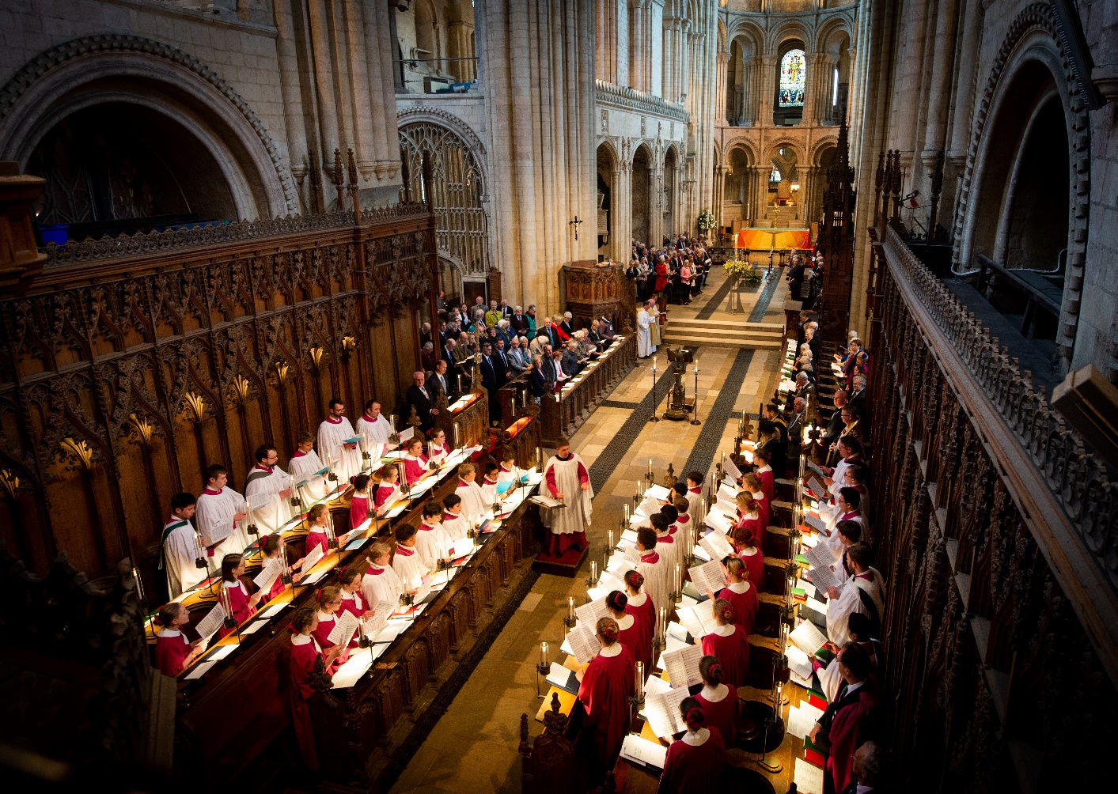

CHORAL SCHOLARSHIPS

2024-25



**Background information to Norwich Cathedral**

Norwich Cathedral has stood for over 900 years as a place of Christian worship, learning and hospitality and the seat of the Bishop of Norwich. Throughout that time, it has welcomed visitors and pilgrims. Today it is the county’s leading visitor destination, welcoming over 500,000 people each year. Special events, such as the ‘Dippy the dinosaur’ exhibition which drew over 234,000 visitors, have given the Cathedral a national reputation for embracing bold and thought-provoking visitor initiatives.

At its away day in July 2023, Chapter agreed three key priorities areas:

1. Growing Faith: enabling all who share in the Cathedral’s life to deepen their encounter with the Gospel of Christ in prayer, worship and daily life

2. Engaging Visitors: growing visitor and pilgrim numbers, enabling all who come to be inspired by Norwich Cathedral and engage with it as a place of worship, learning and hospitality

3. Serving Communities: using the Cathedral’s strengths and partnerships to serve the common good, challenge social and environmental injustice, and inspire communities across Norwich, Norfolk and Waveney

These priorities will guide the Cathedral’s actions and direction in the coming years. Music, and the choir in particular, is at the heart of the Cathedral’s worship and ministry.

**Cathedral Management**

Norwich Cathedral is a registered charity and The Dean and Chapter is the governing body of the Cathedral. It sets policy, direction and key objectives, approves strategy and the annual budget, monitors performance and oversees the affairs and administration of the Cathedral. The Chapter is chaired by the Dean, as Head of the Foundation. There are three Residentiary Canons; Precentor, Mission and Pastoral Care and Librarian. All are members of the Chapter, together with at least three Non-Executive Members of Chapter and a Senior Non-Executive Member of Chapter.

The Chapter is assisted in its management by a number of committees which report to the Chapter in an advisory capacity and make recommendations. These committees each have external professional advisors which are nominated by the Nominations Committee. The College of Canons is an honorary body, and receives and considers the annual report and audited accounts. It takes an interest in the life of the Cathedral, particularly in the wider context of the Diocese of Norwich.

The Cathedral Refectory and Shop form Norwich Cathedral Enterprises Limited, a separate trading company, which is managed by a Board of Directors. All profits from Norwich Cathedral Enterprises Limited are gifted to the Cathedral to further its mission, worship and outreach. The Refectory is successfully operated by BreadSource.

**The City of Norwich**

Norwich is a thriving provincial City which is very much a focus for the County of Norfolk, and the Cathedral is a key part of it. It has a large but compact city centre with excellent shops and restaurants, a daily market, theatres, cinemas and an excellent modern library. The cultural and artistic life of the City is rich and active and the Norfolk and Norwich Festival takes place annually. The University of East Anglia and Norwich University of the Arts are both based in the City and attract a large student population to during term time. There is a regular train service to London Liverpool Street (typical journey time 1 hour 45 minutes), and to Cambridge (1 hour 15 minutes) with then good connections beyond.

**The Cathedral Music Department**

Norwich Cathedral has a flourishing music department that is entering an exciting new chapter, with the completion in August 2023 of the project to rebuild the cathedral organ. The department is a happy team characterised by positive relationships between colleagues and with the rest of the Cathedral community as a whole.

Overall responsibility for the liturgy and music at Norwich Cathedral lies with the Precentor, **Canon Aidan Platten** who joined the Cathedral Chapter in September 2017.

The Master of Music is **Ashley Grote**, who has been in post since September 2012. He previously held posts as Assistant Director of Music at Gloucester Cathedral, Assistant Organist of Westminster Abbey and Organ Scholar of King’s College Cambridge.

**David Dunnett** is the **Organist**, having held the post of Organist and Master of Music from 1996-2007. He came to Norwich having been Sub-Organist of Winchester Cathedral and, before that, Assistant Director of Music at Uppingham School.

The Assistant Organist is **Robbie Carroll**, previously Assistant Director of Music at St Fin Barre’s Cathedral in Cork.

There is a full-time Music and Liturgy Administrator and a part-time Choir Administrator.

There are **six Lay Clerks** who sing alongside **six Choral Scholars**, who are either gap-year or post-graduate singers who typically spend 1-2 years here.

There are **twenty Boy Choristers**, who receive bursaries to attend Norwich School, which is sited within the Cathedral Close.

There are in addition **twenty-four Girl Choristers** aged 11-18, drawn from schools across the area and who receive a termly financial award.

**The life of the Cathedral Choir**

The Cathedral Choir sings seven choral services each week during term-time: Choral Evensong each day Monday-Friday at 5.30pm and on Sundays the Cathedral Eucharist at 10.30am and Choral Evensong at 3.30pm. Typically Tuesday Evensong is sung by the Girl Choristers alongside the Lay Clerks and Choral Scholars, and Thursday Evensong is sung by the Lay Clerks and Choral Scholars only. Saturday is usually clear of any choir duties.

The choir aspires to the highest possible standard of singing and, under the leadership of Ashley Grote since 2012, has established a busy programme of concerts, recordings and other projects alongside the core work of singing for Cathedral worship. The annual performance of a Bach Passion, Handel’s *Messiah* and popular Christmas concert attract large audiences. The choir has an established relationship with the flourishing Norfolk and Norwich Festival and with Norwich Baroque, an ensemble that brings some of the country’s finest period instrument players to the city. The choir’s most recent recording, of sacred choral works by Benjamin Britten, received outstanding reviews. There are regular broadcasts on BBC Radio and tours to Sweden, Germany and Italy. Recent commissions for the choir have included works by Bob Chilcott, Richard Allain, Philip Moore, Ruth Byrchmore, Ben Parry and Malcolm Archer.

In 2017, the Dean and Chapter launched a £2.5 million music appeal to raise money for the complete restoration of the Cathedral’s 105-stop pipe organ and to provide financial support for both its boy and girl choristers. The work on the organ is now complete and an exciting programme of concerts and events to celebrate its return is planned for the year 2023-24, including three broadcasts on BBC radio and an organ festival in July 2024. Following on from the music appeal, a subscription group for music supporters (‘The Statham Society’) has been launched in order to provide ongoing support for music projects.

**Person specification**

The Chapter of Norwich Cathedral seeks to appoint choral scholars for the academic year 2024-25 to sing in the Cathedral Choir. Applicants should be excellent singers with some proven experience of choral singing. The ability to sight-read music confidently is essential, as is a good musical ear and sense of musicianship. Suitable candidates may be looking for either a gap-year or post-graduate placement, or may be undergraduates studying at one of the universities in Norwich. Regardless, candidates should be seeking to gain as much choral singing experience as possible during their time in Norwich and eager to improve themselves as a singer and musician. They should be good at working alongside others in a team, demonstrating a good sense of humour. It may be possible to extend the scholarship for a second year subject to discussion with the Master of Music.

**Duties of a Choral Scholar**

The normal weekly commitment for Choral Scholars is as follows:

Monday 4.55pm Rehearsal

5.30pm Evensong (Boys and Altos, Tenors and Basses)

Tuesdays 4.55pm Rehearsal

5.30pm Evensong (Girls and ATB)

Wednesday 4.55pm Rehearsal

5.30pm Evensong (Boys and ATB)

6.15-7.00pm ATB rehearsal

Thursday 4.55pm Rehearsal

5.30pm Evensong (ATB only)

7.30-9.00pm Cathedral Chamber Choir rehearsal

Friday 4.55pm Rehearsal

5.30pm Evensong (Boys and ATB)

6.15-7.00pm Full rehearsal

Saturday No regular commitments

Sunday 9.30am Full rehearsal

10.30am Sung Eucharist (Boys or Girls and ATB)

2.55pm Full rehearsal

3.30pm Evensong (Boys or Girls and ATB)

Currently, three services each week are live-streamed via the Norwich Cathedral Services YouTube channel (normally Tuesday Evensong and both Sunday services)

**Additional commitments**

The choral scholars are additionally required to sing at special services, concerts and events as directed by the Master of Music, for which extra fees will be payable.

**The Cathedral Chamber Choir**

The Cathedral Chamber Choir normally sing one Sunday of services each term and three concerts per year, at least two of which are accompanied by orchestra. Past performances have included Brahms *Ein Deutsches Requiem,* Mozart *Mass in C minor,* Bach *Mass in B minor* and *Magnificat in D,* as well as a cappella works including Howells’ *Requiem* and Parry’s *Songs of Farewell.* The choral scholars are required to be members of the Cathedral Chamber Choir, who rehearse on Thursday evenings each week from 7.30 – 9.00pm.

**Singing Tuition**

Part of the aim of the choral scholarships is to enable young singers to develop their vocal potential so, with this in mind, free singing tuition is provided for choral scholars. Currently, **Richard Edgar-Wilson** visits Norwich monthly during term times to give most of the Lay Clerks and Choral Scholars vocal tuition. If there is good reason for a choral scholar to study with a different teacher, this can be arranged in consultation with the Master of Music.

**The Aston library and the Runnett collection**

The Cathedral library houses an extensive music library, comprising amongst other things the music libraries of the late Professor Peter Aston and of Brian Runnett, Organist of Norwich Cathedral from 1967 who was tragically killed in a car accident in 1970. Choral Scholars are encouraged to use the Cathedral library and its resources for personal reading and study if they wish to do so.

**Scholarship & Accommodation**

The Dean and Chapter want choral scholars to play a full part in the life of the Cathedral, maximizing the educational opportunities of their time in the Cathedral Choir. With this in mind, rent-free, furnished accommodation is provided for all choral scholars in two shared flats. The cost of council tax and all utilities is met by the Dean and Chapter.

The choral scholarship honorarium is £2,000 for the academic year. This will be paid in three equal instalments in September, January and April, to coincide with the terms of the academic year. Since this is a Scholarship, it will not be subject to HMRC. The Chapter will also pay for attendance at those special services for which fees are payable, a fee of £75 or such other amount as may from time to time be agreed. Extra fees are payable for most concerts, recordings and broadcasts as advised by the Master of Music.

**Absences**

It is understood that choral scholars may wish to be absent from time to time in order to undertake professional engagements and other opportunities which may enhance their prospects as a singer. The Master of Music will always try to accommodate such reasonable requests, and if permission for absence is given, a deputy will be provided at the Chapter’s expense.

**Holidays**

Outside of Choir activities, Choral scholars will have free time of not less than i) seven weeks holiday in the summer (should the scholarship be for a period of more than one academic year), ii) 14 days, including two Sundays, at Christmas and Easter and iii) seven days at each half-term, to include at least one Sunday. The dates of all holidays are determined by the Cathedral Chapter.

**Other work**

It is perfectly acceptable for choral scholars to undertake employment outside of their Choral Scholar duties should they wish to do so, as long as their choir duties are in no way compromised. In the past choral scholars have worked at a number of local schools and we can help put successful candidates in touch with relevant Head Teachers and school Directors of Music.

**Equal Opportunities**

The Cathedral operates an equal opportunities policy.

**Safeguarding**

Norwich Cathedral is committed to safeguarding and promoting the welfare of children, young people and vulnerable adults, and all applicants must be willing to undergo screening appropriate to the post, including checks with past employers and an Enhanced Check with the Disclosure & Barring Service.

**How to Apply**

**Applications are welcomed at any time.**

Please complete the application form supplied. We cannot consider a CV as an application, although supporting materials can be accepted.

Please bear in mind that auditions will be offered on the basis of information supplied in the application form, so do complete this as fully as possible to give us the best impression of your experience to date. We have a limited number of scholarships available, so early application is encouraged.

We actively encourage submission of this application by e-mail. If you are completing the application form on paper, please use black ink to help us photocopy it; add whatever supplementary forms you see fit. If you are completing the form electronically, please take whatever space is necessary for your replies and attach any supporting documentation.

**Applications should be addressed to: Mrs Susan Bulpitt, PA to the Chapter Steward, The Chapter Office, Norwich Cathedral, 65 The Close, Norwich, NR1 4DH or by email to recruitment@cathedral.org.uk**

**Interviews and Auditions**

If invited for audition, candidates will be asked to prepare two contrasting pieces of their own choice and undertake some sight-reading and aural tests. There will be a short interview with the Master of Music and Canon Precentor, and the opportunity to look around the choral scholars’ accommodation.

Job Applicant Privacy Notice

**What this notice covers**

The Dean and Chapter of Norwich is committed to protecting the privacy and security of your personal information.

This Privacy Notice describes how we collect and use personal information about you during our recruitment process, in accordance with the General Data Protection Regulation (GDPR) and data protection legislation.

**Identity of the data controller**

The Dean and Chapter of Norwich is a “data controller”. This means that we are responsible for deciding how we hold and use personal information about you. We are required under data protection legislation to notify you of the information contained in this privacy notice.

This notice does not form part of any contract of employment or other contracts to provide services. We may update this notice at any time.

It is important that you read this notice, together with any other privacy notice(s) we may provide in the future, so that you are aware of how and why we are using such information when collecting or processing personal information about you.

**Categories of personal data we process**

We will collect, store, and use the following categories of personal information about you:

* personal contact details (including name, title, addresses, telephone numbers, personal email addresses)
* details of your qualifications, skills, experience and employment history
* information about your current level of remuneration, including benefit entitlements
* whether you have any disabilities for which we need to make reasonable adjustments during the recruitment process
* information about your entitlement to work in the UK
* other information included in a CV or cover letter or as part of the application process
* equal opportunities monitoring information, including information about your race or ethnicity, religious beliefs, sexual orientation and political opinions
* information about professional or regulatory registrations
* information about criminal convictions and offences

**Sources of personal data**

We collect personal information about you through the application and recruitment process, either directly from you or from an employment agency or background check provider. We may sometimes collect additional information from third parties including former employers and credit reference agencies.

**Our lawful basis for processing your data**

We will use your personal information in the following circumstances:

* where we need to take steps at your request prior to and when entering into a contract with you
* where we need to comply with a legal obligation
* where it is necessary for our legitimate interests or those of a third party and your interests and fundamental rights do not override those interests

We will process health information if we need to make reasonable adjustments to the recruitment process for candidates who have any disabilities.

We will process other special categories of data, such as information about ethnic origin, sexual orientation, health or religion or belief, for equal opportunities monitoring purposes as permitted by data protection legislation.

For some roles, we will be obliged to seek information about criminal convictions and offences. We will only seek this information if it is necessary to do so - such as to comply with a regulatory requirement to establish whether or not an individual has committed an unlawful act.

**Our purposes for processing your data**

* making a decision about your recruitment or appointment
* determining the terms on which you work for us
* checking you are legally entitled to work in the UK
* administering the contract we are proposing to enter into with you
* assessing qualifications to determine your suitability for a particular job or task
* checking you are able to undertake regulated work with vulnerable groups
* education, training and development requirements
* complying with health and safety obligations
* to prevent fraud
* equal opportunities monitoring

Some of the above grounds for processing will overlap and there may be several grounds that justify our use of your personal information.

We will not use your data for any purpose other than the recruitment exercise for which you have applied. If your application is unsuccessful, and we would like to keep your personal data on file in case there are future employment opportunities for which you may be suited, we will ask for your consent before we keep your data for this purpose and you are free to withdraw your consent at any time.

**Who has access to your data?**

Your information will be shared internally with employees involved in the recruitment process and decision making, employees within our HR team, and IT employees only if access to the data is necessary for the performance of their roles.

We will not share your data with third parties unless your application for employment is successful and we make you an offer of employment. We may then share your personal information with third parties if required by law or where we have a legitimate reason for doing so.

Recipients of your data may include former employers whom we obtain references from, organisations who carry out employment background checks, and any regulatory bodies where enhanced checks are needed.

When sharing your information with third parties, we will ask that they respect the security of your data and treat it in accordance with the law.

We may transfer your personal information outside the UK (or EU). If we do, you can expect a similar degree of protection in respect of your personal information.

**Security of your data**

We have put in place appropriate security measures to prevent your personal information from being accidentally lost, used or accessed in an unauthorised way, altered or disclosed. In addition, we ensure that access to your personal information is limited to those employees, agents, contractors and other third parties who have a business need to access this.

We have put in place procedures to deal with any suspected data security breach and will notify you and any applicable regulator of a suspected breach where we are legally required to do so.

**How we decide how long to retain your data**

We will only retain your personal information for as long as necessary to fulfil the purposes we collected it for, including for the purposes of satisfying any legal, accounting, or reporting requirements.

To determine the appropriate retention period for personal data, we consider the amount, nature, and sensitivity of the personal data. We also consider the potential risk of harm from unauthorised use or disclosure of your personal data, the purposes for which we process your personal data and whether we can achieve those purposes through other means.

**Your rights**

You have the right to:

* **request access** to, and a copy of, your personal information
* **request correction** of the personal information that we hold about you
* **request that we delete your** personal information
* **object to processing** of your personal information where we are relying on a legitimate interest (or those of a third party) and there is something about your particular situation which makes you want to object to processing on this ground
  + you also have the right to object where we are processing your personal information for direct marketing purposes.

If you believe the Dean and Chapter of Norwich has not complied with your rights, you can complain to the Information Commissioner.

**What if you do not provide personal data?**

There is no statutory or contractual requirement on you to provide us with personal data, however, if you do not provide personal data, it is likely to be impossible for the Dean and Chapter of Norwich to progress with your job application or enter into an employment relationship with you.

**Automated decision-making**

The Dean and Chapter of Norwich may make use of electronic automated decision-making systems. We would only do so in the following circumstances:

* where we have notified you of the decision and given you 21 days to request reconsideration
* where it is necessary to perform the contract with you and appropriate measures are in place to safeguard your rights
* in limited circumstances, with your explicit written consent and where appropriate measures are in place to safeguard your rights

Employment decisions are not based solely on automated decision–making.

**Changes to this privacy notice**

The Dean and Chapter of Norwich reserves the right to update this privacy notice at any time, and we will provide you with a new privacy notice when we make any substantial updates. We may also notify you in other ways from time to time about the processing of your personal information.