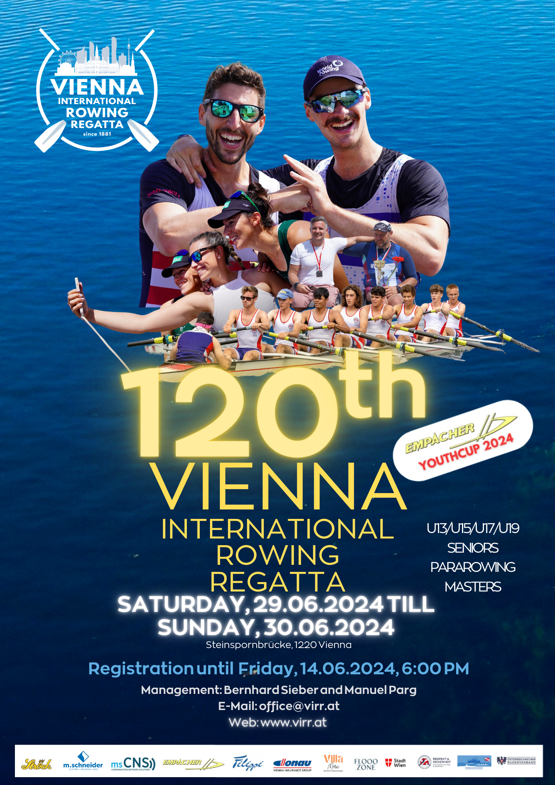

Races in Raceorder - Overview
Overview – Races per Boatclass
Race | Boatclass (*Youthcup) | Schortcut | Distance in m | Entry Fee
1 | Masters Women‘s Pair | MW2- | 1000 | € 50,00
2 | Masters Men’s Four | MM4- | 1000 | € 60,00
3 | U17 Women‘s Quad* | JWB4X | 1500 | € 60,00
4 | U17 Men’s Double* | JMB2X | 1500 | € 50,00
5 | U13 Men’s Single* | SchMB1X | 500 | € 20,00
6 | U13 Women’s Double* | SchWB2X | 500 | € 25,00
7 | U19 Men’s Pair* | JMA2- | 2000 | € 50,00
8 | U19 Women’s Four* | JWA4- | 2000 | € 60,00
9 | Women’s Pair | W2- | 2000 | € 50,00
10 | Men’s Double + Men‘s Lightweight Double | M2X + LM2x | 2000 | € 50,00
11 | Women’s Quad | W4X | 2000 | € 60,00
12 | Masters Men’s Pair | MM2- | 1000 | € 50,00
13 | Masters Women´s Four | MW4- | 1000 | € 60,00
14 | U15 Men‘s Single* | SCHM1X | 1000 | € 35,00
15 | U15 Women’s Double* | SCHW2X | 1000 | € 50,00
16 | U17 Women’s Four* | JWB4- | 1500 | € 60,00
17 | U17 Men’s Pair* | JMB2- | 1500 | € 50,00
18 | U19 Men’s Double* | JMA2X | 2000 | € 50,00
19 | U19 Women’s Single* + U19 Women’s Lightweight Single* | JWA1X+LW | 2000 | € 35,00
20 | Men’s Eight | M8+ | 2000 | € 80,00
21 | Masters Men’s Double | MM2x | 1000 | € 50,00
22 | Masters Women’s Quad | MW4x | 1000 | € 60,00
23 | Men’s Pair | M2- | 2000 | € 50,00
24 | Women’s Single + Women’s Lightweight Single | W1X+LW | 2000 | € 35,00
25 | U15 Men’s Quad* | SCHM4X | 1000 | € 60,00
26 | U17 Men’s Single* | JMB1X | 1500 | € 35,00
27 | U17 Women’s Eight* | JWB8+ | 1500 | € 80,00
28 | U13 Women’s Single* | SchWB1X | 500 | € 20,00
29 | U13 Men’s Double* | SchMB2X | 500 | € 25,00
30 | U19 Men’s Four* | JMA4- | 2000 | € 60,00
31 | U19 Women’s Pair* | JWA2- | 2000 | € 50,00
32 | Women’s Quad | W4- | 2000 | € 60,00
33 | Masters Women’s Single | MW1X | 1000 | € 35,00
34 | Masters Men’s Eight | MM8+ | 1000 | € 80,00
35 | PR3 Mixed Double and Inclusion-Mixed-Double | PR3+INKMix2X | 2000 | € 50,00
36 | PR1 Men’s Single and PR2 Mixed Double | PR1M1X+PR2Mix2X | 2000 | € 35,00
37 | U17 Men’s Four* | JMB4- | 1500 | € 60,00
38 | U17 Women’s Double* | JWB2X | 1500 | € 50,00
39 | U15 Men’s Double* | SCHM2X | 1000 | € 50,00
40 | U15 Women’s Single* | SCHW1X | 1000 | € 35,00
41 | U19 Men’s Single* + U19 Men’s Lightweight Single* | JMA1X+LW | 2000 | € 35,00
42 | U19 Women’s Quad* | JWA4X | 2000 | € 60,00
43 | Men’s Single + Men’s Lightweight Single | M1X+LW | 2000 | € 35,00
44 | Women’s Eight | W8+ | 2000 | € 80,00
45 | Masters Women’s Eight | MW8+ | 1000 | € 80,00
46 | Masters Men’s Single | MM1X | 1000 | € 35,00
47 | U17 Men’s Quad | JMB4X | 1500 | € 60,00
48 | U17 Women’s Quad | JWB2- | 1500 | € 50,00
49 | U19 Women’s Double | JWA2X | 2000 | € 50,00
50 | Women’s Double + Women’s Lightweight Double | W2X + LW2x | 2000 | € 50,00
51 | Men’s Four | M4- | 2000 | € 60,00
52 | Men’s Quad | M4X | 2000 | € 60,00
53 | PR1 Women’s Single | PR1W1X | 2000 | € 35,00
54 | Masters Women’s Double | MW2X | 1000 | € 50,00
55 | Masters Men’s Quad | MM4X | 1000 | € 60,00
56 | U15 Women’s Quad* | SCHW4X | 1000 | € 60,00
57 | U19 Men’s Quad | JMA4X | 2000 | € 60,00
58 | U17 Women’s Single* | JWB1X | 1500 | € 35,00
59 | U17 Men’s Eight* | JMB8+ | 1500 | € 80,00

Race | Boatclass (*Youthcup) | Shortcut | Distance in m | Entry Fee
U13 Women
28 | U13 Women’s Single* | SchWB1X | 500 | € 20,00
6 | U13 Women’s Double* | SchWB2X | 500 | € 25,00
U13 Men
5 | U13 Men’s Single* | SchMB1X | 500 | € 20,00
29 | U13 Men’s Double* | SchMB2X | 500 | € 25,00
U15 Women
40 | U15 Women’s Single* | SCHW1X | 1000 | € 35,00
15 | U15 Women’s Double* | SCHW2X | 1000 | € 50,00
56 | U15 Women’s Quad* | SCHW4X | 1000 | € 60,00
U15 Men
14 | U15 Men’s Single* | SCHM1X | 1000 | € 35,00
39 | U15 Men’s Double* | SCHM2X | 1000 | € 50,00
25 | U15 Men’s Quad * | SCHM4X | 1000 | € 60,00
U17 Women
58 | U17 Women’s Single* | JWB1X | 1500 | € 35,00
48 | U17 Women’s Pair* | JWB2- | 1500 | € 50,00
38 | U17 Women’s Double* | JWB2X | 1500 | € 50,00
16 | U17 Women’s Four* | JWB4- | 1500 | € 60,00
3 | U17 Women’s Quad* | JWB4X | 1500 | € 60,00
27 | U17 Women’s Eight* | JWB8+ | 1500 | € 80,00
U17 Men
26 | U17 Men’s Single* | JMB1X | 1500 | € 35,00
17 | U17 Men’s Pair* | JMB2- | 1500 | € 50,00
4 | U17 Men’s Double* | JMB2X | 1500 | € 50,00
37 | U17 Men’s Four* | JMB4- | 1500 | € 60,00
47 | U17 Men’s Quad * | JMB4X | 1500 | € 60,00
59 | U17 Men’s Eight* | JMB8+ | 1500 | € 80,00
U19 Women
19 | U19 Women’s Single* + U19 Lightweight Women’s Single* | JWA1X+LJWA1X | 2000 | € 35,00
31 | U19 Women’s Pair* | JWA2- | 2000 | € 50,00
49 | U19 Women’s Double* | JWA2X | 2000 | € 50,00
8 | U19 Women’s Four* | JWA4- | 2000 | € 60,00
42 | U19 Women’s Quad* | JWA4X | 2000 | € 60,00
U19 Men
41 | U19 Men’s Single* + U19 Lightweight Men’s Single* | JMA1X+LJMA1X | 2000 | € 35,00
7 | U19 Men’s Pair* | JMA2- | 2000 | € 50,00
18 | U19 Men’s Double* | JMA2X | 2000 | € 50,00
30 | U19 Men’s Four* | JMA4- | 2000 | € 60,00
57 | U19 Men’s Quad* | JMA4X | 2000 | € 60,00
Women
24 | Women’s Single + Women’s Lightweight Single | W1X+LW1X | 2000 | € 35,00
9 | Women’s Pair | W2- | 2000 | € 50,00
50 | Women’s Double + Women’s Lightweight Double | W2X+LW2x | 2000 | € 50,00
32 | Women’s Four | W4- | 2000 | € 60,00
11 | Women’s Quad | W4X | 2000 | € 60,00
44 | Women’s Eight | W8+ | 2000 | € 80,00
Men
43 | Men’s Single + Men’s Lightweight Single | M1X+LM1X | 2000 | € 35,00
23 | Men’s Pair | M2- | 2000 | € 50,00
10 | Men’s Double + Men’s Lightweight Double | M2X+LM2X | 2000 | € 50,00
51 | Men’s Four | M4- | 2000 | € 60,00
52 | Men’s Quad | M4X | 2000 | € 60,00
20 | Men’s Eight | M8+ | 2000 | € 80,00
Para
53 | PR1 Women’s Single | PR1W1X | 2000 | € 35,00
36 | PR1 Men’s Single and PR2 Mixed Double | PR1M1X+PR2Mix2X | 2000 | € 35,00
35 | PR3 Mixed Double and Inclusion-Mixed-Double | PR3+INKMix2X | 2000 | € 50,00
Masters Women
33 | Masters Women’s Single | MW1X | 1000 | € 35,00
54 | Masters Women’s Double | MW2X | 1000 | € 50,00
1 | Masters Women’s Pair | MW2- | 1000 | € 50,00
22 | Masters Women’s Quad | MW4X | 1000 | € 60,00
13 | Masters Women’s Four | MW4- | 1000 | € 60,00
45 | Masters Women’s Eight | MW8+ | 1000 | € 80,00
Masters Men
46 | Masters Men‘s Single | MM1X | 1000 | € 35,00
21 | Masters Men’s Double | MM2X | 1000 | € 50,00
12 | Masters Men’s Pair | MM2- | 1000 | € 50,00
55 | Masters Men’s Quad | MM4X | 1000 | € 60,00
2 | Masters Men’s Four | MM4- | 1000 | € 60,00
34 | Masters Men’s Eight | MM8+ | 1000 | € 80,00
Organizing Committee
Vienna Rowing Association
Anton Bosch Gasse 27/16
1210 Wien
Austria
Email: office@ruderverband.wien
Web: www.ruderverband.wien
Chairman of the Vienna Rowing Association: Andreas Kral
Regatta management: Manuel Parg and Bernhard Sieber
Email: office@virr.at
Mobile: +43 664 5535058 / +43 664 75053026

Provisional Timetable

Fr., 14.06. | 18:00 hrs | Closing Date for Entries
Fr., 28.06. | 10:00 hrs | Start of training
 |  | Teammanager’s Meeting*
 |  | Jury Meeting
Sa., 29.06. | 08:00 hrs | Expected start of racing
So., 30.06. | 07:30 hrs | Expected start of racing

* The "Team Managers’ Meeting" will take place on Friday, June 28th, 2024 and is mandatory for all team managers! The exact time and location will be published with the entry results at the latest.

General Regulations
- The regatta takes place on the regatta course Vienna - Neue Donau/Steinspornbrücke according to the regulations of the RoR of the FISA supplemented by the RWB of the ÖRV. The course has 6 lanes and is equipped with an Albano system and a traffic light start system.
- The start for 2000m races will be from the starting bridge with a traffic light start, for all other race distances there will be a flying start.
- The boat classes and the order of the races are shown in the race program on page 2.

- Age categories
SchM-B/SchW-B | = U13 | 2012 and younger
SchM/SchW | = U15 | 2010/2011
JMB/JWB | = U17 | 2008/2009
JMA/JWA | = U19 | 2006/2007
M/W | = Men and Women | 2005 and older

- Junior rowers: must be swimming competent and insured. All Austrian juniors - also U13/U15 - who start are only allowed to start with a valid junior license. The junior licenses of the registered rowers must be available to the secretariat of the ÖRV at the latest by the registration deadline of the regatta. If the license of a rower is not available at the time of the registration deadline, the rower loses his (her) eligibility to start. The entry is invalid.

- Lightweights: Lightweight rowers will start in the respective open boat classes as shown on page 2 and will be scored separately.
A female single sculler may not weigh more than 59 kg (junior 57.5 kg).
A male single sculler may not weigh more than 72.5 kg (junior 67.5kg).
The weighing of the light weights will take place 2 to max. 1 hour before the first race of the team on each regatta day in the marked room.

- Coxswains: The minimum weight of the coxswains results from the RWB. The coxswains will be weighed in race uniform at the earliest two and at the latest one hour before the first race in which they participate on each regatta day. For necessary weights, which are not brought along, a deposit of 20,- euros is to be deposited.

Progression System
- All races will take place on a maximum of 6 starting lanes.
- The races of all boat classes on Saturday are Heats and count as qualification for the final races on Sunday. If there are less than 7 boats entered in a class, the Saturday race will be held as a race for lanes.
- If there are more than 18 entries for a race, the heats will be held as a time trial. Alternate starts on 2 lanes at 30 second intervals.
- The progression mode is based on the number of entries per race and is available on the website www.virr.at/information. Those who did not start or finish on Saturday will be placed in the last final on Sunday.
- The organizer reserves the right to seed teams regardless of the preliminary race.

Entries and entry fees
- Entries are to be made exclusively at http://regatten.rudern.at/.
- The entries must contain all information of the prescribed forms.
- Entry Deadline: Friday, 14th June, 2024 at 18:00 hrs.
- Late entries will be accepted until Friday, 28th June, 2024 at 18:00 hrs.
Races will be held if at least two boats are registered at the entry deadline.
The OC is responsible for the decision of the combination of races with single registrations. Late entries will only be accepted for races existing on June, 14th 2024. However, there is no entitlement for acceptance of a late entry. A decision in this regard is at the sole discretion of the OC. Late entries will be classified according to availability. Entry fee for late entries according to RWB with 50% surcharge.
- Mixed club crews are allowed, except for the U13 and U15 races.
- By registering, the registering club confirms that the participants have been informed that participation in the races may only be completed with appropriate clothing and equipment and in sufficient physical condition.
- The registering club confirms that the registered members agree to the processing of their personal data by the organizer and the ÖRV for the purpose of informing the public about participation and results within the framework of the data protection regulations; this agreement also applies to the publication of photos and film recordings.
- The entry fees are to be transfered to the account,
IBAN: AT85 6000 0101 1015 5749, BIC: BAWAATWW in the name of "Wiener Ruderverband".
with the reference "VIRR 2024 + Name of Rowing Club“

The entry fees are to be transferred until Monday, 24th June, 2024 at 18:00 hrs.

- Cash payments are not possible. If a race is cancelled, the entry fee will be refunded according to RWB §37 (6).

- Entry fees are valid per boat class and boat for the whole race weekend (one price for Saturday and Sunday).
Boatclass  (U15, U17, U19, M/W, MM/MW) | Fee per Entry and Weekend
1x | € 35,00
2x/2- | € 50,00
4x/4- | € 60,00
8+ | € 80,00
Boatclass  (U13) | Fee per Entry and Weekend
1x | € 20,00
2x | € 25,00

- Foreign clubs pay 50% of the fees and a maximum of € 800,-
- Austrian clubs pay 100% of the fees and a maximum of € 1.500,-
- With the entry a team manager incl. phone number has to be announced to office@virr.at. The team manager agrees to receive information about the regatta via Whatsapp group.

Para-Rowing
- PR1 and PR3 follow the international classification guidelines, but a start is also possible for rowers without an official classification.
- Inclusion boats: must be seated by at least one para-rower.
- Mixed classes: Teams must consist of both male and female athletes.

Youthcup 2024
The club with the youth team that scores the most total points according to the criteria below will be awarded. The ranking is based on the 31 races marked with "*" (all U13, U15, U17, U19 races - see page 2).
The points classification is composed of start points and performance points:
- Start points: for each athlete competing in a final race the club receives 1 point (incl. coxswains).
- Performance points: see table below
Entries** | 2 | 3 | 4 | 5 | 6 | 7 | ≥ 8
- place | 2 | 3 | 4 | 5 | 6 | 7 | 8
- place | 0 | 1 | 2 | 3 | 4 | 5 | 6
- place | - | 0 | 1 | 2 | 3 | 4 | 5
- place | - | - | 0 | 1 | 2 | 3 | 4
- place | - | - | - | 0 | 1 | 2 | 3
- place | - | - | - | - | 0 | 1 | 2
- place | - | - | - | - | - | 0 | 1
- place | - | - | - | - | - | - | 0
>9. place | - | - | - | - | - | - | -
** The number is determined by the number of boats starting in one boat class over all finals on Sunday.
Mixed Club Crews: Each club within the Crew receives the number of starting points of the starting athletes belonging to the club (incl. coxswains) and the full number of performance points of the won placing (see table; e.g. Performance points: Mixed Crew AB wins a race with 6 starting boats and is composed of athletes from club A and club B: both club A and club B receive 6 points). If a racing group is registered as an association, this association receives the points, the decisive factor is the registered team name. Mixed Crews in U13 and U15 are not allowed.
Note: Points will only be awarded if the team competes in both the preliminary race / heat (on Saturday) and the final race (on Sunday).
Prize: The club with the most total points (start and performance points added) will receive the Youth Cup and a cash prize. The payment will be made to the authorized entrant or team manager.
Further Details (go to: https://www.virr.at/information/clubs)

Einheitliches Gendern: einmal mit : , dann wieder mit * oder mit großem I

Masters
- Entries for Masters races are only valid with indication of the year of birth.
The rowers must be able to prove their age with an official document.
The international age categories A to J are valid.
A - minimum age 27 years | B - average age 36 years
C - average age 43 years | D - average age 50 years
E - average age 55 years | F - average age 60 years
G - average age 65 years | H - average age 70 years
I - average age 75 years | J - average age 80 years

  - The race will be held with at least two teams from two clubs (regardless of whether they belong to the same age category (e.g. A+A; then no handicap is applied) or whether they belong to two different, but no more than 2 adjacent handicap age categories (e.g. A+B or B+C; then the handicap is applied according to the table below)).

  - Table of Handicap: (time advantage in seconds for the 1000 m distance); The time differences given apply only to adjacent age categories for races over 1,000 meters.

Age categroy | A | B | C | D | E | F | G | H | I | J | K
Boatclass
4x/8+ | 0 | 2 | 3 | 4 | 5 | 6 | 7 | 8 | 9 | 10 | 11
2x | 0 | 2 | 4 | 5 | 6 | 7 | 8 | 9 | 10 | 12 | 14
1x | 0 | 2 | 5 | 6 | 7 | 8 | 9 | 10 | 11 | 13 | 15

- The umpires will announce at the start whether, depending on the wind conditions, the start will be with a handicap or whether the handicap will be settled at the finish.
- If the starting umpire decides on a false start, the starting procedure will not be stopped. The guilty team receives a time penalty of 15 seconds.

Miscellaneous
- Big Blades are not allowed in U13 and U15 races.
- The winning teams of all final races on Sunday will receive prizes.
  - In races with more than 3 starting final boats: Place 1-3 will receive medals.
  - In races with 3 or less starting final boats: 1st place will receive a medal.
  - In combined races: the above two points are valid for each starting category. There will be one award ceremony per category after the finish of the best placed boat in each category.
- In Master races: Exclusively 1st place in each age category will receive a medal, regardless of whether the age categories are raced together or separated.

  - The storage of the boats and the parking of the boat transport trolleys are exclusively at your own risk. The organizer does not assume any liability.
- For the access to the regatta area with boat trailers and/or crew buses an entry permit is available against a deposit of 20,- euros.
- The COVID preventive measures are based on the legal requirements valid for the regatta weekend and will be strictly observed.
- Liability: The organizer is liable according to the provisions of Austrian statutory law. The insurance of material and persons is a matter of the participants. The organizer does not assume any liability for damages of any kind.
- Approved by the Technical Commission of the ÖRV on 07th of Feb 2024 regarding conformity to the rules and regulations of the ÖRV and any deviations therefrom. The organizing club is liable for the compliance with all (also official) regulations.

