Kaffetårnet – a story of signage
Edvard Alexander Rølvaag
Re-store: Values
Fall 2022
AHO

Synopsis
60 years ago, the city center of Oslo was crowded with neon signage. Through the years many of them were demounted and forgotten, while others have become recognizable landmarks in the city – the Freia sign in Karl Johans gate being the most iconic. Further west, in the industrial harbor of Filipstad we find two other well-known signs; the Ali Kaffe and Evergood signage on Kaffetårnet – the coffee tower.

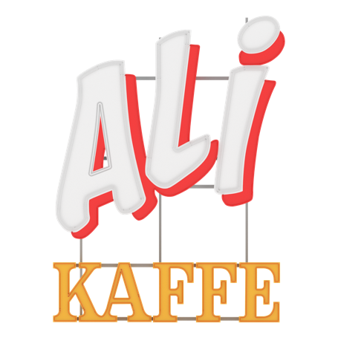
Since the 1960s, Kaffetårnet has been a significant imprint on the Oslo skyline, facing the fjord. Convincing the municipal building authorities to allow such a high-rising industrial tower proved difficult for business owner Joh. Johansson. Once realized however, the vertical facility became a great success for the company’s coffee production and further growth. Although residents in the area initially complained about the tower blocking the view of the fjord and the neon signage being too large and too bright, the tower and its signs became a recognizable landmark in Oslo. One may also consider it a symbol of the coffee culture that emerged in Norway after the war.

60 years later, the area of Filipstad is on the edge of total transformation. The industry is moving out and one can no longer smell the scent of newly roasted coffee. A memory of industry will however persist, as the municipality has decided to preserve the tower – and the sign with it.

Research question
What is the relationship between signage and architecture, and how does the combination of the two affect the city around it?
What is preserved when the company moves all activity out of Kaffetårnet and only an empty tower and a sign remain?
