Hearing Loss in Autoimmune Rheumatic Diseases

1. Excellence

1.1 State of the art, knowledge needs and project objectives
Hearing loss is a major public health issue. It affects how we communicate, connect, and live. It is linked to poorer mental health, social isolation, future dementia, and increased healthcare costs (Cunningham et al. 2017, Myrstad et al. 2023). About 1 in 20 adults in high-income countries live with disabling hearing loss, and the number climbs to nearly 50% among men over 75 (Stevens et al. 2013). In 2015, it was the leading contributor to years lived with disability in older adults (Vos et al. 2016). Yet many people live with hearing loss for years before seeking help, because symptoms are gradual, often overlooked, and rarely prioritized. This makes early detection of people with increased risk especially important.
Autoimmune rheumatic diseases (ARDs) like rheumatoid arthritis (RA), spondylarthritis (SpA), psoriatic arthritis (PsA), and systemic lupus erythematosus (SLE) are inflammatory conditions that don’t just affect the joints. Extra-articular manifestations are common; the lungs, skin, eyes, blood vessels, and, importantly, the auditory system can be involved. Many patients report hearing difficulties, tinnitus, or balance problems, suggesting that hearing loss may be a clinically relevant but under-recognized complication (Skare et al. 2025).

1.1.1 Observational evidence linking ARDs to hearing loss
Several cross-sectional studies have shown an increased risk of sensorineural hearing loss (SNHL) in ARD patients. A meta-analysis of 12 studies involving over 20,000 RA patients found 3.4-fold higher odds of SNHL compared with controls, with no corresponding increase in conductive loss (Chaitidis et al. 2020). RA patients tend to hear less well, especially at higher frequencies (2,000–8,000 Hz), compared to matched controls, and the degree of impairment appears to increase with disease duration (Kiakojuri et al. 2019). In SLE, a similar meta-analysis reported 2.3-fold increased odds (Paraschou et al. 2021), and pooled data from studies on ankylosing spondylitis (AS) suggest a SNHL prevalence of ~42% (Yan et al. 2021). These studies consistently point to mild-to-moderate, high-frequency SNHL across several autoimmune diseases and suggest that hearing loss exceeds what would be expected based on age alone.
In addition to hearing loss, many patients also report related symptoms such as vertigo, tinnitus, and hyperacusis, suggesting that auditory involvement in ARDs may extend beyond the cochlea (Tsirves et al. 2019).

1.1.2 Pathophysiological mechanisms
Pathways linking ARDs to hearing loss are biologically plausible and vary by disease. Mechanisms include:
- Immune-mediated cochlear damage, such as vasculitis of cochlear vessels, antibody deposition, and hair-cell injury.
- Ototoxicity from ARD treatment, including non-steroid anti-inflammatory drugs (NSAIDs) and disease-modifying anti-rheumatic drugs (DMARDs), may cause temporary or permanent hearing loss.
- Inflammatory damage to middle-ear joints, particularly in RA, where the small joints may be affected by the same destructive processes as peripheral joints, potentially leading to conductive hearing loss.
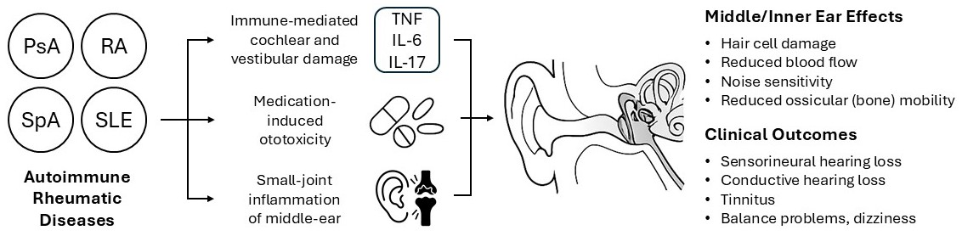
Disease-specific mechanisms vary. In SLE, sensorineural hearing loss (SNHL) may result from cochlear vasculitis or thromboses related to antiphospholipid antibodies (Di Stadio et al. 2017, Chen et al. 2022). In RA, both systemic inflammation and middle ear joint involvement may contribute, along with potential ototoxic effects of treatment (Chen et al. 2022, Chen et al. 2024). In PsA and SpA, evidence is more limited, but emerging studies suggest a role for pro-inflammatory cytokines such as interleukin (IL)-6 and IL-17 (Semenov et al. 2019, Yan et al. 2021, Çağlar Yağcı et al. 2023).

1.1.3 Methodological limitations of prior studies
Despite growing evidence, most prior studies are cross-sectional and/or based on diagnostic codes from administrative data, which may under- or overestimate the true burden (Lin et al. 2013, Huang et al. 2018, Jeong et al. 2019, Lee et al. 2019). Few studies include repeated audiometric testing, limiting their ability to quantify hearing decline over time, and none have prospectively tracked hearing trajectories in ARD cohorts. Confounders like age, noise exposure, ototoxic drugs, and cardiovascular disease are often poorly controlled. It also remains unclear whether ARD-related hearing loss is clinically relevant or which patients are most at risk.

Key Unanswered Questions
- To what extent does hearing worsen over time in individuals with ARDs (beyond normal aging)?
- If hearing does decline, is the degree of loss clinically significant (e.g. impairing communication or quality of life)?
- Are certain patient groups (e.g. based on age, medication use, or disease duration) particularly vulnerable to hearing damage?
- Should patients with ARDs be offered routine hearing monitoring?
- What are the consequences of undetected or untreated hearing loss in patients with chronic inflammatory disease?

1.1.4 Proposed research approach and objectives
To address these gaps, we will use high-quality, longitudinal health and hearing data from the Norwegian HUNT Cohort Study. This unique dataset includes repeated pure-tone audiometry in over 12,000 individuals across two decades. Through linkage to national health registries, we can identify individuals with confirmed diagnoses of ARDs and follow their hearing trajectories over time.
The overall objectives of this project are to:
- Compare longitudinal hearing trajectories in individuals with ARDs and matched population controls
- Quantify the clinical magnitude of any accelerated hearing loss associated with ARDs
- Identify disease-specific and treatment-related factors that predict variation in hearing decline
These aims will provide a strong empirical foundation for future recommendations on hearing monitoring and tailored clinical follow-up in ARDs — with potential implications for prevention and treatment strategies.

1.2 Novelty and ambition
This is the first cohort study to examine the association between ARDs and hearing loss using pure-tone audiometry, the gold standard for hearing assessment. Unlike prior studies, which are mostly small, cross-sectional, and limited by confounding, this project leverages data from a large population-based cohort with 20 years of follow-up.
By combining a cohort design – where exposure (e.g. RA) is established before the outcome (hearing loss) – with longitudinal data on individual hearing trajectories, the study enables robust assessment of both risk and progression of hearing loss. The prospective approach, based on repeated objective measurements, reduces detection bias and allows for precise estimation of clinically relevant change.
The study has strong potential to generate new and generalizable knowledge on the natural history and clinical impact of hearing loss in ARDs. Findings may guide future recommendations for hearing monitoring in rheumatology and contribute to improved patient care and healthcare service planning. The data already exists, and with your support, we hope to fund a PhD student to take on this task together with us.

1.3 Research questions and hypotheses, theoretical approach and methodology

1.3.1 Research questions
This project investigates whether individuals with ARDs, including RA, SpA, PsA, and SLE, are at an increased risk of hearing loss and tinnitus. The following research questions will be addressed through longitudinal, cross-sectional, and sibling analyses:
- Do individuals with ARDs have worse hearing outcomes than those without these diseases?
- To what extent do medications influence the relationship between ARDs and hearing loss?
- Can observed associations be explained by genetic or early environmental factors?

1.3.2 Hypotheses
Hypothesis 1
ARDs are associated with poorer hearing and higher prevalence of tinnitus.
This hypothesis will be examined in two complementary studies, each with their own strengths:
- A longitudinal cohort study (~13,000 individuals with repeated audiometry; 300 with RA 188 with SpA, 242 with PsA and 76 with SLE), analyzing hearing changes over 20 years and incidence of hearing loss, as well as the effect of disease duration.
- A large cross-sectional dataset (over 78,000 observations from either HUNT2 or HUNT4, including 2114 with RA, 443 SLE, and 1179 with SpA, and 1490 with PsA). We will use regression models with robust standard error estimation.
Hypothesis 2
Medication modifies the association between ARDs and hearing loss.
We will explore whether use of DMARDs or NSAIDs alters the association between ARDs and hearing outcomes, either through ototoxicity or inflammation control. Medication will be modeled as a potential effect modifier, and we will test interaction terms between ARD status and medication use. We will also explore direct associations between specific drug classes and hearing, using both interaction and stratified analyses.

This hypothesis will primarily be addressed using cross-sectional audiometric data from HUNT2 and HUNT4, aligned with prescription data from the Norwegian Prescription Database. If data availability permits, supplementary longitudinal analyses may be conducted to explore whether sustained medication use is associated with greater hearing decline over time.

We acknowledge the challenge of confounding by indication, as medication use may correlate with disease severity. Associations will therefore be interpreted cautiously and considered hypothesis-generating. Where possible, we will adjust for disease duration and activity. Findings will be contextualized with existing randomized studies on hearing-related side effects. As this is an exploratory aim, no separate power calculation will be performed.

Hypothesis 3
Genetic and familial factors may contribute to the observed association between ARDs and hearing loss or tinnitus.
We will explore this in the third article using sibling analyses, leveraging the fact that approximately half of HUNT participants have at least one sibling also in the cohort. By applying fixed-effects regression to discordant sibling pairs – where one sibling has an ARD and the other does not – we can control for genetic and early environmental factors shared within families. This provides a robust test of whether the associations seen in the main analyses are explained by family background or reflect a more direct link.
We will compare effect sizes from sibling and conventional models to assess any attenuation. A substantial reduction would suggest confounding by shared factors, while persistent effects would support a disease-related association. Although power is lower in within-family analyses, we expect sufficient sensitivity to detect group-level differences of ≥1 dB, which is considered clinically meaningful. We will then assess whether the associations found in the main analysis are weakened.

1.3.3 Theoretical approach and methodology
The project uses a longitudinal cohort design with registry linkage and within-family comparisons. Participants are drawn from the Trøndelag Health Study (HUNT), which includes pure-tone audiometric data from two time points:
- HUNT2 Hearing (1996–1998, n=50,277)
- HUNT4 Hearing (2017–2019, n=28,339)
A total of 12,964 individuals participated in both surveys, enabling intra-individual comparison of hearing thresholds over a ~20-year period (Engdahl et al. 2020). In total, 65,652 individuals participated in at least one wave, resulting in 78,616 unique audiometric observations. The hearing survey is the largest of its kind and considerable resources have been invested in data collection.
Variable type | Variable | Description | Data source / Period
Exposure | Rheumatic disease | Diagnosed RA, SpA, PsA, and SLE | NPR and HNT (1996-2019)
Outcome | Primary: Hearing threshold  Secondary: Hearing loss, tinnitus | Pure-tone audiometry (continuous in dB and categorical); self-reported hearing loss and tinnitus | HUNT2 hørsel (1996-1998) HUNT4 hørsel (2017-2019)
Confounders | Age, sex, education, occupation |  | Administrative registries
Confounders | Comorbidity | Other chronic diseases (e.g. diabetes, cardiovascular disease) | HUNT2, HUNT4, NPR, and HNT
Confounders | Lifestyle factors | E.g. smoking, physical activity, alcohol, noise | HUNT2 and HUNT4
Moderators | Medication use, sex | DMARDs and NSAIDs | Prescription Database (2004-2019)

The dataset is linked to, among others, the main HUNT database, the National Population Register, the Norwegian Labour and Welfare Administration (NAV), the Norwegian Patient Registry (NPR), and hospital records from Nord-Trøndelag Health Trust (HNT). The NPR and HNT contain diagnostic information from specialist healthcare encounters, including ICD-10 codes and dates of diagnosis. NPR data cover the period 2008–2019, while HNT data span 1996–2007. These sources are considered reliable for identifying disease status, as ARDs are chronic conditions typically diagnosed and managed in specialist care. In addition, we have applied to link medication data from the Norwegian Prescription Database (NorPD). The study also leverages sibling data from HUNT to perform within-family analyses, controlling for shared genetic and environmental factors.

1.3.4 Outcome measures
The primary outcome is hearing thresholds, measured in decibels (dB) using pure-tone audiometry. Hearing threshold refers to the quietest sound a person can hear at a given frequency and will be analyzed as a continuous variable to provide sensitive and precise assessment across the frequency spectrum.

Audiogram depicting a high-frequency sloping sensorineural hearing loss
(source: emedicine.medscape.com)
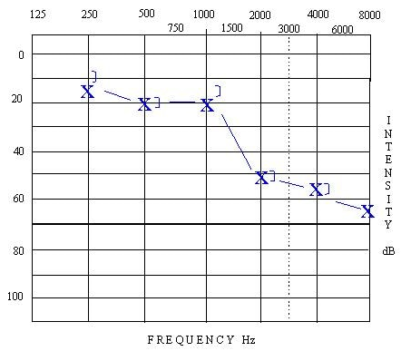
Secondary outcomes include:
- Tinnitus (self-reported, binary)
- Categorical hearing loss defined according to WHO criteria, i.e., a hearing threshold above 25 dB across key speech frequencies (0.5, 1, 2, and 4 kHz) in the better-hearing ear.
- Frequency-specific hearing thresholds (low vs. high frequencies), since studies suggest that high-frequency hearing loss is particularly common in ARDs (Kiakojuri et al. 2019, Yan et al. 2021).
These outcomes reflect different dimensions of hearing impairment and allow for clinical interpretation.

1.3.5 Covariates
Models will adjust for prespecified covariates identified through directed acyclic graphs (DAGs), including:
- Demographic variables: age, sex, education
- Lifestyle factors: smoking status
- Health status: comorbidities (e.g. cardiovascular disease, diabetes)
ARD exposure will be defined using ICD-10 codes from the Norwegian Patient Registry and hospital records: M05–M06 (RA), M07 (PsA), M32 (SLE), and M45–M46 (SpA). In hypothesis 2, medication use (e.g., DMARDs, NSAIDs) will also be included as covariates or potential effect modifiers.

1.3.6 Statistical analysis
We will use multivariable regression models to estimate associations between ARDs and hearing outcomes.
- Primary analysis: linear regression for continuous hearing thresholds
- Tinnitus: logistic regression
- Categorical hearing loss: supplementary logistic models estimating odds ratios and risk differences
- Frequency-specific analysis: separate models for different audiometric frequencies
Models will adjust for relevant covariates as described above. We will also explore whether associations differ by sex (see Section 1.3.7 on gender perspectives).

Power calculations
- Longitudinal cohort: sufficient power (0.80) to detect differences ≥2.5 dB (SD=8)
- Cross-sectional study: able to detect differences ≥1.3 dB (SD=10)
- Smaller ARD groups (e.g., SLE, SpA): able to detect differences of 3–4 dB
- Sibling analysis: lower statistical power overall, but sufficient to detect differences in effect sizes between analytic approaches of ≥1 dB, which is considered clinically meaningful

1.3.7 Ethical considerations
This project is approved by Health Research Ethics (REK; 23178 HUNT Hearing) and has a completed Data Protection Impact Assessment (DPIA). All participants have signed informed consent for their data to be used in research and may withdraw consent at any time. Data linkage has been performed by Statistics Norway (SSB), which also stores the linkage key. All analyses will be conducted within the secure environment of the Services for Sensitive Data (TSD), and identifiable data will not be accessible to the research team.
While identifying associations between chronic disease and hearing loss may carry a risk of stigmatization, we believe the potential benefits, such as improved monitoring, earlier interventions, and better patient care, outweigh this risk. Dissemination efforts will be co-developed with users to ensure that findings are communicated in a responsible and constructive manner.
Gender will be included as a covariate in all analyses, and sex-stratified results will be reported when relevant. Since ARDs are more common in women and hearing loss in men, this is important for identifying sex-specific risk patterns and ensuring generalizability.
The project is observational and registry-based, with no interventions or risks to humans, animals, or the environment. We do not anticipate any negative societal or environmental consequences.

2. Impact

2.1 Potential impact of the proposed research
This project will generate important new knowledge about the long-term prognosis of autoimmune diseases beyond their primary clinical manifestations. If we find that the association with hearing loss is weaker than previously assumed, this would be reassuring for patients. Conversely, if we identify increased risk, it will be essential to improve awareness, enable earlier detection, and explore strategies to preserve hearing.
Importantly: Although several publications claim that patients with ARDs should routinely be offered audiometry, the evidence behind is surprisingly weak. In a healthcare system with limited capacity, we must use our time and resources wisely. If there is no clinically meaningful association – and we have the power to answer this – such routine screening is unnecessary.
The societal relevance is therefore high. Autoimmune diseases often affect individuals of working age, and earlier identification of hearing decline could reduce downstream consequences for employment, mental health, and healthcare use.
Finally, as seen in research on other ototoxic treatments (such as cisplatin in cancer care), systematic investigation of hearing outcomes related to treatment can guide safer and more personalized follow-up. If treatment-related hearing effects are identified, this may inform adjustments in medication choices or monitoring routines. Conversely, if no such effect is found, the results may reassure clinicians and patients that commonly used anti-inflammatory treatments are safe from an auditory perspective (possibly due to the benefits of inflammation control).

2.2 Measures for communication and exploitation
We want the results from this project to matter – not just in academic journals, but also in clinical practice, patient communities, and health policy. This is a collaborative effort across disciplines and sectors, involving researchers from the Norwegian Institute of Public Health (FHI), the National Institute of Occupational Health (STAMI), clinicians from the Department of Rheumatology and the Department of Internal Medicine at Diakonhjemmet Hospital, and representatives from both the Norwegian Association of the Hard of Hearing (HLF) and the Norwegian Rheumatism Association (NRF). This close collaboration across clinical, public health and user arenas strengthens the project's relevance, reach, and ability to impact practice.
Scientific communication and publications
We plan to publish at least three articles in peer-reviewed, open-access journals. Each article will correspond to one of the study’s main hypotheses. The PhD candidate will be responsible for the main analyses and will be first author on all papers. Tentative article titles are:
- Autoimmune rheumatic diseases and longitudinal hearing decline: A population-based cohort study from HUNT
- Medication and hearing outcomes in autoimmune disease: Exploring effect modification by DMARDs and NSAIDs
- Do genes explain it? Sibling analysis of hearing loss in individuals with and without autoimmune rheumatic disease
We will also present findings at relevant international conferences such as EULAR, ACR, and audiology meetings.
Outreach to patient communities
We will work closely with our involved user representatives (see section 3.2), as well as with the organizations HLF and NRF, to ensure that findings are communicated in ways that are both understandable and meaningful. The user representatives will continue to play a central role in interpreting the results, while HLF and NRF will be key dissemination partners. Planned activities include:
- Co-hosted webinars and news articles (platforms available through NRF and REMEDY)
- Written summaries of the project’s findings published in the member magazines of HLF and NRF
Towards health services and policy makers
To reach clinicians, decision-makers, and policy stakeholders, we will share the main results through established platforms such as Dagens Medisin, Forskning.no, and Remedy-senter.no. This will include short news pieces highlighting main results and their relevance for clinical practice. A good example from previous work: Aldring og helse – «Dårlig hørsel er blant de viktigste risikofaktorene for demens hos eldre».

3. Implementation

3.1 Researcher and project group
This project is part of HUNT Hearing, which investigates causes and consequences of hearing loss in the population. We have assembled a strong, motivated and interdisciplinary research team with complementary expertise in audiology, rheumatology, epidemiology, and internal medicine.
The project will be based at REMEDY (Center for Treatment of Rheumatic and Musculoskeletal Diseases) at Diakonhjemmet Hospital, in collaboration with FHI and STAMI. These institutions offer internationally recognized expertise in clinical research, epidemiology, and registry-based methods. REMEDY was rated outstanding in key areas including research quality, publications and support for researchers in the latest EVALMEDHELSE evaluation. Our supervisors from FHI and STAMI have led numerous studies using HUNT Hearing data, resulting in over 60 peer-reviewed publications and several externally funded projects, including previous grants from the Dam Foundation.
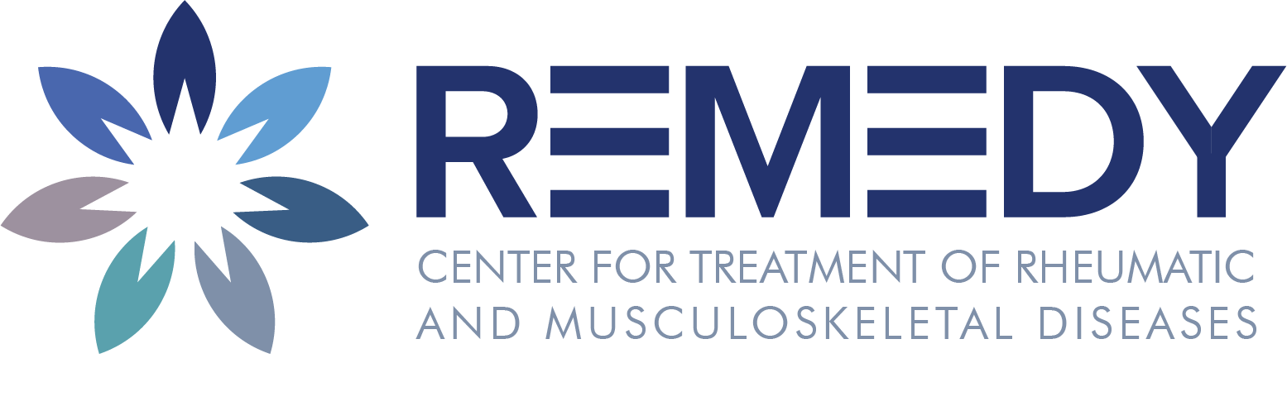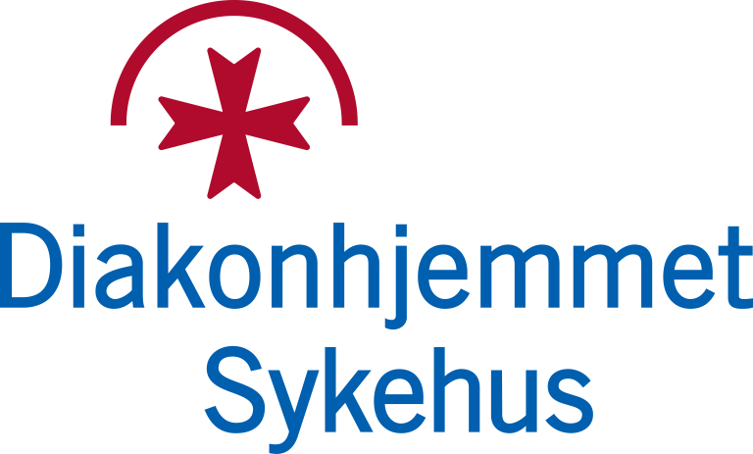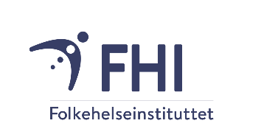

The main supervisor, Alexander Mathiessen, is a medical doctor (MD), PhD, and postdoctoral researcher at Diakonhjemmet Hospital, currently completing his specialization in rheumatology. He has broad research experience in musculoskeletal imaging, epidemiology, and cohort studies, and has lectured at the University of Oslo for several years. Mathiessen currently leads the MERINO RCT trial and the REMEDY Young Researcher Program at Diakonhjemmet Hospital, and acts as scientific advisor to the REMEDY Patient Council. He also supervises a Master student at NTNU. He has authored over 30 peer-reviewed publications and completed a one-year postdoctoral fellowship at Harvard Medical School in Boston, USA. As main supervisor, he will ensure strong clinical and methodological integration across the project.
Co-supervisor Bo Engdahl, PhD, is a senior researcher at FHI and head of the HUNT Hearing. With a background in audiology and acoustics, Engdahl has extensive experience in hearing epidemiology and large-scale population data. He has in-depth knowledge of the HUNT dataset and will play a key role in shaping the study design and analytical approach.
Co-supervisor Lisa Aarhus, MD, PhD, is a specialist in occupational medicine and senior researcher at the National Institute of Occupational Health (STAMI), where she has led research on hearing loss at work using HUNT data. She also has in-depth knowledge of the HUNT Hearing dataset and, like Engdahl, will contribute to data planning and interpretation. She brings broad experience in hearing research, epidemiology, and clinical medicine, and is currently finalizing her specialization in pulmonary medicine at Diakonhjemmet Hospital.
Co-supervisor Erik Øie, MD, PhD, is Professor of Internal Medicine at the University of Oslo and senior consultant in cardiology at Diakonhjemmet Hospital. He has extensive experience in translational research. Øie will contribute to the project with methodological expertise and academic supervision, particularly in the integration of clinical and epidemiological perspectives.
Additional project participants further strengthen the interdisciplinary nature of the team. Sella Aarrestad Provan, MD PhD, is a professor and senior researcher and rheumatologist at Diakonhjemmet Hospital. She leads REMEDY WP6, focusing on long-term outcomes, safety, work participation and health economics through national registry linkage. In this project, she will contribute her unique expertise in registry-based research, and it is also in WP6 in REMEDY that the project will be affiliated.
Leif Erik Vinge, MD, PhD, and Anne Kristin Gulsvik, MD, PhD, are senior doctors at the department of internal medicine at Diakonhjemmet Hospital. Vinge has relevant research experience on comorbidities in ARDs, while Gulsvik has a longstanding interest in epidemiological research on modifiable risk factors and chronic disease. Both will contribute with clinical insight and methodological support to the project.
From the REMEDY Patient Council at Diakonhjemmet Hospital, two user representatives, Eli Ormerod and Ola Jacob Sønsthagen, have been involved since the initial drafting of the protocol and will remain engaged throughout the project (see end of section 3.2.3). They were selected based on relevant user experience to this project and because of their long experience as user representatives in other research projects.

3.2 Project organisation and management

3.2.1 PhD work plan and progression
The PhD candidate will be based at Diakonhjemmet Hospital in a modern, open, and inclusive office environment shared with other PhD candidates, postdocs, senior researchers, statisticians, and study coordinators. The PhD candidate will begin with mandatory coursework and a STATA course during the first semester, followed by data work, statistical analyses, manuscript writing, and thesis development. The candidate will receive regular supervision and mentoring from the project’s interdisciplinary academic team, and participation in international conferences is encouraged to support academic growth and visibility.
All registry linkages (except for prescription data) have already been completed. The dataset is cleaned and stored on the Services for Sensitive Data (TSD) platform at the University of Oslo. A project amendment will be submitted to REK and data owners to formally include the PhD candidate. Analyses and manuscript work can begin as soon as access is granted. Data on medication use will not be relevant until Article 2, so there is sufficient time to obtain this information. The candidate will write three research articles for the thesis and is expected to complete the PhD within three years. A Gantt chart outlining the timeline is provided below.
Activity | 2026 | 2027 | 2028
REK approval | ████
Data analysis and manuscript 1 (H1) | ████████
Mandatory coursework at University of Oslo | ████████ | ████████
Conference preparation and participation | ████ | ████████ | ████████
Data analysis and manuscript 2–3 (H2, H3) |  | ████████
Thesis writing and submission |  |  | ████████
The PhD candidate will also take part in the REMEDY Young Researcher Program (YRP), a free career development initiative for early-career researchers within REMEDY, offering education and networking beyond what is offered through the standard University education. This includes participation in the annual YRP seminars, access to PhD journal clubs and thematic workshops on methodology and academic progression, mentoring, and support on how to incorporate user perspectives in research.

3.2.2 User involvement collaboration
We believe in user involvement from start to finish and will collaborate closely with the REMEDY Patient Council at Diakonhjemmet Hospital. This is a group where people with ARDs receive training and actively contribute to research projects. The user representatives involved in this project are members of the council, and the project applicant, Alexander Mathiessen, has served on its board for the past three years. Through this network, user representatives have free access to national and international courses (sponsored by REMEDY) to strengthen their role in research. The council meets five times a year and is also invited to participate in REMEDY’s annual research seminar, which gathers our entire research community (140 participants in 2025).
Furthermore, we have experienced that working closely with user representatives can be new and unfamiliar to a novice PhD candidate. To support this collaboration, the main supervisor will facilitate early contact and regular follow-up meetings, and the candidate is also offered individual and group mentoring by the head of the REMEDY Patient Council, Marianne Skaar. We also think it is useful for the candidate to be assigned to the new national course in “User involvement in health research” in Bergen – a collaboration between UiB, Neuro-SysMed, CCBIO, NorHEAD, Matrix, NorCRIN, FORMI/OUS and REMEDY. The course is funded by Stiftelsen Dam and coordinated by Nasjonalforeningen for folkehelsen.
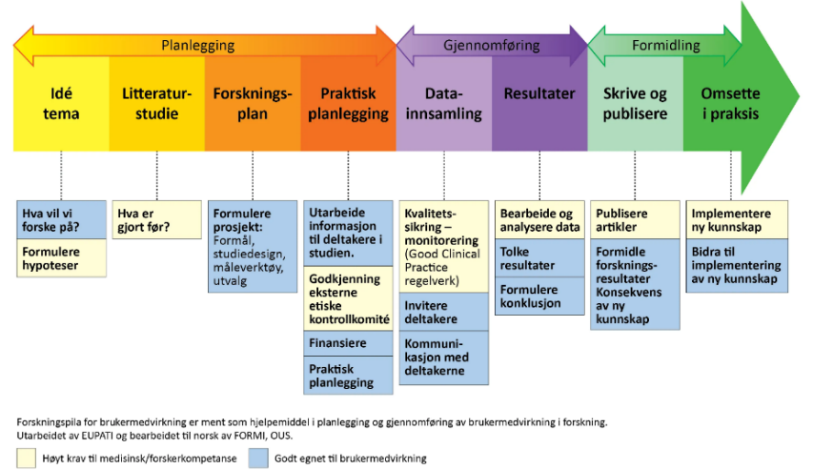
In practice, we will follow the Norwegian recommendations for collaboration between users and researchers, developed by FORMI/OUS. These give step-by-step advice on how to involve users meaningfully throughout the project (see illustration). We will also ensure appropriate recognition of user contributions, including co-authorship and compensation where applicable (de Wit et al. 2024).

3.2.4 NGO collaboration
HLF, the Non-Governmental Organization (NGO) responsible for submitting the application to Dam, has likewise been involved from the beginning. A representative from HLF contributed to the initial protocol development alongside the user representatives, helping ensure the project addresses issues relevant to people with hearing loss. As described in section 2.2, we will continue to collaborate with both HLF and NRF to ensure the findings are communicated in accessible and useful ways to those most affected.

3.2.5 Budget
The budget accounts for the current salary level for a PhD fellow (medical doctor) as of June 2025 at Diakonhjemmet Hospital. We are also required to pay NOK 30,000 to HUNT per publication. The main applicant commits to seek additional funding to ensure that the PhD candidate can complete the degree, attend international conferences annually and compensate user representatives.
…
We appreciate the time and effort the reviewers have dedicated to evaluating our application.

References
Çağlar Yağcı, H., et al. (2023). "Hearing loss can also be seen in patients with nonradiographic axial spondyloarthropathies as well as radiographic axial spondyloarthropathies." Arch Rheumatol 38(2): 257-266.
Chaitidis, N., et al. (2020). "Association of rheumatoid arthritis with hearing loss: a systematic review and meta-analysis." Rheumatol Int 40(11): 1771-1779.
Chen, H., et al. (2022). "Characteristics of Hearing Loss in Patients with Systemic Lupus Erythematosus." J Clin Med 11(24).
Chen, J. J., et al. (2024). "Audiological Features in Patients with Rheumatoid Arthritis: A Systematic Review." Int J Mol Sci 25(24).
Cunningham, L. L., et al. (2017). "Hearing loss in adults." 377(25): 2465-2473.
Di Stadio, A., et al. (2017). "Systemic Lupus Erythematosus and hearing disorders: Literature review and meta-analysis of clinical and temporal bone findings." J Int Med Res 45(5): 1470-1480.
Engdahl, B., et al. (2020). "Better Hearing in Norway: A Comparison of Two HUNT Cohorts 20 Years Apart." Ear Hear 42(1): 42-52.
Huang, C. M., et al. (2018). "Retrospective cohort study on risk of hearing loss in patients with rheumatoid arthritis using claims data." BMJ Open 8(1): e018134.
Jeong, J., et al. (2019). "High Risk of Sudden Sensorineural Hearing Loss in Several Autoimmune Diseases according to a Population-Based National Sample Cohort Study." Audiol Neurootol 24(5): 224-230.
Kiakojuri, K., et al. (2019). "Hearing status in patients with rheumatoid arthritis." Caspian J Intern Med 10(4): 447-451.
Lee, S. Y., et al. (2019). "Increased risk of sudden sensory neural hearing loss in patients with rheumatoid arthritis: a longitudinal follow-up study using a national sample cohort." Clin Rheumatol 38(3): 683-689.
Lin, C., et al. (2013). "Risk of sudden sensorineural hearing loss in patients with systemic lupus erythematosus: a population-based cohort study." Audiol Neurootol 18(2): 95-100.
Myrstad, C., et al. (2023). "Hearing impairment and risk of dementia in The HUNT Study (HUNT4 70+): a Norwegian cohort study." 66.
Paraschou, V., et al. (2021). "Association of systemic lupus erythematosus with hearing loss: a systemic review and meta-analysis." Rheumatol Int 41(4): 681-689.
Semenov, Y. R., et al. (2019). "Association Between Psoriasis with Arthritis and Hearing Impairment in US Adults: Data from the National Health and Nutrition Examination Survey." J Rheumatol 46(6): 587-594.
Skare, T. L., et al. (2025). "Hearing Loss in Connective Tissue Diseases: A Systematic Review." Eur J Rheumatol 12(1): 1-24.
Stevens, G., et al. (2013). "Global and regional hearing impairment prevalence: an analysis of 42 studies in 29 countries." 23(1): 146-152.
Tsirves, G. K., et al. (2019). "Cochlear involvement in patients with systemic autoimmune rheumatic diseases: a clinical and laboratory comparative study." Eur Arch Otorhinolaryngol 276(9): 2419-2426.
Vos, T., et al. (2016). "Global, regional, and national incidence, prevalence, and years lived with disability for 310 diseases and injuries, 1990–2015: a systematic analysis for the Global Burden of Disease Study 2015." 388(10053): 1545-1602.
Yan, F., et al. (2021). "Hearing Loss in Patients With Ankylosing Spondylitis: A Systematic Review and Metaanalysis." J Rheumatol 48(1): 40-47.
Abbreviations
ARD(s) | Autoimmune Rheumatic Disease(s)
DAG(s) | Directed Acyclic Graph(s)
DMARD(s) | Disease-Modifying Anti-Rheumatic Drug(s)
DPIA | Data Protection Impact Assessment
FHI | Folkehelseinstituttet (Norwegian Institute of Public Health)
HLF | Hørselshemmedes Landsforbund (Norwegian Association of the Hard of Hearing)
HNT | Helse Nord-Trøndelag (Nord-Trøndelag Health Trust)
HUNT | Helseundersøkelsen i Nord-Trøndelag (The Trøndelag Health Study)
ICD-10 | International Classification of Diseases, 10th Revision
IL | Interleukin
NAV | Arbeids- og velferdsetaten (Norwegian Labour and Welfare Administration)
NGO | Non-Governmental Organization
NPR | Norsk pasientregister (Norwegian Patient Registry)
NRF | Norsk Revmatikerforbund (Norwegian Rheumatism Association)
NSAID(s) | Non-Steroidal Anti-Inflammatory Drug(s)
NorPD | Reseptregisteret (Norwegian Prescription Database)
PsA | Psoriatic Arthritis
RA | Rheumatoid Arthritis
REK | Regionale komiteer for medisinsk og helsefaglig forskningsetikk (Regional Committees for Medical and Health Research Ethics)
REMEDY | Center for treatment of Rheumatic and Musculoskeletal diseases
SLE | Systemic Lupus Erythematosus
SNHL | Sensorineural Hearing Loss
SSB | Statistisk sentralbyrå (Statistics Norway)
STAMI | Statens arbeidsmiljøinstitutt (National Institute of Occupational Health)
SpA | Spondylarthritis
TSD | Tjenester for sensitive data (Services for Sensitive Data)
YRP | Young Researcher Program

