Evaluating my LED nature art

Which examples of wildlife from our nature walk did you create LED nature art for?

Which image representation are you most happy with?

Why are you happiest with this representation?

Which representation do you think needs to be improved?

Why do you think this representation needs to be improved?

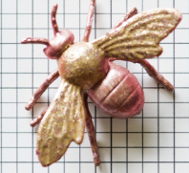
When you planned and programmed your LED representation, you will have found and fixed mistakes. Can you remember what this is called?

