Identifying the actions of a program

For each part of the program, identify the variable and how it is used and when this happens.

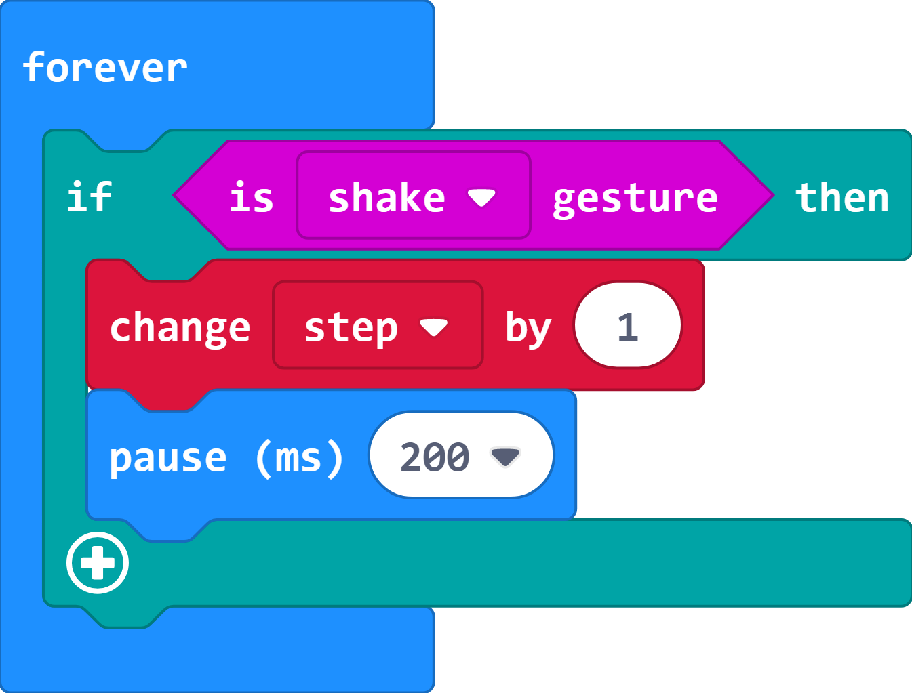
What variable is used?________________________

How is the variable used? ______________________

___________________________________________

When does this happen? _______________________

____________________________________________

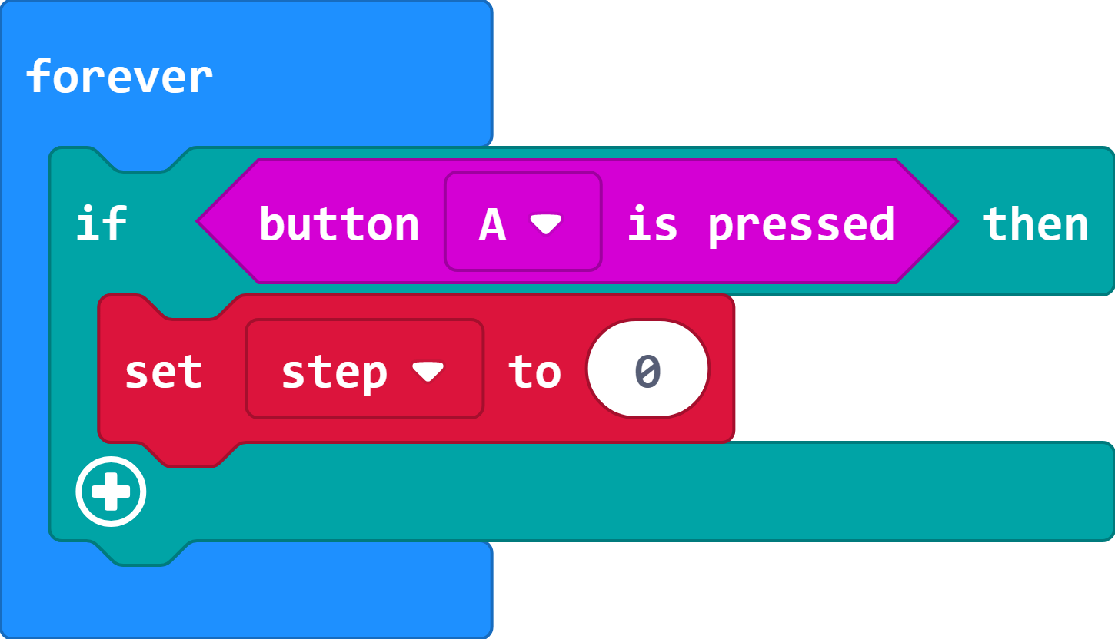
What variable is used?________________________

How is the variable used? ______________________

___________________________________________

When does this happen? _______________________

____________________________________________

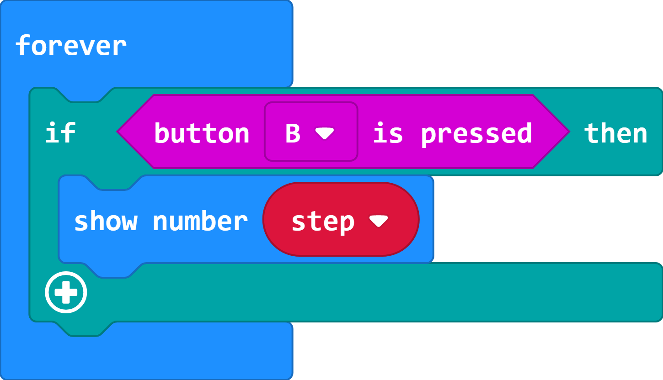
What variable is used?________________________

How is the variable used? ______________________

___________________________________________

When does this happen? _______________________

____________________________________________

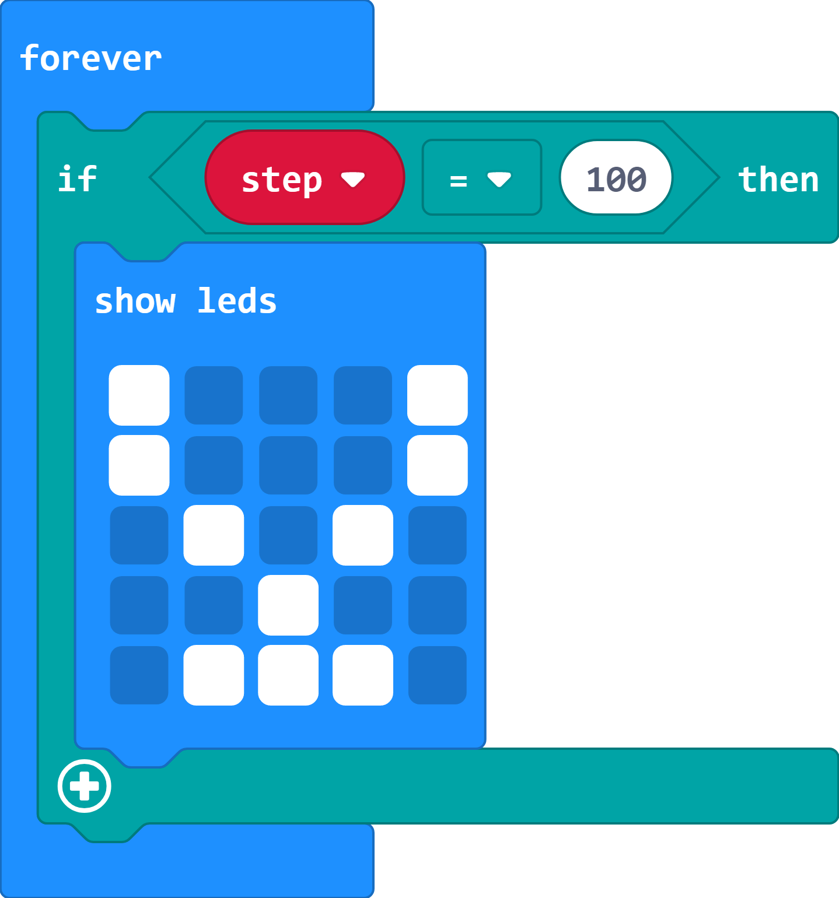
What variable is used?________________________

How is the variable used? ______________________

___________________________________________

When does this happen? _______________________

___________________________________________

