Worksheet: Code with your ML model
The code that displays was designed for a generic project. You need to update it to work correctly for your project. Answer the questions below and work through the instructions.
How many actions are used in the code? | How many actions are in your project?
What action is missing?

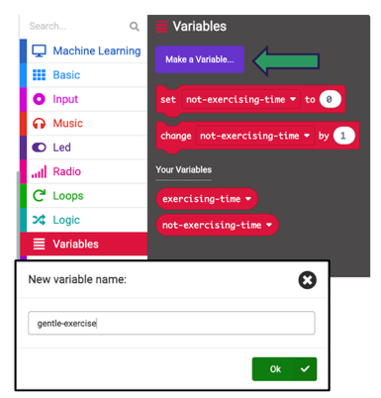
1. Create a ‘gentle-exercise’ variable

Variables are ‘containers’ that store and update data while a program is running. Variable blocks are red in MakeCode.

There are two variables in the project code: ‘exercising’ and ‘not-exercising’. These variables are being used as ‘counters’ – they are storing the total time detected for each action.

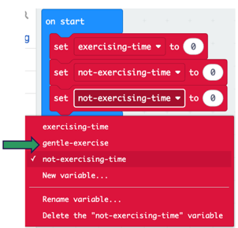
Create a new variable for your new ‘gentle-exercise’ action.

2. Set your new variable to zero.
Duplicate the ‘set … to’ block, or drag a new one from the red Variables
section of the toolbox. Use the drop-down menu to choose your new variable.
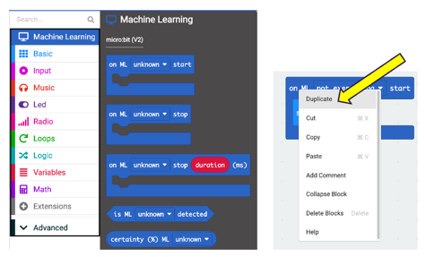

3. Find or duplicate blocks
Collect new blocks from the toolbox or use ‘Duplicate’.

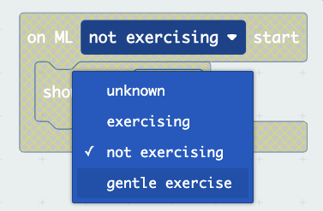
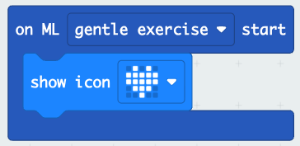
4. Update your new blocks
Use the drop-down menus to update the new code blocks to work with your ‘gentle exercise’ action.

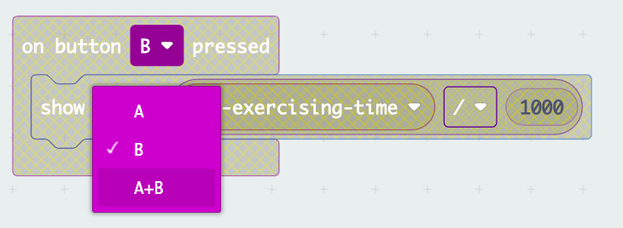
5. Choose a new input
Remember you can press buttons A and B together and use them as a third input.

6. Double check: Have you changed options in all drop down lists when you added new code?

Extension: Try adding a sound block under the ‘show icon’ block. Make sure you choose ‘in background’ in each sound block and use the ‘stop all sounds’ block for ‘not exercising’ to reduce noise.

