Apparent Brightness with Energy Light Meter

DATA RECORDING SHEET
Complete the following table using your BBC micro:bit.

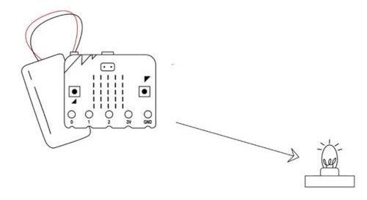 | 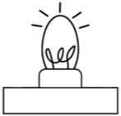
DISTANCE FROM LIGHT SOURCE | LIGHT LEVEL  (Button B to view reading)
2 ft | 59

