Measurement and Conversion with the Distance Calculator

DATA RECORDING SHEET
Complete the following table using your BBC micro:bit.

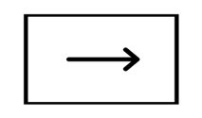 |  | 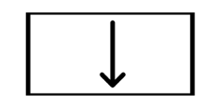 | 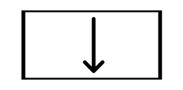 |  |  | 
LENGTH IN FEET (BUTTON B) | LENGTH IN INCHES | WIDTH IN FEET (BUTTON B) | WIDTH IN INCHES | PERIMETER IN FEET | PERIMETER IN INCHES | AREA IN SQUARE FEET
30 ft | 360 in | 22 ft | 264 in | 104 ft | 1248 in | 660 ft²

