Composing Musical Phrases and Algorithms

Create two musical phrases that meet the criteria below
- Each phrase should have 6 notes
- Each phrase should have a repeating note
- At least one phrase should be ascending
- At least one phrase should be descending

Musical Phrase One - Ascending
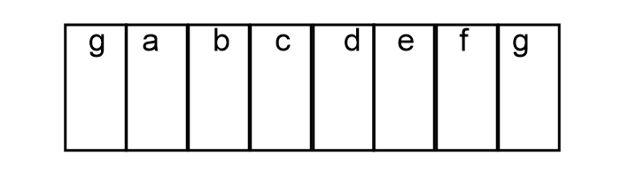

Musical Phrase Two - Descending

