Investigating conductivity

DATA RECORDING SHEET
Complete the following table using your BBC micro:bit. Remember to hold the plastic sheath that goes over the crocodile clip leads to ensure you don’t complete the circuit with your body.

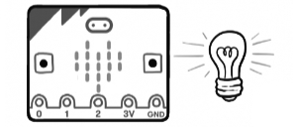 | 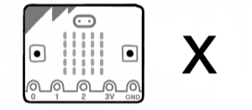
CONDUCTORS | INSULATORS

