Identifying the actions of a program (support)

For each program, highlight the action that the the micro:bit will carry out.
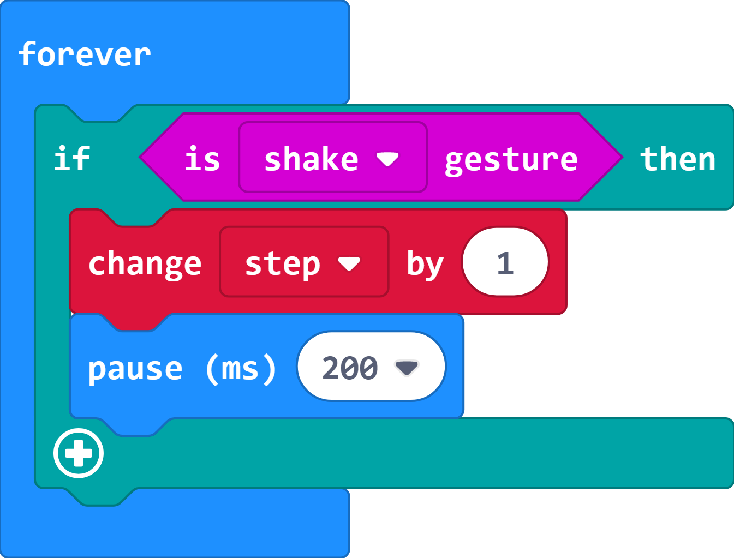
- Set variable step to 0 when button a is pressed.
- Increase variable step by 1 when micro:bit is shaken.
- Show the value of variable step when button b is pressed.
- Show an image of a trophy when the value of variable step equals 100.

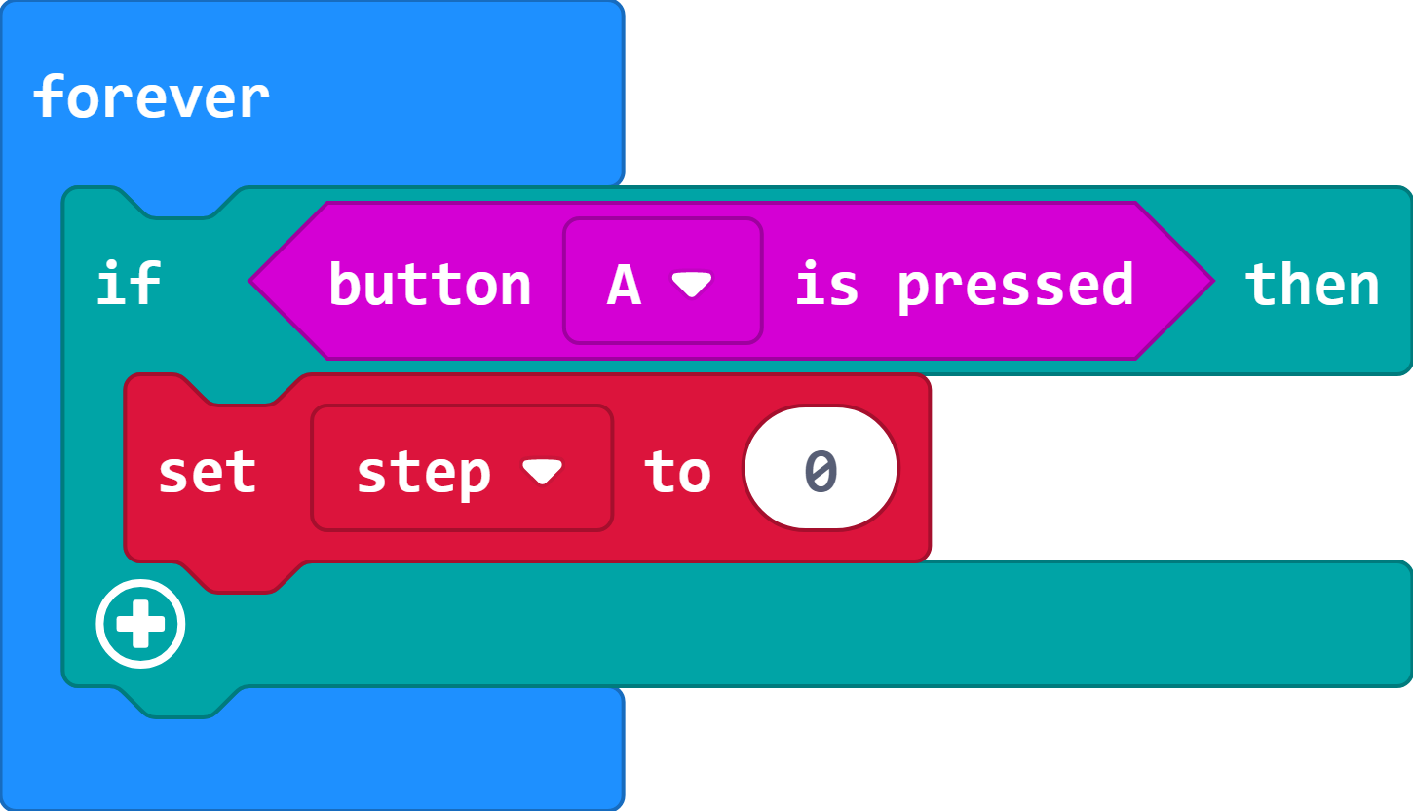
- Set variable step to 0 when button a is pressed.
- Increase variable step by 1 when micro:bit is shaken.
- Show the value of variable step when button b is pressed.
- Show an image of a trophy when the value of variable step equals 100.

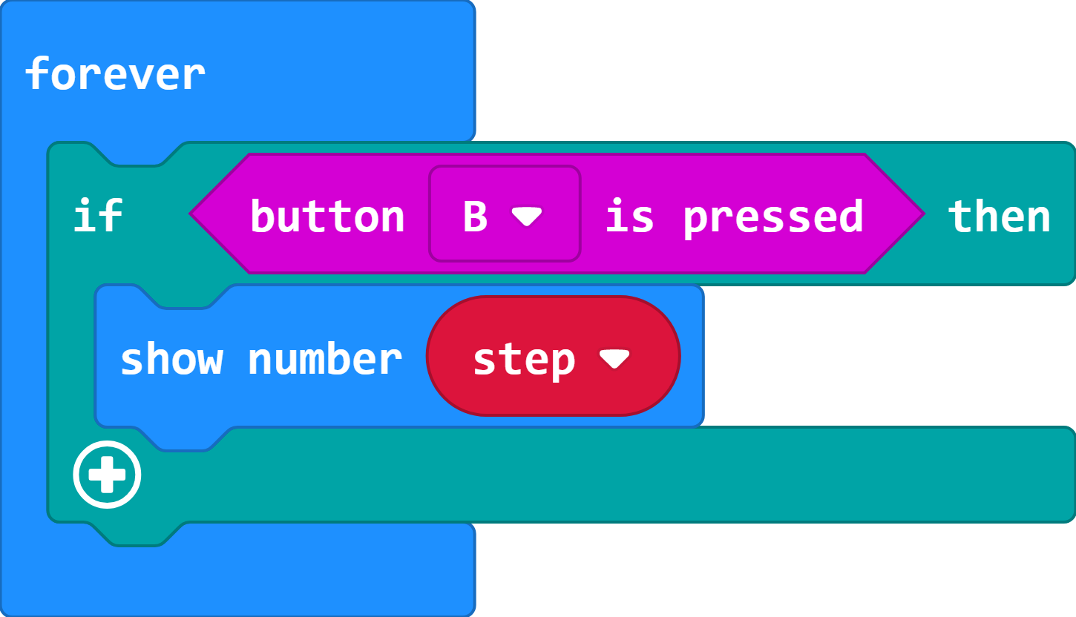
- Set variable step to 0 when button a is pressed.
- Increase variable step by 1 when micro:bit is shaken.
- Show the value of variable step when button b is pressed.
- Show an image of a trophy when the value of variable step equals 100.

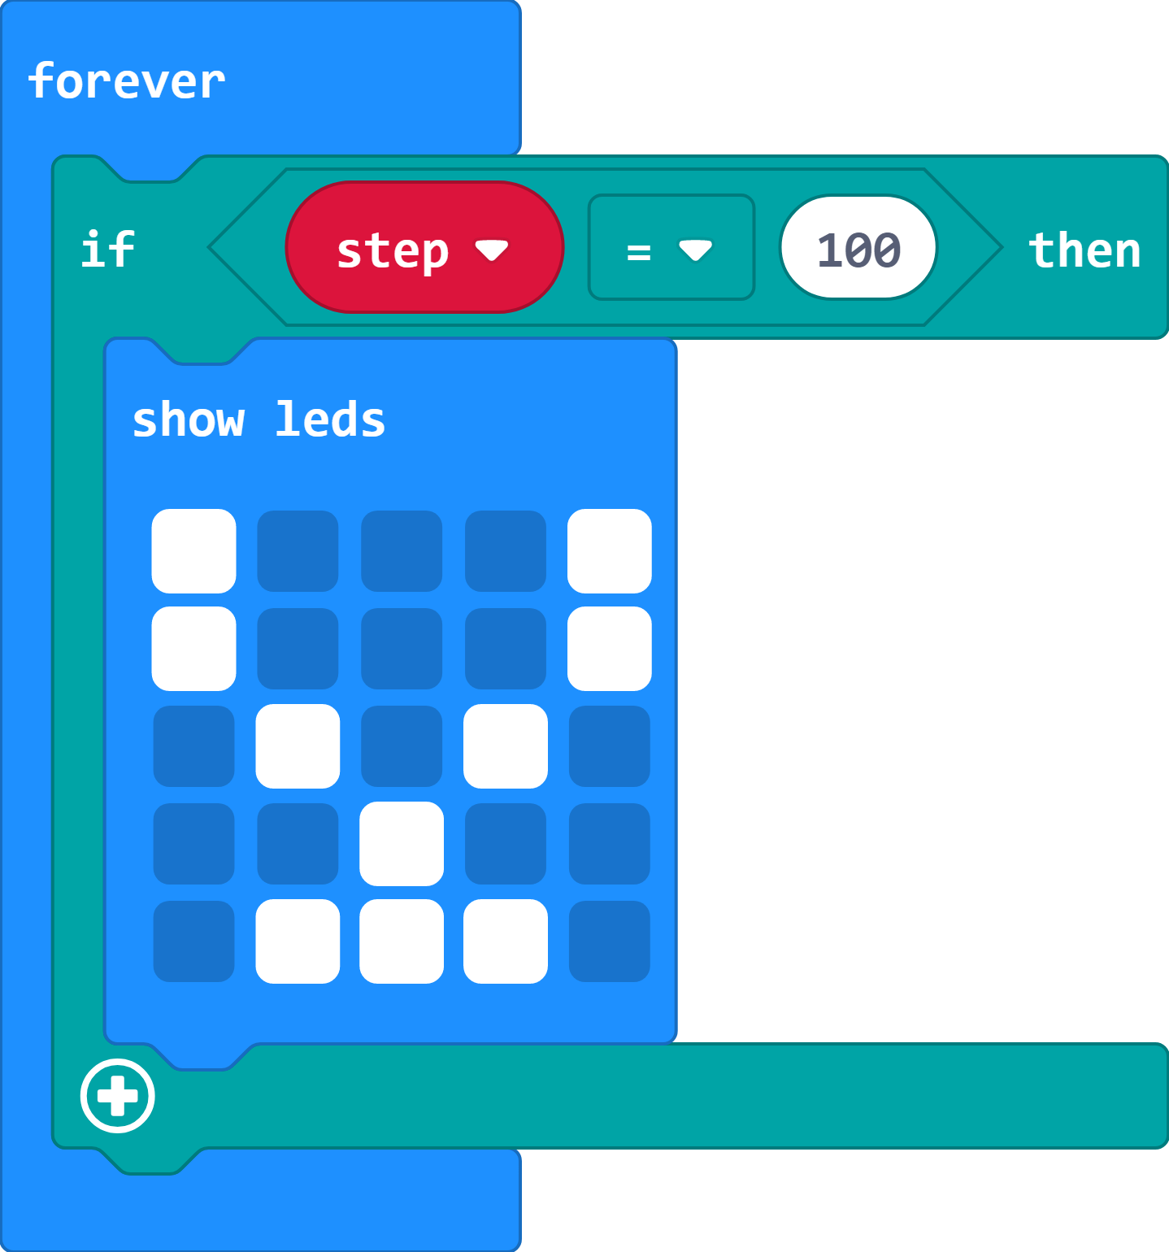
- Set variable step to 0 when button a is pressed.
- Increase variable step by 1 when micro:bit is shaken.
- Show the value of variable step when button b is pressed.
- Show an image of a trophy when the value of variable step equals 100.

