Programing Challenges

Program A

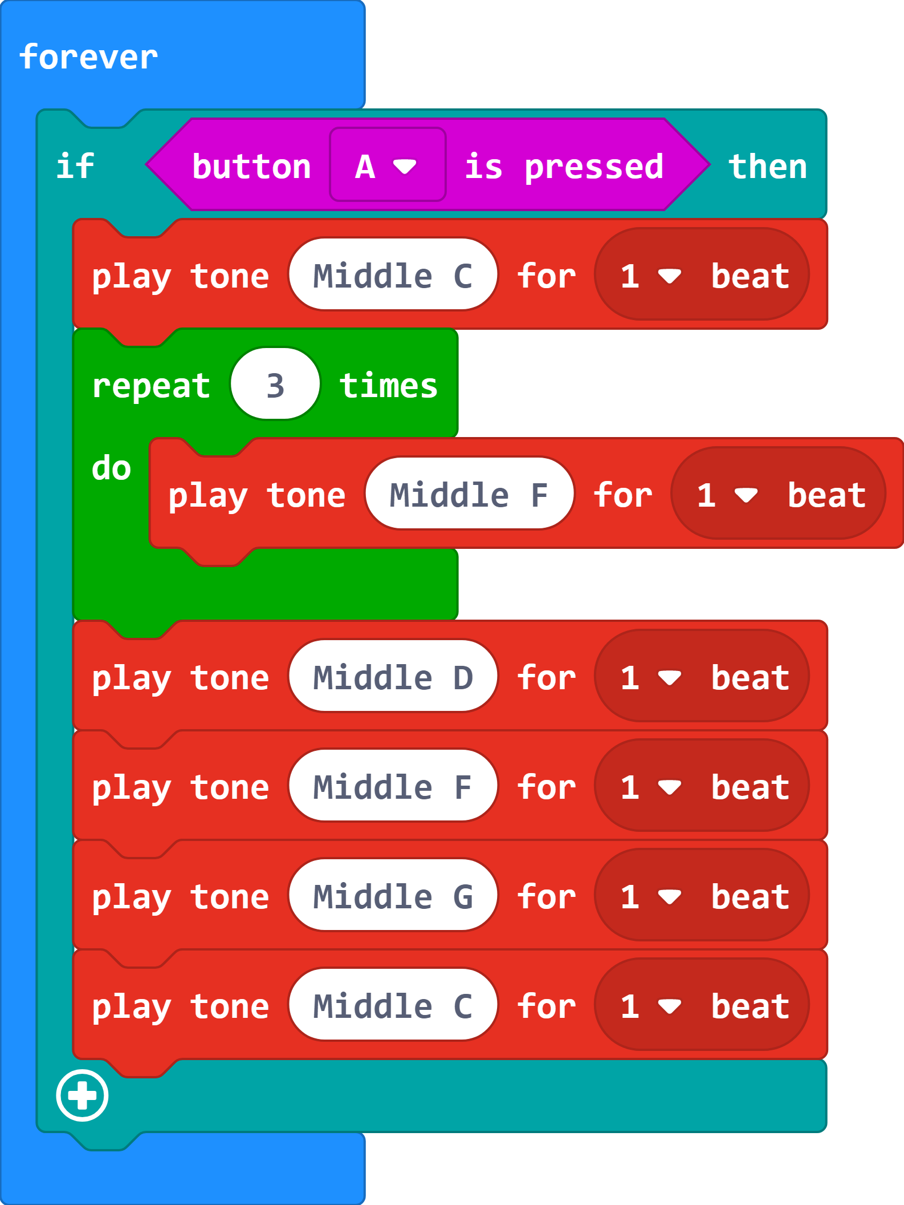

Modify the program so it: | How did you modify the program?

Programing Challenges

Program B
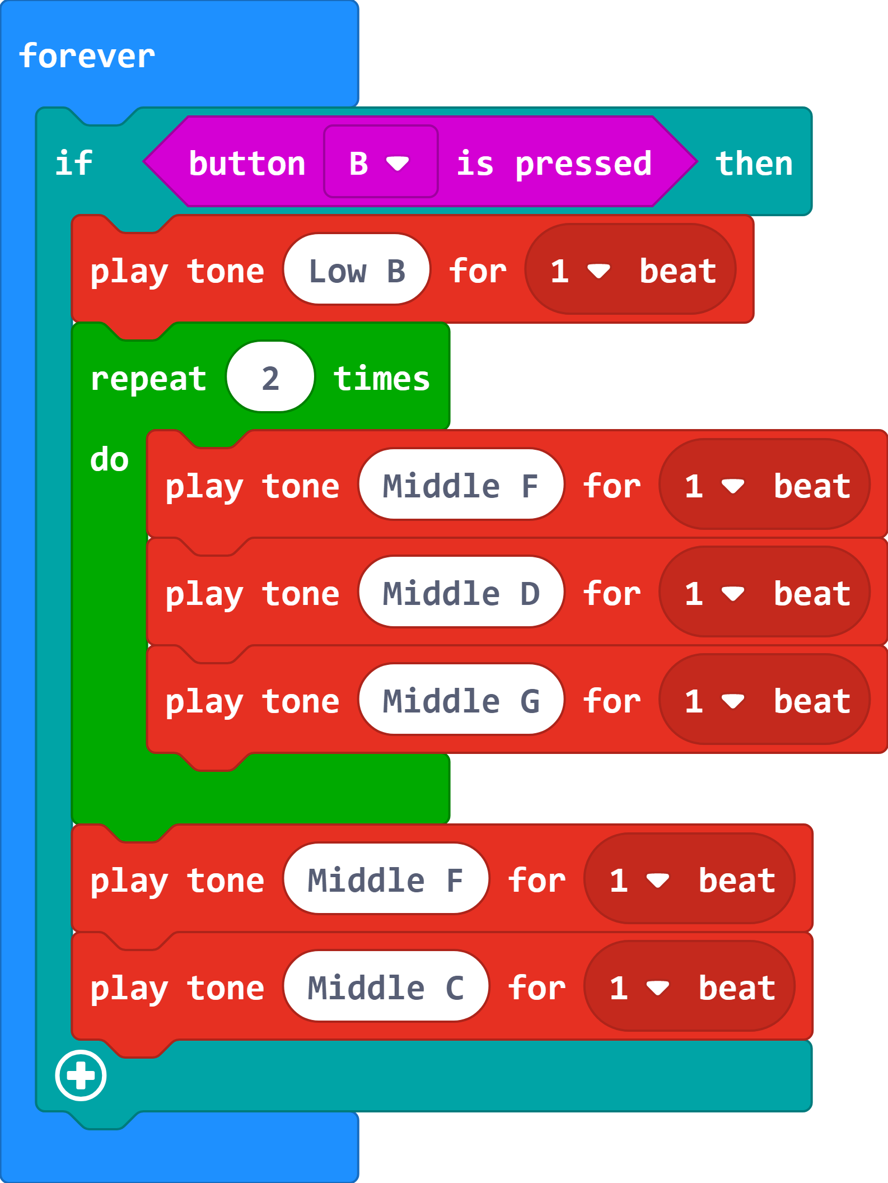

Modify the program so it: | How did you modify the program?

