Goal 14 - Life on land – Auto-farmer

Getting started
A group of famers have some farmland that is at risk of desertification (becoming unusable for farming) and have asked you to develop a prototype to control some LED grow lights and irrigation pumps that they have to help grow plants on the land. The lights and pumps can only be left on or off and the farmers want a system where the turning on and off is automated depending on the wetness/dryness of the land and the light levels to efficiently use water and electricity.
Success criteria
- Design and build a prototype that uses a light sensor to turn on a grow light when the light level drops below a certain level
- The prototype should also use a moisture sensor to turn on irrigation pumps when the soil is dry
- The prototype needs to have a ‘kill switch’ to turn off the lights and pumps

Input process output (IPO)
Light (LED grow lights)
Input | Process | Output
Light level | If light level drops below 45 | Turn on light

Water (irrigation pumps)
Input | Process | Output
Moisture sensor | If moisture level drops below | Turn on irrigation pumps

Building the prototype
To allow us to interact with irrigation pumps and grow lights we are going to need to use a relay. A relay is a switch that can be controlled by a microcontroller. We can program the micro:bit to switch the relay on and off given certain conditions (such as light and moisture levels) and the relay will switch on or off the power to the pumps and lights automatically!

PINS
Using the right pins is important and the table below lists all the available pins on the micro:bit.
Pin | Function 1 | Function 2 | Description
GND |  |  | Ground for both the relay and the moisture sensor
GND |  |  | Ground
3V3 |  |  | 3.3V
0 | Analog In |  | Connected to large pin 0  Used for the signal from the moisture sensor
1 | Analog In |  | Connected to large pin 1
2 | Analog In |  | Connected to large pin 2
3 | Analog In | LED Column 1 | Controls part of LED array
4 | Analog In | LED Column 2 | Controls part of LED array
5 |  | Button A | Connected to Button A on micro:bit
6 |  | LED Column 9 | Controls part of LED array
7 |  | LED Column 8 | Controls part of LED array
8 |  |  | Open GPIO pin
9 |  | LED Column 7 | Controls part of LED array
10 | Analog In | LED Column 3 | Controls part of LED array
11 |  | Button B | Connected to Button B on micro:bit
12 |  |  | Open GPIO pin  Used to control relay 1
13 | SCK |  | GPIO or SPI clock
14 | MISO |  | GPIO or SPI MISO
15 | MOSI |  | GPIO or SPI MOSI
16 |  |  | Open GPIO pin  Used to control relay 2
19 | SCL |  | GPIO or I² clock
20 | SDA |  | GPIO or I² data

We are going to use:
- Pin 0 for analogue input from the moisture sensor
- Pin 12 for the digital out to turn on relay 1 (IN1)
- Pin 16 for the digital out to turn on relay 2 (IN2)
- Pin 17 (3v) to power both the relay and the moisture sensor
- Ground (GND or 0v) for both the relay and the moisture sensor

Wiring it all up
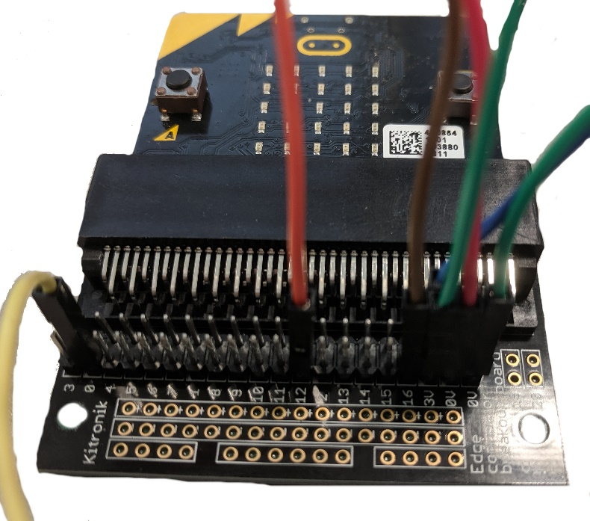 | In this mage you can see how the micro:bit breakout edge connector is used to connect the header cables to the relay and the moisture sensor.
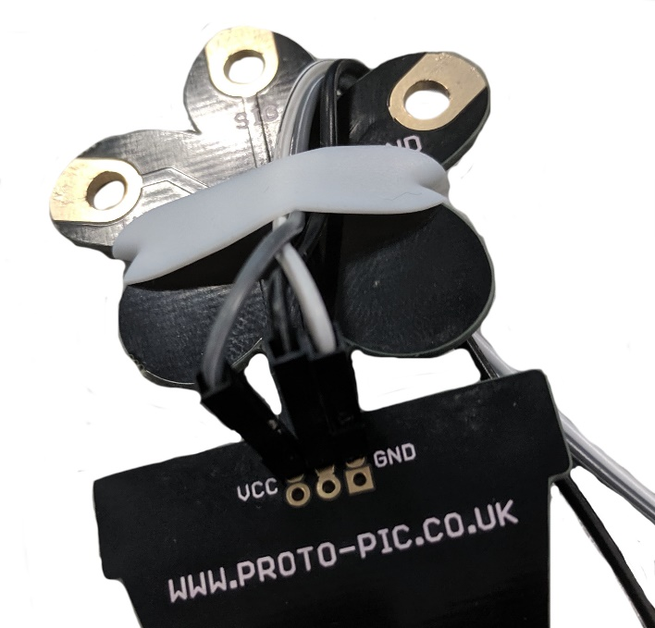 | The cables to the moisture sensor had to be doubled up as the connection on the breakout board are male and the connection on the moisture sensor are female. The connection to the moisture sensor is held in place with an elastic band which is not ideal but to avoid having to solder the connections or use additional header connections this works for a prototype.
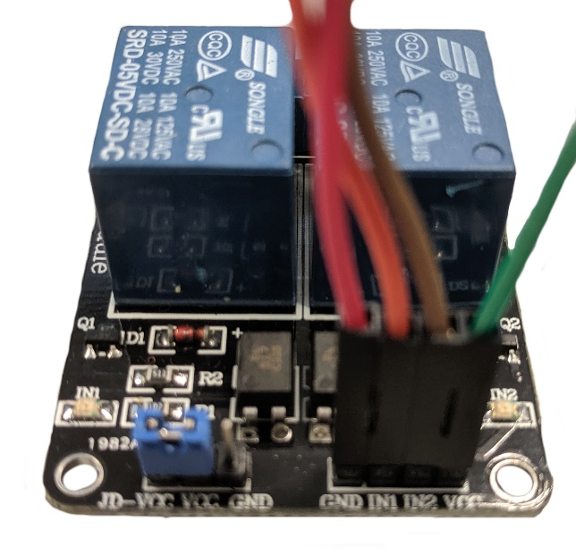 | Here you can see the header wires on the relay board. Notice the cable colours and how they match the pins above.  The picture below shows it all wired up together.
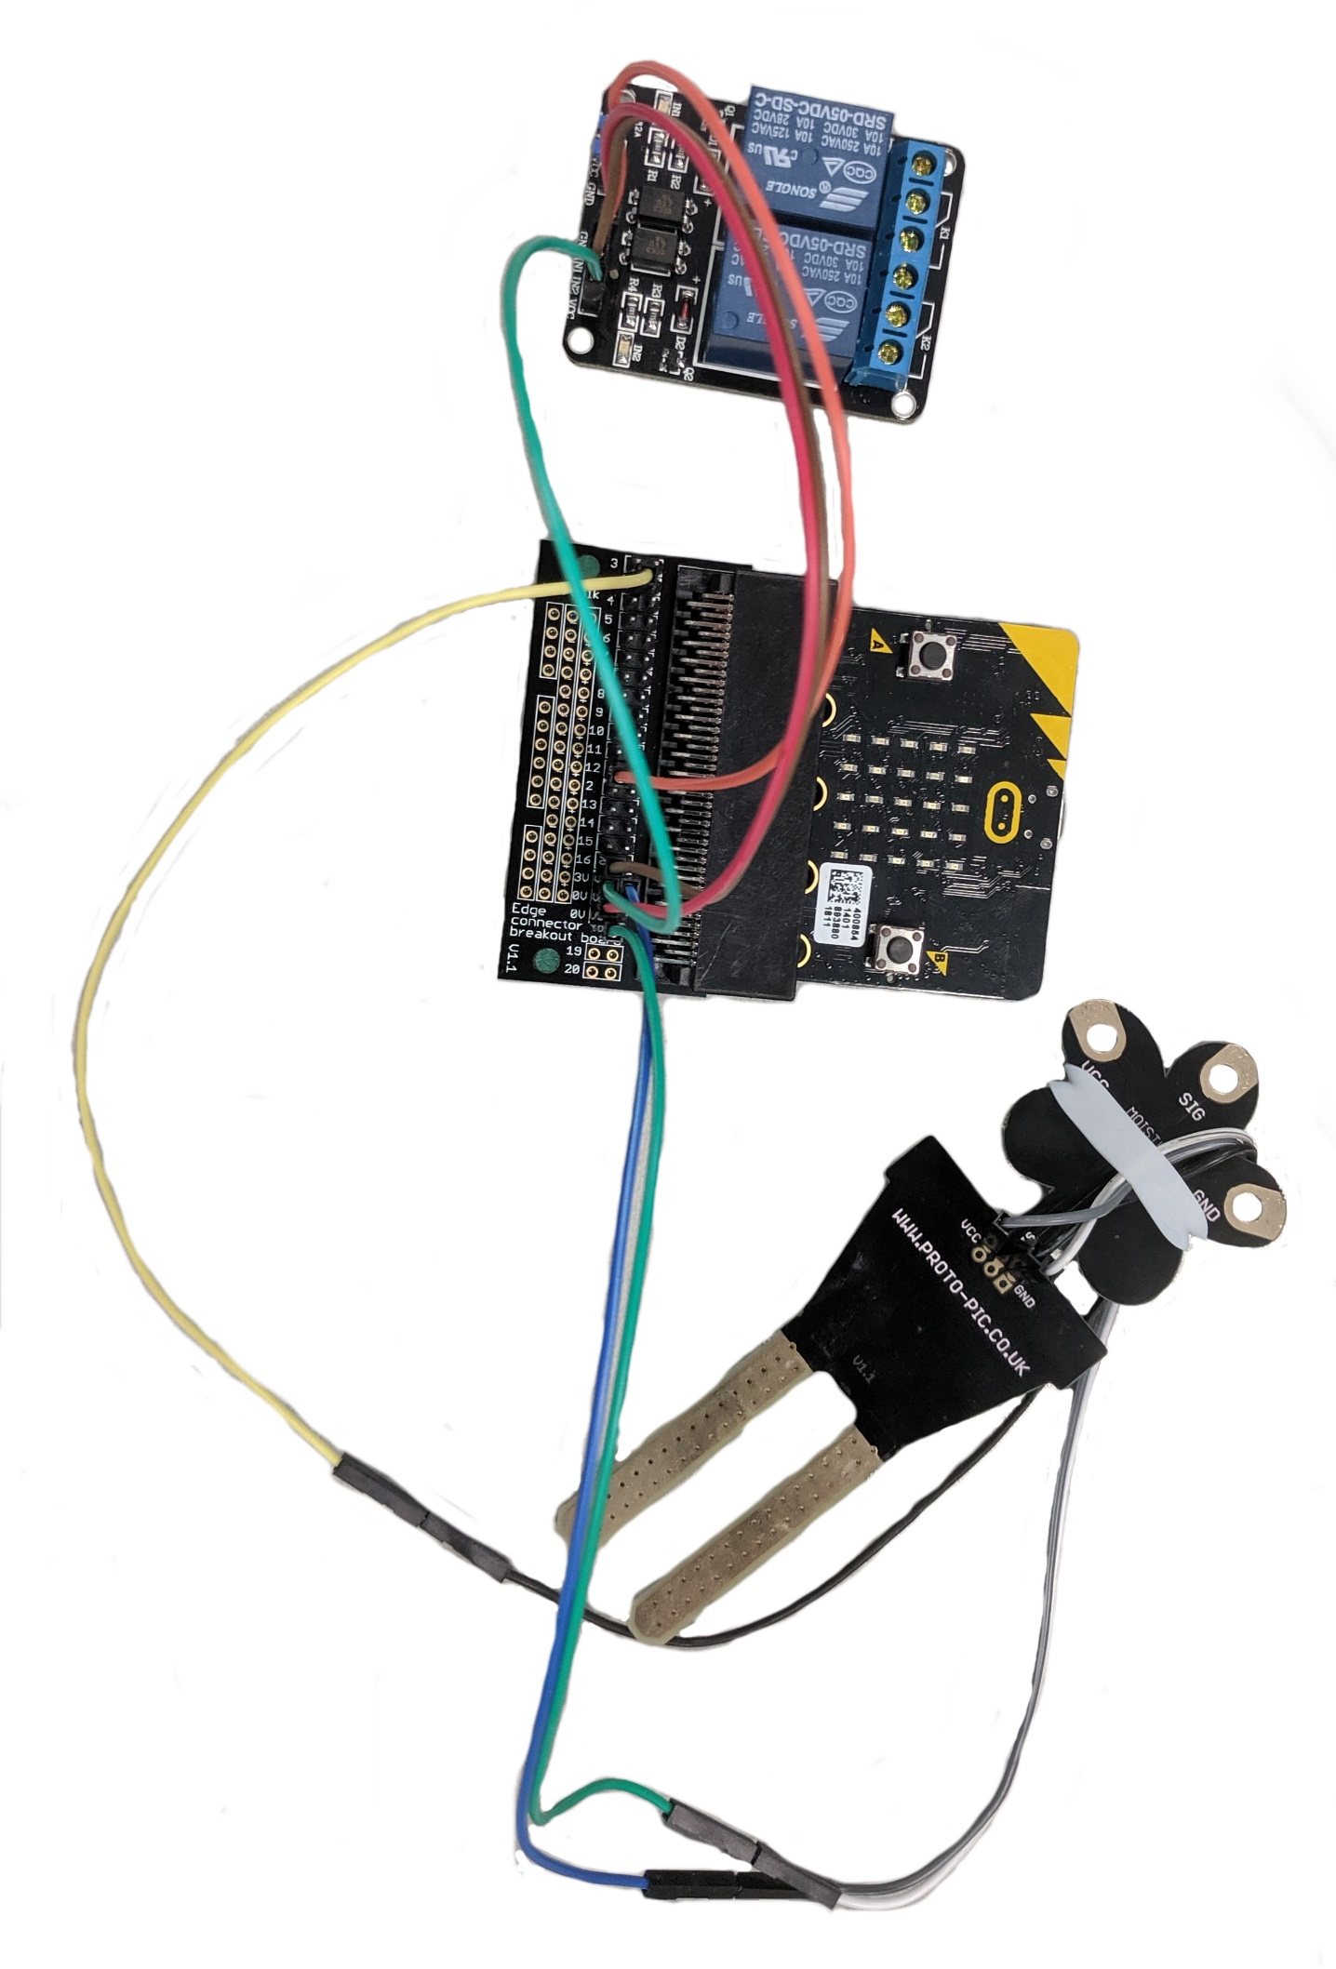Example code
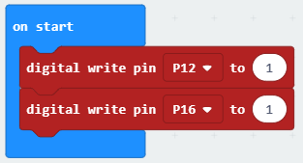 | These blocks set the digital write to 1. This may seem odd as usually 1 = on and 0 = off but the relay being used is ‘active low’ which means it turns the switch on with a 0 rather than a 1.  This just ensure the prototype starts ‘off’ when first powered on.
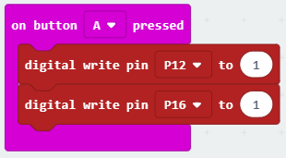 | These blocks add the ability to turn off the relay by pressing the A button.
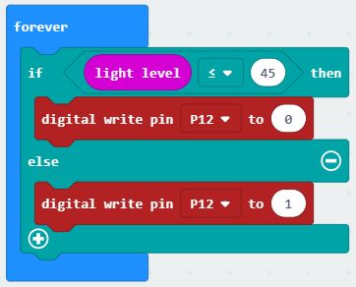 | These blocks sense if the light level (using the light sensor on the micro:bit) falls below 45 then it will turn on pin 12 which would switch the relay switch on which in turn would power the grow light.  The ‘else’ section ensures the grow light would be set to off if the light level is too high.  You will need to experiment to see what the light level threshold should be to turn the light on so as not to waste electricity during the day.
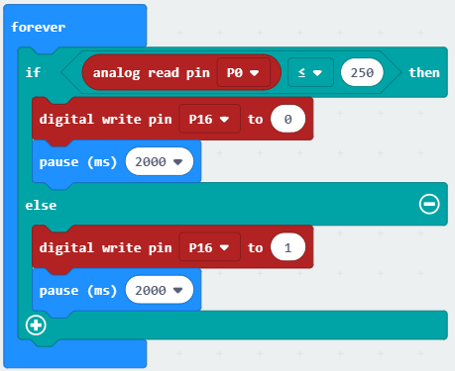 | The analogue read pin gives a value between 0 and 1023. The more electricity it senses the higher the value. If the soil were wet, the water in the soil would conduct a lot of electricity and so the value would be very high. Dry soil would give a low value.  These blocks sense if the analogue read pin value falls below 250 and then turns on pin 16 which would then turn on the irrigation pumps to water the soil.  Pause blocks are needed here or you may find the relay cycles on and off quickly.

Test time!
You will need to test the light and moisture threshold values to make sure that they trigger the relay when they are meant to. The light value worked well under strip lights inside but may not work in actual daylight so this will need to be tested! The moisture values were tested in a cup of water so you will need to test this using some dry soil and some well-watered soil to get the right value. We don’t want to waste any water or electricity.
Stretch tasks
- Add in an LED and solenoid to create a fully working prototype
- Adapt your prototype to use other sensors to control other devices to help the farmers
- Design a system to automate planting seeds
Final thoughts
This project has some real-world applications as efficient use of both water and electricity is important for sustainable farming. Using technology to make things more efficient is a great way to make a difference and to help shape a sustainable future.

