Worksheet: Data samples in CreateAI

Add your own data
Read through the information below, then add your own data, using the table below to record the new exercises or positions you have added to the data set.
- Select ‘exercising’ and add your own data sample – you can choose the specific exercise but make it a big movement.
- Select ‘not exercising’ and add your own data sample.
- Your new samples will appear next to the ‘Record’ button.
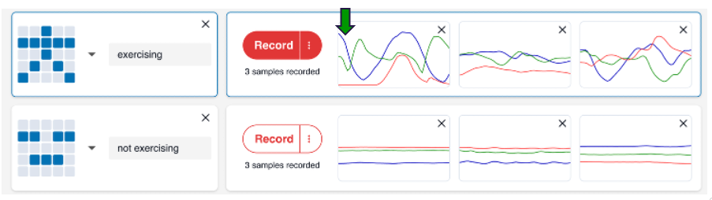
Compare your new samples to the other samples for this action – they should look similar to the ‘exercising’ or ‘not exercising’ samples provided.

What movements or positions did you add?
Exercises or movements you added to ‘exercising’: | Exercises or movements you added to ‘not exercising’:

Save your work
Where did you save your work? | What is the name of the file?

