Lesson 3: Emotion badge

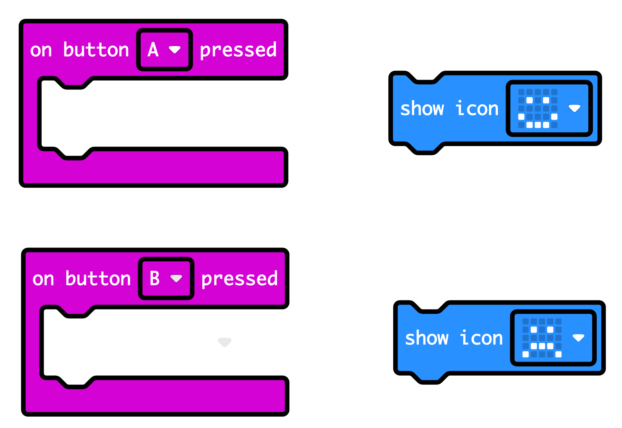

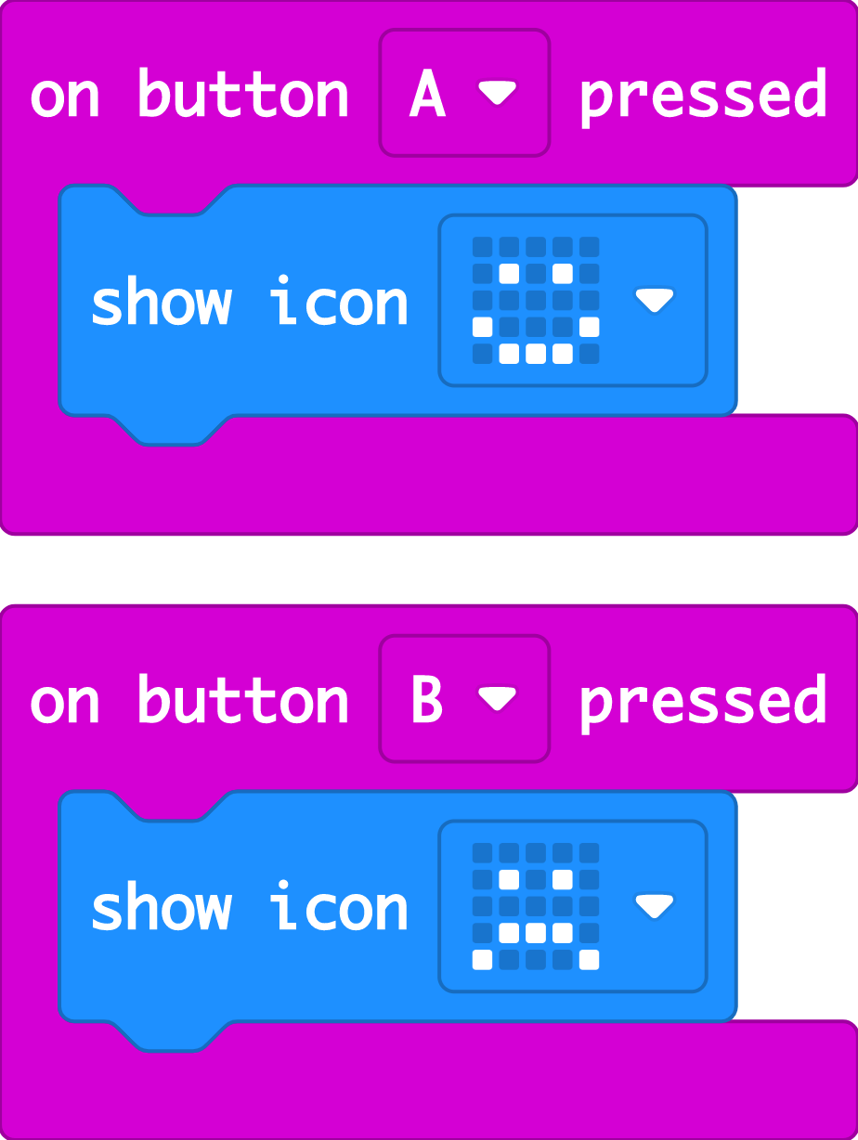

The ‘on button A pressed’ block makes something happen when you press input button A.

The ‘show icon’ block makes an image appear on the LED display output. You can choose different built-in images.

The ‘on button B pressed’ block makes something happen when you press input button B.

So, you can make different outputs happen on the LED display when you press different buttons.

