Barefoot meets micro:bit
Wildlife animations - Lesson 2
Recommended for
ages 7-9
Duration:

1
hour
Concepts and approaches covered
Repetition Programming

Overview
In this lesson, pupils produce further programs with the micro:bit. Pupils produce an animation away from the device by creating a thaumatrope (an animation based on quickly moving between two images), which they share with the class. They then write a program containing their animation and a forever loop using MakeCode, before transferring it to the micro:bit. Pupils go on to use count controlled loops by producing a second animation, which they include within a program.

Pupil objectives
■ I can use repetition within the micro:bit MakeCode editor
■ I can design and code an animation using the micro:bit’s LEDs ■ I can evaluate my work and suggest improvements

Before you start
Check the ‘Technical requirements’ section of the ‘Lesson overview’ document to ensure the micro:bit works successfully with your school.
Ensure the images of the 5 x 5 LEDs are printed out from the ‘LKS2 - Lessons 1 and 2 - LEDs - Blank’ file. Pupils can work individually or in pairs, with each pupil / pair needing at least two images, which are used for the thaumatrope.To produce a thaumatrope, each pupil / pair will need an additional pencil and some tape.
The example thaumatrope from the ‘LKS2 - Lesson 2 - LEDs - Examples’ file should be printed out and attached to a pencil, using tape, to demonstrate to pupils (Please note: the example is also shown on Slide 6 if required).
Check the ‘Health and Safety’ section of the ‘micro:bit lessons overview’ document to ensure the device can be used safely, along with considering your school’s health and safety requirements for learning outside the classroom.
The videos included with these resources can be used as a guide for how to use the micro:bit. The videos can also be shown to pupils within the lessons, as indicated in the lesson plan below.

Resources
■ Desktop or laptop computer with a web browser that can access the micro:bit MakeCode editor - https://makecode.microbit.org/ and an available USB port, which can be used to transfer files to the micro:bit. Further details are outlined in the ‘Technical requirements’ section of the ‘Lesson overview’ document.
■ micro:bit devices
■ Small (A7) size 5 x 5 of LEDs (16 per A4 sheet), which can be used for pupils to produce a thaumatrope
■ Pencil for completing the thaumatrope images
■ To produce a thaumatrope, each pupil / pair will need an additional pencil and some tape.
■ The example thaumatrope should be printed out and attached together to demonstrate to pupils.
■ The following support videos: LKS2 Animation, LKS2 Thaumatrope

Introduction 5 minutes
Explain to pupils they will be using the micro:bit device, which is a special type of computer they can program. Provide pupils with a micro:bit and ask them if they can identify the following parts of the device, which they will be using during these lessons - LEDs; USB connector (Slide 3).
Ask pupils to discuss whether the LEDs are inputs and outputs, and elicit that we say they are outputs, as they are displaying information from the computer.
(Please note - the LEDs are also used as an input to detect light, although this is beyond the scope of this lesson.) Ask pupils to also identify other parts of the device and discuss their functionality using the guidance within the ‘Lesson overview’ as required.

Main activity 50 minutes

Familiarisation - 10 mins
Explain to pupils they will be using the micro:bit to produce a moving image, which is known as an animation. Explain that before we go on to make our animation, pupils will ensure they can remember how to create a program using MakeCode containing one or more images.
Show pupils MakeCode - https://makecode.microbit.org/ and ask them to share (Slide 3):
■ How to create a new project
■ How to place “show icon” blocks into the programming area
■ How to download the program
■ How to transfer the program file to the micro:bit
Remind pupils of how to keep safe when using the micro:bit (Slide 4). Explain to pupils they are to create a program containing at least one image, which they should transfer to the micro:bit (Slide 5). Once pupils have finished the task, they should assist other pupils until everyone in the class has completed it successfully.

Unplugged animation - 20 mins
Explain to pupils they will be making the micro:bit display a moving image, or animation, and we can make an image appear to be moving by quickly flipping between two still images (Slide 6). Explain to pupils we will be first creating our animation away from the micro:bit to make sure it is correctly designed before we begin programming.
Show pupils the thaumatrope (Slide 7) containing the example image and highlight how there is a still image on each side and, when the pencil is spun quickly, it gives the impression the image is moving. Show pupils the blank 5 x 5 LEDs and explain they will be using these to produce their own thaumatrope (Slide 8).
Explain to pupils they are going to go outside the classroom to look for examples in nature that could be used for their own animation. Demonstrate to pupils how to produce an animation of an insect flapping its wings by colouring in the blank 5 x 5 LEDs, as shown on slide 9.
Ensure your school’s requirements for learning outside the classroom are followed and brief pupils as appropriate. When outside, encourage pupils to look for suitable plants or animals they could animate, such as flowers, trees or insects. Once back in the classroom, ask pupils to share their ideas for an animation and, if required, share the examples on slide 10.
Show pupils how to attach the two images to a pencil to create a thaumatrope by attaching two example images from the ‘LKS2 - Lesson 2 - LEDs - Examples’ file to a pencil using tape. Ask pupils to produce their own thaumatrope and to share them with the class once completed. If time, pupils may create further animations using two images.
Programming an animation - 20 mins
Show pupils the MakeCode programming environment containing an animation (Slide 11) and view the output using the on-screen simulator. An example program can be found at - https://makecode.microbit.org/_TgwajDYK1bPC
Ask pupils:
■ Why do we need the ‘pause’ block? (Answer - so the image is displayed for a short amount of time)
■ What do you think the ‘forever’ block does? (Answer - it repeats the instructions for as long as the program is running. Explain to pupils this is why the program is constantly displaying the animation)
Demonstrate to pupils how to transfer the program to the micro:bit and view the animation on the device. Using the images previously produced, ask pupils to create their own animation within MakeCode based on the example on slide 12. Once complete, pupils should attempt the other tasks on the screen. Support pupils as required and remind them each new program needs to be transferred to the micro:bit if required.

Plenary 5 minutes
Ask pupils to share their program with someone near them, including explaining the blocks used within the program (Slide 13). Ask a number of pupils to share a program they particularly liked, including why they liked it.

Differentiation

Support
Pupils could be provided with the required blocks of code for each task, then asked to rearrange the blocks in order

Stretch
More confident pupils could add further images to create a more complex animation. Pupils could also use the ‘repeat X times’ block in ‘Loops’ to enable the animation to only take place a specific number of times, or have one animation take place, followed by another. The ‘LKS2 - Lesson 2 - Stretch - Activities’ file can be provided for pupils, with possible solutions included in the ‘LKS2 - Lesson 2 - Stretch - Solutions’ file.

Assessment opportunities
Informal teacher assessment of understanding through lesson and assessment of pupils’ programs. Key understanding to assess:
■ Can pupils create images to produce the programs specified?
■ Can pupils explain the instructions they used to produce each program?

Teaching notes
Concepts and approaches
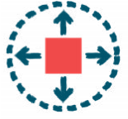
Repetition
Pupils use repeating images within their program to complete each of the tasks.
Programming
Pupils produce programs by entering code using the micro:bit MakeCode editor.

Curriculum links
Please refer to the resource overview page on the website, to understand how the learning objectives covered in this lesson relate to the curriculum in your country.

Taking this further
Pupils could produce a video explaining how to create a program using the micro:bit and / or how quickly switching between still images can create the impression of movement.

We love seeing our resources being used in the classroom.
Please share your comments and pictures via our social channels:
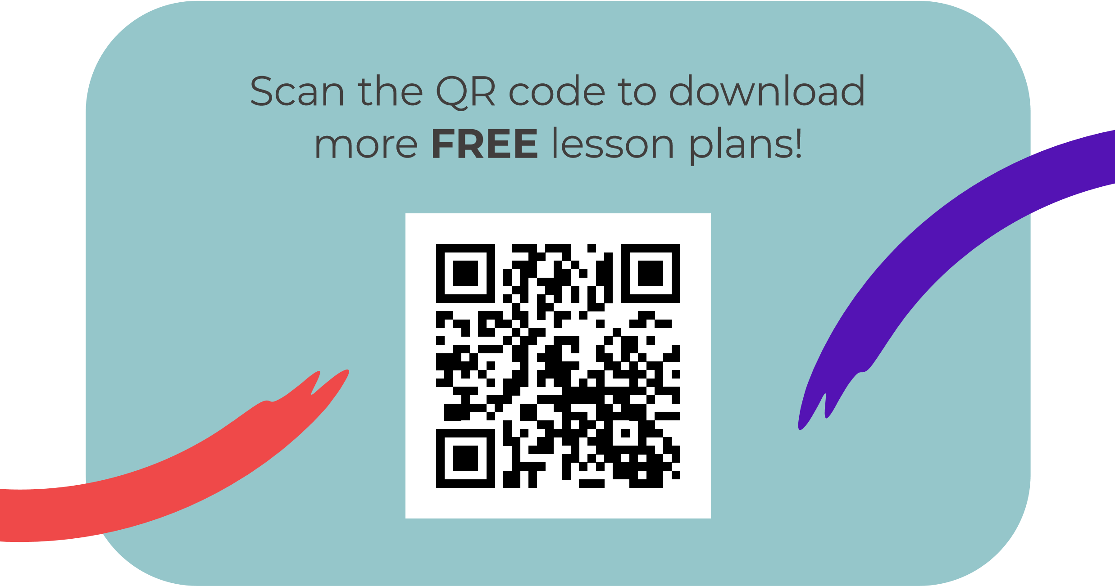
@BarefootComp /barefootcomputing @barefootcomputing
enquiries@barefootcomputing.org | barefootcomputing.org
Supported by With help from

