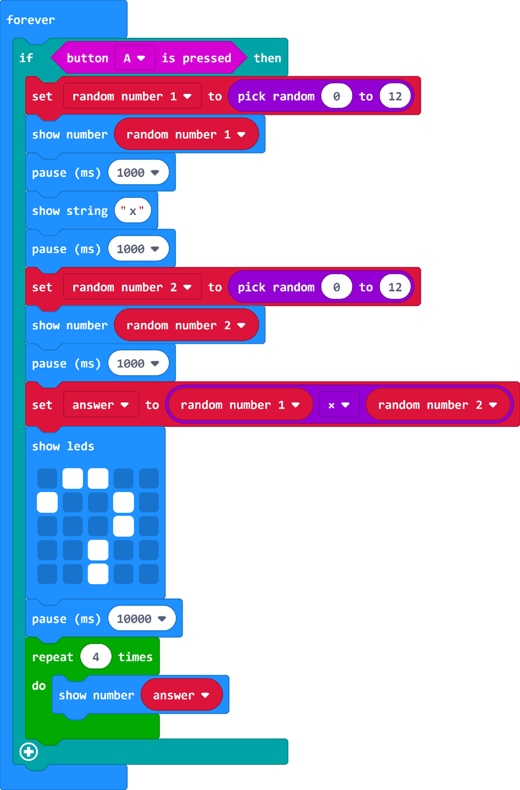
Variable times table program

How many variables are used in this program?
What are the names of the variables used in this program?
How are the values of the variables set?

How are these variables used?

How is the answer calculated?

