Goal 15 - Life on Land – tree protector

Getting started
A flourishing life on land is the foundation for our life on this planet. We are all part of the planet’s ecosystem and we have caused severe damage to it through deforestation, loss of natural habitats and land degradation. Promoting a sustainable use of our ecosystems and preserving biodiversity is not a cause. It is the key to our own survival.

Goal 15.2 - END DEFORESTATION AND RESTORE DEGRADED FORESTS
We have been tasked with creating a product that helps protect forests and combats deforestation. The government want a product that can be attached to trees to alert the authorities if trees are being cut down by illegal loggers.

Success criteria
- Can be attached to a tree securely
- Alerts the authorities if:
  - The tree is cut down
- Gives the authorities the location of the fallen tree

Breaking down the problem
We are going to start by creating a program that uses the micro:bit’s sensors to allow us to sense when a tree has been cut down. We will start with designing the program.

Input, Process, Output (IPO)

We now need to think about the IPO of one of the required features for the product ‘alert authorities if the tree is cut down’. You can use this table to help your design a solution for the other success criteria.
Input | Process | Output
Acceleration and tilt sensor data to sense if tree is falling over | If acceleration of angle of sensor exceeds a threshold then output | Send message to authorities including location data

Pro Tip
The authorities will need GPS co-ordinates so that they can intervene if there is illegal logging occurring. We could ‘hard code’ the GPS co-ordinate into the micro:bit or we could use a GPS peripheral to get a live GPS co-ordinate.  The format of a GPS co-ordinate is made up of a latitude and a longitude:  Latitude: 52.1818424  Longitude: 0.1789449  These combined: 52.1818424,0.1789449  Can you work out where this GPS co-ordinate is for? | 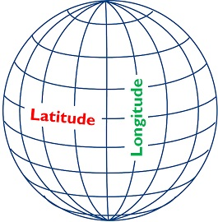

Example code for the node (on the tree)
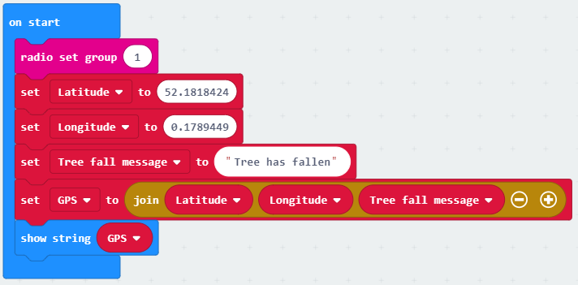 | These blocks run as soon as the micro:bit is powered on.  The first action is to set the ‘radio group’ to 1, this also needs to be done on the gateway so that the micro:bits can talk to each other on the same radio frequency. If these numbers are different, it won’t work!

Next, 2 variables are created to store the GPS data. Latitude and longitude must be split. Why is this? The micro:bit treats variables as numbers by default and the comma (,) confuses it and so it strips out everything after and including the comma.
We then create two more variables, one called ‘tree fall message’ with a message to transmit to the authorities and another called GPS that ‘joins’ the latitude, longitude and the message. The ‘GPS’ variable is then shown on the micro:bit’s screen to show it is working.
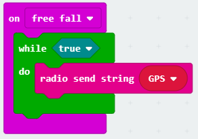 | In this example, the micro:bit waits until it senses a ‘free fall’. This would happen if the tree was chopped down and it fell (assuming the micro:bit is high enough up the tree!). You will need to test this!  Next, we use a ‘while True’ loop, we use this so that the blocks inside it will repeat forever, as True will always be True.  The blocks inside the loop will transmit a string (text) which contains the message, latitude and longitude (as a string). These can be received by the ‘gateway’ and then sent to the authorities who can then come and see if the tree is being chopped down or if it has just fallen over naturally.
Example code for the gateway (with the authorities)
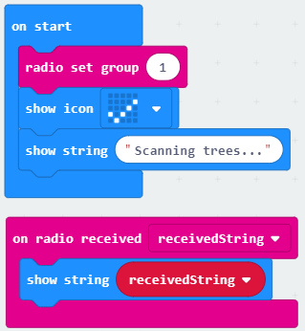 | This first block again runs as soon as the micro:bit is powered on. The ‘radio group’ is set to the same group as the node (this is important).  Next we display a tick and some text to show the programme is active.  The next set of blocks waits to receive a string via radio. It stores this string in a variable called ‘recievedString’ and then shows this string on the LEDs.  This string will be the ‘GPS’ variable sent by the node and contains the GPS co-ordinates of the fallen tree.

Test time!
The alert to the authorities will need to be tested so that it doesn’t send alerts accidently, like if the tree is just blowing in the wind for example. You will need to test the sensitivity and set the thresholds so that they only trigger an alert when they are meant to.

Stretch tasks
- Rather than manually adding the latitude and longitude, adapt your product to be able to get an accurate latitude and longitude from a GPS device
- Adapt your product so that it doesn’t just rely on the micro:bit sensing freefall to alert the authorities. What other sensors or programming techniques could you use to sense if a tree is being cut down?
- Sometimes trees blow over naturally in high winds. The authorities don’t want to investigate every time this happens. They have decided to attach your product to lots of trees in the forest but only want to be alerted if more than one tree collapses per day

Final thoughts
We can protect life on land together. Here you can see what you can do to contribute. Find organizations to support, information to share and some useful tips for your everyday life that can really make a difference.
https://www.globalgoals.org/15-life-on-land
https://www.hackster.io/149085/panic-button-using-xinabox-micro-bit-and-ubidots-bf4dc8

