Lesson 2: Beating heart

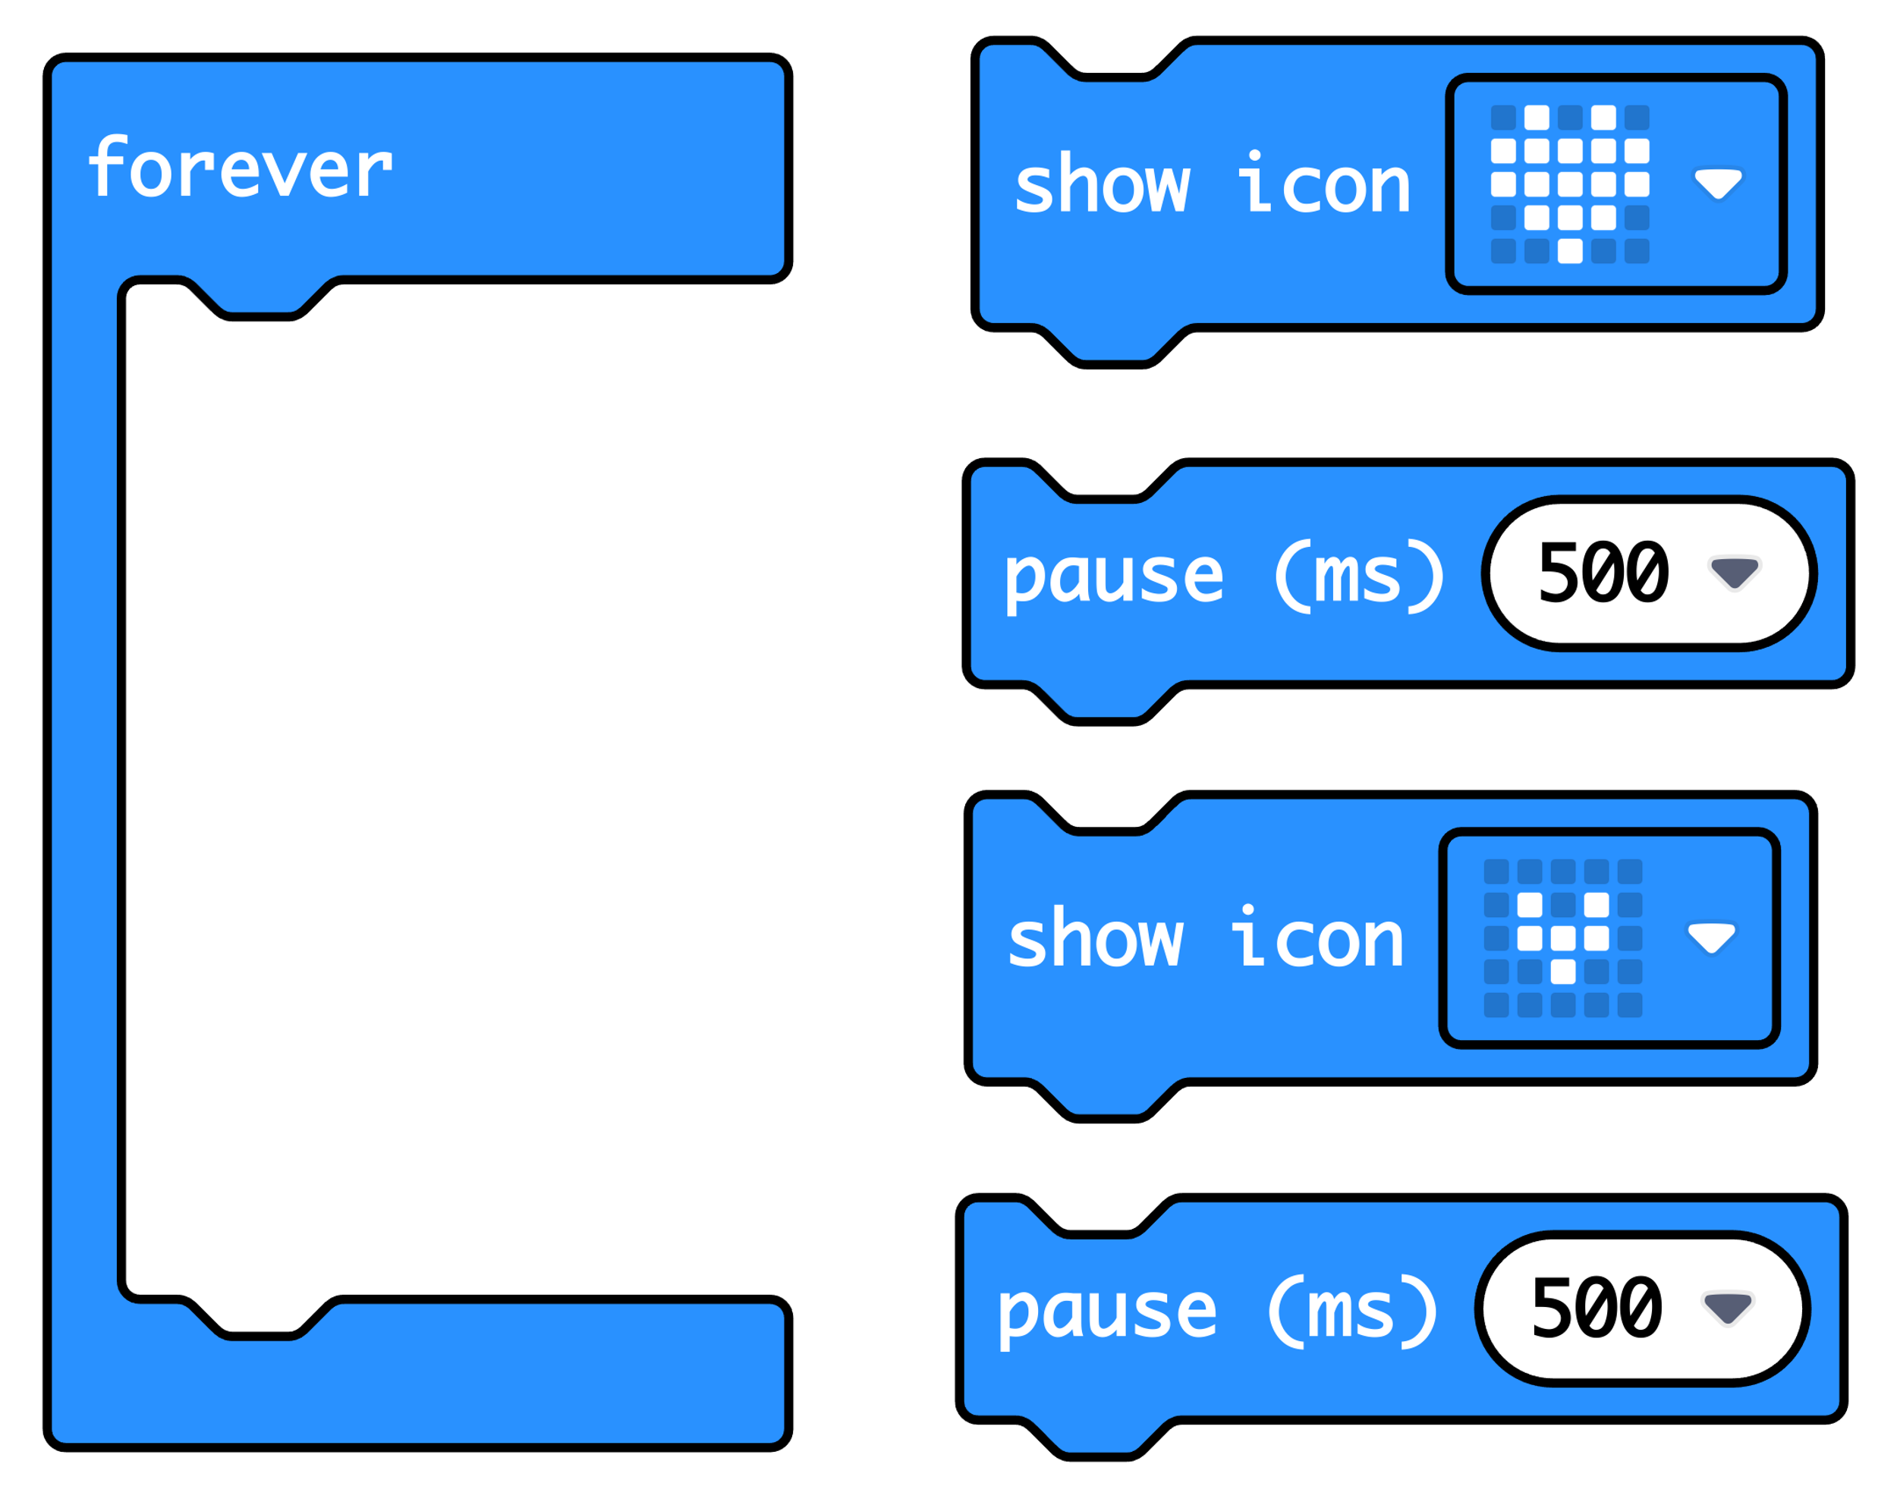
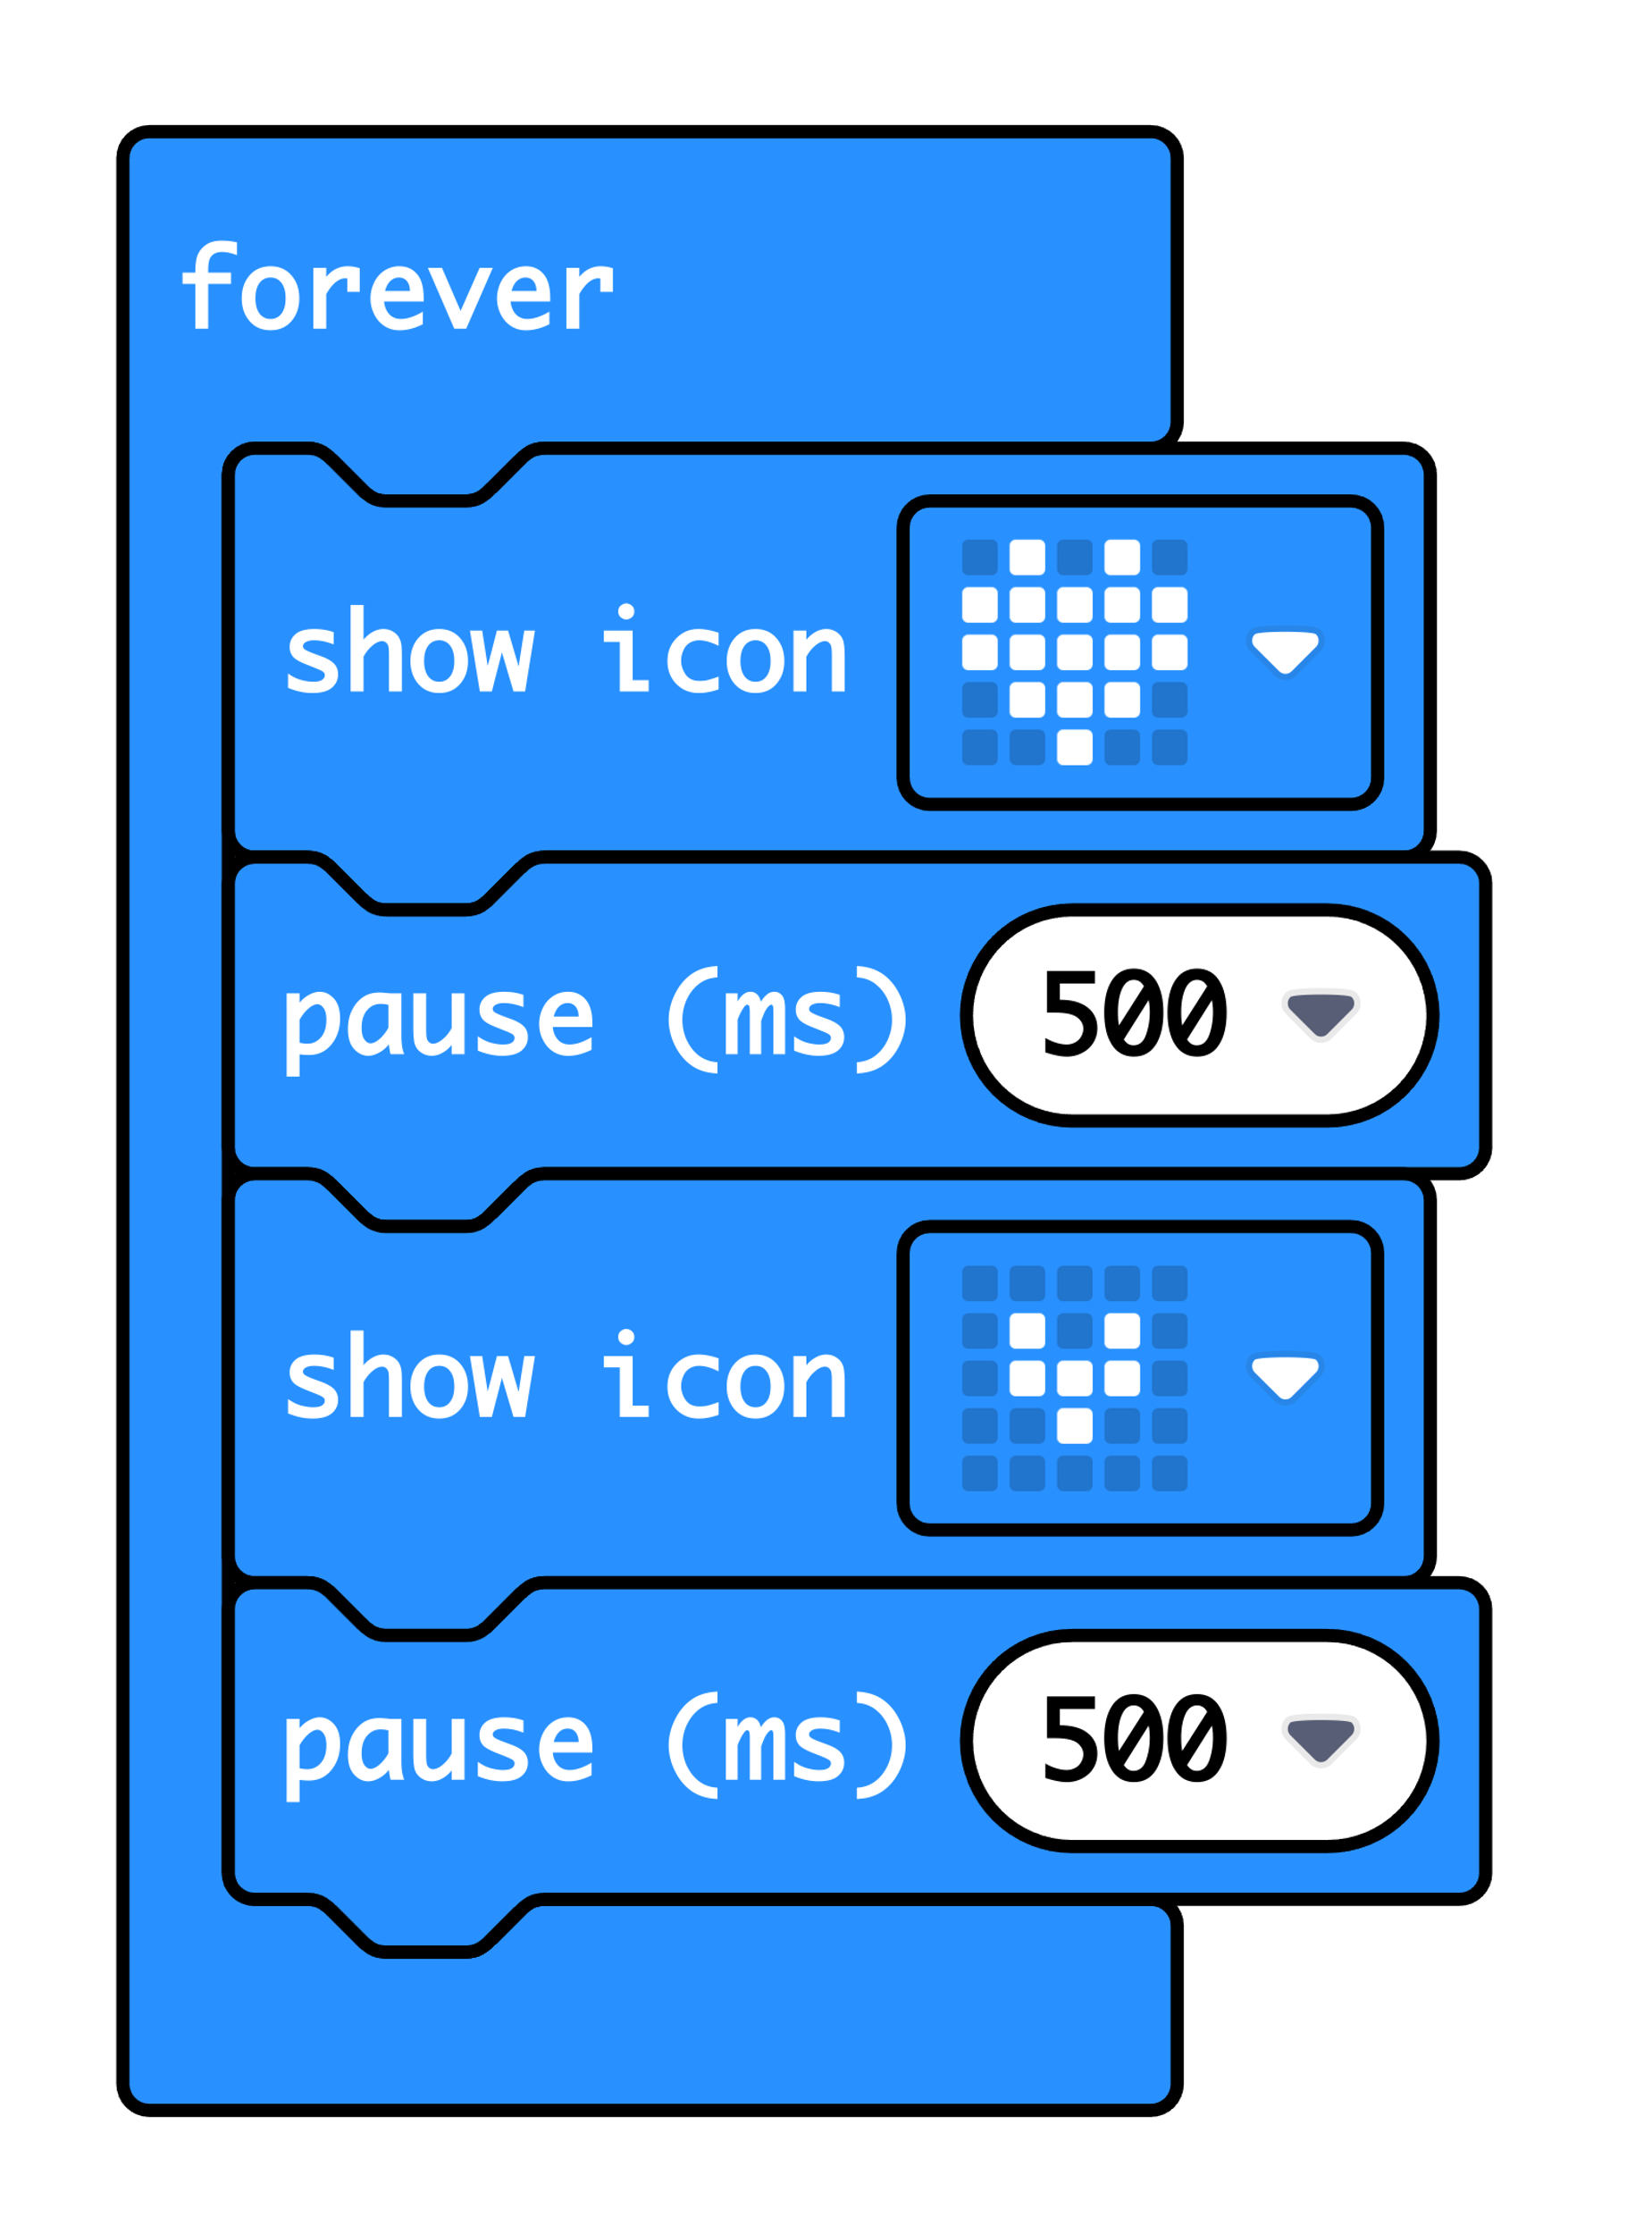

‘Forever’ is a loop that keeps the code running.

‘Show icon’ lights up the LED display output in a pattern.

‘Pause’ makes the micro:bit wait before carrying out the next instruction. 500 milliseconds is half a second.

After carrying out these four instructions, the loop goes back to the top and starts again.

