Investigating the world around us

DATA RECORDING SHEET
Complete the following table using your BBC micro:bit.

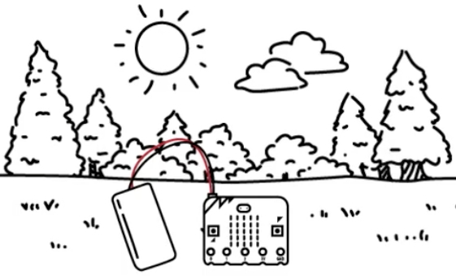 |  | 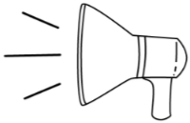 | 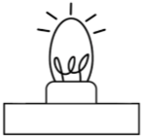
YOUR LOCATION | TEMPERATURE  (button a) | SOUND LEVEL  (button b) | LIGHT LEVEL  (buttons A & b)
Corridor | 20°C | 124 | 99

