Lesson 5: Nightlight

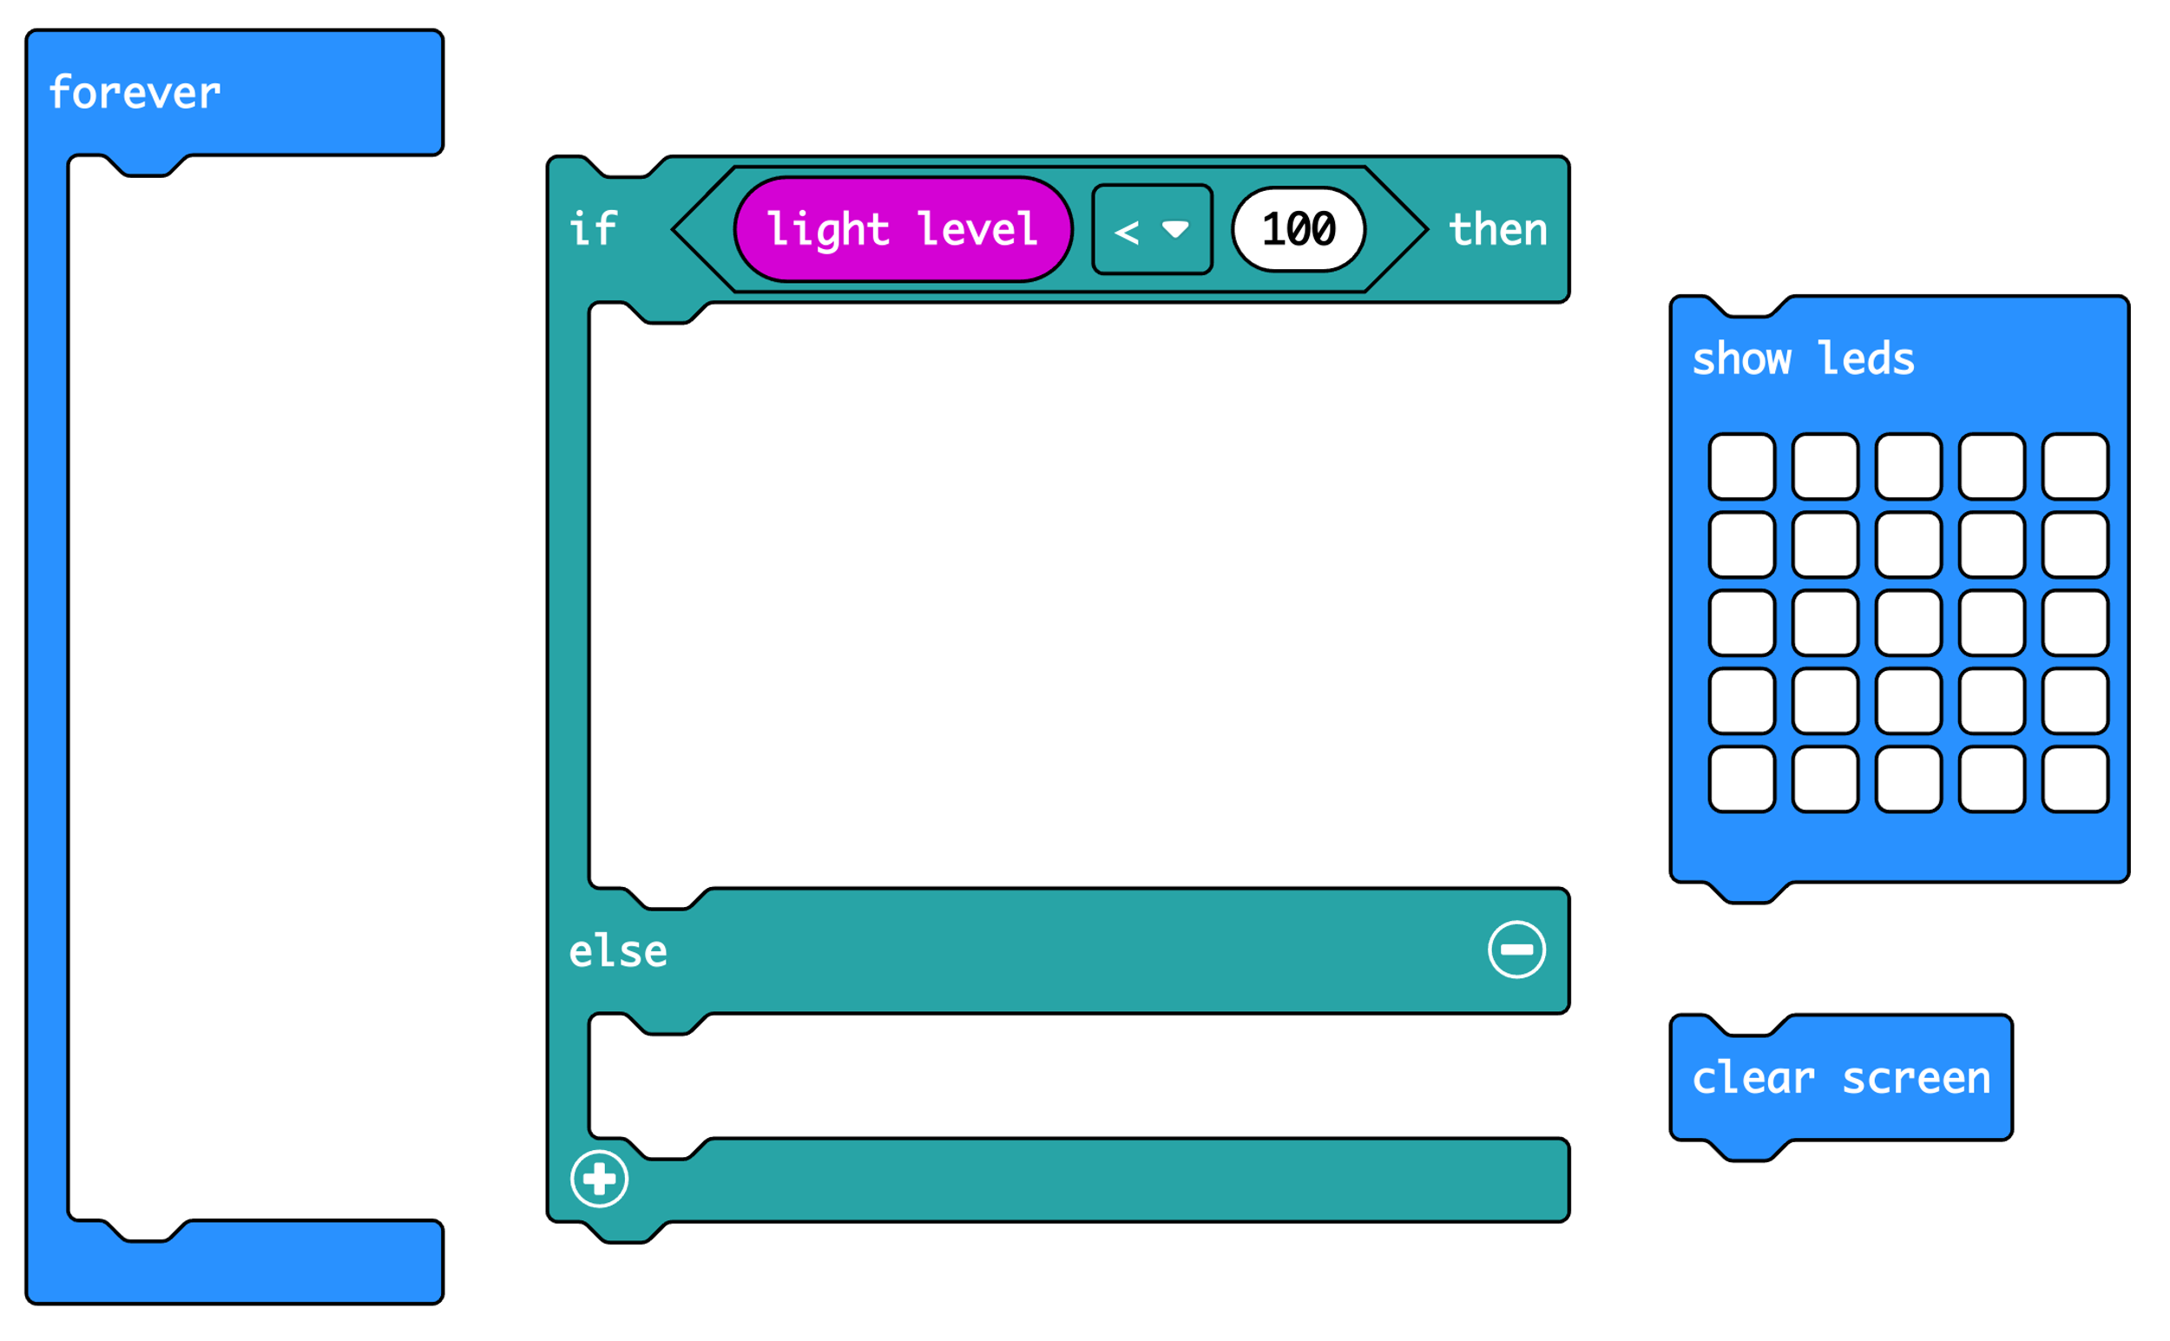

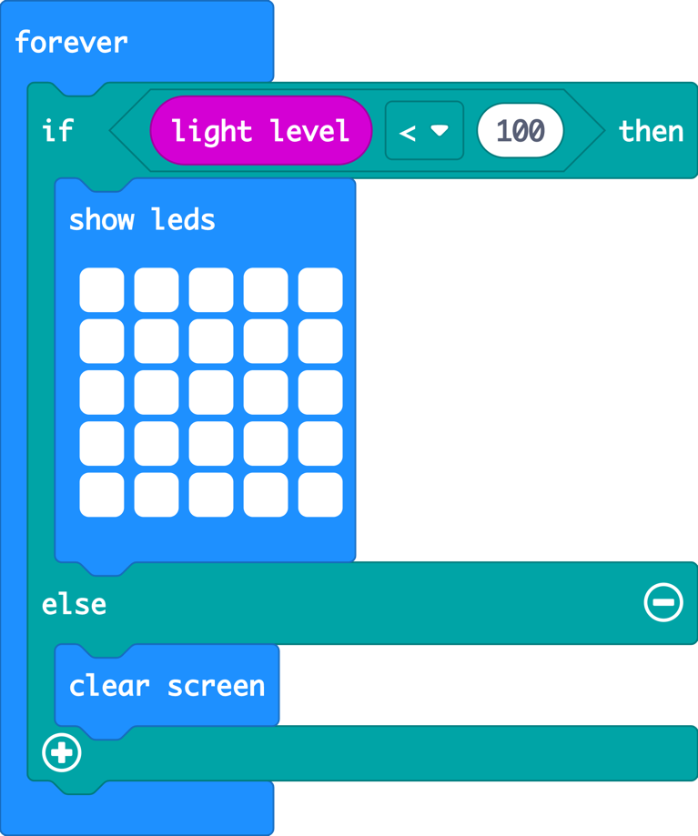
The ‘forever’ loop keeps the micro:bit checking the light level.

The logic ‘if… then’ block checks if the light level is low, less than (<) 100.

If the light level is less than (<) 100, it must be dark, so it lights all the LEDs.

Else (otherwise) the light level must be 100 or more. It must be light, so it turns the LEDs off with ‘clear screen’.

