Investigating sound insulation

DATA RECORDING SHEET
Complete the following table using your BBC micro:bit.
TIP - Remember to reset the receiver micro:bit in between tests, and then press button A to show the latest, maximum reading.

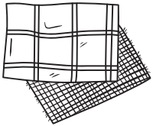 | 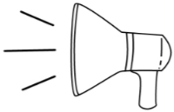
MATERIAL | SOUND LEVEL (0-255)  (BUTTON A)
Tissue paper | 98

