Lesson 6: Rock, paper, scissors

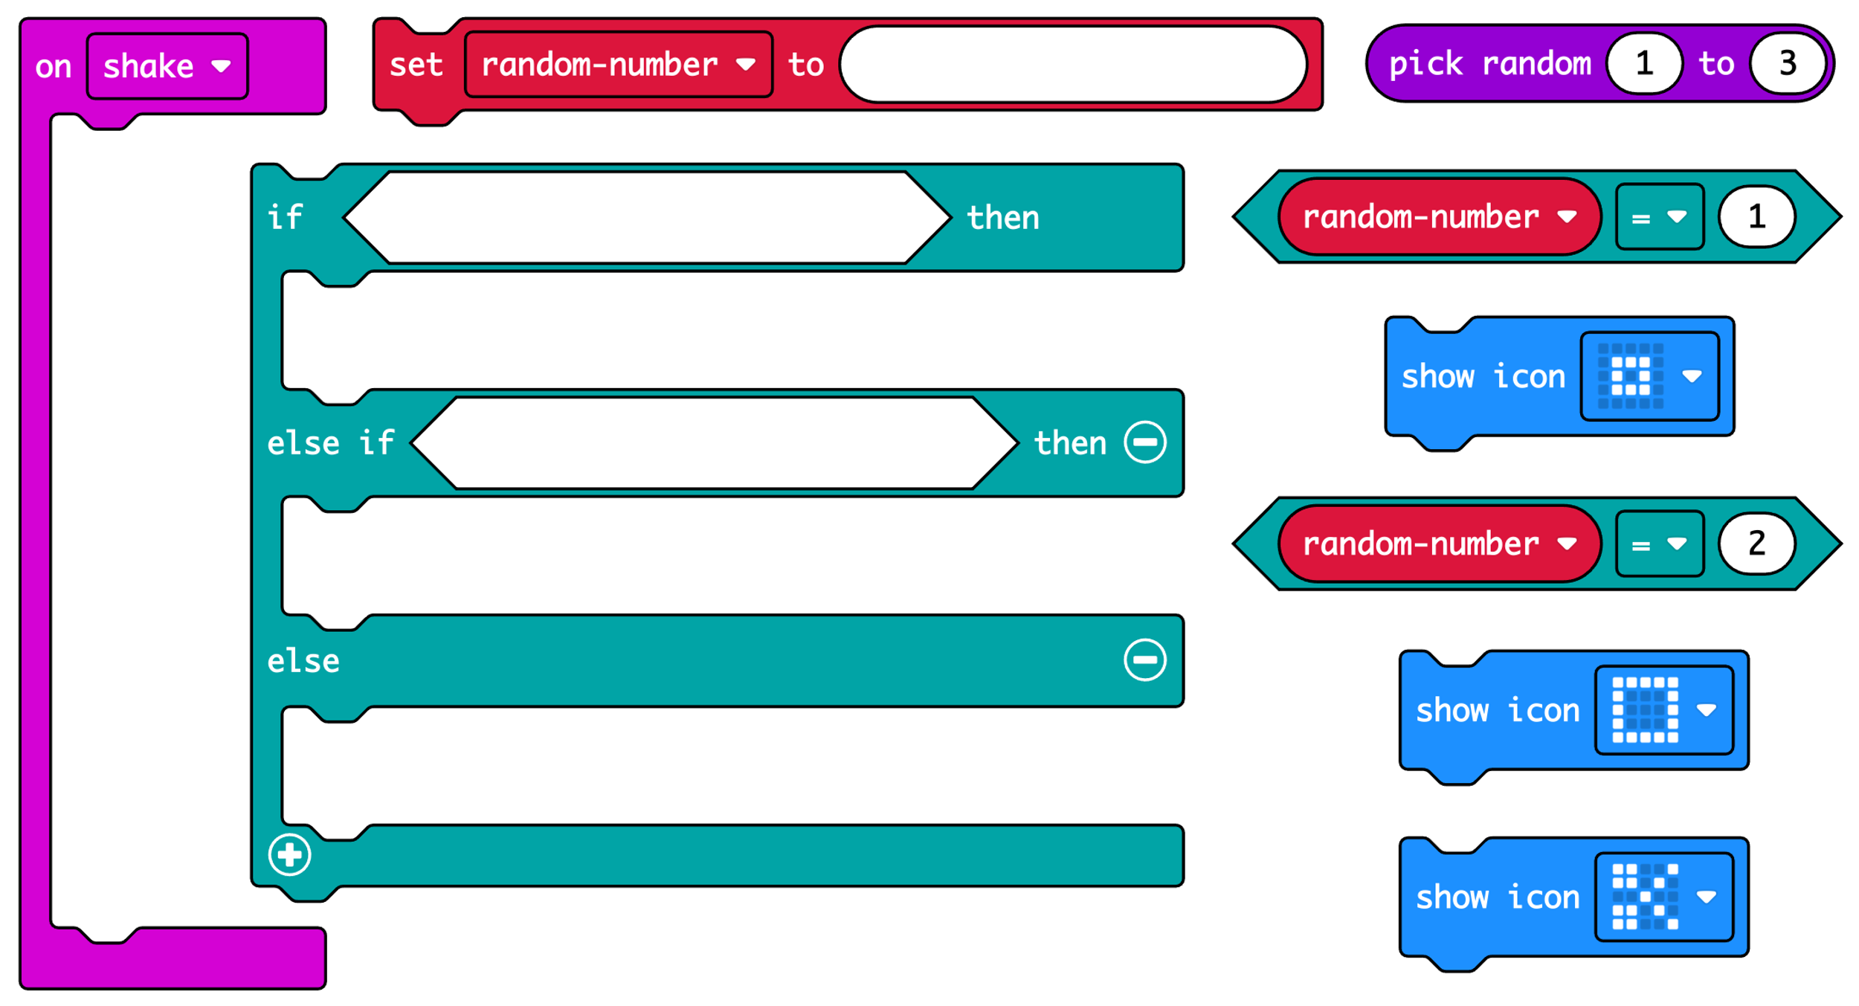

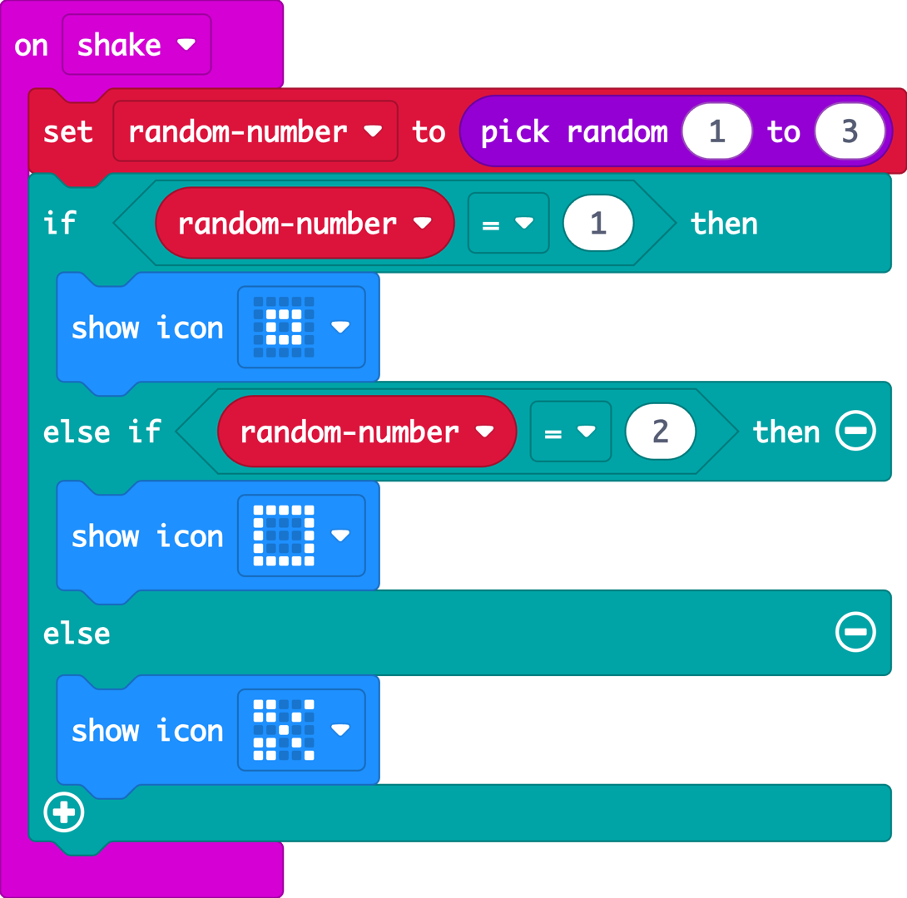
The accelerometer sensor input triggers the ‘on shake’ block.

A random number between 1 and 3 is stored in a variable called ‘random-number’.

The logic ‘if… then… else’ block tests the value of the variable.

If the number is 1, it shows a rock icon.

If the number is 2, it shows a paper icon.

Else, otherwise, if the number is not 1 or 2, it must be 3, so it shows the scissors icon.

