Barefoot meets micro:bit
Recommended for
ages 9-11
Litter Hunt - Lesson 2
Duration:

1
hour
Concepts and approaches covered
Inputs Variables

Overview
In this lesson, pupils remind themselves of how a variable functions within a program. They are then introduced to the problem from an environmental organisation, which requires them to record details of litter in the local area, including identifying litter that can be recycled. Pupils design and develop their program, then take the micro:bit out of the classroom to record details of the litter and undertake a litter pick.

Pupil objectives
■ I can design a counting device using the micro:bit
■ I can program a counting device using the MakeCode editor ■ I can use a counting device to record data

Before you start
Check the ‘Technical requirements’ section of the ‘Lesson overview’ document to ensure the micro:bit works successfully with your school.
Pupils can work individually or in pairs. micro:bit devices should be available from the beginning of the lesson for pupils to examine.
Check the ‘Health and Safety’ section of the ‘micro:bit lessons overview’ document to ensure the device can be used safely, along with considering your school’s health and safety requirements for learning outside the classroom.
During the litter hunt, you may decide to also collect litter. Bin bags, rubber gloves (and other protective clothing) and litter grabber / picker may also be required. Appropriate guidance and risk assessments should be followed to ensure this activity can be undertaken safely.

Resources
■ Desktop or laptop computer with a web browser that can access the micro:bit MakeCode editor - https://makecode.microbit.org/ and an available USB port, which can be used to transfer files to the micro:bit. Further details are outlined in the ‘Technical requirements’ section of the ‘Lesson overview’ document.
■ micro:bit devices
■ If pupils are going to collect litter as part of their litter hunt, further resources may be required, such as
- bin bags, rubber gloves (and other protective clothing), litter grabber / picker

Introduction 10 minutes
Explain to pupils they will be using the micro:bit device, which is a special type of computer they can program. Provide pupils with a micro:bit and ask them if they can identify the following parts of the device, which they will be using during these lessons - LEDs, USB connector, Buttons, Accelerometer (Slide 3).
Ask pupils to discuss whether the LEDs are inputs and outputs, and elicit that we say they are outputs, as they are displaying information from the computer. (Please note - the LEDs are also used as an input to detect light, although this is beyond the scope of this lesson.) Explain the buttons and accelerometer are inputs, as they take information from the outside world. Ask pupils to also identify other parts of the device and discuss their functionality using the guidance within the ‘Lesson overview’ as required.
Explain to pupils they will be using the micro:bit to produce a button race game, which will enable them to see who can press the micro:bit buttons the fastest. Add that before we go on to make our game, pupils will ensure they can remember how to create a program using MakeCode.
Show pupils MakeCode - https://makecode.microbit.org/ and ask them to share (Slide 4):
■ How to create a new project
■ How to place “show icon” blocks into the programming area
■ How to download the program
■ How to transfer the program file to the micro:bit
Remind pupils of how to keep safe when using the micro:bit (Slide 5). Explain to pupils they are to create a program containing at least one image, which they should transfer to the micro:bit (Slide 6). Once pupils have finished the task, they should assist other pupils until everyone in the class has completed it successfully.

Main activity 50 minutes

Variable refresher - 5 mins
Explain to learners they will be using the micro:bit to store data about litter in the local area, which they will record using a variable. Remind learners a variable is a named space in the micro:bit’s memory, which we can use to store data. Show learners the questions on slide 3, which are repeated from lesson one and ask them to discuss the answers with a partner, before sharing their thoughts with the class.

Developing a litter analysis program - 10 mins
Explain to pupils a local environmental organisation has asked you to design a program using the micro:bit to store information about litter in the local area (Slide 4). Outline how the program should store information about litter that can and cannot be recycled. Explain to children they will be taking their micro:bit outside the classroom to record real data once they have produced their program.
Show the algorithm on slide 5 and explain to pupils the algorithm’s functionality is similar to the button pressing game they produced in lesson 1. Explain the algorithm also includes the value of each variable being displayed when the relevant button is pressed. Ask pupils to discuss why this might have been included and outline it allows us to easily view the new value of the variable, which would have been difficult to see during the button pressing race.
Explain to pupils the code blocks to produce their program are available in an example program, which they should rearrange to ensure it meets the requirements outlined in the algorithm. Show pupils the available blocks (Slide 6) and ask them to work in pairs to rearrange the blocks based on the algorithm, using the example program at their own computers - https://makecode.microbit.org/_DfqXAaYe3e3u or - https://bit.ly/mb-bf (Note: This pedagogical approach, where pupils rearrange blocks of code, is known as a ‘Parson’s Problem’).

Producing and testing a litter analysis program - 15 mins
Once pupils have rearranged their code blocks, ask them to check their program with the completed code on the board (Slide 7) and to ensure it functions as expected. An example completed program is available here - https://makecode.microbit.org/_0xaHykE7mDg5
Show pupils the micro:bit battery pack and how to attach it to the device (Slide 8). Ask pupils to remove their micro:bit from the USB cable, attach the battery pack and ensure it functions away from the machine. Emphasise to pupils they should hold the plastic connector when disconnecting the battery pack, rather than pulling on the wires.

Go on litter hunt - 20 mins
Explain to pupils they are going to go outside the classroom to look for litter that can and cannot be recycled, which they will record with their micro:bit. Ask pupils to discuss materials and objects that can be recycled (slide 9) and share the list on slide 10 if required.
Ensure your school’s requirements for learning outside the classroom and collecting litter
(if appropriate) are followed and brief pupils as needed. When outside, remind pupils to use their micro:bit to record each item of litter using the appropriate button. Once back in the classroom, ask pupils to share the data they collected.
Plenary 5 minutes
Ask pupils to share their results from the litter pick (Slide 11), along with how they could present their data to the local environmental organisation.

Differentiation

Support
Pupils could be provided with the required blocks of code for each task, then asked to rearrange the blocks in order.

Stretch
More confident pupils could add additional instructions to their program, such as a smiley face when a button is pressed. Different images could be displayed depending on whether an object that can be recycled or cannot be recycled is found. Finally, an additional variable could be added to record items pupils are unsure whether they can be recycled. Data could be stored in this new variable, along with viewing the value, by pressing buttons A and B together. The ‘UKS2 - Lesson 2 - Stretch - Activities’ file can be provided for pupils, with possible solutions included in the ‘UKS2 - Lesson 2 - Stretch - Solutions’ file.

Assessment opportunities
Informal teacher assessment of understanding through lesson and assessment of pupils’ programs. Key understanding to assess:
■ Can pupils design a program based on their knowledge of how the micro:bit functions?
■ Can pupils explain the instructions they used to produce each program?

Teaching notes
Concepts and approaches

Variables
Pupils use variables to store a range of values, including a counter of button presses within their game

Inputs
The buttons and sensors both take information from the outside world into the micro:bit for processing, so are classified as inputs.

Curriculum links
Please refer to the resource overview page on the website, to understand how the learning objectives covered in this lesson relate to the curriculum in your country.

We love seeing our resources being used in the classroom.
Please share your comments and pictures via our social channels:
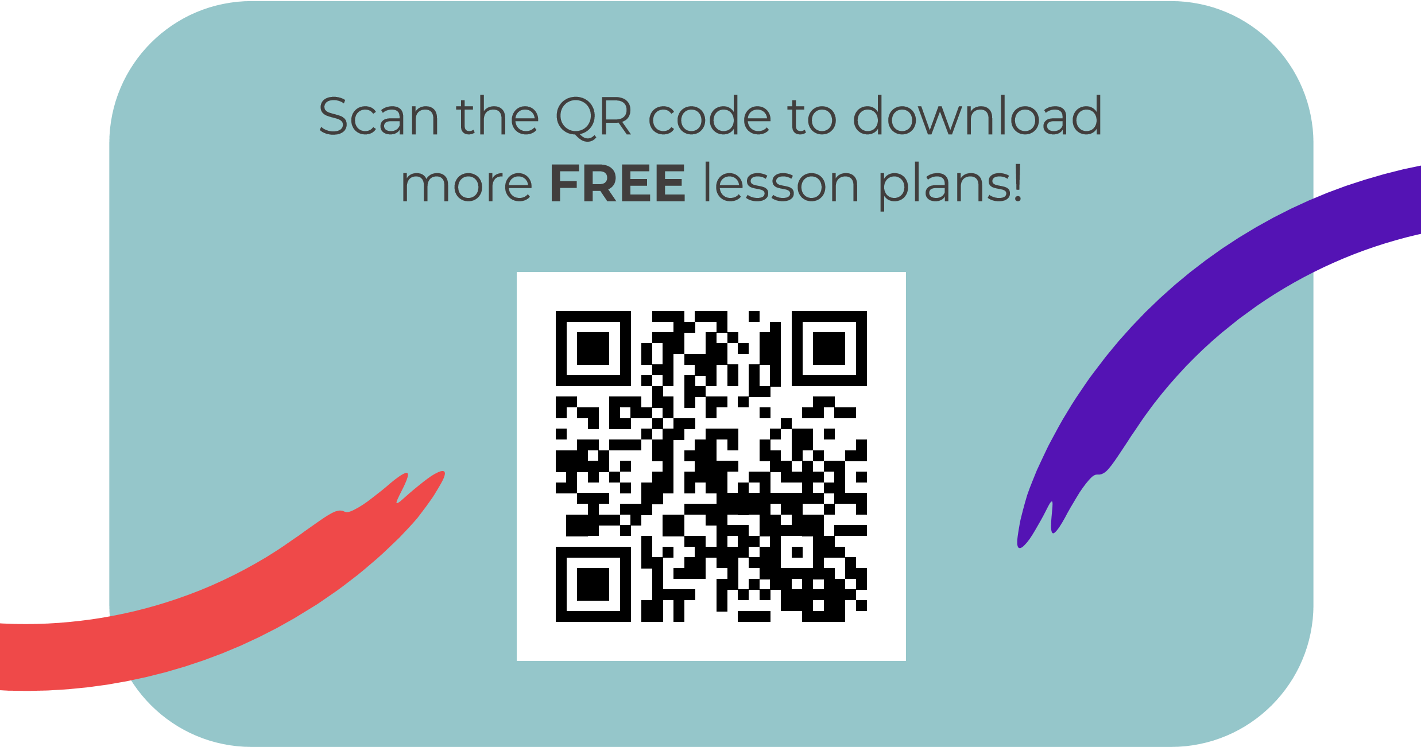
@BarefootComp /barefootcomputing @barefootcomputing
enquiries@barefootcomputing.org | barefootcomputing.org
Supported by With help from

