Lesson 1: Name badge

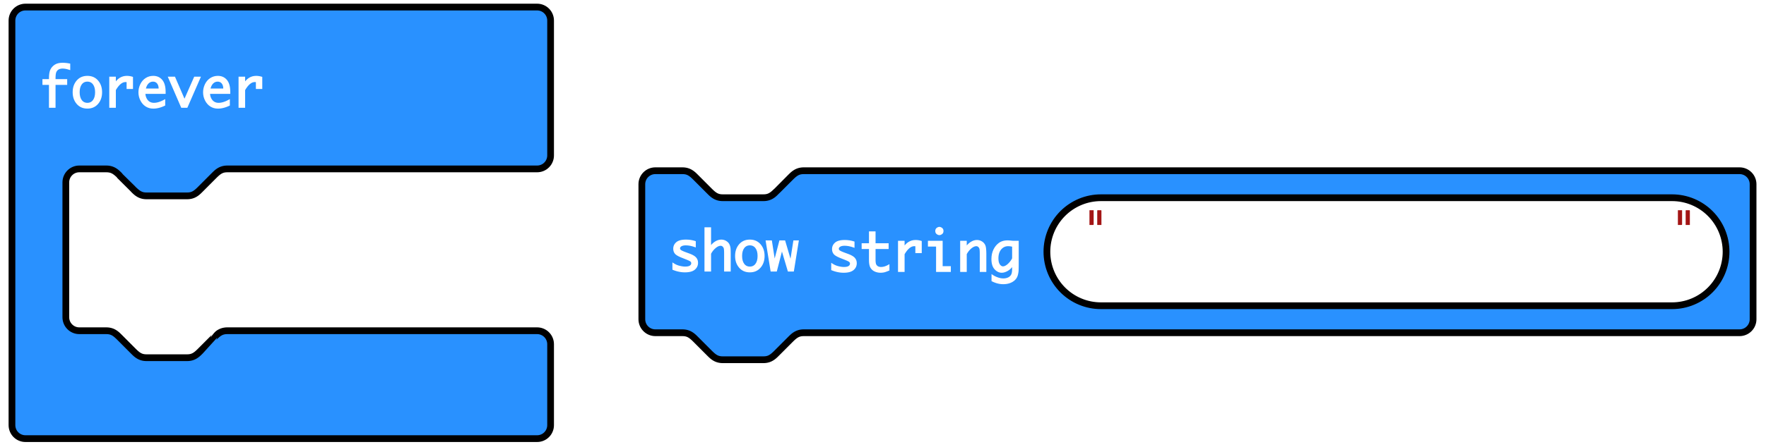

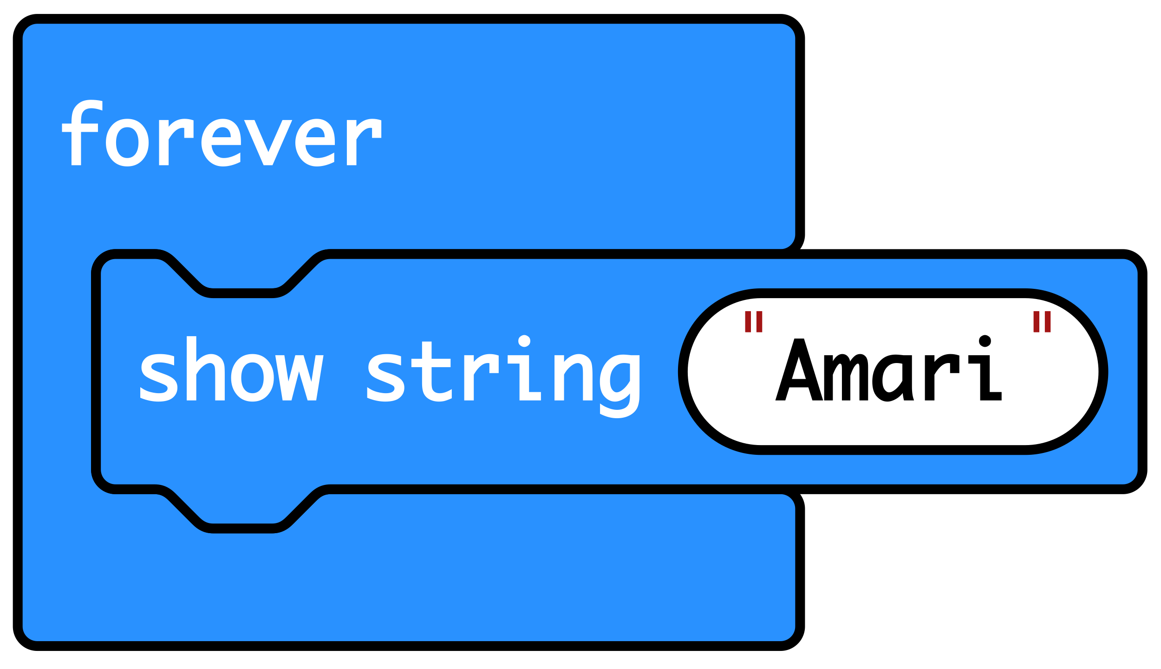
‘Forever’ is a loop that keeps the code running.

‘Show string’ scrolls the string of letters that make up your name across the LED display output.

The code then goes back to the top and runs again.

