Investigating conductivity

DATA RECORDING SHEET
Complete the following table using your BBC micro:bit.

TIP - Hold the plastic sheath on your crocodile clip leads so you don’t complete the circuit with your body.

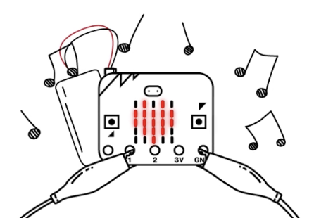 | 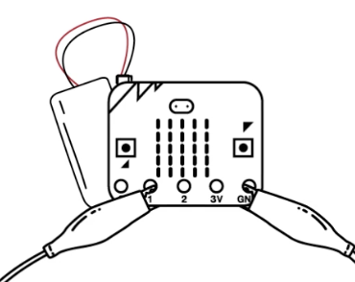
CONDUCTORS | INSULATORS
coin | cotton wool

