INTERNATIONAL ORGANISATION FOR STANDARDISATION
ORGANISATION INTERNATIONALE DE NORMALISATION
ISO/IEC JTC 1/SC 29/WG 4
CODING OF MOVING PICTURES AND AUDIO

ISO/IEC JTC 1/SC 29/WG 4 m 55089
Online – October 2020

Title: MIV CE1-Related - Activation of a transparency attribute and application to MPI encoding
Authors: J. Fleureau, R. Doré, B. Chupeau, F. Thudor, G. Briand, T. Tapie (Interdigital)

Abstract

In this contribution, we propose to enable a transparency attribute within a MIV profile at the cost of very few changes in the current specification. Indeed, this attribute already exists in the V3C specification, but it is simply not activated in any profile of MIV so far. We also show, that in addition to enable transparency in a MIV scenario, the activation of this supplementary attribute in combination with the constant patch feature also makes MIV compatible with the transport of the so called “MPI” a.k.a. Multiplane Images. These layered representations of volumetric scenes are very popular and attractive for the quality of the subjective view synthesis that they allow at very low computational costs. We bring some experimental results within the TMIV framework that demonstrate the interest of supporting such a representation for its graceful degradation properties as well as its rendering efficiency. On this basis, we emphasize again the need of enabling a transparency attribute as of this first version of the MIV specification for a possible larger deployment and adoption of the standard.

- Introduction

As of today, the existing MIV profiles only supports one unique “texture” attribute. Such a limitation especially prevents the current version of the standard from properly rendering volumetric scenes with transparent objects or parts (see Figure 1). More importantly at this stage of the standard, it is also an obstacle for properly handling contours or thin objects which are well known to be efficiently rendered making use of an additional “alpha” components to correctly blend the foreground and the background (see Figure 2).


Figure 1: Example of a transparent bay window.
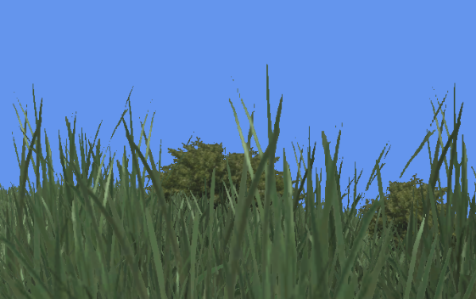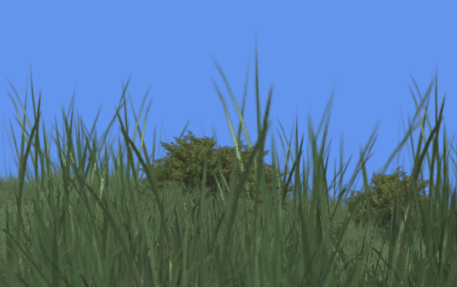
Figure 2: Sharp (left) vs smooth (right) edges.

Such observations make relevant the question of activating a transparency component in a MIV profile. It is even more relevant when you know that V3C already defines such an attribute which would make the change quite straightforward.

However, enabling this additional attribute not “only” allows for enabling transparency in the current Multi - View + Depth (MVD) paradigm of MIV, it also makes possible for alternative volumetric scene representations to be quite directly supported by this modified version of the MIV standard.

- Multiplane Images (MPI)

It is especially the case of the so-called MPI a.k.a. Multiplane Image which is a very popular layered representation (see [1], [2], [3] for instance) of a volumetric scene. In such a representation, the volumetric scene is viewed as a set of slices “regularly” sampled at different depth from a given reference point of view (see Figure 3).

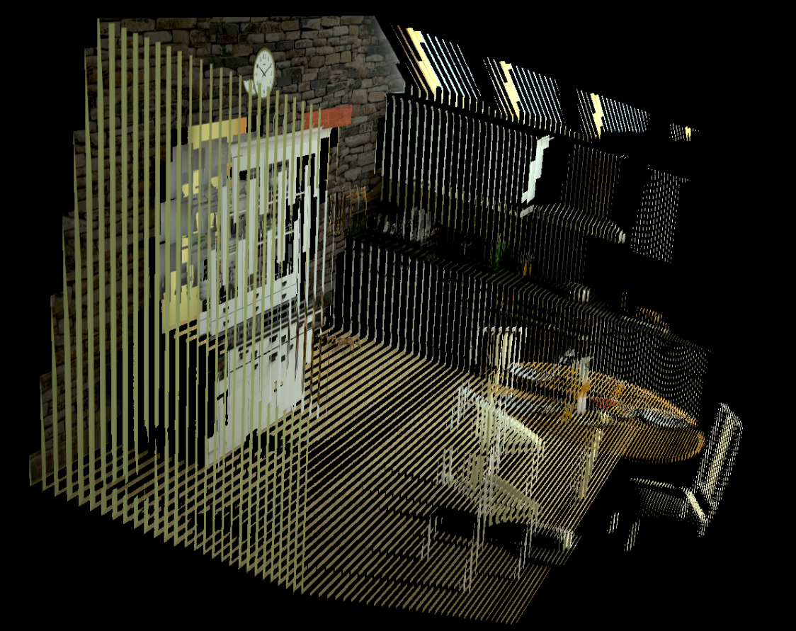
Figure 3: MPI slices for Kitchen (perspective projection).

The MPI is then defined by this set of slices / layers (typically 100 to 300) where each layer is a frame obtained by projecting the part of the 3D scene contained within the layer on a reference camera positioned at the given reference point of view. If the 3D input scene is given under the shape of a MVD set (as it is the case in the current MIV CTC), then the reference point of view may be chosen to be at the center of the input rig of cameras and the projection parameters (type and resolution) may be chosen to be consistent with the ones of the input rig (see Figure 3 and 4).

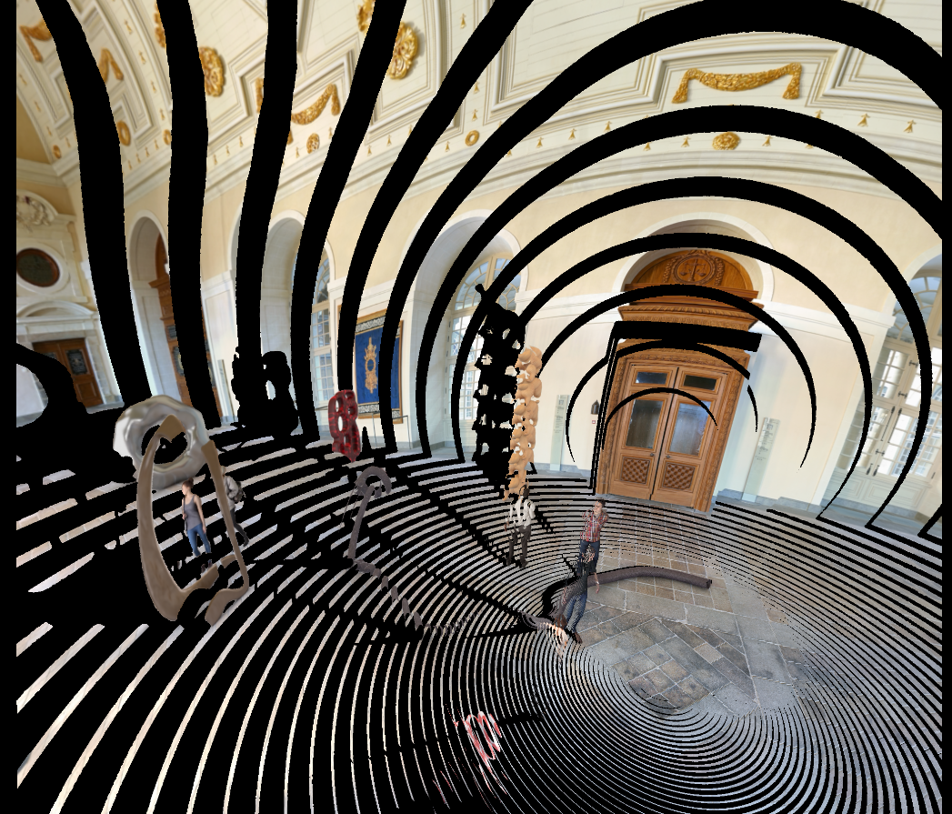
Figure 4: MPI / MSI slices for Museum (equirectangular projection).

In addition to color information, each layer also carries out transparency information (a per-pixel scalar value comprised between 0 and 1) dedicated to representing the level of transparency of each pixel of the layer frame (see Figure 5). Such a level is typically set to 1 when the pixel is associated to a non-contour part of an opaque surface, but it may be lower when it is associated to an object contour or even to a transparent object (see Figure 6).

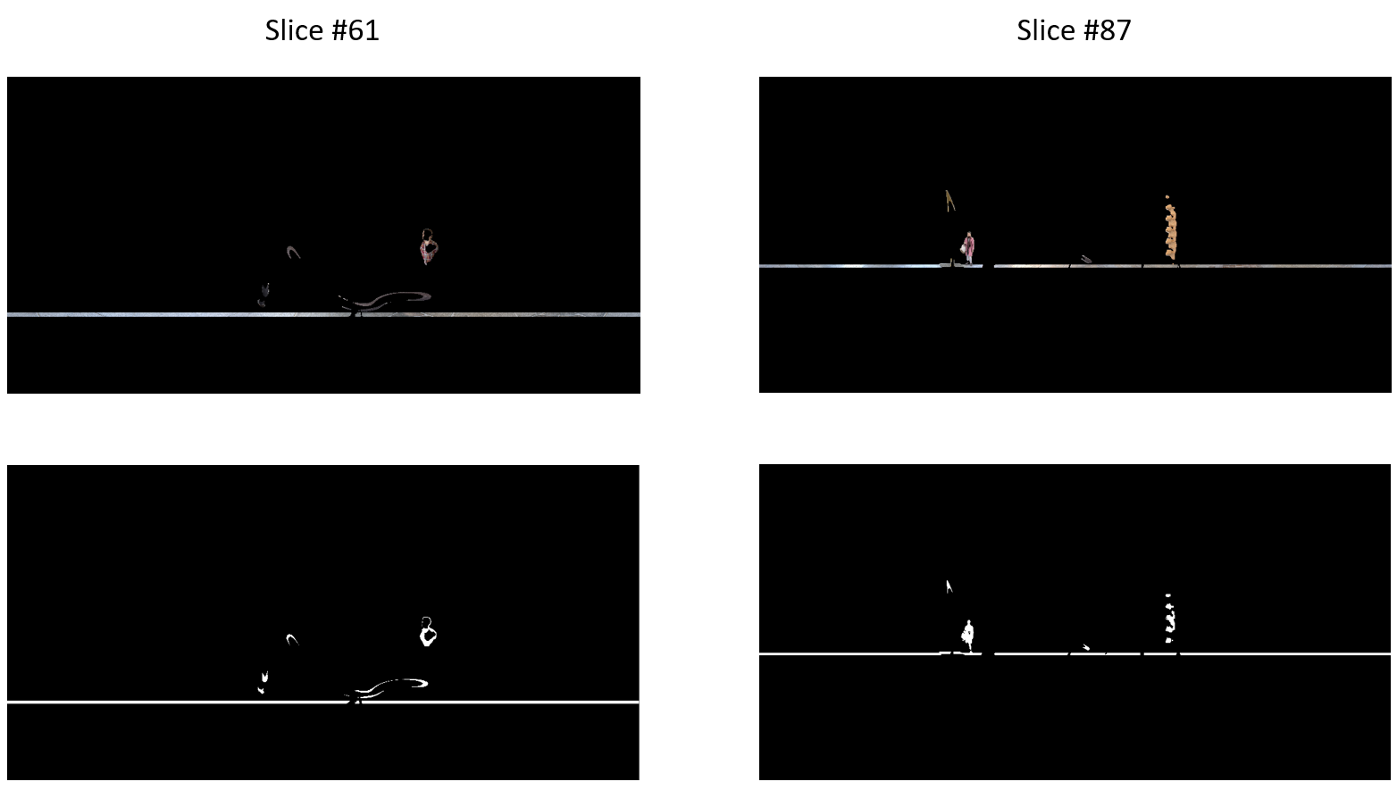
Figure 5: Example of layer frames for Museum (top: color, bottom: transparency).
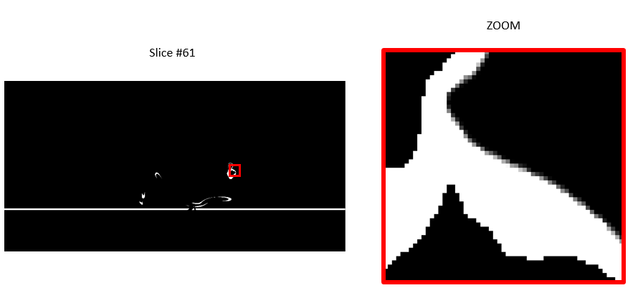
Figure 6: Anti-aliasing management on contour by lowering the transparency value.

Once computed, the rendering of an MPI is straightforward: given a desired viewport camera, one just has to project and blend the different layers from the closest to the furthest, taking into account the associated transparency values (reversed Painter’s algorithm). As soon as the cumulated / blended transparency of a given pixel of the viewport is saturated (greater than 1), then all later blended fragments are discarded. The simplicity of the synthesis stage relies on the fact that all the complexity (visibility, anti-aliasing, etc.) is handled when the MPI itself is created and not when the view synthesis is done.

When it is properly constructed, a MPI representation therefore offers 2 main advantages: i) it allows for visually plausible rendering from multi-view inputs with graceful degradation and contour handling because of the transparency attribute and ii) the synthesis process is very cheap in terms of computational requirements which makes possible fast rendering on low-end devices.

The main drawbacks of such a representation are related to: i) the difficulty to construct the MPI representation itself, i.e. to find a proper way to correctly estimate the color and transparency levels of each pixels of each layer, ii) the fuzziness introduced at the synthesis stage intrinsically due to the layered representation itself (the geometry being quite “strongly” quantized, reprojection “errors” occurs at the rendering tending to a loss in sharpness) and iii) the decrease of the synthesis quality when far from the reference MPI center.

- MPI to MIV

Even if it may seem uneasy at first glance, encoding MPI by the mean of an extended MIV bitstream which would enable a transparency attribute is in fact quite straightforward.

Indeed, each layer of a MPI may be considered as a Texture + Transparency frame “captured” from the unique reference camera used to build the MPI.

Therefore, a MPI may be in turn considered as a Multi – View + Transparency (MVT) frame where:

- each view is a layer of the MPI,
- all views share the same camera information (the MPI reference camera),
- each view has a constant depth (the depth of the associated layer),
- there is no inter-view redundancy (as the MPI is a non-redundant representation of the volumetric scene in itself),
- each view is very sparse (as it only contains the information at a certain depth – see Figure 5).

Applying a strategy very similar to the one currently done at the encoding stage of the TMIV to the MPI (i.e. clustering, aggregation and packing – no pruning is required since there is no inter-view redundancy), it is therefore possible to obtain a set of Texture + Transparency atlas frames (see Figure 6) as well as an associated patch list.

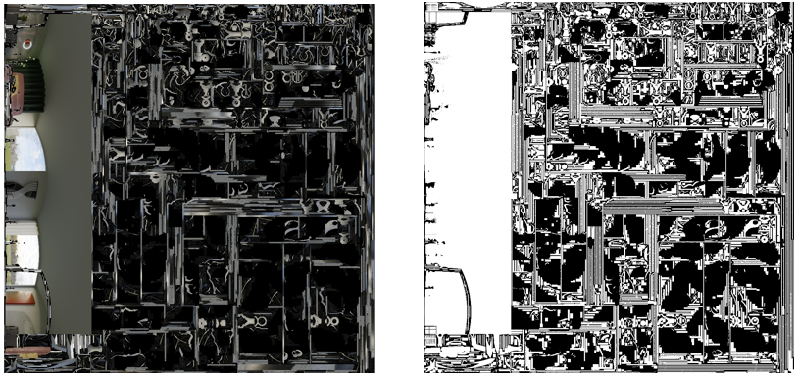
Figure 7: Example of Texture + Transparency atlas frames

It is noteworthy to mention that:

- even if at the encoding side, each layer may be considered as a view for algorithmic reasons, from a syntactic point of view, one unique view is transmitted with a set of constant depth patches, the constant depth varying from one patch to another depending on which layer the said patch has been extracted from,
- the transparency atlas naturally embeds an occupancy information as a null value indicates a fully transparency, i.e. no content,
- the transparency information does not need to be quantized with a high dynamic range and 8 bits are more than enough.

In the end, the generated bitstream is a fully MIV compliant bitstream taking advantage of the constant patch feature as well as the extra transparency attribute.

- Partial implementation in TMIV

An implementation of the MPI framework introduced hereinbefore has been done to evaluate the performances of this MIV-based porting of MPI.

As mentioned in section 2, the way the MPI itself is inferred from a MV(+D) input is a critical part and highly determines the final quality of the synthesis. Many approaches exist to fill the set of layers (making use of dedicated heuristic or relying on deep learning, exploiting the depth information or not…) and it is still a very hot research topic.

However, when the depth information is present and when its quality is high (for CG content of the CTC for instance), some quite simple “depth-driven” heuristics may be considered to create a proper MPI. It is this latter kind of approaches that we have chosen to use in the context of this contribution for sake of simplicity. Because of this choice, performances on low depth quality contents will have to be considered carefully in the following.

In few words, to get the color and transparency information of one pixel of one given layer, a reprojection in the source input views of the considered pixel at the layer depth is done which makes possible to get an average color as well as an estimation of the transparency by the means of a visibility criterion based on the source depth information. The number of layers used for the MPI representation is determined by the mean of a heuristic law considering the reference camera resolution as well as the expected viewing excursion (typically, the rig baseline).

A porting of an existing in-house GPU implementation into the TMIV reference software has been tempted at first, but it has been quickly abandoned because of its highly prohibited running time. Indeed, a CPU implementation is not really suited for MPI generation algorithm because of the amount of data to generate. To overcome this difficulty and make possible to carry on the experiment, it has been decided to use the in-house GPU-based code to generate the Texture + Transparency atlas frames as well as the associated MIV metadata bitstream.

On the other hand, the synthesis stage, which is far simpler has been integrated as a new synthesizer into the TMIV 6.0 code. The TMIV code has been also patched consistently to support an additional transparency attribute. All the modifications have been uploaded on the git repository in a dedicated branch (http://mpegx.int-evry.fr/software/MPEG/MIV/CE/CE1.git, branch=m55089, commit=92ac9119).

Finally, the GPU generated atlas frames have been lossless encoded with HM and uploaded on the MPEG server (http://mpegfs.int-evry.fr/mpegcontent, in the directory /MPEG-I/Interdigital/m55089_data) with the corresponding metadata bitstreams to make the synthesis results reproducible.

- Evaluation

This framework has been evaluated following the A97 CTC conditions.

All mandatory contents have been included in the study (SA, SB, SC, SD, SE, SJ, SN, SP) as well as the non-mandatory synthetic content SO and SQ. The remaining contents were not tested because they were either natural content with very low quality depth maps (and thus not compatible with the chosen MPI creation process – cf. previous section) or contents with too large baseline for a MPI-based approach (SR).

Regarding the video coding settings, a new set of QPs had to be selected due to the quite different nature of the generated atlas frames compared to the regular TMIV ones. It is especially the case of the transparency attribute which was generated making use of only 16 levels (4 bits) but reshaped on 10 bits to be consistent with the TMIV inputs and CTC habits. Such a low internal bit depth therefore allows for coding at high QPs. On the other hand, the texture has been coded similarly to what is done in the CTC. No QP tuning per sequence was done and the chosen QP settings may be found in Table 1.

 | TEXTURE | TRANSPARENCY
QP1 | 22 | 40
QP2 | 27 | 42
QP3 | 32 | 45
QP4 | 37 | 47
QP5 | 42 | 50
Table 1: QP settings.

For every sequence, a unique 4Kx4K atlas frame per attribute (texture + transparency) has been used.

We thank ETRI who has accepted to cross-check our results.

  - Objective performances

We provide hereafter the quantitative results summary (see Table 2 and Figure 8), but more detailed results may be found in the attached results datasheet.
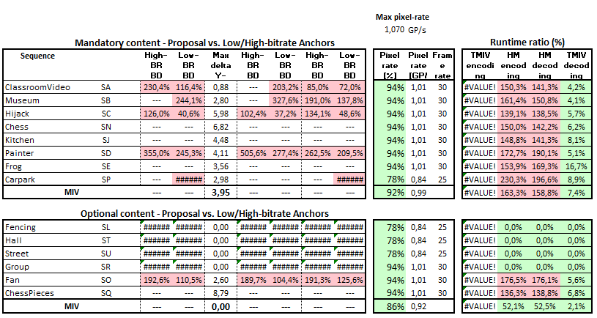
Table 2: Results Summary

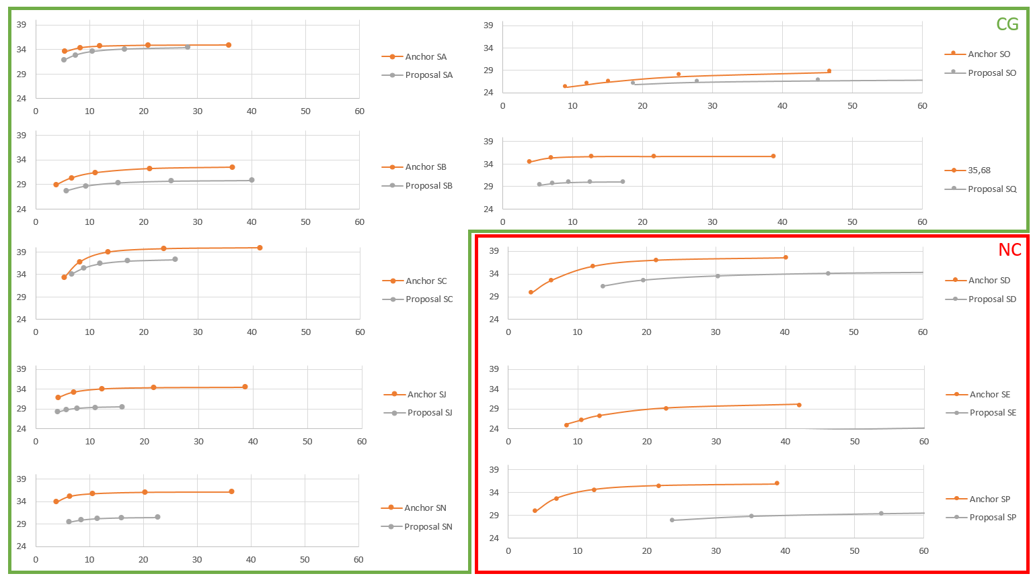
Figure 8: Bitrate / Distortion diagrams for CG and NC

    - WS-PSNR

Objective quality metrics are unquestionably very bad for all contents.

On CG sequences, one may observe a loss of around 2 to 5dB on all sequences which is typically due to reprojection errors mentioned in section 2 and intrinsically related to the layered nature of an MPI. Note that the metric variations across the different views are quite low compared to these obtained with TMIV 6.0. Regarding the overall bitrates, although no QP tuning has been performed, they are quite comparable for SA and SB, but significantly lower on SC, SJ, SN and SQ for high bitrates and significantly higher for SO, still for high bitrates.

On NC sequences, as expected, results are even worse for the reasons we mentioned before. When the input depth maps are not consistent or too noisy (SE or SP), the chosen approach to generate the MPI tends to fulfill all the layers (which are not sparse anymore), which then leads to a saturation of the atlas frames (with a lot of small patches) and therefore very high bitrates. It is a bit less true for D which has the best depth quality among NC sequences and where this phenomenon is attenuated.

    - Decoding time

Regarding the decoding time, it is typically 10x faster and even 20x faster if we disregard the NC sequences which are a bit special in the context of this evaluation. It clearly demonstrates the rendering efficiency offered by an MPI representation which low complexity make possible to address low-end devices.

    - Pixel rate and memory

The pixel rates remain just below the maximum tolerated pixel rate. However, things are a bit different if we consider the memory impact. This latter is related to the quantity of embedded V-RAM required on a GPU to decode a MIV content. As the transparency attribute requires few bits to be properly encoded (typically less than 1 byte), once decoded, the cumulated weight of the texture and transparency attributes atlas frames are exactly comparable to the weight of a texture atlas frame combined to a depth atlas frame at half resolution but encoded on 10 bits (i.e. requiring 2 bytes of memory per pixel when decoded). It is also noteworthy mentioning that a lot of low-end hardware decoders (running under Android especially) only support 8-bit decoding which means that an 8-bit transparency atlas frame could be properly decoded but not a 10-bit geometry one.

  - Subjective performances

Side-by-side videos at comparable bitrates as well as individual pose traces have been generated and uploaded on the MPEG server (http://mpegfs.int-evry.fr/mpegcontent, in the directory /MPEG-I/Interdigital/m55089_pose-traces).

We remind here again how carefully the results on NC sequences should be considered. Except for SD where pose traces at low QPs may be compared with the one generated with TMIV 6.0, it is not the case for SE and SP due to the way we have built the associated MPI. One can refer to [1] for instance to see the potential of MPI-based rendering of natural MVD sequences when dedicated algorithms are employed.

That said, if we now consider the CG set of sequences for which the selected MPI creation process was dedicated, the subjective performances are very different from what could be suggested by the objective metrics.

At high bitrates especially, the performances are better for SB, SO and SQ (see Figure 9, 10 and 11) and they are very comparable for SA, SC and SN. On these latter contents, the subjective performances remain competitive at medium bitrates. The stability of the contours as well as the smoothness of the image are typical of one can expect from an MPI-based rendering. In that sense, the challenging but very likely content SO where thin objects are numerous is clearly better handled by an MPI-based implementation.

At low bitrates, while the geometry (contours) remains quite stable, some important “banding” color artifacts appears (especially visible for SC, SN and SQ) that degrade the quality of experience (see Figure 12 - left). These artifacts are very related to the nature of the atlas obtained from a MPI which is populated with “thin” patches (see Figure 12 - right) subject to texture coding artifacts. Such artifacts could be certainly mitigated by making use of perceptually based video encoder (cf. professional encoder) or by a better QP tuning.

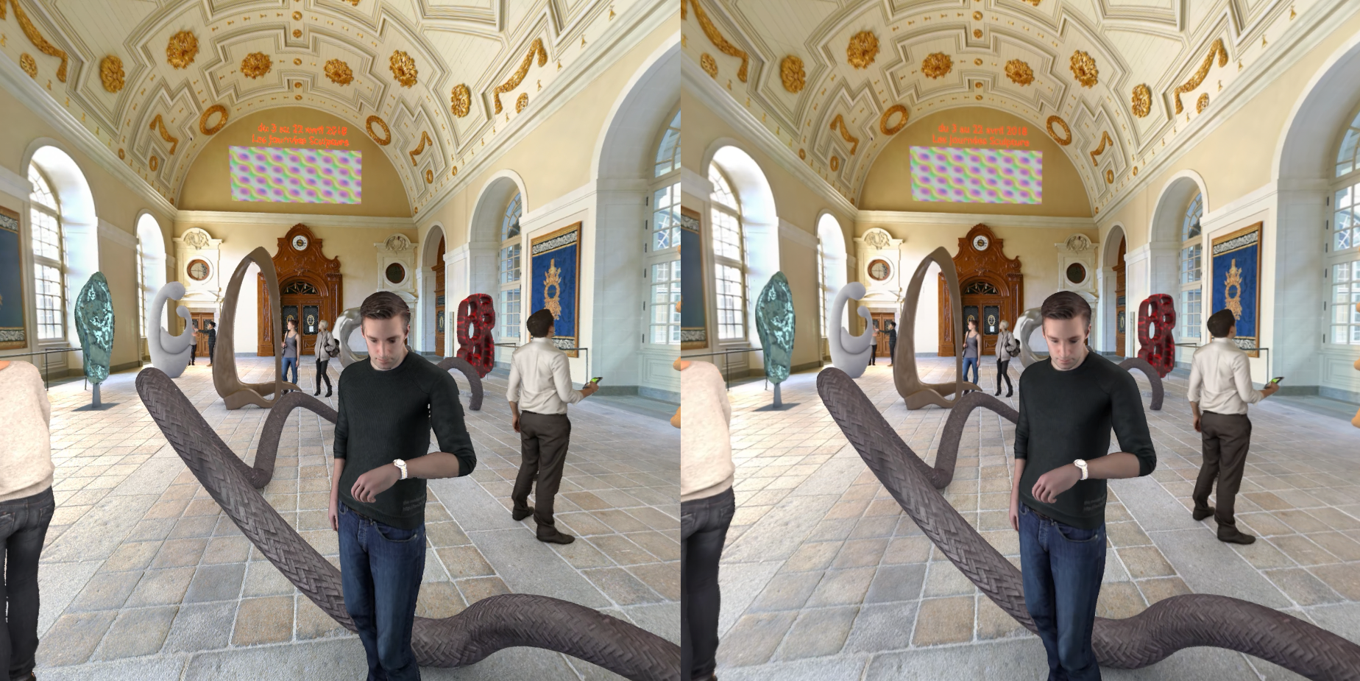
Figure 9: TMIV6.0 QP1 (left) vs TMIV6.0-MPI QP1 (right) for SB

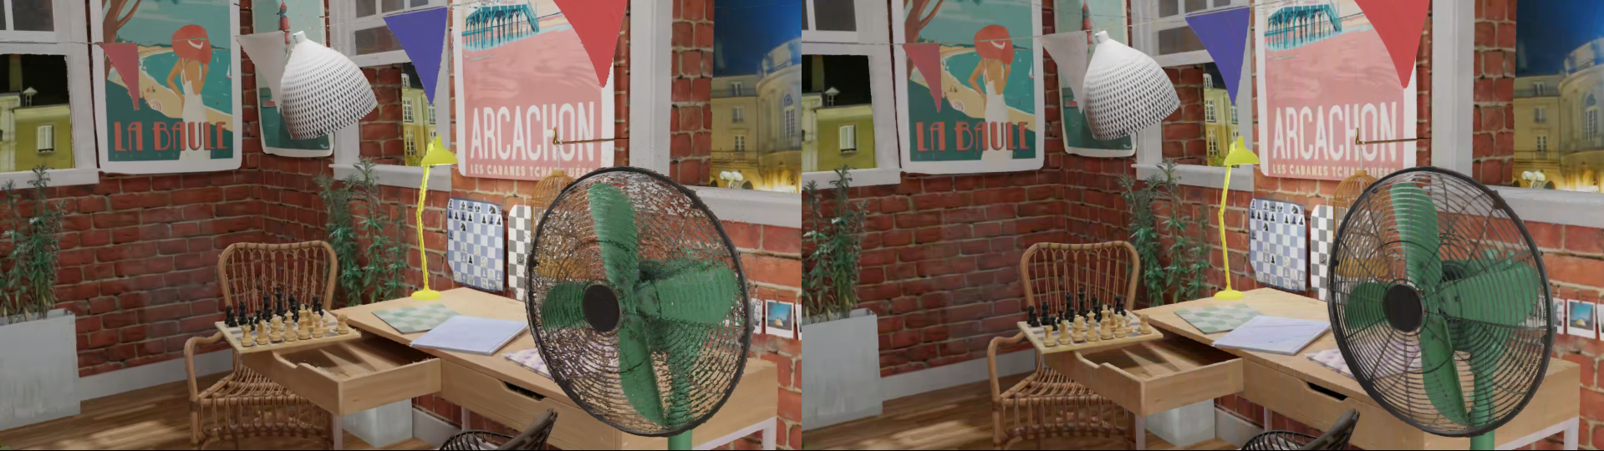
Figure 10: TMIV6.0 QP1 (left) vs TMIV6.0-MPI QP3 (right) for SO

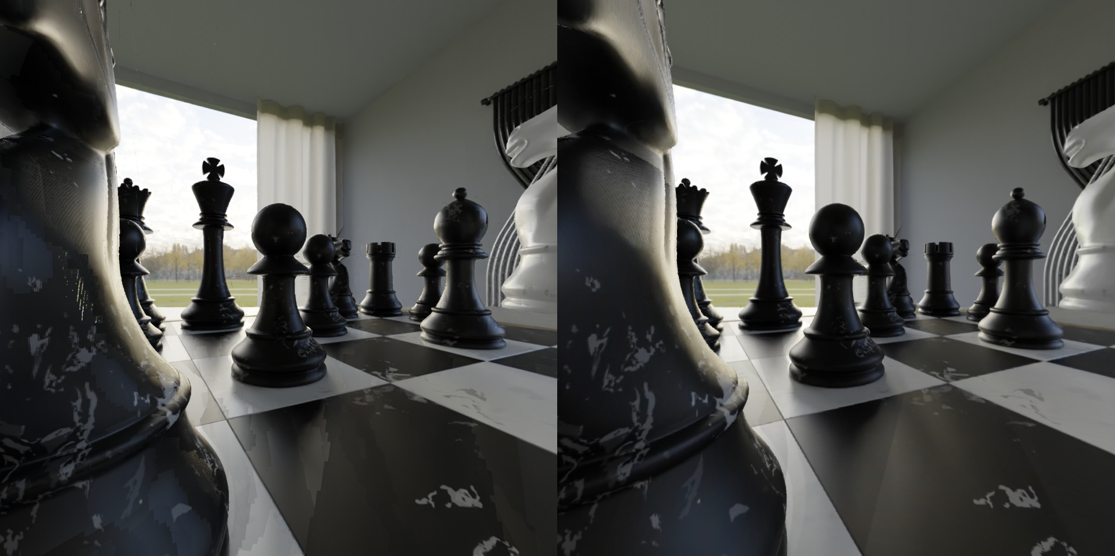
Figure 11: TMIV6.0 QP2 (left) vs TMIV6.0-MPI QP1 (right) for SN

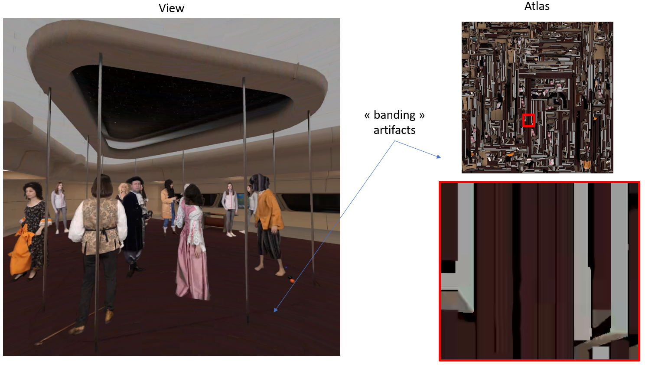
Figure 12: “Banding” artifacts in view (left) and atlas (right) frames for SC QP5

For SJ, subjective performances are a bit lower (see Figure 13). It is first due to some quantization effects that may be observed on the chairs and furniture when the view to synthesize is far from the central position used for the MPI generation (see section 2). The second issue is due to the bad transparency management on the jug of water which may be surprising since a transparency layer has been introduced. This latter issue is not due to the MPI paradigm itself (which can handle transparency) but rather on the way it has been generated (depth-driven only).

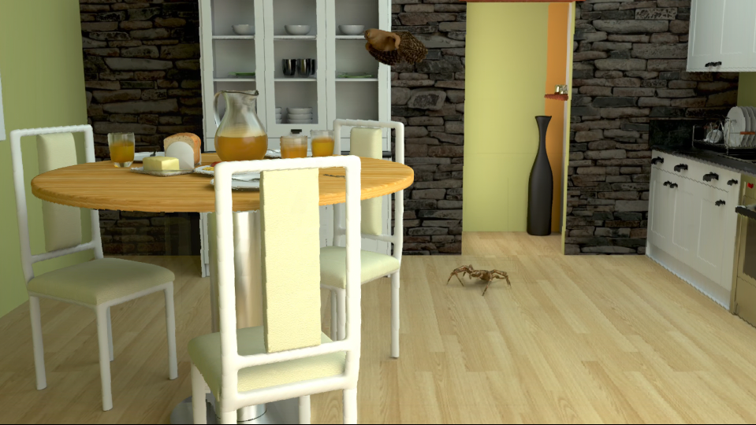
Figure 13: Quantization artifacts on chairs and jug fuzziness for SJ QP3.

  - Evaluation summary

As a conclusion of this evaluation section, we can say that the subjective performances of our MIV-based porting of MPI are worthy of interest, in contradiction to what objective results may have expressed.

The generated pose traces are competitive and even visually better in certain cases compared to TMIV 6.0 (except for NC for which obvious reasons have been stressed out before). Some sequences like SO are properly handled by the means of this additional transparency information which enables a proper rendering of thin objects. The rendering times are unquestionably lower which demonstrates the potential of an MPI-based approach within a regular MIV bitstream for a large deployment including low-end devices.

Additionally, the contradictions of the objective and subjective evaluations highlight again (as suggested before by Orange and Nokia in m54364) the weaknesses of the conclusions one can draw based on the objective metrics only. Such a matter should be definitively discussed again and further in the future.

- Transparency profile

In the previous sections, we have demonstrated how the activation of a transparency attribute in the standard in combination with the constant depth patches feature could make MIV support MPI-based atlases. As mentioned in introduction, the transparency support in MIV could also benefit to many other scenarios, especially those requiring a more “basic” support of transparency.

Therefore, we propose to introduce an additional profile in MIV that would support an additional transparency attribute and that would be generic enough to cover a broad scope of applications. In this latter, the concept of occupancy is carried out by the transparency attribute itself which null value is synonym of empty space (see Section 3). The constant depth patch feature should be activatable to make possible the encoding of MPI content. On the other hand, making use of a regular geometry stream should be still possible for more “ordinary” usage. The following Table 3 summarizes the difference of this new profile with the existing ones.

Syntax element  (V3C 2nd Edition) | MIV Main profile | MIV Extended profile | MIV Geometry Absent profile | MIV Transparency profile
vuh_unit_type | 0 (V3C_VPS), 1 (V3C_AD),  3 (V3C_GVD), 4 (V3C_AVD),  6 (V3C_CAD) | 0 (V3C_VPS),  1 (V3C_AD),  2 (V3C_OVD),  3 (V3C_GVD),  4 (V3C_AVD),  5 (V3C_PVD),  6 (V3C_CAD) | 0 (V3C_VPS),  1 (V3C_AD),  2 (V3C_OVD),  3 (V3C_GVD),  4 (V3C_AVD),  5 (V3C_PVD),  6 (V3C_CAD) | 0 (V3C_VPS),  1 (V3C_AD),  3 (V3C_GVD),  4 (V3C_AVD),  5 (V3C_PVD),  6 (V3C_CAD)
vps_extension_present_flag | 1 | 1 | 1 | 1
vps_miv_extension_present_flag | 1 | 1 | 1 | 1
ptl_profile_toolset_idc | 64 | 65 | 66 | 67
vps_map_count_minus1[ atlasID ] | 0 | 0 | 0 | 0
vps_occupancy_video_present_flag[ atlasID ] | 0 | 0, 1 | 0 | 0
vps_geometry_video_present_flag[ atlasID ] | 1 | 1, 0 | 0 | 0, 1
vps_attribute_video_present_flag[ atlasID ] | 1 | 1 | 1 | 1
vps_packed_video_present_flag[ atlasID ] | 0 | 0, 1 | 0, 1 | 0, 1
ai_attribute_count[ atlasID ] | 1 | 1 | 1 | 2
ai_attribute_type_id[ atlasID ][ 0 ] | 0 | 0 | 0 | 0
ai_attribute_dimension_minus1[ atlasID ][ 0 ] | 2 | 2 | 2 | 2
ai_attribute_dimension_partitions_minus1[ atlasID ][ 0 ] | 0 | 0 | 0 | 0
ai_attribute_type_id[ atlasID ][ 1 ] | - | - | - | 2
ai_attribute_dimension_minus1[ atlasID ][ 1 ] | - | - | - | 0
ai_attribute_dimension_partitions_minus[ atlasID ][ 1 ] | - | - | - | 0
vme_embedded_occupancy_flag | 1 | 0, 1 | 0 | 0
asps_raw_patch_enabled_flag | 0 | 0 | 0 | 0
asps_eom_patch_enabled_flag | 0 | 0 | 0 | 0
asps_plr_enabled_flag | 0 | 0 | 0 | 0
asps_extension_present_flag | 1 | 1 | 1 | 1
asps_miv_extension_present_flag | 1 | 1 | 1 | 1
asme_patch_constant_depth_flag | 0 | 0, 1 | 0, 1 | 0, 1
asme_patch_constant_depth_flag | | vps_geometry_video_present_flag[ atlasID ] | 1 | 1 | 0, 1 | 1
afti_single_tile_in_atlas_frame_flag | 1 | 0, 1 | 0, 1 | 0, 1
Table 3: Transparency profile and comparison with the other profiles.

- Recommendations

In this contribution, we have tried to show how an additional transparency attribute could be of great interest for a broader deployment of the MIV standard, both in terms of rendering capabilities as well as in terms of computational requirements. We have also shown that, at the cost of this “slight” change, MPI-based atlases could be quite straightforwardly carried by a V3C bitstream.

Consequently, we recommend adopting an additional profile in MIV (cf. Table 3) that would make possible to enable an extra transparency attribute in a sufficiently broad manner.

- Bibliography

[1] “Soft 3D Reconstruction for View Synthesis”, Eric Penner and Li Zhang, 2017, ACM Transactions on Graphics (Proc. SIGGRAPH Asia) (vol. 6)

[2] “Stereo Magnification: Learning view synthesis using multiplane images”, T. Zhou, R. Tucker, J. Flynn, G. Fyffe, N. Snavely, 2018, ACM Trans. Graph. (Proc. SIGGRAPH) (vol. 37)

[3] “Single-view View Synthesis with Multiplane Images”, R. Tucker, N. Snavely, 2020, IEEE Conference on Computer Vision and Pattern Recognition (CVPR)

