INTERNATIONAL ORGANISATION FOR STANDARDISATION
ORGANISATION INTERNATIONALE DE NORMALISATION
ISO/IEC JTC 1/SC 29/WG 2
MPEG TECHNICAL REQUIREMENTS

ISO/IEC JTC 1/SC 29/WG 2 m55984
Online – January 2021

Source | InterDigital
Status | Input contribution
Title | Vibrotactile and Kinesthetic content for AHG MPEG-haptics
Authors | Fabien Danieau (fabien.danieau@interdigital.com)  Quentin Galvane (quentin.galvane@interdigital.com)  Philippe Guillotel (philippe.guillotel@interdigital.com)

Contents
1. Abstract 2
2. Introduction 2
3. Content list 3
3.1 Vibrotactile 3
3.1.1 IDCC-vib-Carpet-8kHz-16-nopad 3
3.1.2 IDCC-vib-Paper-8kHz-16-nopad 3
3.1.3 IDCC-vib-Towel-8kHz-16-nopad 4
3.1.4 IDCC-vib-Rain-8kHz-16-nopad 5
3.1.5 IDCC-vib-HeartBeat-8kHz-16-nopad 6
3.2 Kinesthetic 6
3.2.1 IDCC-kin-BigBuckBunny-8kHz-16-nopad 7
3.2.2 IDCC-kin-Rollercoaster-8kHz-16-nopad 7
3.2.3 IDCC-kin-BikeRiding-8kHz-16-nopad 8
3.2.4 IDCC-kin-HorseRiding-8kHz-16-nopad 9
3.2.5 IDCC-kin-ForceXFast-8kHz-16-nopad 9
3.2.6 IDCC-kin-ForceXSlow-8kHz-16-nopad 10
3.2.7 IDCC-kin-ForceYFast-8kHz-16-nopad 10
3.2.8 IDCC-kin-ForceYSlow-8kHz-16-nopad 11
3.2.9 IDCC-kin-ForceZFast-8kHz-16-nopad 12
3.2.10 IDCC-kin-ForceZSlow-8kHz-16-nopad 12
4. References 13
5. Annex: copyright group and contents 13

Abstract
At the 131 MPEG meeting, an AhG was setup with the mandate to prepare a Call for Proposals for the coded representation of Haptics. Among its mandates, the group had to i) collect test materials for use with the CfP and subsequent specification development and ii) study and propose methods to evaluate CfP responses.
This contribution proposes a set of test materials that can be used by proponents to develop their response to the CfP.

Introduction
Traditionally, haptics considers two main types of stimuli: vibrotactile and kinesthetic. Content representative of these two types of haptic signals is thus required. The various type of content proposed here were either captured from the real world or synthesized from computer simulations. Each of them is store in a .wav file sampled at 8kHz and 16bits. Values are normalized between –1 and 1.

Content is provided in four zip files, one file for vibrotactile and kinesthetic. Each of these files being duplicated with a raw file and a padded file. Padded folder contains the same signal that in raw but with 1 second of silence before and after the signal.

Each raw data file is associated with an OHM description meta-data file (described in MPEG document m55985). All the information included in the OHM file is provided here with the description of the content.

The naming convention used is the following:

<contentprovidername>-<type>-<contentname>-<samplingrate>-<bitspersample>-<padding>.<ext>

Where:
- <contentprovidername> - one of IMMR, APPL, IDCC, ACTK - the content providers
- <type> - vib for vibrotactile and kin for kinesthetic
- <contentname> - descriptive content name with no dashes (-) in the name. (E.g., BikeRiding, HeartBeat, etc.)
- <samplingrate> - in the form <num>kHz. E.g., 8kHz, 16kHz, etc.
- <bitspersample> - a number representing the bits per sample. E.g. 8, 16, etc.
- <padding> - will be pad if padding is used. Will be nopad if no padding is used.
- <ext> - one of ahap, ivs, wav

Illustrative examples:
- IMMR-vib-explosion-8kHz-16-pad.wav – Vibrotactile content from Immersion, titled ‘explosion’ sampled at 8 kHz, 16 bits/sample, with 1000 ms leading and trailing silence.
- IDCC-kin-ForceXSlow-16kHz-8-nopad.wav – Kinesthetic content from InterDigital, titled ‘ForceXSlow’ sampled at 16 kHz, 8 bits/sample, with no padding.

Content list

Vibrotactile
The signals represent vibrations to be rendered on a vibrating actuator. It has been tested with the reference vibrotactile setup developed for the AHG mpeg-haptics (Actronika mockup). A content may have multi channels that mean that each channel could be applied on different part of the user’s body.

IDCC-vib-Carpet-8kHz-16-nopad
Recording of a finger rubbing the surface of a carpet using a Senheiser ME66/K6 microphone on a Zoom R16 recorder (see [2]). It generates a wav file at 44.1kHz and 24bits. A representative part of the content has been cropped and downsampled to 8kHz and 16bits.

('channels:', 1)
('bits per sample:', 16)
('framerate:', 8000)
('nframes:', 32000)
('duration secs', 4)
(‘body parts’, right hand fingers)

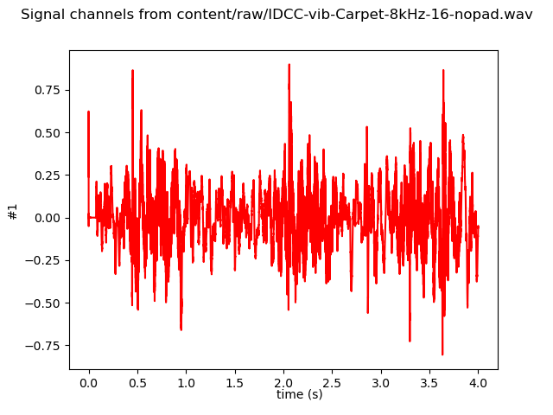

IDCC-vib-Paper-8kHz-16-nopad
Recording of a finger rubbing the surface of a piece of paper using a Senheiser ME66/K6 microphone on a Zoom R16 recorder (see [2]). It generates a wav file at 44.1kHz and 24bits. A representative part of the content has been cropped and downsampled to 8kHz and 16bits.

('channels:', 1)
('bits per sample:', 16)
('framerate:', 8000)
('nframes:', 32000)
('duration secs', 4)
(‘body parts’, right hand fingers)

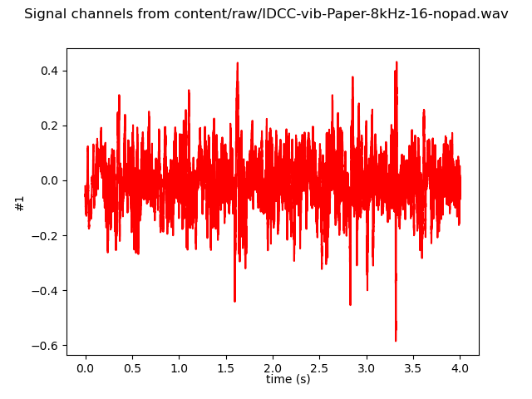

IDCC-vib-Towel-8kHz-16-nopad
Recording of a finger rubbing the surface of a towel using a Senheiser ME66/K6 microphone on a Zoom R16 recorder (see [2]). It generates a wav file at 44.1kHz and 24bits. A representative part of the content has been cropped and downsampled to 8kHz and 16bits.

('channels:', 1)
('bits per sample:', 16)
('framerate:', 8000)
('nframes:', 32000)
('duration secs', 4)
(‘body parts’, right hand fingers)

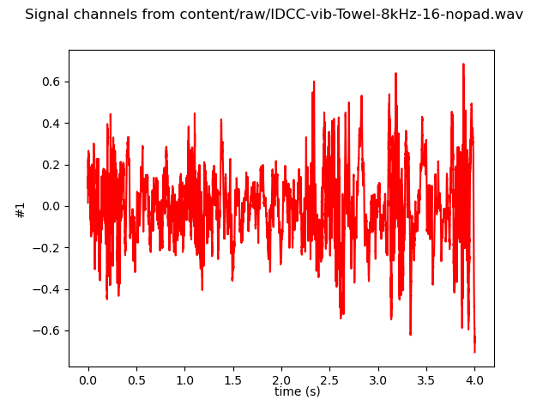

IDCC-vib-Rain-8kHz-16-nopad
Synthetic signal simulating a rain effect. It is composed of four channels with random succession of silences and sines at various amplitudes. Channels are meant to be rendered on different locations of the user’s body (for instance head, torso, left arm, right arm).

('channels:', 4)
('bits per sample:', 16)
('framerate:', 8000)
('nframes:', 32000)
('duration secs', 4)
(‘body parts’, Head, left arm, right arm, upper chest)

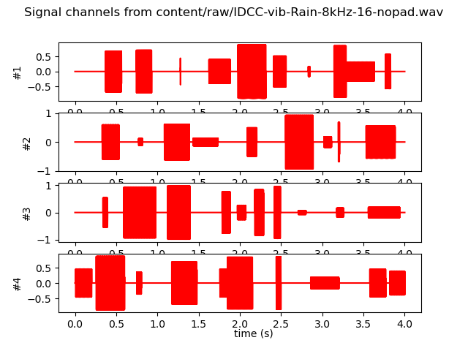

IDCC-vib-HeartBeat-8kHz-16-nopad
Synthetic signal simulating a heartbeat effect. It was modeled as a succession of silences and sines.

('channels:', 1)
('bits per sample:', 16)
('framerate:', 8000)
('nframes:', 24000)
('duration secs', 3)
(‘body parts’, upper chest + left arm)

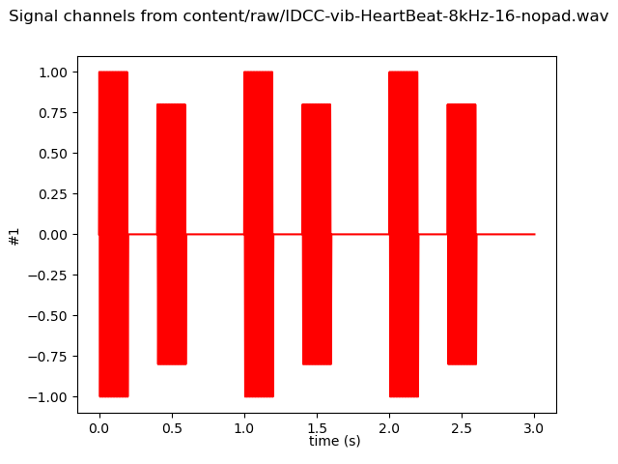

Kinesthetic
The kinesthetic signals represent a force to be rendered on a force-feedback device. It has been tested with a 3D System Touch. The first three channels are the signals for the X, Y and Z axes respectively. If any, the three other channels are the signals for the torque along the X, Y and Z channels.

The device and associated orientation are depicted in the figure below:
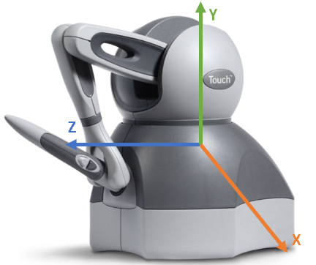

The various figures thereafter show the different signals. The values are rescaled according to the original dynamic range (i.e. the normalization has been removed).

IDCC-kin-BigBuckBunny-8kHz-16-nopad
Synthetic signal to be associated to an extract of the Blender movie Big Buck Bunny ©. They represent physical events happening in the movie. Signals have been computer generated.

('channels:', 3)
('bits per sample:', 16)
('framerate:', 8000)
('nframes:', 40000)
('duration secs', 5)
(‘body parts’, full body)

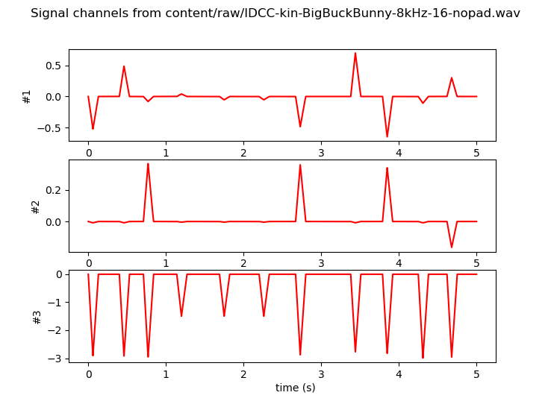

IDCC-kin-Rollercoaster-8kHz-16-nopad
Synthetic signal to be associated to first person point of view of a rollercoaster ride. They match the movement of the cart. Signals have been computer generated.

('channels:', 6)
('bits per sample:', 16)
('framerate:', 8000)
('nframes:', 40000)
('duration secs', 5)
(‘body parts’, full body)

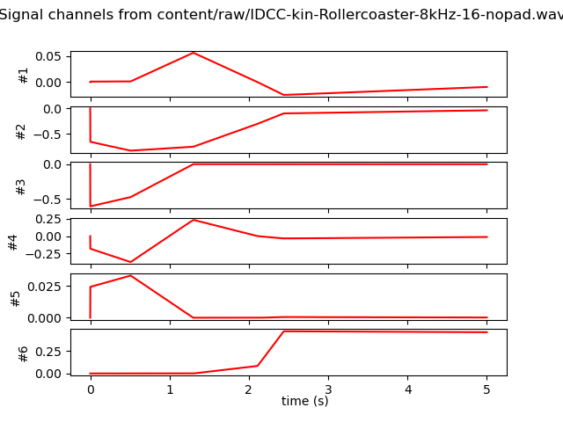

IDCC-kin-BikeRiding-8kHz-16-nopad
Captured signal to be associated to first person point of view of a bike ride. Signals were captured with an Ultimate IMU board (ADXL345 accelerometer and ITG-3200 gyroscope, see [1]) at 200Hz, and downsampled at 30Hz directly on the board. Acceleration is used for the three first channels while rotation speed for the three others. The signals have been usampled using a linear interpolation.

('channels:', 6)
('bits per sample:', 16)
('framerate:', 8000)
('nframes:', 40000)
('duration secs', 5)
(‘body parts’, full body)

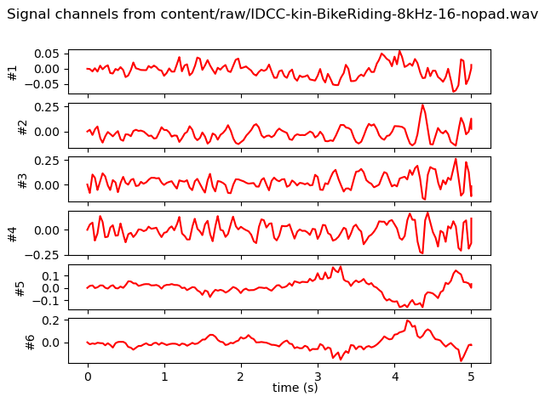

IDCC-kin-HorseRiding-8kHz-16-nopad
Captured signal to be associated to first person point of view of a horse ride. Signals were captured with an Ultimate IMU board (ADXL345 accelerometer and ITG-3200 gyroscope, see [1]) at 200Hz, and downsampled at 30Hz directly on the board. Acceleration is used for the three first channels while rotation speed for the three others. The signals have been usampled using a linear interpolation.

('channels:', 6)
('bits per sample:', 16)
('framerate:', 8000)
('nframes:', 40000)
('duration secs', 5)
(‘body parts’, full body)

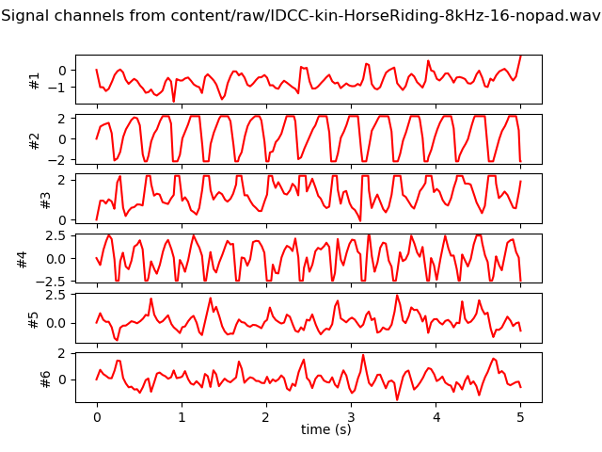

IDCC-kin-ForceXFast-8kHz-16-nopad
Synthetic simple signal of a up down force along the X axis during 2 seconds.

('channels:', 3)
('bits per sample:', 16)
('framerate:', 8000)
('nframes:', 16000)
('duration secs', 2)
(‘body parts’, Right hand palm)

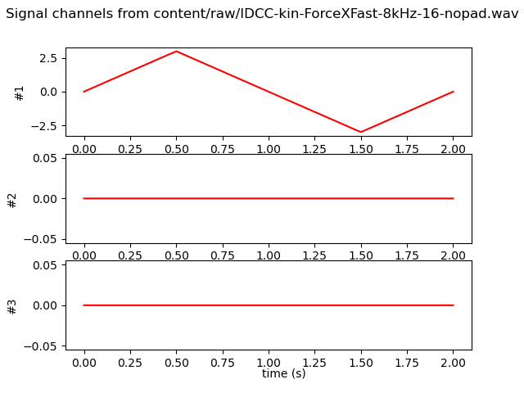

IDCC-kin-ForceXSlow-8kHz-16-nopad
Synthetic simple signal of a up down force along the X axis during 4 seconds.

('channels:', 3)
('bits per sample:', 16)
('framerate:', 8000)
('nframes:', 32000)
('duration secs', 4)
(‘body parts’, Right hand palm)

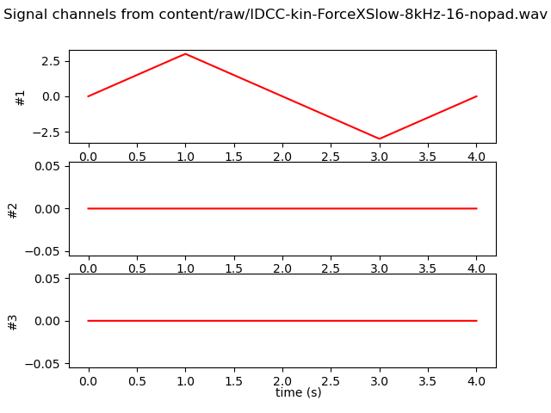

IDCC-kin-ForceYFast-8kHz-16-nopad
Synthetic simple signal of a up down force along the Y axis during 2 seconds.

('channels:', 3)
('bits per sample:', 16)
('framerate:', 8000)
('nframes:', 16000)
('duration secs', 2)
(‘body parts’, Right hand palm)

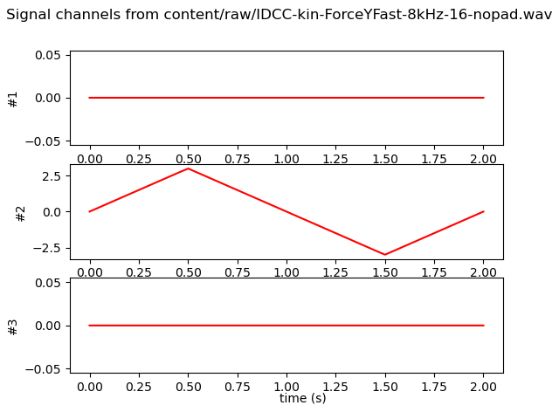

IDCC-kin-ForceYSlow-8kHz-16-nopad
Synthetic simple signal of a up down force along the Y axis during 4 seconds.

('channels:', 3)
('bits per sample:', 16)
('framerate:', 8000)
('nframes:', 32000)
('duration secs', 4)
(‘body parts’, Right hand palm)

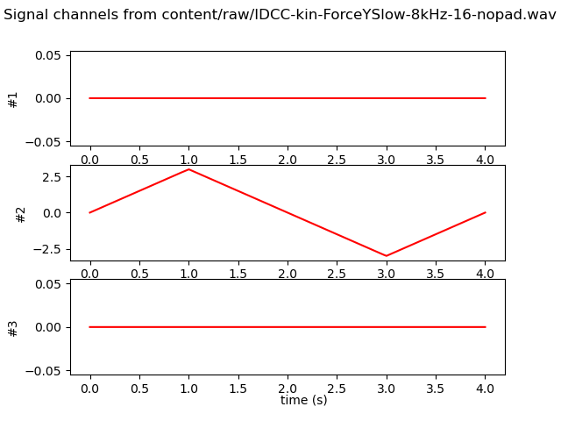

IDCC-kin-ForceZFast-8kHz-16-nopad
Synthetic simple signal of a up down force along the Z axis during 2 seconds.

('channels:', 3)
('bits per sample:', 16)
('framerate:', 8000)
('nframes:', 16000)
('duration secs', 2)
(‘body parts’, Right hand palm)

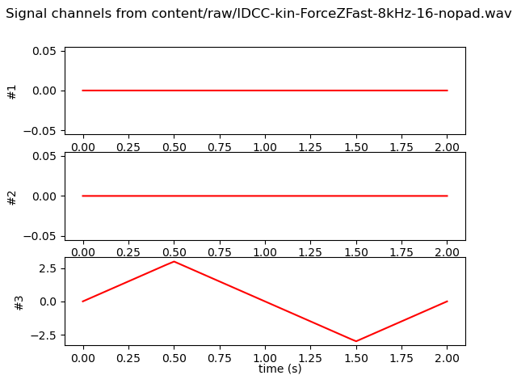

IDCC-kin-ForceZSlow-8kHz-16-nopad
Synthetic simple signal of a up down force along the X axis during 4 seconds.

('channels:', 3)
('bits per sample:', 16)
('framerate:', 8000)
('nframes:', 32000)
('duration secs', 4)
(‘body parts’, Right hand palm)

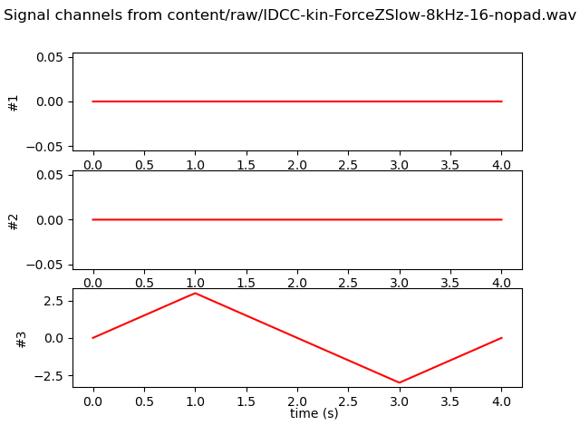

References

[1] Framework for enhancing video viewing experience with haptic effects of motion Danieau, Fabien, Fleureau, Julien, Cabec, Audrey, Kerbiriou, Paul, Guillotel, Philippe, Mollet, Nicolas, Christie, Marc, and Lécuyer, Anatole, In 2012 IEEE Haptics Symposium (HAPTICS) 2012

[2] Texture rendering on a tactile surface using extended elastic images and example-based audio cues Fleureau, Julien, Lefevre, Yoan, Danieau, Fabien, Guillotel, Philippe, and Costes, Antoine, In International Conference on Human Haptic Sensing and Touch Enabled Computer Applications 2016

Annex: copyright group and contents

WARNING: DO NOT REMOVE THIS NOTICE - AUTHORIZATION SUBJECT TO RESTRICTIONS
This copyright document relates to the following contents:
All files included in the directory Interdigital_Vibrotactile_Content[X] (with X as index or suffix or absent)
All files included in the directory Interdigital_Kinesthetic_Content[X] (with X as index or suffix or absent)
with the names nnnn.wav files for the haptic signals and associated nnnn.ohm for the descriptive meta-data files.

This haptic content (“Content”) may only be used for the purpose of developing, testing and promulgating technology standards developed by the MPEG, JPEG, VCEG, JVET standardization groups and for academic research without any commercial use or intent (a commercial use including without limitation the creation of any intellectual property right)(“Purpose”), under InterDigital R&D France (“InterDigital”) owned or controlled copyrights, by individual(s) or organization(s) that participates, contributes or is part of such standardization groups (“User(s)”).

RESTRICTIONS: No license whatsoever is implied except from this expressed limited personal, non-sublicensable, non-transferrable authorization. In particular no right under any patent of InterDigital or its affiliates is granted. Any other use is strictly prohibited. This Content cannot be distributed or otherwise disposed of or made available (via internet or otherwise), broadcasted, used for providing any services to third parties or for any commercial use, nor copied (except as technically necessary for the Purpose), modified, adapted, translated, exchanged, integrated, without limitation. This Content and all intellectual property rights, titles and interests therein, are and remain the exclusive property of InterDigital or its affiliates.
The Content may be disclosed to third Parties or publicly performed for the Purpose only. In no circumstances the Content may be delivered to any third Party. In any demonstration of the content, the following publication must be mentioned:
Fabien Danieau, Quentin Galvane, Philippe Guillotel, Interdigital, Vibrotactile and Kinesthetic content for the AHG MPEG-haptics, ISO/IEC JTC1/SC29/WG2 MPEG133/m55984, January 2021.
Philippe Guillotel, Fabien Danieau, Quentin Galvane, Interdigital, OHM file format for haptic data description, ISO/IEC JTC1/SC29/WG2 MPEG133/m55985, January 2021.

NO WARRANTY: This Content is supplied "as is" and without any warranty of any kind, expressed or implied, including but not limited to any warranty for accuracy or performance, fitness for a general or particular purpose, or any warranty arising by statute or by law, or non-infringement of any third parties’ rights. In no event will InterDigital be liable for damages of any kind, including without limitation, any special, indirect, incidental, or consequential damages even if InterDigital has been advised of the possibility of such damages. This authorization is effective as of the date of use of the Content. InterDigital may nevertheless terminate it at any time for any reason upon notice to User(s). It is governed by the laws of France without regard to conflict of laws. It shall be exclusively submitted to the first instance civil court of Paris, France in the event of a dispute not settled amicably.

BY USING THIS CONTENT USER(S) AGREES AND ACCEPTS THE ABOVE MENTIONNED TERMS AND CONDITIONS. IF USER(S) DOES NOT AGREE TO THESE TERMS AND CONDITIONS, IT SHALL NOT ACCESS OR OTHERWISE USE THIS CONTENT. DO NOT REMOVE OR MODIFY INTERDIGITAL OR ITS AFFILIATES’ NAMES, SIGNS, LOGOS, NOTICES OF/IN THE CONTENT.

Any use (including citation) of the Content must explicitly contain the following sentence "copyright: InterDigital. All rights reserved"
Copyright © 2019 – InterDigital
All Rights Reserved “

